2021-24 American Rescue Plan
Elementary and Secondary School Emergency Relief Fund
Local Educational Agency ARP ESSER Plan,
Application and Assurances

[LEA and Number]

Purpose
Florida must subgrant not less than 90 percent of its total ARP ESSER allocation to local educational agencies (LEAs) (including charter schools that are LEAs) to help meet a wide range of needs arising from the coronavirus pandemic, including reopening schools safely, sustaining their safe operation, and addressing students’ social, emotional, mental health, and academic needs resulting from the pandemic. The State must allocate these funds to LEAs on the basis of their respective shares of funds received under Title I, Part A of the Elementary and Secondary Education Act of 1965 (ESEA) in fiscal year (FY) 2020.

The purpose of this document is to guide districts to plan for the continued implementation of reopening and recovery through the utilization of the 2021-24 ARP ESSER and to assure federal requirements are met. Florida utilized the 2020-21 District Reopening Plan and the Spring 2021 Education Plan to respond to and mitigate the impact of the emergency and to promote the health, safety, and welfare of persons connected with Florida’s educational system.

The Department recognizes that the safe return to in-person instruction must be accompanied by a focus on meeting students’ academic, social, emotional, and mental health needs, and by addressing the opportunity gaps that existed before – and were exacerbated by – the pandemic. In this document, districts will describe how they will support the development of high-quality plans for the use of ARP ESSER funds to achieve these objectives for the following student groups: students from low-income families, from each racial or ethnic background, by gender, English Language Learners, students with disabilities, experiencing homelessness, in foster care, migratory students and other student groups.

Directions
Districts shall submit its ARP ESSER application to the Office of Grants Management via ShareFile on or before November 12, 2021. ShareFile access has been established for the ARP ESSER Lump Sum program for each LEA. The complete application shall include:

- LEA ARP ESSER Plan, Application and Assurances utilizing this template;
- DOE 100A Project Application Form; and
- DOE 101 Budget Narrative Form.

Each LEA developed and made publicly available on the LEA’s website a plan for the safe return of in-person learning in the Fall of 2020. This was before the enactment of the ARP Act. This plan must be updated to address the requirements of the U.S. Department of Education’s Interim Final Rule, 88 FR 21195. The requirements of the Interim Final Rule are summarized in Appendix A. Each LEA shall seek public comment on the updated plan and take such comments into account prior to the submission of the final plan to the Department. Updated plans must comply with state law, including any applicable executive order, any agency emergency action, or any agency regulation or rule. No later than 60 days from receipt of its DOE 200, Project Award Notice, each LEA shall email its updated final plan to recoveryplan@fldoe.org. The subject line of the email must include district name and Plan for the Safe Return of In-person Instruction. Upon the Department’s approval, the LEA shall post this plan on the LEA’s website within 90 days of the award.

Part I: Implementation Plan

The LEA will submit an implementation plan, outlining planned activities for each of the following uses of funds under section 2001(e) of the ARP Act. The description must be adequate to ascertain that the proposed use of funds is necessary to prevent, prepare for, or respond to the COVID-19 pandemic, including its impact on the social, emotional, mental health, and academic needs of students.
Activities should be numbered consecutively. If the LEA does not plan any activities for one or more authorized uses, please indicate that there are no planned activities. School district LEAs shall include the activities identified for charter schools within the LEA, aggregated at the district/LEA level.

Activity 1: Addressing Learning Loss (at least 20% of total allocation). Of the total amount allocated to an LEA, the LEA must reserve at least 20 percent of funds to address learning loss through the implementation of evidence-based interventions such as summer learning or summer enrichment, extended day, comprehensive afterschool programs, or extended school year programs, and ensure that those interventions respond to students’ social, emotional, and academic needs and address the disproportionate impact of COVID-19 on underrepresented student subgroups (each major racial and ethnic group, children from low-income families, children with disabilities, English learners, gender, migrant students, students experiencing homelessness, and children and youth in foster care).

1). Provide high quality instructional materials - $5,544,731
Rationale: Improve the overall educational achievement of underperforming students. According to research that has been completed on unfinished learning as a result of Covid 19 shutdowns and quarantines, fewer students are ready for grade-level work this year. In order to close these gaps, each K-5 classroom will be provided with the materials needed to expose all students to grade level text aligned to their instruction and the BEST Standards.

Charter services:

Provide summer and school year enrichment and tutoring materials, supplies, workbooks and curriculum - $892,683
Rationale: In order to improve the overall educational achievement of underperforming students, materials are needed for instruction, summer programs and tutoring to address learning loss. Professional development will be provided to assist in learning the new curriculum.

2). Provide Cambridge AICE/IB Program - $2,457,712
Rationale: To meet the academic needs of students, the district would like to increase access to college readiness and credits for college by implementing AICE or IB in all secondary schools and pre AICE/IB in elementary schools.

3). Provide an incentive bonus for two schools who were in school improvement status - $1,862,072
Rationale: Provide incentive bonus to instructional staff at two School Improvement schools. An MOU was drafted to provide a recruiting and retention incentive for highly qualified, experienced teachers as well as a bonus for instructional staff if the school grade improves or is maintained at a C or above. This opportunity ensures that the most qualified and experienced teachers are working with the students that demonstrate the most severe learning loss and gaps.

4). Provide additional intervention and support to English Language Learners. $1,601,827
Rationale: To meet the academic needs of ESOL students, the ESOL Resource Teacher will provide comprehensible Instruction to English Language Learners using ESOL Strategies in order to develop the student’s ability to effectively communicate using the English language as well as acquire the necessary academic skills and concepts to be college and career ready. Provide ELL Acceleration Tutoring to all schools with qualifying numbers. Increased parent involvement with English Language Learners.

5). Provide Additional Paraprofessional support - $1,208,271
Rationale: Students with IEPs in grades K-1 may have significant learning gaps as a result of academic or behavioral deficits that have widened as a result of the circumstances related to the COVID 19 pandemic. Many of these students would benefit from additional paraprofessional support in the general education setting where they will have access to rigorous, grade-level instruction alongside their peers without disabilities.

6). Provide Additional Support to SI Schools - $1,082,103
Rationale: As the TSSSA and UniSIG Grants phase out support for two of our struggling schools, we would like to maintain the current academic support by maintaining the extra allocated positions including: ELA K-2 Instructional Literacy Coach, Reading Intervention Teacher, MTSS Intervention Coach, Content Area Coach Math, and the 8 extra Teacher Assistants. These positions will support our struggling schools to improve academic performance.

7). Increase opportunities for VPK - $1,083,800
Rationale: It is the mission and vision of Destination Lake to expand our Pre-K and early learning opportunities for our youngest learners in Lake County. In order to meet the needs of our families, full day/full year VPK programs will provide opportunities for these students to have the much needed extra time to learn, practice and master Kindergarten Readiness Skills. These programs will lay down a strong foundation in which future learning will be built upon. The funding will support the VPK programs funded with ESSER II and add additional VPK programs.

8). Increase remediation and intervention opportunities for exceptional students - $901,201
Rationale: After school tutoring in reading and math will be available to students in grades K-12 to address the skills gaps. With the increased use of technology for learning, some students with visual impairments are in need of Chromebooks with a larger screen for greater accessibility. These skills are critical for students who may have learning gaps due to the pandemic and can benefit all students in need of tools for learning.

9). Provide intervention tracking system and progress monitoring for student interventions - $583,443
Rationale: Performance Matters allows teachers effective and efficient access to student performance data and intervention outcomes. This system tracks the design and implementation of targeted interventions, provides the Problem Solving Team (PST) and parents with easy to read progress monitoring data including graphic representations for easy data analysis, and assists the PST in applying decision rules to determine the student’s rate of improvement and establishing next steps. Performance matters also enables data to be efficiently generated to support data analysis and problem solving with regard to all manner of academic and behavioral data, including Early Warning Sign (EWS) indicators, to ensure both behavioral and academic interventions are monitored and supported in every school.

10). Provide additional staff to implement, monitor, and support interventions and the district MTSS Framework - $ 551,598
Rationale: With the increased activities aligned to the current district MTSS Framework, additional district staff are necessary to provide professional learning and on-site support to all schools in the planning, delivery, and monitoring of academic and behavior interventions.

11). Provide tutoring to underperforming students in danger of failing - $500,000
Rationale: Students have regressed due to school closures, quarantining, and different learning platforms including distance learning. To address those deficits, we will offer tutoring to students in the evenings.

12). Provide Edgenuity courses to remediate learning loss and recover course credits - $438,000
Rationale: Provide additional credit recovery and educational support to alternative and DJJ schools. This agreement with Edgenuity, Inc. includes the following: Florida certified teachers, Instructional Services 10 Month reusable enrollment single course seats, an Edgenuity Success Coach who will support staff with enrolling students into instructional services, and concept coaching for all core courses.

13). Provide extended learning opportunities to recover learning loss - $538,477
Rationale: ELC provides programs for students in K-8 during the academic school year and summer break. These programs are designed to give students a safe place to learn, socialize and grow. During the school year, the program provides sessions before and after the school day. These sessions include but are not limited to; homework assistance, STEM activities, access to technology, growth skills and the opportunity to participate in school based clubs, tutoring and activities that take place outside of the school day.

14). Provide ACT Non Reportable for Concordant for Grad Scores - $96,800
Rationale: Due to the cancellation of the 2019-2020 Florida state assessments and the rising concordant score requirements, 50% of Lake County’s rising senior class have not met the ELA requirement and 28% have not met the math requirement. The ACT Non Reportable exam will allow our seniors extended time on the ACT exam and allow them to retake only the portions of the exam for which they are seeking a concordant score.

15). Provide summer learning tutoring for English Language Learners - $56,587
Rationale: The purpose of Summer English Language Learner (ELL) tutoring is to improve the overall educational achievement of ELLs by increasing English Language proficiency. Summer ELL tutoring will target ELLs in all grades who are not proficient in English speaking, listening, reading, and writing skills who need additional language and academic support.

16). Provide Edgenuity courses to remediate and to address learning loss and recover course credits - $29,000
Rationale: The Academy of Lake Hills is a special day school for students with the most significant social, behavioral, and mental health needs. The challenges resulting from their disabilities, along with the circumstances resulting from the COVID 19 pandemic, have caused many students who attend The Academy to fall behind in credits.

Charter Activities:

17). Provide licenses and subscriptions for various software programs to include Apex, Achieve 3000, Renaissance Star, Generation Genius, IXL Learning, Times Tales, Moby Max, BrainPOP, Star Fall, Tumblebooks, ESL-Lounge, Hand2Mind.com, Renaissance Learning/Lalilo, Easy CBM.com, Performance Matters and Edgenuity to charter schools. - $412,314
Rationale: Several charters chose to utilize their funding to support and address learning loss through the use of educational software. These software subscriptions are designed to address the students’ learning needs at their individual level, provide screening, motivation and progress monitoring to meet their unique goals. Included in this cost is the professional development and tutorials needed to use the programs.

18). Provide the salaries and benefits for positions at the charter schools to include instructors and paraprofessionals. - $3,784,548
Rationale: These charter positions will be used to work with students in the MTSS process and/or students that are struggling with coursework. These positions will address learning loss among students due to the effects of the covid-19 pandemic.

19). Provide the salaries and benefits for the summer learning & enrichment programs and tutoring programs to include instructional and non-instructional staff at various charter schools and rates. - $879,036
Rationale: To better address the learning loss created by the covid-19 pandemic, extra summer instruction and tutoring are needed to target students’ social, emotional and academic needs. Participation in the summer/tutoring programs will be open to struggling students with an emphasis on targeting students identified as achieving below grade level as determined by progress monitoring tools.

20). Provide the salaries and benefits for positions at the charter schools to include Potential Specialists, MTSS Clerks, Guidance Counselors, MTSS Data and Intervention Clerks and Coaches, and Academic Coaches - $389,276
Rationale: Clerical support is needed to track fidelity and ensure appropriate subgroups are addressed. Intervention coaches are needed to strongly support and model evidence-based interventions for teachers. This position will lead team based data chats after each benchmark period, track student growth and lead one on one data chats with teachers at all grade levels to determine the best interventions for the students. Guidance Counselors are needed for summer enrichment to respond to student’s social, emotional, and academic needs and address the disproportionate impact of covid-19 on underrepresented student subgroups. The Academic Coach will be used to train teachers and assist in implementing evidence-based activities to meet the comprehensive needs of students.

21). Provide transportation for charter summer and tutoring programs to include bus driver/monitor salaries and benefits, gasoline/diesel, and bus maintenance. - $74,100
Rationale: In order to meet the needs of underrepresented student subgroups, we must ensure transportation to and from both summer programs and tutoring programs. Many students do not have the needed transportation to attend these programs if we do not provide it.

22). Provide custodial costs for the charter school summer enrichment programs. - $14,400
Rationale: The charter would like to support the summer enrichment and learning loss prevention activities and to sanitize and minimize the spread of infectious diseases in the summer by providing custodial services during the summer sessions.

Activity 2 (A) Any activity authorized by the Elementary and Secondary Education Act of 1965.

Charter activities:

23). Provide resources and curriculum - $595,394
Rationale: To support the academic needs of students, additional curriculum will be requested for both the math and reading that will align with the BEST standards. This will support student core instruction, differentiated instruction and instruction in the Tier II and III students.

24). Provide parent involvement activities for parent meetings/trainings - $5,000
Rationale: The charter will offer evening parenting classes to help equip parents with strategies to support their students at home. Classes for VPK parents will also be provided to share ideas and strategies to have the VPK student ready for kindergarten. Supplemental materials will be required for parent training and student support.

25). Provide professional development for implementation of new curriculum - $80,000
Rationale: PD will also be needed to support the teachers and paraprofessionals with implementation of the curriculum that will be aligned to the new standards. Planning time will be provided to create pacing guides and lesson plans that will maximize the curriculum in order to help with learning loss.

26). Provide technology support for devices on campus and supporting student learning from home - $50,000
Rationale: A technology support staff position is needed to assist teachers and students with devices on campus and to support students when under a “mandated stay at home” order or in case of future school closures. The part time position will span 2 years.

Activity 2 (B) Any activity authorized by the Individuals with Disabilities Education Act.

Charter activities:

27). Provide ESE Teachers and SPED Program Specialist to work with ESE students - $450,000 Rationale: An additional four ESE teachers and one SPED Program Specialist will be hired to support students with disabilities. The extension of our ESE educators will allow more time for instructors to work with students as their case load will be much smaller. More effective individualized instruction will be available to address learning loss created by covid-19.

28). Provide ESE Planning hours to meet the BEST standards - $30,000
Rationale: Planning time will be used to create lesson plans, pacing guides and specific instruction for ESE students and will also be available for any of our ESE staff members.

29). Professional Development for ESE personnel to meet the BEST standards - $65,000
Rationale: PD will also be needed to support the teachers and paraprofessionals with implementation of the curriculum that will be aligned to the new standards.

Activity 2 (C) Any activity authorized by the Adult Education and Family Literacy Act.

No planned activities.

Activity 2 (D) Any activity authorized by the Carl D. Perkins Career and Technical Education Act of 2006.

No planned activities.

Activity 2 (E) Coordination of preparedness and response efforts of local educational agencies with State, local, Tribal, and territorial public health departments, and other relevant agencies, to improve coordinated responses among such entities to prevent, prepare for, and respond to coronavirus.

30). Provide COVID Reporting Manager - $129,089
Rationale: The district requests funds to pay for a Covid 19 manager to coordinate between Lake County Schools and the Lake County Health department to respond to the pandemic.

Activity 2 (F) Activities to address the unique needs of low-income children or students, children with disabilities, English learners, racial and ethnic minorities, students experiencing homelessness, and foster care youth, including how outreach and service delivery will meet the needs of each population.

Charter Activities:

31). Provide Student Admission for Academic Field Trips $25,000
Rationale: Due to the economically disadvantaged population at the school, many students are unable to attend academic field trips. By not attending these field trips, students miss opportunities for in depth, hands-on experience and a chance to build background knowledge that can contribute to their academic success. Funds would be used for student admission to these field trips examples include: the zoo, St. Augustine, Kennedy Space Center, Barberville Pioneer Settlement and Old Florida Museum etc.

32). Provide Flocabulary Subscription $ 3,500
Rationale: Flocabulary is a highly engaging and motivating program that sparks engagement and provides background knowledge in all of the core content areas along with social-emotional learning and life skills. It reinforces tier 2 and tier 3 academic vocabulary and provides standards-aligned lessons to pair with music videos. The software also integrates with Google Classroom and other online learning platforms should virtual learning be needed again.

33).Provide Family School Liaison Instructor $ 150,000
Rationale: The charter will employ a Family School Liaison Instructor who will be responsible for working directly with students and parents who have experienced academic deficiencies as a result of special needs presented by low-income students or students with disabilities, ELL, racial and ethnic minorities, homeless students and foster care youth. This person will provide supports for students significantly behind in academics due to excessive absences or other social/emotional issues that interfere with their schooling.

34). Provide Quick Reads Levels C, D and E $ 1,387.50
Rationale: These intervention kits will be used with at-risk students and ELL’s. They are used as MTSS intervention for fluency and comprehension in the upper grades. The systematic and targeted instruction allows teachers to easily and effectively provide targeted interventions.

35). Provide VPK Teacher and Paraprofessional, and VPK classroom setups to include manipulatives, FF&E and curriculum $ 118,988
Rationale: Early childhood is the foundation upon which every aspect of children’s development relies. We have a need for additional VPK classrooms focusing on the school’s ELL and economically disadvantaged population. During the pandemic, many children missed critical skills needed for learning the language and academic success. The additional VPK classes will provide those students and families the opportunity and support to safeguard their child’s learning and development.

Activity 2 (G) Developing and implementing procedures and systems to improve the preparedness and response efforts of local educational agencies.

No planned activities.

Activity 2 (H) Training and professional development for staff of the local educational agency on sanitation and minimizing the spread of infectious diseases.

No planned activities.

Activity 2 (I) Purchasing supplies to sanitize and clean the facilities of a local educational agency, including buildings operated by such agency.

36). PPE and additional custodial supplies - $500,000
Rationale: Purchasing additional supplies used to sanitize and clean all facilities. Purchasing PPE for students/staff to reduce the spread of covid-19.
Charter services:

Provide charter schools with cleaning and custodial supplies, PPE, custodial/janitorial services provided by charter staff or contracted companies. $721,304
Rationale: Purchase additional supplies/PPE and provide for additional cleaning to minimize the spread of covid-19. Purchase of PPE for students/staff to reduce the spread of covid-19.

37). Increase, or replace custodial equipment - $125,000
Rationale: The district proposes replacing or increasing custodial equipment used to maintain our buildings based on the need of each site.

38). Apply antimicrobial surface treatment monthly - $800,000
Rationale: Applying Antimicrobial surface treatment to all surfaces on a monthly basis will reduce bacteria and viruses.

Activity 2 (J) Planning for, coordinating, and implementing activities during long-term closures, including providing meals to eligible students, providing technology for online learning to all students, providing guidance for carrying out requirements under the Individuals with Disabilities Education Act and ensuring other educational services can continue to be provided consistent with all Federal, State,
and local requirements.

No activities planned.

Activity 2(K) Purchasing educational technology (including hardware, software, and connectivity) for students who are served by the local educational agency that aids in regular and substantive educational interaction between students and their classroom instructors, including low-income students and children with disabilities, which may include assistive technology or adaptive equipment.

39). Purchasing additional cybersecurity software - $650,000
Rationale: In order to add additional protection of Student, Employee and Financial Information in an expanding online learning environment, the district is requesting additional funds to increase cyber security.

Charter services:

40). Provide Technology Support personnel - $41,693
Rationale: Due to increased technology equipment and programs, there is a need for additional technology support personnel to support students, staff and families.

41). Provide device management licenses and Go Guardian subscriptions - $35,450
Rationale: To support the technology required for connectivity for student use in regular and substantive educational interaction between students and their classroom instructors, licensing and subscriptions are needed. Teachers need software to track what students are doing while on campus and at home on the devices. Subscriptions are needed to support instruction.

42). Provide charters with technology equipment and supplies to enhance technology to allow for in person and distance learning - $1,805,880
Rationale: Charter schools still need various technology items to assist with distance and in school learning to aid in substantive educational interaction to address the learning losses created by covid-19. This includes headphones, chromebooks, displays, interactive monitors, chromeboxes, carts, keyboards, mice, surge suppressors, I-pads, laptops, device cases, smartboards, and wireless access points.

Activity 2(L) Providing mental health services and supports, including through the implementation of evidence-based full-service community schools.

Charter activities:

43). Provide mental health training for both instructional and non-instructional staff with the use of consultants - $15,000
Rationale: Mental health training is required for all employees in order to help support the students’ social and emotional well-being as they continue to cope with the pandemic.

44). Provide mental health materials and supports (curriculum and chapter books) - $40,000
Rationale: To help ensure social, emotional and mental health needs of all students and particularly those students disproportionately impacted by the pandemic, the charter will dedicate funding to a SEL curriculum. This includes age appropriate picture and chapter books.

Activity 2(M) Planning and implementing activities related to summer learning and supplemental afterschool programs, including providing classroom instruction or online learning during the summer months and addressing the needs of low-income students, children with disabilities, English learners, migrant students, students experiencing homelessness, and children in foster care.

No activities planned

Activity 2(N) Addressing learning loss among students, including low-income students, children with disabilities, English learners, racial and ethnic minorities, students experiencing homelessness, and children and youth in foster care, of the local educational agency, including by—
(i) administering and using high-quality assessments that are valid and reliable, to accurately assess students’ academic progress and assist educators in meeting students’ academic needs, including through differentiating instruction;
(ii) implementing evidence-based activities to meet the comprehensive needs of students;
(iii) providing information and assistance to parents and families on how they can effectively support students, including in a distance learning environment; and
(iv) tracking student attendance and improving student engagement in distance education.

Charter activities:

45). Provide charter computer software subscriptions to address learning loss, track student attendance and improve student engagement in distance education and to provide pre and post testing of students. - $194,000
Rationale: These programs will be used to support students academically and track their attendance and performance. Some examples include Colegia, I-ready, IXL, Renaissance learning, and USA test prep.

46). Provide charter intervention materials and social emotional curriculum - $116,000
Rationale: The charter would like to purchase these materials to implement evidence-based activities to meet the comprehensive needs of students, and reduce the impact of covid-19 on the social, emotional, mental health and academic needs of students.

47). Provide non-enrollment assistance salaries and benefits - $95,368
Rationale: This position is needed to track unenrolled students and manage absences due to covid-19 for record keeping purposes, and to organize online learning platforms for the 2022-23 and 2023-24 school years.

48). Provide a Reading Interventionist salaries and benefits - $90,000
Rationale: This position is needed to implement evidence-based activities to meet the comprehensive needs of students who experienced learning loss since the pandemic began.

Activity 2(O) School facility repairs and improvements to enable operation of schools to reduce risk of virus transmission and exposure to environmental health hazards, and to support student health needs.

49). Roof replacement - $1,558,400
Rationale: The district has identified buildings with past or present leaking roofs. Water intrusion has compromised roofing systems, leading to microbial growth and other air quality issues. The district proposes to replace the identified roofs and remediate growth, thereby improving the air quality of the buildings.

Charter services:

Roof repairs/replacement at Alee Charter School - $100,000
Rationale: To reduce the risk of environmental health hazards such as dampness, mold or other airborne viruses/bacteria due to water leaks, the charter requests to use ESSER III funding for roof repairs or replacement.

50). Window replacement - $1,377,000
Rationale: The district has identified buildings with inefficient windows due to outdated design, leaking seals, as well as windows with caulking that contains asbestos. The district is proposing to replace the identified windows in order to abate the asbestos and increase the insulation value of the windows. Insulation improvements will improve indoor air quality by increasing the efficiency of our HVAC systems and by reducing moisture.

Charter services:

Window replacement at Minneola Charter School - $60,000
Rationale: To address moisture issues within the classrooms, the charter would like to use ESSER III funding to repair or replace windows that do not close properly.

51). District-wide flooring replacement - $2,456,241
Rationale: The district has identified several areas with flooring that contains natural fibers or bonding materials made with asbestos. The district is proposing to abate the asbestos, and replace carpets made with natural fibers, with vinyl flooring, or anti-microbial carpet tile to reduce harborage for microbial growth and improve indoor air quality.

52). Add outside covered areas for food service, classrooms, and recreation spaces - $1,450,000
Rationale: The district proposes adding additional covered areas based on school needs. The space can be used for eating space when students cannot properly social distance in current cafeterias. The space can also be used for outside classroom space, and/or recreation. The additional space will increase the amount of time students can stay outside for fresh air, and can increase exercise and recreation.

Charter services:

Provide Back pavilion repair, Shade structure and a storage building - $200,000
Rationale: Repair the back pavilion structure where students go to lunch in order to have less students inside in one designated area. A shade structure will be built over the courtyard cement pad that will allow small group instruction outside which will keep the spread of the virus down. Tables have already been purchased, but shade is needed. A storage structure unit is needed to house the additional curriculum supplies, custodial supplies and furniture that are needed to support students and reduce the spread of the virus.

Construction of a covered patio area for Spring Creek charter. – $50,000
Rationale: SCCS needs a patio cover constructed over an existing outdoor concrete pad. This patio will be used to seat students during breakfast and lunch in an effort to reduce the number of students seated in the cafeteria and reduce the chances of virus transmission. This area can also be used for small group instruction during classes.

Construction of covered classroom space and eating area - $150,000
Rationale: To reduce the spread of covid-19 additional outside classroom space is needed as well as an area for eating.

53). Replace inoperable or condemned playground equipment - $1,188,000
Rationale: The district has identified playground equipment that is either inoperable or does not meet current code (condemned). The district proposes replacing the equipment with a standard set of playground equipment that meets or exceeds current code, including a shade covering. The replacement of playground equipment will increase the amount of time students can stay outside for fresh air, exercise and recreation.

Charter services:

Provide outdoor playground and PE equipment including coverings for the playground – $80,000 Rationale: School facility improvements will allow students and staff to learn in a safe and healthy environment while safely social distancing. The planned improvements will further protect students and staff from other environmental hazards.

54). Increase outside physical education and recreational facilities -
Rationale: The district proposes adding additional physical education and recreation fields, Courts, etc. The additional space will increase the amount of time students can stay outside for fresh air, and will increase exercise and recreation.

55). District-wide repair or replacement of waste/potable water lines - $758,000
Rationale: The district has identified several waste/potable lines that have had recurring issues such as blockages and/or leaks. The district proposes to repair and or replace the lines in order to reduce water intrusion which facilitates microbial growth. This will improve the air quality of affected buildings.

56). Bottle Filler Retrofits for Fountains - $380,000
Rationale: The district purchased 2 bottle filler retrofits for water fountains per school. This allowed children to fill water bottles without risk of spreading the disease. It is necessary to provide water throughout the day to our students. The District would like to add additional bottle filler retrofits where needed.

Charter services:

Add water bottle filling stations at Mascotte Elementary school - $6,316
Rationale: To reduce the spread of covid-19 the charter would like to purchase water bottle filling stations to provide water to students in water bottles.

57). District-wide Inspection and/or testing of water fixtures - $265,000
Rationale: The District proposes inspecting and/or testing water fixtures to determine leaks and moisture to identify units for replacement. By identifying and replacing the leaking fixtures, water intrusion and microbial growth can be reduced, therefore improving the air quality of facilities.

Charter services:

58). Provide metal detectors and wands for Alee charter school - $4,400
Rationale: Alee Academy would like to purchase an upgraded metal detector temperature scanner that will not only scan students and staff for contraband, weapons or other prohibited items, but will also scan for temperatures. This device will allow for swift detection of anyone with a fever to assist in identifying potential covid-19 or other viral infections that could lead to a school closure or quarantine.

59). Provide charter door scanner entry system for Alee charter school - $5,000
Rationale: This system will provide a badge to enter the premises. Any outside guests will need to be allowed or buzzed in. This will reduce the amount of contact with school personnel to limit exposure to covid-19.

60). Provide air purifiers at Minneola Elementary charter - $100,000
Rationale: To improve air quality in the classrooms the charter would like to purchase air purifiers for each classroom.

61). Provide A/C Maintenance contract for 2 years at Pinecrest Four Corners charter – $66,853
Rationale: The charter wishes to improve the school’s climate control system to reduce the risk of virus transmission and other airborne health hazards by contracting to maintain the school’s HVAC systems.

Activity 2(P) Inspection, testing, maintenance, repair, replacement, and upgrade projects to improve the indoor air quality in school facilities, including mechanical and nonmechanical heating, ventilation, and air conditioning systems, filtering, purification and other air cleaning, fans, control systems, and window and door repair and replacement.

62). Install additional CO2 and humidity monitors/sensors - $4,900,000
Rationale: By adding additional CO2 Monitors and humidity controls, our HVAC systems operate more efficiently while increasing air circulation and improving air quality.

63). Provide A/C repair and door repairs/replacements at Round Lake charter school - $30,000
Rationale: Several classroom air conditioning units need repaired in order to properly function and ventilate for the students and staff. There are also several doors that need replacing on the portables to reduce the humidity in the classrooms.

64). HVAC upgrades to more efficient units - $2,327,000
Rationale: The district has identified several HVAC systems that are inefficient. The District proposes replacing the HVAC systems with more modern equipment that includes humidity and CO2 monitors and controls to improve indoor air quality.

Charter services:

Provide HVAC replacement units - $355,538
Rationale: Imagine charter has requested to replace the HVAC systems on campus to improve air quality for students.

65). Install equipment to HVAC systems to treat the air for bacteria, & viruses, etc. - $800,000
Rationale: The District has installed Bi-Polar Ionization devices in all HVAC systems during the 2020-21 fiscal year. Bi-Polar Ionization devices help reduce airborne viruses and bacteria, therefore improving air quality. These funds would be used to reimburse the cost of the devices and their installation.

66). District Wide HVAC Rebalancing - $658,000
Rationale: The district proposes to re-balance HVAC systems to increase air circulation and fresh air intakes to ensure they are working properly and meet or exceed all current building codes.

67). Activity: Provide additional staff to address air quality and environmental issues - $587,896
Rationale: Hire an environmental specialist to conduct indoor environmental sampling, oversee disposal of HAZMAT, and coordinate asbestos and microbial growth remediation projects. Hire and equip a dedicated HVAC duct cleaning team to service ductwork on a regular basis. Through early identification of air quality issues and additional HVAC cleaning and maintenance, the district can improve air quality and mitigate environmental hazards within District buildings.

68). Increase HVAC Filter Replacement - $528,000
Rationale: Increasing the frequency of replacing HVAC Filters improves air quality and circulation. Additionally, it increases the operating life of the equipment.

69). Provide dedicated HVAC duct cleaning team with appropriate equipment - $148,000
Rationale: By increasing HVAC cleaning and maintenance, the district can improve air quality and mitigate other environmental hazards within our buildings.

Activity 2(Q) Developing strategies and implementing public health protocols including, to the greatest extent possible and not inconsistent with state law, policies in line with guidance from the Centers for Disease Control and Prevention for the reopening and operation of school facilities to effectively maintain the health and safety of students, educators, and other staff.

No planned activities.

Activity 2(R) Other activities that are necessary to maintain the operation of and continuity of services in local educational agencies and continuing to employ existing staff of the local educational agency.

70). Maintaining Instructional Allocations – $13,019,365
Rationale: The District allocates Instructional and Student Support positions based on individual school enrollments. During the 2020-21, 2021-22, and 2022-23 academic years, the district will continue to allocate teaching positions based on the 2019-20 enrollments, prior to the beginning of Covid-19.

71). Retention and Recruitment - $1,252,828
Rationale: Lake County Schools is facing critical labor shortages in instructional and most non-instructional positions. These shortages are not forecasted to be temporary. To mitigate the long-term impacts of our current staffing issues the district must implement strategic measures in the areas of recruitment and retention. Many activities will be subject to the collective bargaining process with our unions. Other activities and programs that might entice prospective employees to join our team will require additional resources to be contributed to our recruitment efforts. Once bargaining has completed, these activities will be submitted on a budget amendment to have the details approved by FLDOE.

Strategic marketing and direct recruitment activities to generate quality leads for vacant positions - TBD
Rationale: Private companies and neighboring school districts are investing heavily in strategic marketing campaigns, additional exposure, and hosting more recruiting events. The associated costs to attract qualified individuals have also increased significantly alongside the ever-increasing demand for high-quality employees.

Para to Pro Program with UCF - TBD
Rationale: As Lake County Schools continues to strengthen its relationship with the University of Central Florida, participation in the Para to Pro Program will open advancement opportunities for our current employees. Potential areas of assistance may include tuition assistance, exam fees, Chromebooks/ materials, internship support, and employment guarantee/promissory notes

Cover cost of Subject Area Exams and related application fees - TBD (subject to bargaining)
Rationale: Lake County Schools currently covers the cost of state-required exams in the areas of Professional Education and General Knowledge through reimbursement. Covering the cost of Subject Area exams will help to fill instructional position vacancies with properly certified teachers. Areas of focus will include reading, math, English, ESOL, and exceptional education.

Provide support to individuals pursuing employment as teacher assistants and other positions for advancement - TBD (subject to bargaining)
Rationale: Lake County Schools will cover the cost of the first attempt for current substitute teachers for the state-mandated para-pro assessment. Reimbursement will be provided for all others upon securing a teacher assistant position with the district.

Cover screening and training costs for Bus Drivers
Costs: TBD (subject to bargaining)
Rationale: A current obstacle to new bus drivers joining the district is a lack of compensation during the 40 hour training period as well as the cost of drug screening. By supporting applicants through this process individuals currently seeking employment will be more inclined to join our team.

Employee referral incentive - TBD (subject to bargaining)
Rationale: A referral incentive will be designed to recruit new talent to the district and honor our current employees as well. For our most critical areas (Teachers, Teacher Assistants, Bus Drivers, Custodians, etc.) the referring employee would receive an incentive at the end of the probationary period and one-year anniversary for the new employee.

Employee attendance and substitute incentives - TBD (subject to bargaining)
Rationale: Recovering learning loss for the students of Lake County Schools is only possible if we reduce absenteeism among our current employees. Strategic attendance incentives will be considered.

Discounted rates for the ELC program for all employees - TBD (subject to bargaining)
Rationale: As a recruitment and retention strategy discounted rates for the ELC program will be considered. Child care is often an expensive obstacle for those who wish to join Lake County Schools. Our ELC programs provide an unmatched benefit unique to our schools. Offering a discounted program could make the difference between personnel choosing to make Lake County Schools their home for employment.

Retention Compensation - $17,795,139
Rationale: As with all industries right now, the school district is having difficulty filling positions both instructional and non-instructional on a continual basis. In an effort to retain our current employees, the board has requested we provide retention bonuses to be dispersed in two separate payments. The first payment will be provided in the 2021/22 fiscal year for $2000 per employee and the second bonus will be provided upon the employees’ return to employment in 2022/23 for $1000 per employee. Retention payments will total $3000 per employee for a total cost of $17,795,139 including benefits.

Increase HR staff by adding a non-instructional recruitment partner - $204,351
Rationale: Historically Lake County Schools focused primarily on recruiting instructional staff. Now that an equal demand exists to fill vacancies for all non-instructional positions, we must expand our recruiting capacity within the HR department. By adding a non-instructional recruitment partner, specialized attention will be dedicated to talent acquisition in some of the vital areas for student success.

72). Interview Stream - $17,850
Rationale: Interview stream was purchased during covid-19 to continue to be able to interview candidates through an online video system. This continues to be needed as a form of interviewing as we continue to have concerns with spacing and travel for safety. In addition, it allows us to interview and find the right people to help lead our district in closing the achievement gap no matter where they are located in an inexpensive and efficient manner for both the candidate and the interviewer.

Charter services:
73). Maintaining charter school positions - $2,336,878
Rationale: The salaries and benefits of multiple positions at several charters have been requested to maintain the operation and continuity of services. Such positions include Teachers, ESE Teachers, Interventionists, ESOL Teacher, Teachers Assistants, Guidance Counselors, Grant Managers, Clerical staff, MTSS Coordinators, ESE School Specialists, Custodial positions and Data analysts.
74). Retention and Recruitment bonuses - $215,300
Rationale: Imagine and Mascotte charters request to use ESSER III funds for retention and/or recruitment bonuses. At this time, positions are difficult to fill and the bonuses are needed to ensure continuity of services and ensure continuous employment of existing staff.
75). Provide software platform for observations for Mascotte charter - $4,285
Rationale: Observe for Success is a software based platform that school leaders use to observe and evaluate teacher and staff performance and gives meaningful and feedback about their effectiveness.
76). Provide software for work at home situations for Mascotte charter - $3,000
Rationale: Sage 50 is a software subscription that allows the bookkeeper to work from home should we have to quarantine again.

Activity 2 (S) Administration. LEAs may take reasonable and necessary administrative costs, to include direct and indirect costs. Indirect costs may be taken up to the negotiated, unrestricted indirect cost rate. However, to ensure that the total administrative costs are reasonable, the total direct and indirect costs may not exceed five percent (5%) of the LEA’s total award.

77). Additional Fiscal Support – $74,312
Rationale: With the increased workload of grants flowing through to our district, we added a second position to work specifically with Cares ACT, CRRSA and other pandemic related grants.
Charter services:
78). Provide charter schools with salaries and benefits for various Administrative positions - $69,620 Rationale: Spring Creek Charter requests to use ESSER III funding to pay for 10% of the salaries of 2 bookkeepers and 1 accountant. Round Lake Charter requests to use their funding for 10% of their bookkeepers’ salary, and 10% of their charter consultants’ salary. Portions of these positions have been utilized to help monitor and maintain the Cares Act, CRRSA and other pandemic related grants that are dispersed. In addition, Round Lake would like to request 10% of their Administrators salaries/benefits as the Administrators have all spent time overseeing the programs for ESSER as well as working through covid-19 related matters.

79). Indirect Cost - $1,268,910
Rationale: The district has a state approved indirect cost rate of 3.86%. The Indirect cost will offset the additional cost of administering the additional programs listed above.

Charter services:

Indirect Costs – $4,461
Rationale: The district has a state approved IDC of 3.86%. The indirect cost will offset additional cost of administering the programs listed above.

Part II: Ensuring Effectiveness of Interventions

Please describe how the LEA will ensure that the interventions it implements, including but not limited to the interventions under section 2001(e)(1) of the ARP Act to address the academic impact of lost instructional time, will respond to the academic, social, emotional, and mental health needs of all students, and particularly those students disproportionately impacted by the COVID-19 pandemic, including students from low-income families, students of color, English learners, children with disabilities, students experiencing homelessness, children and youth in foster care, and migratory students. In your response, please include a description of interventions and strategies that are aligned to the LEA’s data (disaggregated by subgroup), and describe how the LEA will measure the effectiveness of the selected interventions.

ESSER III - Academic Plan Narrative

Summary of districts plan to address and remediate learning loss among k-12 students
Lake County Schools’ Multi-Tiered System of Supports (MTSS) is an evidence-based framework for school improvement. This framework involves the systematic use of multiple sources of data to most efficiently allocate academic and behavioral resources for the purpose of improving learning for all students. Through a Multi-Tiered System of Supports, schools focus on high-quality core instruction and provide interventions which are appropriately matched to the needs of students for the purposes of remediation and enrichment.
To ensure efficient use of resources, schools begin with the identification of trends and patterns through the analysis of universal data (i.e. school-wide and grade/course-level data). This data analysis drives the strategies and initiatives to eliminate barriers and improve the effectiveness of core and academic and behavioral systems for all students. For students who are under performing significantly as compared to their peers, supplemental and targeted interventions and support are provided, both in small groups and individually, at increasing levels of intensity.
Since achievement gaps have been exacerbated due to the pandemic among all student subgroups, the strengthening of our Multi-Tiered System of Supports was essential and deliberate. Additional opportunities to close gaps and recover learning loss are presented in our proposed projects and activities. Monthly, Early Warning Sign (EWS) indicators which include academic, behavioral, and attendance data are tracked district-wide to support data-based problem solving and ongoing progress monitoring. Specific EWS indicators analyzed consist of attendance, discipline, retention, course failure, and mobility indicators by subgroup. Students exhibiting multiple warning signs are prioritized for additional interventions through the district's Multi-Tiered System of Support. Students exhibiting academic warning signs are provided the opportunity to receive targeted tutoring with certified teachers. The district has also purchased additional licenses for intervention programs in Reading and Math to provide continuous learning support to all students as needed. Master schedules at all schools have been structured to include an intervention block to ensure time is provided within the school day to schedule and support individual student needs through data-based problem-solving. Elementary schools have an additional intensive intervention block 4 times a week. Middle and High schools have an additional intensive intervention block at least 2 times a week. During this time, and at all levels, students receive targeted interventions based on current formative assessment data.

Pre-post assessments to assist teachers on meeting needs and differentiating instruction
Data-based decision making requires that the problem-solving team begin the school improvement planning process by analyzing quantitative data using universal screeners at Tier 1. Data is also analyzed at Tiers 2 and 3 which reflects the rate of student progress and level of performance to evaluate how groups of students are responding to given interventions. Problem solving efforts must focus on that which is in the realm of control of the educational system and is alterable, gathering relevant information in the domains of instruction, curriculum, environment, and finally the learner(s) [ICEL] through the use of reviews, interviews, observations, and tests [RIOT] to determine factors that contribute to the identified problem. Using this “ICEL by RIOT” matrix assists problem solving teams in engaging in root cause analysis to inform school improvement initiatives at all tiers.
Additional progress monitoring data, in the form of pre- and post- assessments, are utilized and monitored to assist teachers in meeting student needs and differentiating instruction. These progress monitoring measures serve to quantify a student rate of improvement, or responsiveness to instruction/interventions, and to assist in the evaluation of the effectiveness of instruction and interventions currently in place. Pre- and post- assessments include the following:
- iReady: i-Ready Diagnostic is an adaptive assessment designed to provide teachers with actionable insight into student needs. The Diagnostic offers a complete picture of student performance and growth, eliminating the need for multiple/redundant tests. Diagnostic results also set a personalized learning path for each student, ensuring they are working on instruction which appropriately matches their unique learning needs.
- APM: Adaptive Progress Monitoring (APM) is an online assessment tool to help assess students' current knowledge, skills, and abilities in Reading for grades 3-10, and Mathematics for grades 3-8. The items selected have been used on the FSA and are aligned to the Florida Reading and Mathematics Standards.
- LSAs: The Lake Standards Assessments consist of three quarterly assessments and a Midyear LSA. The Quarterly Assessments are aligned to FLDOE standards and local curriculum scope and sequence. The Midyear LSA is aligned to FLDOE Test Design Summary and Blueprints. Lake County Schools has devoted time and resources to ensure the LSAs are a useful tool to inform teaching and learning. The development of the LSAs is aligned with best practices in psychometric testing and education (AERA, APA, & NCME, 2014; Haladyna & Rodriguez, 2013; Lane, Raymond, & Haladyna, 2016).

Evidenced Based Interventions
Lake County Schools utilizes multiple evidenced based interventions to support student acceleration. The Five Aspects of Intervention Fidelity are also utilized to support intervention fidelity. Available interventions, tools, and resources have been organized into a separate matrix for elementary and secondary literacy, elementary and secondary math, and behavior. They may be found below.

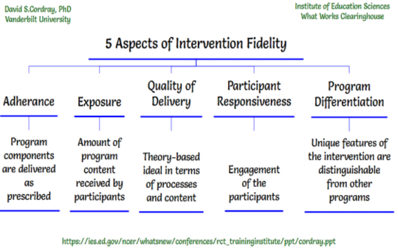

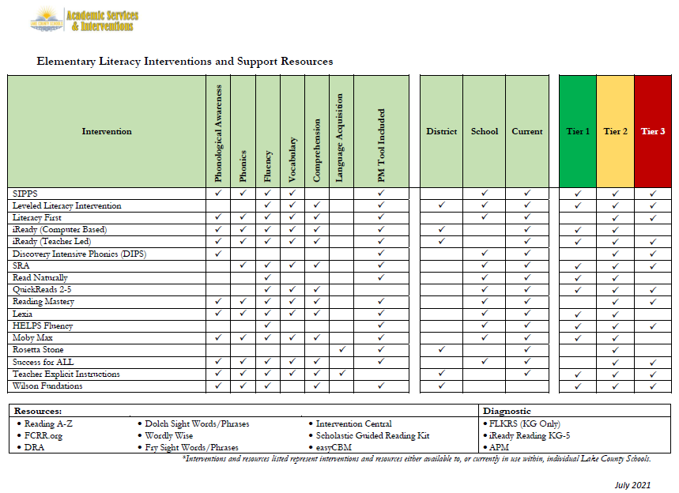

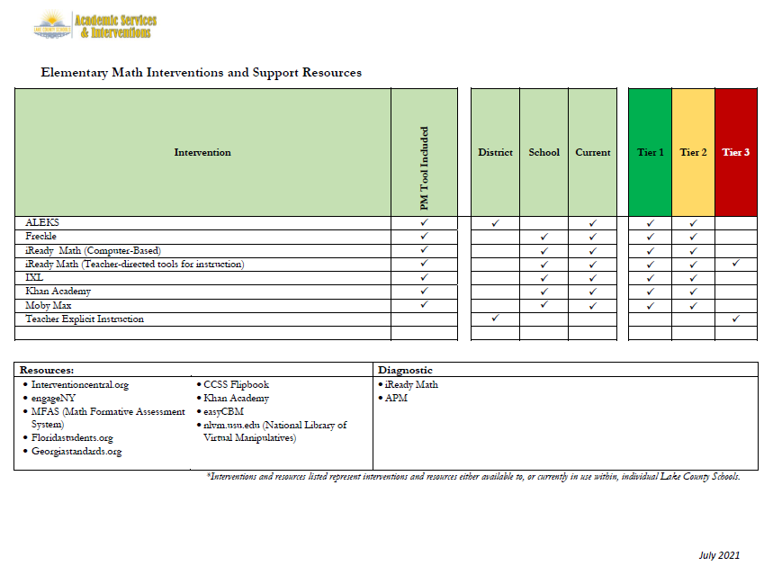
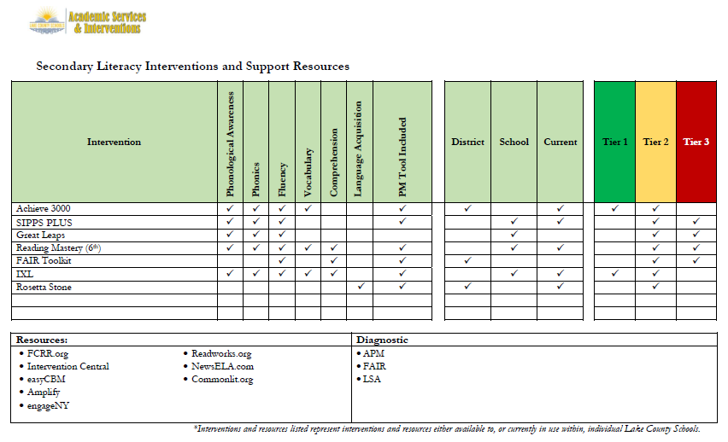

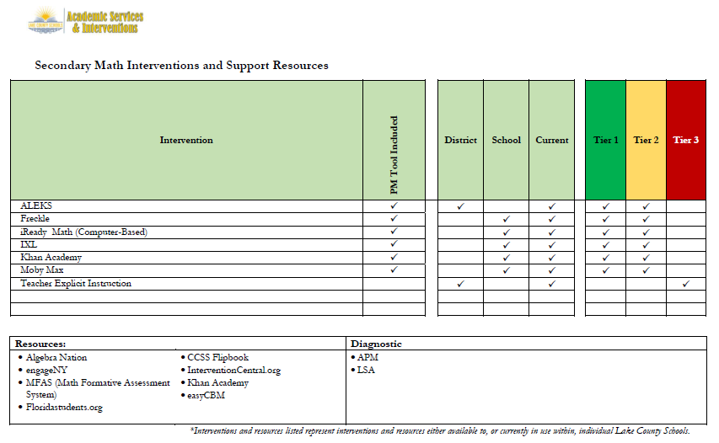
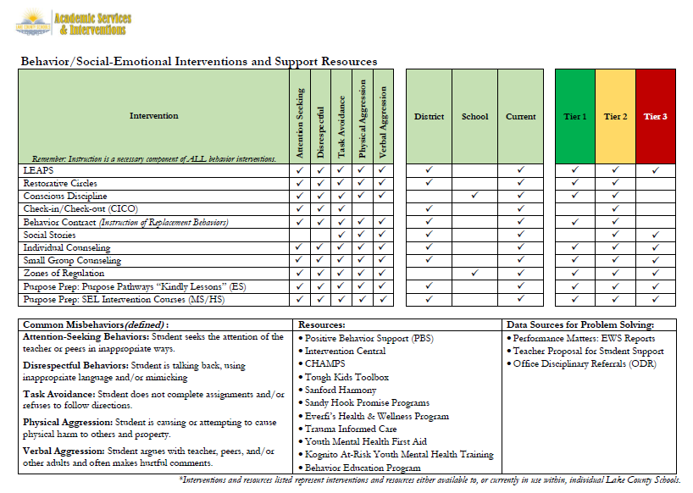

MTSS PD to Classroom Teachers, Leaders, & Support Staff
Each school establishes and supports a school-based Problem Solving Team (PST) who meets to review school-wide and student data, plan interventions, and use the 4-Step Problem-Solving model to make instructional decisions during the school year. Each Problem Solving Team meeting is unique in its purpose, outcomes, documentation, and expertise required by its members. For this reason, the PST includes individuals who have a diverse skill set which can address a variety of behavioral and academic needs. Some PST meetings may require all members to be in attendance, while meetings focused on a targeted topic, such as reading, math, chronic absenteeism, or behavior, would only require specific members. In this case, a subcommittee which is composed of members with expertise related to the area of focus, would meet to establish supplemental supports, match them to identified student needs, and establish a system for monitoring fidelity and student response to interventions (RTI).
Ongoing professional development and on-site support is provided to schools, teachers and leaders in order to meet this expectation. Virtual and face-to-face options, as well as videos and a district MTSS Guide are available to teachers and leaders for on-demand and direct support. As a result of Tier 1 data analysis, the PST will have a list of students whom they have identified as needing supplemental intervention. At the first of the two types of Tier 2 meetings, a subcommittee of the PST will assemble to match students to appropriate interventions based on identified needs as evidenced through data analysis. The PST will establish the intervention within the Performance Matters platform, specifically defining the logistics, focus and rationale of the intervention. Student Response to Intervention (RTI) data will be reviewed at scheduled RTI meetings, which are the second type of Tier 2 meeting. At that time, decision rules will be applied that will result in a determination of next steps which could include fading, continuing, modifying, or changing the intervention. In a small percentage of cases, students may need to add an extra layer of support through the addition of a more intensive, Tier 3 intervention.

Information and Assistance to Parents
Lake County Schools is committed to providing high-quality instruction and intervention support to promote the highest achievement of all students, both academically and behaviorally. At each school, a team of professionals reviews school-wide data to identify students requiring additional support. The implementation of a Multi-Tiered System of Supports (MTSS) provides assistance to students, families and teachers in seeking positive solutions. A parent guide is provided to parents that explains the District’s MTSS (Multi-Tiered System of Supports) and how this framework for providing instruction and intervention aligned to student needs will support their child. It also outlines for parents how they can remain involved in their child’s educational process.

Parents are empowered to inquire about their child’s progress through various methods including the MTSS Parent Guide, though it is the school’s obligation to keep parents informed. When students are included in interventions at Tiers 2 and 3, the parent can expect the following to occur: 1) Instruction and Interventions that are appropriately matched to their student’s needs; 2) Levels of support (academic and/or behavioral) that increase beyond instruction which is provided to all students; 3) Progress monitoring and feedback regarding their child’s’ response to the intervention(s) being provided; 4) Involvement in data-based problem solving and decision making about instruction and intervention for their child. Parents are notified of students’ response to Tier 2 and Tier 3 interventions at strategic points throughout the year. However, if a parent has questions or concerns at any time while their child is receiving interventions, a conference can be scheduled to review their child’s data and understand next steps involving instruction and interventions. Parents are beneficial in this process, as they offer valuable information on how their child learns best and what motivates them.

Part III LEA Plan for Safe Return of In-Person Instruction

Each LEA developed and made publicly available on the LEA’s website a plan for the safe return of in-person learning in the Fall of 2020. This was before the enactment of the ARP Act. This plan must be updated to address the requirements of the U.S. Department of Education’s Interim Final Rule, 88 FR 21195. The Interim Final Rule “does not mandate that an LEA adopt the CDC guidance, but only requires that the LEA describe in its plan the extent to which it has adopted the key prevention and mitigation strategies identified in the guidance.” 88 FR at 21200. Any updated LEA plan must be consistent with state law, including any applicable executive order, any agency emergency order, or any agency regulation or rule. Note specifically that LEA policies must comply with section 381.00316, Florida Statutes, and that any policies implemented after August 9, 2021 must comply with Florida Department of Health Rule 64DER21 -12, F.A.C., and any policies implemented after September 22, 2021 must comply with Florida Department of Health Rule 64DER21-15, F.A.C.

Each LEA must seek public comment on the plan and take such comments into account prior to submission of the final plan to the Department within 60 days of the award. Upon the Department’s approval, the LEA shall post this updated plan on the LEA’s website within 90 days of the award.

☒ By checking this box, the LEA acknowledges the requirement that each LEA shall update its Plan for Safe Return of In-Person Instruction to reflect the requirements stated above, shall seek public comment on the updated plan and take such comments into account prior to the submission of the final plan to the Department within 60 days of the award. Upon the Department’s approval, the LEA shall post this updated plan on the LEA’s website within 90 days of the award.

Part IV: Assurances

The district must agree to ALL of the assurances by checking the corresponding boxes.

☒ Assurance 1: LEA Periodic Plan Update with Public Comment. As required in the U.S. Department of Education’s Interim Final Rule, 88 FR 21195, the LEA must regularly, but no less frequently than every six months, review and as appropriate, revise its plan for the safe return to in-person instruction and continuity of services. In determining whether revisions are necessary, and in making any revisions, the LEA must seek public input and take such input into account. If at the time the LEA revises its plan the CDC has updated its guidance on reopening schools, the revised plan must address the extent to which the LEA has adopted policies, and describe any policies, for each of the updated safety recommendations. Significantly, the Interim Final Rule “does not mandate that an LEA adopt the CDC guidance, but only requires that the LEA describe in its plan the extent to which it has adopted the key prevention and mitigation strategies identified in the guidance.” 88 FR at 21200. Any updated LEA plan must be consistent with state law, including any applicable executive order, any agency emergency order, or any agency regulation or rule. Specifically, LEA policies must comply with section 381.00316, Florida Statutes, and any policies implemented after August 9, 2021 must comply with Florida Department of Health Rule 64DER21 -12, F.A.C., and any policies implemented after September 22, 2021 must comply with Florida Department of Health Rule 64DER21-15, F.A.C.
☒ Assurance 2: Continue progress monitoring and interventions. The district agrees to provide robust progress monitoring and requisite interventions must be extended to all students with tiered support for students who are performing below grade level and are not making adequate progress. Students who are receiving instruction through innovative teaching methods must transition to another teaching method if they fail to make adequate progress. The district agrees to provide monthly progress monitoring reports to parent/guardians for students identified as performing below grade level and/or demonstrating decline on the district’s progress monitoring system.

☒ Assurance 3: Allowable Uses of Funds. The LEA will use funds for activities allowable under section 2001(e) of the CRRSA Act.

☒ Assurance 4: Maintenance of Equity. The LEA will comply with all requirements relating to Maintenance of Equity, in accordance with section 2004(c) of the ARP Act.

☒ Assurance 5: Reporting. The LEA will comply with all reporting requirements, and submit required reports to the Florida Department of Education at such time and in such manner and containing such information as the department may subsequently require.

☒ Assurance 6: Audits, Inspections or Examinations. The LEA will cooperate with any examination of records with respect to such funds by making records available for inspection, production, and examination, and authorized individuals available for interview and examination, upon the request of (i) the Florida Department of Education, the Florida Auditor General; (ii) the Department and/or its Inspector General; or (iii) any other federal or state agency, commission, or department in the lawful exercise of its jurisdiction and authority.

Acknowledgement

Local Educational Agency Chief Executive Officer or Authorized Representative

Name and title of person responsible for completion and submission
Thomas Scott Ward
Contact information: email, phone number
Wardt1@lake.k12.fl.us (352) 253-6566
Superintendent signature (or authorized representative)

