# Grade 3 Accelerated B.E.S.T. Instructional Guide for Mathematics

The B.E.S.T. Instructional Guide for Mathematics (B1G-M) is intended to assist educators with planning for student learning and instruction aligned to Florida’s Benchmarks for Excellent Student Thinking (B.E.S.T.) Standards. This guide is designed to aid high-quality instruction through the identification of components that support the learning and teaching of the B.E.S.T. Mathematics Standards and Benchmarks. The B1G-M includes an analysis of information related to the B.E.S.T. Standards for Mathematics within this specific mathematics course, the instructional emphasis and aligned resources. This document is posted on the [B.E.S.T. Standards for Mathematics webpage](https://www.fldoe.org/academics/standards/subject-areas/math-science/mathematics/bestmath.stml) of the Florida Department of Education’s website and will continue to undergo edits as needed.

## Structural Framework and Intentional Design of the B.E.S.T. Standards for Mathematics

Florida’s B.E.S.T. Standards for Mathematics were built on the following.

* The coding scheme for the standards and benchmarks was changed to be consistent with other content areas. The new coding scheme is structured as follows:

Content.GradeLevel.Strand.Standard.Benchmark.

* Strands were streamlined to be more consistent throughout.
* The standards and benchmarks were written to be clear and concise to ensure that they are easily understood by all stakeholders.
* The benchmarks were written to allow teachers to meet students’ individual skills, knowledge and ability.
* The benchmarks were written to allow students the flexibility to solve problems using a method or strategy that is accurate, generalizable and efficient depending on the content (i.e., the numbers, expressions or equations).
* The benchmarks were written to allow for student discovery (i.e., exploring) of strategies rather than the teaching, naming and assessing of each strategy individually.
* The benchmarks were written to support multiple pathways for success in career and college for students.
* The benchmarks should not be taught in isolation but should be combined purposefully.
* The benchmarks may be addressed at multiple points throughout the year, with the intention of gaining mastery by the end of the year.
* Appropriate progression of content within and across strands was developed for each grade level and across grade levels.
* There is an intentional balance of conceptual understanding and procedural fluency with the application of accurate real-world context intertwined within mathematical concepts for relevance.
* The use of other content areas, like science and the arts, within real-world problems should be accurate, relevant, authentic and reflect grade-level appropriateness.

## Components of the B.E.S.T. Instructional Guide for Mathematics

The following table is an example of the layout for each benchmark and includes the defining attributes for each component. It is important to note that instruction should not be limited to the possible connecting benchmarks, related terms, strategies or examples provided. To do so would strip the intention of an educator meeting students’ individual skills, knowledge and abilities.

Benchmark

focal point for instruction within lesson or task

This section includes the benchmark as identified in the [B.E.S.T. Standards for Mathematics](https://www.cpalms.org/uploads/docs/standards/BEST/MA/MathBESTStandardsFinal.pdf). The benchmark, also referred to as the Benchmark of Focus, is the focal point for student learning and instruction. The benchmark, and its related example(s) and clarification(s), can also be found in the course description. The 9-12 benchmarks may be included in multiple courses; select the example(s) or clarification(s) as appropriate for the identified course.

Connecting Benchmarks/Horizontal Alignment

in other standards within the grade level or course

This section includes a list of connecting benchmarks that relate horizontally to the Benchmark of Focus. Horizontal alignment is the intentional progression of content within a grade level or course linking skills within and across strands. Connecting benchmarks are benchmarks that either make a mathematical connection or include prerequisite skills. The information included in this section is not a comprehensive list, and educators are encouraged to find other connecting benchmarks. Additionally, this list will not include benchmarks from the same standard since benchmarks within the same standard already have an inherent connection.

Terms from the K-12 Glossary

This section includes terms from Appendix C: K-12 Glossary, found within the B.E.S.T. Standards for Mathematics document, which are relevant to the identified Benchmark of Focus. The terms included in this section should not be viewed as a comprehensive vocabulary list, but instead should be considered during instruction or act as a reference for educators.

Vertical Alignment

across grade levels or courses

This section includes a list of related benchmarks that connect vertically to the Benchmark of Focus. Vertical alignment is the intentional progression of content from one year to the next, spanning across multiple grade levels. Benchmarks listed in this section make mathematical connections from prior grade levels or courses in future grade levels or courses within and across strands. If the Benchmark of Focus is a new concept or skill, it may not have any previous benchmarks listed. Likewise, if the Benchmark of Focus is a mathematical skill or concept that is finalized in learning and does not have any direct connection to future grade levels or courses, it may not have any future benchmarks listed. The information included in this section is not a comprehensive list, and educators are encouraged to find other benchmarks within a vertical progression.

Purpose and Instructional Strategies

This section includes further narrative for instruction of the benchmark and vertical alignment. Additionally, this section may also include the following:

* explanations and details for the benchmark;
* vocabulary not provided within Appendix C;
* possible instructional strategies and teaching methods; and
* strategies to embed potentially related Mathematical Thinking and Reasoning Standards (MTRs).

Common Misconceptions or Errors

This section will include common student misconceptions or errors and may include strategies to address the identified misconception or error. Recognition of these misconceptions and errors enables educators to identify them in the classroom and make efforts to correct the misconception or error. This corrective effort in the classroom can also be a form of formative assessment within instruction.

**Strategies** to Support Tiered Instruction

The instructional strategies in this section address the common misconceptions and errors listed within the above section that can be a barrier to successfully learning the benchmark. All instruction and intervention at Tiers 2 and 3 are intended to support students to be successful with Tier 1 instruction. Strategies that support tiered instruction are intended to assist teachers in planning across any tier of support and should not be considered exclusive or inclusive of other instructional strategies that may support student learning with the B.E.S.T. Mathematics Standards. For more information about tiered instruction, please see the Effective Tiered Instruction for Mathematics: ALL Means ALL document.

Instructional Tasks

demonstrate the depth of the benchmark and the connection to the related benchmarks

This section will include example instructional tasks, which may be open-ended and are intended to demonstrate the depth of the benchmark. Some instructional tasks include integration of the Mathematical Thinking and Reasoning Standards (MTRs) and related benchmark(s). Enrichment tasks may be included to make connections to benchmarks in later grade levels or courses. Tasks may require extended time, additional materials and collaboration.

Instructional Items

demonstrate the focus of the benchmark

This section will include example instructional items which may be used as evidence to demonstrate the students’ understanding of the benchmark. Items may highlight one or more parts of the benchmark.

*The strategies, tasks and items included in the B1G-M are examples and should not be considered comprehensive.

# Mathematical Thinking and Reasoning Standards

MTRs: Because Math Matters

Florida students are expected to engage with mathematics through the Mathematical Thinking and Reasoning Standards (MTRs) by utilizing their language as a self-monitoring tool in the classroom, promoting deeper learning and understanding of mathematics. The MTRs are standards which should be used as a lens when planning for student learning and instruction of the B.E.S.T. Standards for Mathematics.

## Structural Framework and Intentional Design of the Mathematical Thinking and Reasoning Standards

The Mathematical Thinking and Reasoning Standards (MTRs) are built on the following.

* The MTRs have the same coding scheme as the standards and benchmarks; however, they are written at the standard level because there are no benchmarks.
* In order to fulfill Florida’s unique coding scheme, the 5th place (benchmark) will always be a “1” for the MTRs.
* The B.E.S.T. Standards for Mathematics should be taught through the lens of the MTRs.
* At least one of the MTRs should be authentically and appropriately embedded throughout every lesson based on the expectation of the benchmark(s).
* The bulleted language of the MTRs were written for students to use as self-monitoring tools during daily instruction.
* The clarifications of the MTRs were written for teachers to use as a guide to inform their instructional practices.
* The MTRs ensure that students stay engaged, persevere in tasks, share their thinking, balance conceptual understanding and procedures, assess their solutions, make connections to previous learning and extended knowledge, and apply mathematical concepts to real-world applications.
* The MTRs should not stand alone as a separate focus for instruction but should be combined purposefully.
* The MTRs will be addressed at multiple points throughout the year, with the intention of gaining mastery of mathematical skills by the end of the year and building upon these skills as they continue in their K-12 education.

MA.K12.MTR.1.1 Actively participate in effortful learning both individually and collectively.

Mathematicians who participate in effortful learning both individually and with others:

* Analyze the problem in a way that makes sense given the task.
* Ask questions that will help with solving the task.
* Build perseverance by modifying methods as needed while solving a challenging task.
* Stay engaged and maintain a positive mindset when working to solve tasks.
* Help and support each other when attempting a new method or approach.

Clarifications:

Teachers who encourage students to participate actively in effortful learning both individually and with others:

* Cultivate a community of growth mindset learners.
* Foster perseverance in students by choosing tasks that are challenging.
* Develop students’ ability to analyze and problem solve.
* Recognize students’ effort when solving challenging problems.

MA.K12.MTR.2.1 Demonstrate understanding by representing problems in multiple ways.

Mathematicians who demonstrate understanding by representing problems in multiple ways:

* Build understanding through modeling and using manipulatives.
* Represent solutions to problems in multiple ways using objects, drawings, tables, graphs and equations.
* Progress from modeling problems with objects and drawings to using algorithms and equations.
* Express connections between concepts and representations.
* Choose a representation based on the given context or purpose.

Clarifications:

Teachers who encourage students to demonstrate understanding by representing problems in multiple ways:

* Help students make connections between concepts and representations.
* Provide opportunities for students to use manipulatives when investigating concepts.
* Guide students from concrete to pictorial to abstract representations as understanding progresses.
* Show students that various representations can have different purposes and can be useful in different situations.

MA.K12.MTR. 3.1 Complete tasks with mathematical fluency.

Mathematicians who complete tasks with mathematical fluency:

* Select efficient and appropriate methods for solving problems within the given context.
* Maintain flexibility and accuracy while performing procedures and mental calculations.
* Complete tasks accurately and with confidence.
* Adapt procedures to apply them to a new context.
* Use feedback to improve efficiency when performing calculations.

Clarifications:

Teachers who encourage students to complete tasks with mathematical fluency:

* Provide students with the flexibility to solve problems by selecting a procedure that allows them to solve efficiently and accurately.
* Offer multiple opportunities for students to practice efficient and generalizable methods.
* Provide opportunities for students to reflect on the method they used and determine if a more efficient method could have been used.

MA.K12.MTR.4.1 Engage in discussions that reflect on the mathematical thinking of self and others.

Mathematicians who engage in discussions that reflect on the mathematical thinking of self and others:

* Communicate mathematical ideas, vocabulary and methods effectively.
* Analyze the mathematical thinking of others.
* Compare the efficiency of a method to those expressed by others.
* Recognize errors and suggest how to correctly solve the task.
* Justify results by explaining methods and processes.
* Construct possible arguments based on evidence.

Clarifications:

Teachers who encourage students to engage in discussions that reflect on the mathematical thinking of self and others:

* Establish a culture in which students ask questions of the teacher and their peers, and error is an opportunity for learning.
* Create opportunities for students to discuss their thinking with peers.
* Select, sequence and present student work to advance and deepen understanding of correct and increasingly efficient methods.
* Develop students’ ability to justify methods and compare their responses to the responses of their peers.

MA.K12.MTR.5.1 Use patterns and structure to help understand and connect mathematical concepts.

Mathematicians who use patterns and structure to help understand and connect mathematical concepts:

* Focus on relevant details within a problem.
* Create plans and procedures to logically order events, steps or ideas to solve problems.
* Decompose a complex problem into manageable parts.
* Relate previously learned concepts to new concepts.
* Look for similarities among problems.
* Connect solutions of problems to more complicated large-scale situations.

Clarifications:

Teachers who encourage students to use patterns and structure to help understand and connect mathematical concepts:

* Help students recognize the patterns in the world around them and connect these patterns to mathematical concepts.
* Support students to develop generalizations based on the similarities found among problems.
* Provide opportunities for students to create plans and procedures to solve problems.
* Develop students’ ability to construct relationships between their current understanding and more sophisticated ways of thinking.

MA.K12.MTR.6.1 Assess the reasonableness of solutions.

Mathematicians who assess the reasonableness of solutions:

* Estimate to discover possible solutions.
* Use benchmark quantities to determine if a solution makes sense.
* Check calculations when solving problems.
* Verify possible solutions by explaining the methods used.
* Evaluate results based on the given context.

Clarifications:

Teachers who encourage students to assess the reasonableness of solutions:

* Have students estimate or predict solutions prior to solving.
* Prompt students to continually ask, “Does this solution make sense? How do you know?”
* Reinforce that students check their work as they progress within and after a task.
* Strengthen students’ ability to verify solutions through justifications.

MA.K12.MTR.7.1 Apply mathematics to real-world contexts.

Mathematicians who apply mathematics to real-world contexts:

* Connect mathematical concepts to everyday experiences.
* Use models and methods to understand, represent and solve problems.
* Perform investigations to gather data or determine if a method is appropriate.
* Redesign models and methods to improve accuracy or efficiency.

Clarifications:

Teachers who encourage students to apply mathematics to real-world contexts:

* Provide opportunities for students to create models, both concrete and abstract, and perform investigations.
* Challenge students to question the accuracy of their models and methods.
* Support students as they validate conclusions by comparing them to the given situation.
* Indicate how various concepts can be applied to other disciplines.

## Examples of Teacher and Student Moves for the MTRs

Below are examples that demonstrate the embedding of the MTRs within the mathematics classroom. The provided teacher and student moves are examples of how some MTRs could be incorporated into student learning and instruction. The information included in this table is not a comprehensive list, and educators are encouraged to incorporate other teacher and student moves that support the MTRs.

| **MTR** | **Student Moves** | **Teacher Moves** |
| --- | --- | --- |
| MA.K12.MTR.1.1  *Actively participate in effortful learning both individually and collectively.* | * Students engage in the task through individual analysis, student-to-teacher interaction and student-to-student interaction. * Students ask task-appropriate questions to self, the teacher and to other students. *(MTR.4.1)* * Students have a positive productive struggle exhibiting growth mindset, even when making a mistake. * Students stay engaged in the task to a purposeful conclusion while modifying methods, when necessary, in solving a problem through self-analysis and perseverance. | * Teacher provides flexible options (i.e., differentiated, challenging tasks that allow students to actively pursue a solution both individually and in groups) so that all students have the opportunity to access and engage with instruction, as well as demonstrate their learning. * Teacher creates a physical environment that supports a growth mindset and will ensure positive student engagement and collaboration. * Teacher provides constructive, encouraging feedback to students that recognizes their efforts and the value of analysis and revision. * Teacher provides appropriate time for student processing, productive struggle and reflection. * Teacher uses data and questions to focus students on their thinking; help students determine their sources of struggle and to build understanding. * Teacher encourages students to ask appropriate questions of other students and of the teacher including questions that examine accuracy. *(MTR.4.1)* |
| MA.K12.MTR.2.1  *Demonstrate understanding by representing problems in multiple ways.* | * Students represent problems concretely using objects, models and manipulatives. * Students represent problems pictorially using drawings, models, tables and graphs. * Students represent problems abstractly using numerical or algebraic expressions and equations. * Students make connections and select among different representations and methods for the same problem, as appropriate to different situations or context. *(MTR.3.1)* | * Teacher provides students with objects, models, manipulatives, appropriate technology and real-world situations. *(MTR.7.1)* * Teacher encourages students to use drawings, models, tables, expressions, equations and graphs to represent problems and solutions. * Teacher questions students about making connections between different representations and methods and challenges students to choose one that is most appropriate to the context. *(MTR.3.1)* * Teacher encourages students to explain their different representations and methods to each other. *(MTR.4.1)* * Teacher provides opportunities for students to choose appropriate methods and to use mathematical technology. |
| MA.K12.MTR.3.1  *Complete tasks with mathematical fluency.* | * Students complete tasks with flexibility, efficiency and accuracy. * Students use feedback from peers and teachers to reflect on and revise methods used. * Students build confidence through practice in a variety of contexts and problems. *(MTR.1.1)* | * Teacher provides tasks and opportunities to explore and share different methods to solve problems. *(MTR.1.1)* * Teacher provides opportunities for students to choose methods and reflect (i.e., through error analysis, revision, summarizing methods or writing) on the efficiency and accuracy of the method(s) chosen. * Teacher asks questions and gives feedback to focus student thinking to build efficiency of accurate methods. * Teacher offers multiple opportunities to practice generalizable methods. |
| MA.K12.MTR.4.1  *Engage in discussions that reflect on the mathematical thinking of self and others.* | * Students use content specific language to communicate and justify mathematical ideas and chosen methods. * Students use discussions and reflections to recognize errors and revise their thinking. * Students use discussions to analyze the mathematical thinking of others. * Students identify errors within their own work and then determine possible reasons and potential corrections. * When working in small groups, students recognize errors of their peers and offers suggestions. | * Teacher provides students with opportunities (through open-ended tasks, questions and class structure) to make sense of their thinking. *(MTR.1.1)* * Teacher uses precise mathematical language, both written and abstract, and encourages students to revise their language through discussion. * Teacher creates opportunities for students to discuss and reflect on their choice of methods, their errors and revisions and their justifications. * Teachers select, sequence and present student work to elicit discussion about different methods and representations. *(MTR.2.1, MTR.3.1)* |
| MA.K12.MTR.5.1 *Use patterns and structure to help understand and connect mathematical concepts.* | * Students identify relevant details in a problem in order to create plans and decompose problems into manageable parts. * Students find similarities and common structures, or patterns, between problems in order to solve related and more complex problems using prior knowledge. | * Teacher asks questions to help students construct relationships between familiar and unfamiliar problems and to transfer this relationship to solve other problems. *(MTR.1.1)* * Teacher provides students opportunities to connect prior and current understanding to new concepts. * Teacher provides opportunities for students to discuss and develop generalizations about a mathematical concept. *(MTR.3.1, MTR.4.1)* * Teacher allows students to develop an appropriate sequence of steps in solving problems. * Teacher provides opportunities for students to reflect during problem solving to make connections to problems in other contexts, noticing structure and making improvements to their process. |
| MA.K12.MTR.6.1 *Assess the reasonableness of solutions.* | * Students estimate a solution, including using benchmark quantities in place of the original numbers in a problem. * Students monitor calculations, procedures and intermediate results during the process of solving problems. * Students verify and check if solutions are viable, or reasonable, within the context or situation. *(MTR.7.1)* * Students reflect on the accuracy of their estimations and their solutions. | * Teacher provides opportunities for students to estimate or predict solutions prior to solving. * Teacher encourages students to compare results to estimations and revise if necessary for future situations. *(MTR.5.1)* * Teacher prompts students to self-monitor by continually asking, “Does this solution or intermediate result make sense? How do you know?” * Teacher encourages students to provide explanations and justifications for results to self and others. *(MTR.4.1)* |
| MA.K12.MTR.7.1 *Apply mathematics to real-world contexts.* | * Students connect mathematical concepts to everyday experiences. * Students use mathematical models and methods to understand, represent and solve real-world problems. * Students investigate, research and gather data to determine if a mathematical model is appropriate for a given situation from the world around them. * Students re-design models and methods to improve accuracy or efficiency. | * Teacher provides real-world context to help students build understanding of abstract mathematical ideas. * Teacher encourages students to assess the validity and accuracy of mathematical models and situations in real-world context, and to revise those models if necessary. * Teacher provides opportunities for students to investigate, research and gather data to determine if a mathematical model is appropriate for a given situation from the world around them. * Teacher provides opportunities for students to apply concepts to other content areas. |

Grade 3 Accelerated Areas of Emphasis

In Grade 3 Accelerated Mathematics, instructional time will emphasize five areas:

(1) extending understanding of place value in multi-digit whole numbers;

(2) adding and subtracting multi-digit whole numbers, including using a standard algorithm;

(3) building an understanding of multiplication and division, the relationship between them and the connection to area of rectangles;

(4) developing an understanding of fractions and

(5) extending geometric reasoning to lines, angles and attributes of quadrilaterals.

The purpose of the areas of emphasis is not to guide specific units of learning and instruction, but rather provide insight on major mathematical topics that will be covered within this mathematics course. In addition to its purpose, the areas of emphasis are built on the following:

* Supports the intentional horizontal progression within the strands and across the strands in this grade level or course.
* Student learning and instruction should not focus on the stated areas of emphasis as individual units.
* Areas of emphasis are addressed within standards and benchmarks throughout the course so that students are making connections throughout the school year.
* Some benchmarks can be organized within more than one area.
* Supports the communication of the major mathematical topics to all stakeholders.
* Benchmarks within the areas of emphasis should not be taught within the order in which they appear. To do so would strip the progression of mathematical ideas and miss the opportunity to enhance horizontal progressions within the grade level or course.

The table below shows how the benchmarks within this mathematics course are embedded within the areas of emphasis.

| **Number Sense and Operations** | **Extending Understanding of Place Value in Multi-digit Whole Numbers** | **Adding and Subtracting Multi-digit Whole Numbers** | **Building Understanding of Multiplication and Division** | **Building Understanding of Fractions** | **Extending Geometric Reasoning to Lines, Angles and Attributes of Quadrilaterals** |
| --- | --- | --- | --- | --- | --- |
| MA.3.NSO.1.1 | X | X |  |  |  |
| MA.3.NSO.1.2 | X | X |  |  |  |
| MA.3.NSO.1.3 | X | X |  |  |  |
| MA.3.NSO.1.4 | X | X |  |  |  |
| MA.3.NSO.2.1 | X |  | X |  |  |
| MA.3.NSO.2.2 |  |  | X |  |  |
| MA.3.NSO.2.3 | X |  | X |  |  |
| MA.3.NSO.2.4 |  |  | X |  |  |
| MA.4.NSO.1.2 | X |  | X |  |  |
| MA.4.NSO.1.3 | X |  | X |  |  |
| MA.4.NSO.1.4 | X |  | X |  |  |
| MA.4.NSO.2.1 |  |  | X |  |  |
| MA.4.NSO.2.2 |  |  | X |  |  |
| MA.4.NSO.2.5 | X |  | X |  |  |

| **Fractions** | **Extending Understanding of Place Value in Multi-digit Whole Numbers** | **Adding and Subtracting Multi-digit Whole Numbers** | **Building Understanding of Multiplication and Division** | **Building Understanding of Fractions** | **Extending Geometric Reasoning to Lines, Angles and Attributes of Quadrilaterals** |
| --- | --- | --- | --- | --- | --- |
| MA.3.FR.1.1 |  |  |  | X |  |
| MA.3.FR.1.2 |  |  |  | X |  |
| MA.3.FR.1.3 |  |  |  | X |  |
| MA.3.FR.2.1 |  |  |  | X |  |
| MA.3.FR.2.2 |  |  |  | X |  |
| MA.4.FR.1.1 |  |  |  | X |  |
| MA.4.FR.1.3 |  |  |  | X |  |
| MA.4.FR.1.4 |  |  |  | X |  |
| MA.4.FR.2.1 |  |  |  | X |  |
| MA.4.FR.2.2 |  |  |  | X |  |
| MA.4.FR.2.3 |  |  |  | X |  |

|  |  |  |  |  |  |
| --- | --- | --- | --- | --- | --- |
| **Algebraic Reasoning** | **Extending Understanding of Place Value in Multi-digit Whole Numbers** | **Adding and Subtracting Multi-digit Whole Numbers** | **Building Understanding of Multiplication and Division** | **Building Understanding of Fractions** | **Extending Geometric Reasoning to Lines, Angles and Attributes of Quadrilaterals** |
| MA.3.AR.1.1 |  |  | X |  |  |
| MA.3.AR.1.2 |  | X | X |  |  |
| MA.3.AR.2.1 |  |  | X |  |  |
| MA.3.AR.2.2 |  |  | X |  |  |
| MA.3.AR.2.3 |  |  | X |  |  |
| MA.3.AR.3.1 |  |  | X |  |  |
| MA.3.AR.3.2 |  |  | X |  |  |
| MA.3.AR.3.3 |  |  | X |  |  |
| MA.4.AR.1.2 |  |  |  | X |  |
| MA.4.AR.2.1 |  |  | X |  |  |
| MA.4.AR.2.2 |  |  | X |  |  |
| MA.4.AR.3.1 |  |  | X |  |  |
| MA.4.AR.3.2 |  |  | X |  |  |

|  |  |  |  |  |  |
| --- | --- | --- | --- | --- | --- |
| **Measurement** | **Extending Understanding of Place Value in Multi-digit Whole Numbers** | **Adding and Subtracting Multi-digit Whole Numbers** | **Building Understanding of Multiplication and Division** | **Building Understanding of Fractions** | **Extending Geometric Reasoning to Lines, Angles and Attributes of Quadrilaterals** |
| MA.3.M.1.1 |  | X |  | X |  |
| MA.3.M.1.2 |  | X | X |  |  |
| MA.3.M.2.1 |  | X |  |  |  |
| MA.3.M.2.2 |  | X |  |  |  |

|  |  |  |  |  |  |
| --- | --- | --- | --- | --- | --- |
| **Geometric Reasoning** | **Extending Understanding of Place Value in Multi-digit Whole Numbers** | **Adding and Subtracting Multi-digit Whole Numbers** | **Building Understanding of Multiplication and Division** | **Building Understanding of Fractions** | **Extending Geometric Reasoning to Lines, Angles and Attributes of Quadrilaterals** |
| MA.3.GR.1.1 |  |  |  | X |  |
| MA.3.GR.1.2 |  |  |  | X |  |
| MA.3.GR.1.3 |  |  |  | X |  |
| MA.3.GR.2.1 |  | X |  | X |  |
| MA.3.GR.2.2 |  |  | X | X |  |
| MA.3.GR.2.3 |  | X | X | X |  |
| MA.3.GR.2.4 |  | X | X | X |  |
| MA.4.GR.1.1 |  |  |  | X |  |
| MA.4.GR.1.2 |  |  |  | X |  |
| MA.4.GR.1.3 |  |  |  | X |  |
| MA.4.GR.2.1 |  |  | X |  |  |
| MA.4.GR.2.2 |  |  | X |  |  |

|  |  |  |  |  |  |
| --- | --- | --- | --- | --- | --- |
| **Data Analysis & Probability** | **Extending Understanding of Place Value in Multi-digit Whole Numbers** | **Adding and Subtracting Multi-digit Whole Numbers** | **Building Understanding of Multiplication and Division** | **Building Understanding of Fractions** | **Extending Geometric Reasoning to Lines, Angles and Attributes of Quadrilaterals** |
| MA.3.DP.1.1 |  |  | X |  |  |
| MA.3.DP.1.2 |  |  | X |  |  |

## Number Sense and Operations

**MA. 3.NSO.1** *Understand the place value of four-digit numbers.*

### MA.3.NSO.1.1 & MA.4.NSO.1.2

Benchmark (Grade 3)

MA.3.NSO.1.1 Read and write numbers from 0 to 10,000 using standard form, expanded form and word form.

*Example:* The number two thousand five hundred thirty written in standard form is 2,530 and in expanded form is 2,000 + 500 + 30.

Benchmark (Grade 4)

MA.4.NSO.1.2 Read and write multi-digit whole numbers from 0 to 1,000,000 using standard form, expanded form and word form.

*Example:* The number two hundred seventy-five thousand eight hundred two written in standard form is $275,802$ and in expanded form is $200,000+70,000+5,000+800+2$ or $(2×100,000)+(7×10,000)+(5×1,000)+(8×100)+(2×1)$.

Connecting Benchmarks/Horizontal Alignment

* MA.3.NSO.1.2, MA.3.NSO.1.3
* MA.4.NSO.1.3
* MA.4.NSO.2.5

Terms from the K-12 Glossary

* Expression
* Whole number

Vertical Alignment

|  |  |
| --- | --- |
| **Previous Benchmarks**   * MA.2.NSO.1.1 * MA.2.NSO.1.2 | **Next Benchmarks**   * MA.5.NSO.1.2 |
|  |  |

Purpose and Instructional Strategies

The purpose of this benchmark is for students to express numbers in standard form, expanded form, and word form. This work extends from the Grade 2 expectation to read and write numbers within 1,000 using standard form, expanded form and word form (MA.2.NSO.2.1). This work extends to reading and writing multi-digit whole numbers up to 1,000,000 using standard form, expanded form and word form within this Grade 3 Accelerated course. Additionally, translating from written form to symbolic form builds the understanding of place-value position which extends to decimal place values in Grade 5 (MA.5.NSO.1.2).

* Students learn to express multi-digit whole numbers using the place value of digits to name them in words.
  + For example, two thousand five hundred thirty is named after the 2 in the *thousands* place, the 5 in the *hundreds*  place, and the 3 in the *tens*  place. Students express multi-digit whole numbers by decomposing them by place value and showing them as an addition expression with the value of each nonzero digit. For example, 2,530 is decomposed as $2,000+500+30$.
* Students should have ample practice expressing numbers orally in standard form to reinforce the connection between how to say the number correctly and the value of the number.
* Decomposing numbers in expanded form helps students understand how addition and subtraction algorithms work, as well as helps them use the distributive property when multiplying multi-digit numbers (*MTR.2.1*).
* During instruction, teachers should related all three forms using place value charts and place value manipulatives (e.g. blocks) (*MTR.3.1, MTR.4.1, MTR.5.1*).
* Students should have opportunities to explore flexibly grouping. For example, that 285 could be 28 tens + 5 ones or 1 hundred, 18 tens and 5 ones, etc.
* Throughout instruction, teachers can ensure students have practice with problems that include both vertical and horizontal forms, including opportunities for students to apply the commutative and associative properties. This will provide students opportunities to explain their thinking and show their work by using place-value strategies and algorithms in addition to verifying that their answer is reasonable (*MTR.3.1, MTR.6.1*).

Decomposing numbers flexibly helps students reason through multiplication and division strategies. Multiple representations of the number *(MTR.2.1)* allow for opportunities to apply the commutative and associative properties. This will allow students to explain their thinking and show their work using place-value strategies and algorithms, in addition to verifying that their answer is reasonable.

Common Misconceptions or Errors

* When the value of a digit in a multi-digit whole number is 0, students can misunderstand that it represents 0 of that place value.
  + For example, in the number 2,530, there are 0 *ones*. In the number 1,008, there are 0 *hundreds* and 0 *tens*.
* Students may have misconceptions when translating word form to standard form. Numbers like one thousand often do not cause a problem; however, a number like three thousand four can cause problems for students. Many students will understand the 3,000 and the 4 but then instead of placing the 4 in the ones place, students will write the numbers as they hear them, 30,004, not understanding that this number represents more than 3,004.
* Instruction includes explanation of the word *and* when reading and writing in word form. Students should understand that the word *and* represents a decimal point in a number and separates the portions of the number that are greater than and less than 1.
  + For example, when reading 5,074, students should read as follows: five thousand seventy-four. Students may want to read the number five thousand *and* seventy-four, which is incorrect word form for whole numbers.

Strategies to Support Tiered Instruction

* Instruction includes using models and writing three- and four-digit numbers with a zero in various place values. A place value chart and models such as base-ten blocks or place value disks can be used to help students understand that when the value of a digit in a multi-digit whole number is 0, it represents a 0 of that place value.
* For example, in the number 1,030 there are 0 *hundreds* (beyond the ten *hundreds* represented by the 1 in the *thousands* place) and 0 *ones* (beyond the *ones* represented by the other digits.

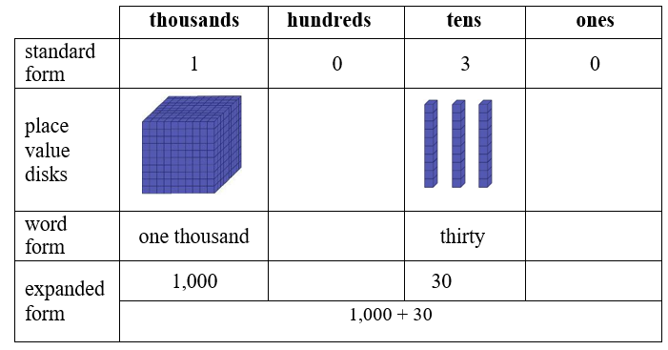

* For example, in the number 203, there are 0 *tens.*

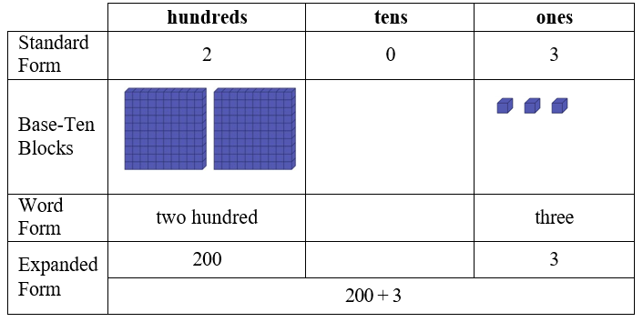

* Instruction includes opportunities to model and write numbers with a zero in various place values. A place value chart and models such as base-ten blocks or place value disks can be used to help students understand that when the digit in a multi-digit whole number is 0, it represents a 0 of that place value. Extend this understanding to include writing numbers in word and expanded form.
  + For example, in the number 40,607 there are $0 thousands$ and .

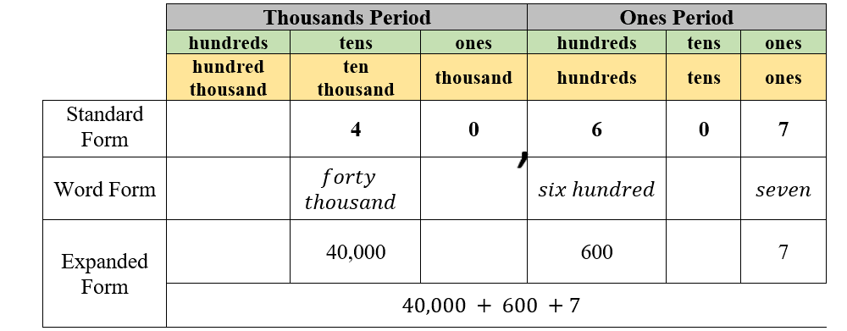

* + For example, in the number 1,002 there are $0 hundreds$ and $0 tens$.

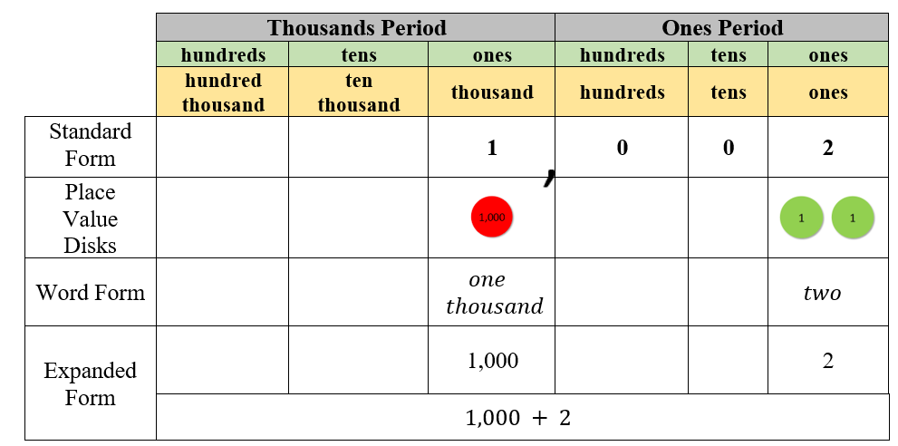

Instructional Tasks

*Instructional Task 1*

Henry says that the number 9,300 is read as nine thousand three. Noelle says that 9,300 is read as nine thousand thirty. Do you agree with either Henry or Noelle? Why or why not? Use expanded form to prove your thinking.

*Instructional Task 2*

Write each number in standard form and in expanded form.

$Eight hundred two thousand five hundred fifty$

$Twenty thousand three$

$One thousand four hundred fifty-six$

$Seven hundred nineteen thousand two hundred forty-eight$

$Three thousand eighty-one$

*Instructional Task 3*

Have students choose a card to determine if they will create a four- five- or six-digit number.

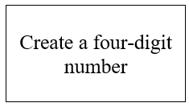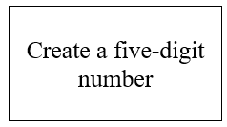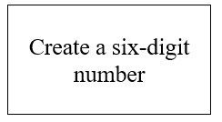

Students may choose the digits to create their number, but they must use only one zero. Then, have students fill in the chart below for each number they create.

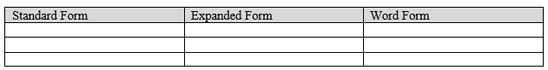

*Enrichment Task 1*

Callie selects the digit cards shown below.

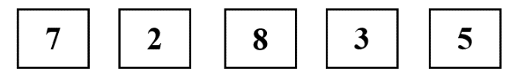

Part A: How can Callie organize the cards to create the greatest number? Write the number in standard form, word form and expanded form.

Part B: How can Callie organize the cards to create the least number? Write the number in standard form, word form and expanded form

Instructional Items

*Instructional Item 1*

Which shows three thousand seventy-nine in expanded form?

1. 300 + 70 + 9
2. 3,000 + 70 + 9
3. 3,000 + 70 + 90
4. 3,000 + 700 + 90

Instructional Item 2

Select all the ways to rename the number 65,704.

$60,000+500+70+4$

1. Sixty-five thousand seven hundred four
$60,000+5,000+700+4$

2. Six thousand five hundred seventy-four
3. 600,000 + 5,000 + 70 + 4

*The strategies, tasks and items included in the B1G-M are examples and should not be considered comprehensive.

### MA.3.NSO.1.2

Benchmark

MA.3.NSO.1.2 Compose and decompose four-digit numbers in multiple ways using thousands, hundreds, tens and ones. Demonstrate each composition or decomposition using objects, drawings and expressions or equations.

*Example:* The number 5,783 can be expressed as 5 *thousands* + 7 *hundreds* + 8 *tens* + 3 *ones* or as 56 *hundreds* + 183 *ones*.

Connecting Benchmarks/Horizontal Alignment

* MA.3.NSO.1.1
* MA.3.NSO.2.1
* MA.4.NSO.1.2

Terms from the K-12 Glossary

* Expression
* Whole numbers

Vertical Alignment

|  |  |
| --- | --- |
| **Previous Benchmarks**   * MA.2.NSO.1.1 * MA.2.NSO.1.2 | **Next Benchmarks**   * MA.4.NSO.1.1 * MA.5.NSO.1.3 |

Purpose and Instructional Strategies

The purpose of this benchmark is for students to identify ways numbers can be written flexibly using decomposition in addition to students knowing that number sense and computational understanding is built on a firm understanding of place value. This work extends from the Grade 2 expectation to compose and decompose three-digit numbers in multiple ways using hundreds, tens and ones (MA.2.NSO.1.2). This work prepares students for expressing how the digit in a multi-digit whole number changes if the digit moves one place to the left or right in the Grade 4 Accelerated course.

* Allow students to explore the relationship between adjacent place values as they are composing and decomposing numbers in multiple ways. For example, 1,243 can be expressed as *1 thousand + 2 hundreds + 4 tens + 3 ones* or *12 hundreds + 4 tens + 3 ones.* One thousand is 10 times greater than one hundred, so when we decompose the one thousand into 10 *hundreds* when expressing 1,243 we now have *12 hundreds.* Multiple representations of multi-digit whole numbers allow students to identify opportunities for regrouping while adding and subtracting. For example, when subtracting 5,783 – 892, we can represent 5,783 as 5 *thousands* + 6 *hundreds* + 18 *tens* + 3 *ones* by regrouping 1 *hundred*  as 10 *tens* , allowing us to subtract 9 *tens* *(MTR.2.1, MTR.3.1)*.
* Students should use objects (e.g., base ten blocks), drawings, and expressions or equations side-by-side to compare the representations. Model to show how multiple representations relate to the original number. For example, use base ten blocks to show how in the number 5,783, 1 *hundred* can be regrouped as 10 *tens* to express it as5 *thousands* + 6 *hundreds* + 18 *tens* + 3 ones , while asking students how they are the same *(MTR.2.1)*.
* Allow students to decompose numbers in as many ways as possible with objects, manipulatives, expressions and equations. Have students compare the representations shared *(MTR.4.1)*.
* Students should see examples of numbers within 10,000 where zero is a digit and make sense of its value.
* Flexibility of place value is a prerequisite for conceptual understanding of a standard algorithm for addition and subtraction with regrouping.

Common Misconceptions or Errors

* Students can misunderstand that the 5 in 57. They may see the 5 as representing 5, not 50 or 5 *tens*. Students need practice with representing two and three-digit numbers with manipulatives that group (base ten blocks) and those that do NOT group, such as counters, etc.
* Students can misunderstand that when decomposing a number in multiple ways, the value of the number does not change. 879 is the same as 87 *tens* + 9 *ones* and 8 *hundreds* + 79 *ones*.

Strategies to Support Tiered Instruction

* Instruction includes decomposing numbers using manipulatives that group (such as base ten blocks) and those that do not group (such as counters). When decomposing a number, students focus on the value of each digit based on its place value. To reinforce this concept, students may count by units based on the place value.
* For example, decompose 362 using base ten blocks and explain the value of each digit.

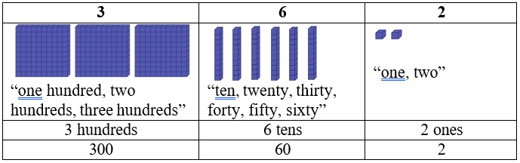

* For example, represent 34 using counters and explain the value of each digit. Students group 10 ones as a group of ten and focus on the value of each digit based on its place value. To reinforce this concept, students count by units based on the place value.

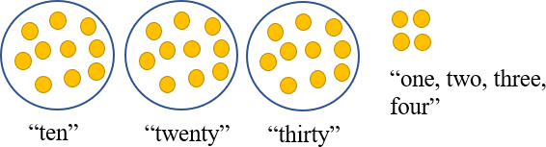

* Teacher provides opportunities to decompose numbers in multiple ways using manipulatives and a chart to organize their thinking and asks students to name/identify the different ways to name the values (regrouping the hundreds into tens and the tens into the ones, e.g., 36 *tens* and 2 *ones* or 3 *hundreds* and 62 *ones*, etc.)
  + For example, students decompose 362 in multiple ways using hundreds, tens, and ones.

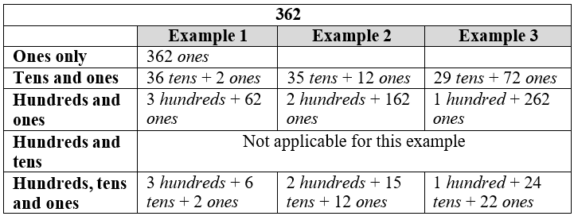

* For example, students decompose 34 in multiple ways using tens and ones

|  |  |  |  |
| --- | --- | --- | --- |
| **34** | | | |
|  | **Example 1** | **Example 2** | **Example 3** |
| **Tens** | 3 *tens* + 4 *ones*  3 tens  Graphic to explain example 3 ones | 2 *tens* + 14 *ones* | 1 *tens* + 24 *ones* |
| **and** |
| **ones** |

Instructional Tasks

*Instructional Task 1*

Part A. Express the number 5,783 using only thousands and ones.

Part B. Express the number 5,783 using only hundreds and ones.

Part C. Express the number 5.783 using only tens and ones.

*Instructional Task 2*

Decompose the following number in two different ways: 6,905.

*Instructional Task 3*

Determine what number is shown below.

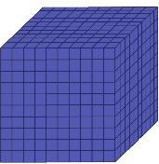   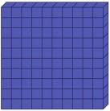      Graphic to explain example  Graphic to explain example  Graphic to explain example 



*Enrichment Task 1*

The number 9,465 is expressed in multiple ways in the chart below.

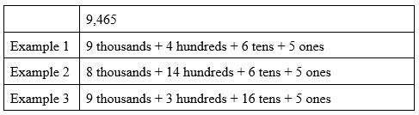

Part A: Compare the thousands and hundreds from Examples 1 and 2. What do you notice?

Part B: Compare the hundreds and tens from Examples 1 and 3. What do you notice?

Part C: Can you represent this number in at least two other ways not shown in the chart?

Instructional Items

*Instructional Item 1*

Select all the ways that express the number 8,709.

1. 8,000 + 600 + 19
2. 8,000 + 700 + 19
3. 879 *ones*
4. 8 *thousands* + 6 *hundreds* + 10 *tens* + 9 *ones*

*Instructional Item 2*

4,851 = 3 *thousands* + _______ *hundreds* + 5 *tens* + 1

*Instructional Item 3*

What is the value of this expression?

71 *hundreds* + 53 *ones*

*Instructional Item 4*

How many total hundreds are in the number 9,844?

1. 9
2. 98
3. 984
4. 9,844

*Enrichment Item 1*

Fill in the missing information, including the Target Number, in the chart below.

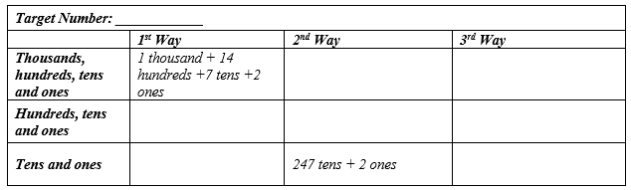

*The strategies, tasks and items included in the B1G-M are examples and should not be considered comprehensive.

### MA.3.NSO.1.3 & MA.4.NSO.1.3

Benchmark (Grade 3)

MA.3.NSO.1.3 Plot, order and compare whole numbers up to 10,000.

*Example:* The numbers 3,475; 4,743 and 4,753 can be arranged in ascending order as 3,475; 4,743 and 4,753.

Benchmark Clarifications:

*Clarification 1:* When comparing numbers, instruction includes using an appropriately scaled number line and using place values of the thousands, hundreds, tens and ones digits.

*Clarification 2:* Number lines, scaled by 50s, 100s or 1,000s, must be provided and can be a representation of any range of numbers.

*Clarification 3:* Within this benchmark, the expectation is to use symbols (<, > or =).

Benchmark (Grade 4)

MA.4.NSO.1.3 Plot, order and compare whole numbers up to 1,000,000.

*Example:* The numbers 75,421; 74,241 and 74,521 can be arranged in ascending order as 74,241; 74,521 and 75,421.

Benchmark Clarifications:

*Clarification 1:* When comparing numbers, instruction includes using an appropriately scaled number line and using place values of the hundred thousands, ten thousands, thousands, hundreds, tens and ones digits.

*Clarification 2:* Scaled number lines must be provided and can be a representation of any range of numbers.

*Clarification 3:* Within this benchmark, the expectation is to use symbols (<, > or =).

Connecting Benchmarks/Horizontal Alignment

* MA.3.NSO.1.1, MA.3.NSO.1.2
* MA.3.AR.2.2
* MA.4.NSO.1.2, MA.4.NSO.1.3
* MA.4.NSO.2.5
* MA.4.FR.1.4

Terms from the K-12 Glossary

* Number Line
* Whole Number

Vertical Alignment

|  |  |
| --- | --- |
| **Previous Benchmarks**   * MA.2.NSO.1.3 | **Next Benchmarks**   * MA.5.NSO.1.4 |

Purpose and Instructional Strategies

* The purpose of these benchmarks is for students to compare two numbers by examining the place values of *hundred thousands*, *ten thousands*, *thousands*, *hundreds*, *tens* and *ones* in each number. This work extends from the Grade 2 expectation to plot, order and compare up to 1,000 (MA.2.NSO.1.3). In Grade 3 Accelerated, the magnitude of numbers extends to 1,000,000.
* Instruction should use the terms greater than, less, than, and equal to, as well as the corresponding symbols (>, <, and =). Students should use place value strategies and number lines (horizontal and vertical) to justify how they compare numbers and explain their reasoning. For example, in comparing 4,743 and 4,753, a student might say both numbers have the same value of 1,000s and the same value of 100s; however, the value in the 10s place is different so that is where the comparison of the two numbers would be determined. Instruction should not rely on tricks for determining the direction of the inequality symbols. Students should read entire statements (e.g., read 4,753 > 4,743, “4,753 is greater than 4,743” and vice versa) *(MTR.2.1, MTR.3.1)*.
* Students should understand the meaning of the ≠ symbol through instruction. It is recommended that students use = and ≠ symbols first. Once students have determined that numbers are not equal, then they can determine “how” they are not equal, with the understanding now that the number is either greater than (>) or less than (<).If students cannot determine if amounts are ≠ or =, then they will struggle with < or >. This will build understanding of statements of inequality and help students determine differences between inequalities and equations *(MTR.6.1)*.
* Students need opportunities to compare numbers in various situations to build procedural fluency and to compare numbers with the same number of digits, numbers that have the same number in the leading digit position, and numbers that have different numbers of digits and different leading digits (e.g., compare the four numbers) *(MTR.5.1)*.
* Students should practice putting sets of whole numbers in ascending and descending order.
* During instruction, students should apply understanding of flexible representations from MA.4.NSO.1.2 to help them reason while plotting, ordering and comparing).

Common Misconceptions or Errors

* Often students think of these relational symbols as operational symbols instead. To address this misconception, allow students to have practice using the number line and/or place value blocks to see the relationship between one number and the other.
* Students often assume that the first digit of a multi-digit number indicates the size of a number. The assumption is made that 864 is greater than 2,001 because students are focusing on the leading digit instead of the place values of the number.

Strategies to Support Tiered Instruction

* Instruction includes use of a number line, base-ten blocks, place value charts and relational symbols to demonstrate the relationship between one number and the other.
* Graphic to explain example For example, the teacher uses a number line and relational symbols to compare 487 and 623, labeling the endpoints of the number line 0 and 1,000. The teacher asks students to place 487 and 623 on the number line, discussing the placement of the numbers and distance from zero. Next, the teacher uses the number line to demonstrate that 487 is closer to zero than 623 so 487 < 623 and that 623 is farther from zero so 623 > 487. Then, the teacher explains that 487 and 623 are not the same point on the number line so 487 ≠ 623 and asks students to identify numbers that are greater than... and less than...Finally, the teacher repeats with two four-digit numbers (number line endpoints of 0 and 10,000) and discusses the placement of the other numbers on the number line and if their values are greater than or less than other numbers.
  + For example, the teacher uses base-ten blocks, a place value chart and relational symbols to compare 274 and 312. The teacher has students represent 274 and 312 using base-ten blocks and a place value chart and asks students to compare these numbers, beginning with the greatest place value. Next, the teacher explains that the number 274 has 2 hundreds and the number 312 has 3 hundreds so 274 < 312 and 312 > 274 and that 274 and 312 have different digits in the hundreds place so 274 ≠ 312.

|  |  |  |
| --- | --- | --- |
| **Hundreds** | **Tens** | **Ones** |
| **2**  **Graphic to explain example Graphic to explain example** | **7**  Graphic to explain example Graphic to explain example Graphic to explain example Graphic to explain example Graphic to explain example Graphic to explain example Graphic to explain example | **4**  Graphic to explain example Graphic to explain example Graphic to explain example Graphic to explain example |
| **3**  **Graphic to explain example Graphic to explain example Graphic to explain example** | 1  Graphic to explain example | **2**  Graphic to explain example Graphic to explain example |

* Instruction includes the use of a number line, models such as place value disks, place value charts and relational symbols to compare numbers that have a different amount of digits.
  + For example, when comparing 789 and 1,202 the teacher labels the endpoints of the number line 0 and 2,000 and the midpoint of 1,000. The teacher asks students to place 789 and 1,202 on the number line and discusses the placement of the numbers and distance from zero, using the number line to show that 789 is closer to zero than 1,202 so $789 <1,202.$ Also, the teacher uses the number line to show that 1,202 is farther from zero so $1,202>789$. The teacher explains that 789 and 1,202 are different points on the number line so $789≠1,202,$ asking students to identify numbers that are greater than... and less than.... The teacher repeats with numbers that have a different amount of digits (number line endpoints of 0 and 100,000 marked with multiples 10,000) and discusses the placement of the other numbers on the number line and if their values are greater than or less than other numbers.

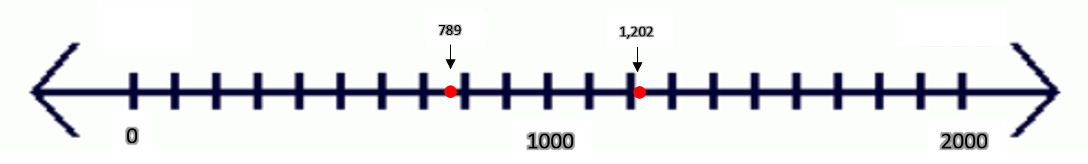

Instructional Tasks

*Instructional Task 1*

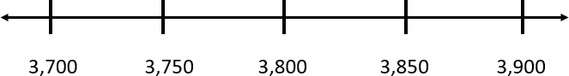 Plot the numbers 3,790, 3,890, 3,799, 3,809 on the number line below.

Choose two values from the list and compare them using >, <, or =.

Choose a number between 3,799 and 3,809 and plot it on the number line.

Use evidence from your number line to justify which number is greatest.

*Instructional Task 2*

Provide students with a variety of different number cards such as 2,905 or 3,001 or 2,555 or 2,919 and symbol cards such as <, >, and =. Have students place the number cards along the number line in the correct location. Then, have students compare the numbers in a variety of number sentences using <, > and =. Students can then list the numbers from least to greatest.

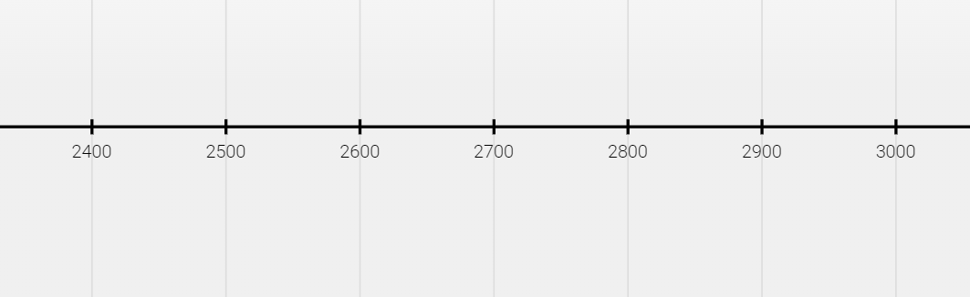

*Enrichment Task 1*

Teacher uses a number line, base-ten blocks, place value charts and relational symbols to demonstrate the relationship between one number and the other.

* The teacher can use dice to help build multi-digit whole numbers at random. Provide students with as many dies as there are places in the number being created. For example, students will need four dies for a four-digit number. Have students roll the dies to create four four-digit numbers. Next, the teacher provides a scaled number line for students to plot their numbers on. The students are rolling four-digit numbers, so the number line will be scaled with the endpoints of 0 and 10,000. The teacher then asks students to identify the greatest number and plot it on the number line. Students will continue to identify the numbers in descending order until all numbers have been plotted on the number line. The teacher can repeat the activity by having students roll new multi-digit numbers. The number line can be scaled with endpoints 0 to 100,000 for students rolling five-digit numbers, and endpoints 0 to 1,000,000 for six-digit numbers

Instructional Items

*Instructional Item 1*

Select all of the following that are correct.

1. 8,989 > 8,898
2. Eight thousand, nine hundred eighty-nine < eight thousand, eight hundred ninety-eight
3. 8,898 > 8,000 + 900 + 80 + 9
4. Eight thousand, eight hundred ninety-eight > 8,898
5. 8,000 + 900 + 80 + 9 > 8,000 + 800 + 90 + 8

*Enrichment Item 1*

Which values correctly complete the inequality?

$$___________> 237,856$$

$50,000+ 30,000 + 7,000 + 800+60+8$

$200,000+ 30,000 + 7,000+800 + 50+6$

$Two hundred forty thousand$

$Two hundred thirty-seven thousand eight hundred fifty-six$

1. 237,901
2. 227,799

*The strategies, tasks and items included in the B1G-M are examples and should not be considered

### MA.3.NSO.1.4 & MA.4.NSO.1.4

Benchmark (Grade 3)

MA.3.NSO.1.4 Round whole numbers from 0 to 1,000 to the nearest 10 or 100.

*Example:* The number 775 is rounded to 780 when rounded to the nearest 10.

*Example:* The number 745 is rounded to 700 when rounded to the nearest 100.

Benchmark (Grade 4)

MA.4.NSO.1.4 Round whole numbers from 0 to 1,000 to the nearest 10, 100 or 1000.

*Example: The number 6,325 is rounded to 6,300 when rounded to the nearest 100.*

*Example: The number 2,550 is rounded to 3,000 when rounded to the nearest 1,000*.

Connecting Benchmarks/Horizontal Alignment

* MA.3.NSO.1.3
* MA.3.NSO.2.1
* MA.4.NSO.2.5

Terms from the K-12 Glossary

* Number Line
* Whole Number

Vertical Alignment

|  |  |
| --- | --- |
| **Previous Benchmarks**   * MA.2.NSO.1.4 | **Next Benchmarks**   * MA.5.NSO.1.5 |

Purpose and Instructional Strategies

The purpose of these benchmarks is for students to use place value understanding to explain and reason about rounding. It is important for students to have numerous experiences using a number line, a place-value chart and a hundred chart to support their work with rounding to assist with their understanding of knowing when and why to round numbers providing opportunities to investigate and explore place value *(MTR.2.1)*. These benchmarks continue instruction of rounding from Grade 2, where students rounded numbers from 0 to 100 to the nearest 10 (MA.2.NSO.1.4).

* Instruction of rounding should include place value representations (e.g., base ten blocks) and number lines (both horizontal and vertical) *(MTR.2.1)*.
* Students should identify benchmarks based on place value to justify rounding. For example, when rounding 643 to the nearest ten, students should use place value to determine that 643 falls between the benchmark tens, 640 and 650. Between 640 and 650, a number line shows that 643 is closer to 640 than 650. When rounding 643 to the nearest hundred, students should use place value to determine that 643 is between the benchmark hundreds, 600 and 700. Between 600 and 700, 643 is closer to 600 than 700 *(MTR.2.1, MTR.3.1)*.
* During instruction have students practice identifying possible answers and halfway points. In addition to understanding that, by rule, if a number is exactly at the halfway point of two possible answers, the number is rounded up. For example, students learn the convention that when the value to the right of the rounded place value is 5, they round up to the greater of the two benchmark values. For example, when rounding 765 to the nearest ten, 765 is the same distance between 760 and 770. The rounding convention tells us to round up to 770 *(MTR.2.1, MTR.3.1)*.
* For 4.NSO.1.4, the concept of rounding is extended to include a larger number set and includes rounding to the nearest 1,000 and to digits other than the leading digit (e.g., round 23,960 to the nearest hundred). This requires more complex thinking than rounding to the nearest ten thousand because the digit in the hundreds place represents 900 and when rounded it becomes 1,000, not just zero. Students should also begin to develop some efficient rules for rounding fluently by building from the basic strategy of - “Is 37 closer to 30 or 40?” Number lines are effective tools for this type of thinking. Students need to generalize the rule for much larger numbers and rounding to values that are not the leading digit.
* Rounding numbers is a skill that helps students estimate reasonable solutions when adding or subtracting. Instruction of rounding skills should be taught within the context of estimating while adding or subtracting. Rounding numbers in an expression should be done before performing operations to estimate reasonable sums or differences. Rounding sums and differences should not be done after students have already performed operations.
* Instruction should not focus on tricks for rounding that do not focus on place value understanding or the use of number lines.

Common Misconceptions or Errors

* Students can confuse the place value to which they are rounding. For example, students mistakenly round 923 to 900 when rounding to the nearest ten because they observe 2 tens and round to 900, instead of using the ones value of 3 to help them determine that 923 is closest to 920. The use of benchmarks numbers and number lines helps students understand rounding conceptually.
* Students assume numbers that are already located at benchmarks cannot be rounded. For example, students think that 920 cannot be rounded to the nearest ten.
* It is imperative for students to develop a conceptual understanding of rounding, such as what the benchmarks are, using place value understanding to round numbers without instruction of mnemonics, rhymes or songs. Teaching only rote procedures for rounding may lead to misconceptions about the magnitudes of numbers. Students may need to have a strong foundation of place value concepts before students may find success with rounding.

Strategies to Support Tiered Instruction

* Instruction includes using number lines, benchmark numbers and place value understanding to round numbers to the nearest ten and hundred. To develop a conceptual understanding of rounding, such as what the benchmarks are, students use place value understanding to round numbers without instruction using mnemonics, rhymes or songs.
  + Graphic to explain example For example, students round 439 to the nearest hundred using a number line and place value understanding. The teacher explains that the endpoints of our number line will be represented using hundreds, because we are rounding to the nearest hundred. The teacher then explains that there are 4 *hundreds* in the number 439 and one more hundred would be 5 hundreds and represents these endpoints on the number line as 4 *hundreds* (400) and 5 *hundreds* (500). Next, the teacher explains that the mid-point on the number line can be labeled as 4 *hundreds* and 5 *tens* (450). This midpoint is halfway between 400 and 500. The teachers ask students to plot 439 on the number line and discuss if it is closer to 400 or 500. Then, the teacher explains that 439 rounds to 400 because it is 61 units away from 500 and only 39 units away from 400 and that a number rounds to the closest benchmark number.
  + For example, students round 76 to the nearest ten using a number line and place value understanding. The teacher explains that the endpoints of the number line will be represented using tens, because we are rounding to the nearest ten. Then, the teacher explains that there are 7 *tens* in the number 76 and one more ten would be 8 *tens* and represents these endpoints on the number line as 7 *tens* (70) and 8 *tens* (80). The mid-point on the number line can be labeled as 7 *tens* and 5 *ones* (75). This midpoint is halfway between 70 and 80 or 5 units from 70 and 5 units from 80. The teacher asks students to plot 76 on the number line and discuss if it is closer to 70 or 80. Then, the teacher explains that 76 rounds to 80 because it is 6 units away from 70 and only 4 units away from 80. Once students master this concept, there should be a discussion about rounding the number 75 where the 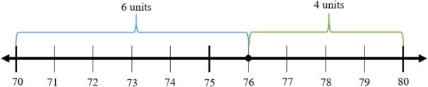choice is made to round it up to 80.

Instructional Tasks

*Instructional Task 1 (MTR.3.1, MTR.7.1)*

Part A: Emily is thinking of a mystery number that rounds to 350 when rounded to the nearest ten and 300 when rounded to the nearest hundred. Could Emily’s number be 344? Why or why not?

Part B: Give two numbers that could be Emily’s mystery number. Justify your answer using a number line.

*Instructional Task 2*

Part A: What is the greatest number that rounds to 8,000 when rounded to the nearest thousand?

Part B: What is the least number that rounds to 8,000 when rounded to the nearest thousand?

*Enrichment Task 1*

Part A: Round 5,817 to the nearest ten. Then round 5,817 to the nearest hundred. Finally, round 5,817 to the nearest thousand.

Part B: Why does the rounded value of 5,817 change when it is rounded to the nearest ten, hundred and thousand? Explain using benchmark numbers and place value.

Instructional Items

*Instructional Item 1*

Identify all the true statements.

a. 302 rounded to the nearest ten is 300.

b. 302 rounded to the nearest ten is 310.

c. 302 rounded to the nearest hundred is 300.

d. 493 rounded to the nearest ten is 500.

e. 493 rounded to the nearest ten is 490.

f. 493 rounded to the nearest hundred is 500.

*Instructional Item 2*

What is $5,686$ rounded to the nearest $thousand$?

$5,000$

$5,700$

$6,000$

$6,600$

*Enrichment Item 1*

Which number has the same value when rounded to the nearest hundred as it does when rounded to the nearest thousand?

$5,908$

$6,082$

$6,974$

$7,153$

*The strategies, tasks and items included in the B1G-M are examples and should not be considered

### **MA.3.NSO.2** Add and subtract multi-digit whole numbers. Build an understanding of multiplication and division operations.

### MA.3.NSO.2.1

Benchmark

MA.3.NSO.2.1 Add and subtract multi-digit whole numbers including using a standard algorithm with procedural fluency.

Connecting Benchmarks/Horizontal Alignment

* MA.3.NSO.1.4
* MA.3.AR.1.2
* MA.3.M.1.2

Terms from the K-12 Glossary

* Whole Number
* Equal sign
* Equation
* Expression

Vertical Alignment

|  |  |
| --- | --- |
| **Previous Benchmarks**   * MA.2.NSO.2.1 * MA.2.NSO.2.2 * MA.2.NSO.2.3 * MA.2.NSO.2.4 | **Next Benchmarks**   * MA.4.NSO.2.7 |

Purpose and Instructional Strategies

The purpose of this benchmark is for students to add and subtract multi-digit whole numbers with procedural fluency. In Grade 2, students added and subtracted multi-digit whole numbers up to 1,000. In Grade 3, the magnitude of numbers increase. Students use skills from the procedural reliability stage in Grade 2 to become fluent with efficient and accurate procedures, including standard algorithms for addition and subtraction by the end of the Grade 3 Accelerated course.

* A standard algorithm is defined as any efficient and accurate procedure that allows students to add and subtract whole numbers. Students’ choices of standard algorithms for addition and subtraction do not need to be the same *(MTR.5.1)*.
* Students should be able to justify their use of a standard algorithm for adding and subtracting by explaining the steps mathematically. Each student should be able to explain when regrouping is needed, and how regrouping is computed using their chosen algorithm. During instruction, teachers and students should work together to relate place value understanding to algorithms *(MTR.3.1, MTR.4.1, MTR.5.1)*.
* Problems should include both vertical and horizontal forms, including opportunities for students to apply the Commutative and Associative properties.
* Instruction of this benchmark should be taught with MA.3.NSO.1.4. Students should use rounding to estimate reasonable solutions of sums and differences before calculating *(MTR.6.1)*.
* Instruction for this benchmark includes reinforcing the concept that when students use an algorithm to add and subtract, they are finding the sum or difference of like units. For example, we add ones to ones, tens to tens, hundreds to hundreds, etc. This concept helps prepare for adding and subtracting decimals in Grades 4 and 5*.*

Common Misconceptions or Errors

* Students who learn a standard algorithm without being able to explain why it works using place value understanding often make computational errors and/or cannot determine if their solutions are reasonable. To assist students with this misconception, teachers should have students to justify the algorithm they choose by checking for reasonableness.
* Students who cannot explain their steps mathematically often have difficulty understanding regrouping. Many computational errors are a result of students not discovering this conceptual understanding while they practiced adding and subtracting with procedural reliability in Grade 2 (MA.2.NSO.2.3 and MA.2.NSO.2.4). Instruction that focuses on learning standard algorithms for addition and subtraction as a series of steps without checking for conceptual understanding will contribute to regrouping errors.

Strategies to Support Tiered Instruction

* Instruction includes guiding students through the process of estimating reasonable values for sums and differences using understanding of place value, addition and subtraction.
  + For example, students make reasonable estimates for the sum of 174 + 253. Instruction includes a prompt such as “Before using an algorithm, we will estimate the sum to make sure that we are using the algorithm correctly and our answer is reasonable. The first addend of 174 is close to the benchmark number 200 and the second addend of 253 is close to the benchmark number 250. So, we can use 200 + 250 = 450 to estimate that our sum should be close to 450.”
* Instruction includes guiding students through the process of explaining and justifying the chosen algorithm and determining if an algorithm was used correctly by reviewing the reasonableness of solutions.
  + 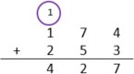For example, students use a standard algorithm to solve 174 + 253 and explain their thinking using a place value visual representation. Instruction includes a prompt such as “Begin by adding in the ones place. 4 ones plus 3 ones is 7 ones. Because the total number of ones is less than 10 ones, it is not necessary to regroup. Next, add in the tens place. 7 *tens* plus 5 *tens* is 12 *tens*. Because I have more than 10 *tens* it is necessary to regroup the 10 *tens* to make one *hundred*. After composing a group of 10 *tens*, there are 2 *tens* remaining. Finally, add 1 *hundred* plus 2 *hundreds*. Add the 1 *hundred* that was regrouped from the tens place. The sum is 427. Our sum of 427 is close to our estimate of 450, which helps us determine that our answer is reasonable.
  + For example, students use a standard algorithm to solve 327 – 174 and explain their thinking using a place value visual representation. Instruction includes prompt such as “Begin subtracting 174 starting in the ones place. 7 *ones* minus 4 *ones* are 3 ones. There are not enough tens to subtract 7 *tens* from 2 *tens*. It is necessary to decompose one *hundred* into 10 *tens*. Now there are 12 *tens*, and there is enough to subtract 7 *tens*. 12 *tens* minus 7 *tens* equals 5 *tens*. Finally, subtract the hundreds: 3 *hundreds* minus 1 *hundred* equals 2 *hundreds*. The difference is 253.”

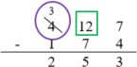

* + For example, students use a standard algorithm and place value blocks to solve 62 – 37 and explain their thinking using a place value visual representation. Instruction includes a prompt such as “Begin subtracting 37 starting in the ones place. There are not enough ones to subtract 7 *ones* from 2 *ones*. It is necessary to decompose one ten into 10 *ones*. Now there are 12 *ones* and there is enough to subtract 7 *ones*. 12 *ones* take away 7 *ones* equals 5 *ones*. Finally, subtract the tens: 5 *tens* minus 3 *tens* is 2 *tens*. The difference is 25.”

|  |  |
| --- | --- |
| **tens** | **ones** |
| Graphic to explain example | |

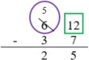



* Teacher provides guidance on using strategies based on place value to add and subtract.
* For example, students use strategies based on place value to solve 174 + 253. Students can decompose each number into expanded form, then add each place value separately (add the ones together, the tens together, and the hundreds together). Then, students can add together the sums of the ones, tens and hundreds to compute the sum.

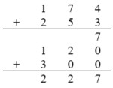Graphic to explain example sum of ones

sum of tens

sum of hundreds

Instructional Tasks

*Instructional Task 1*

Miranda finds 492 seashells during her vacation. She now has 1,045 seashells in her collection. How many seashells did she have in her collection before vacation?

Part A. Solve using a standard algorithm.

Part B. Indicate one step where you needed to regroup while solving and show how you did it using words or a pictorial model.

*Instructional Task 2*

*Shay wants to find the sum of 2,417 and 3,568. Explain the steps for finding the sum of 2,417 and 3,568. Be sure to include the words thousands, hundreds, tens, ones, and sum in your explanation*

*Instructional Task 3*

Mount Pleasant Elementary School had a penny fundraiser last week to raise money for families that were affected by the recent storm. The chart below shows how many pennies they raised each day.

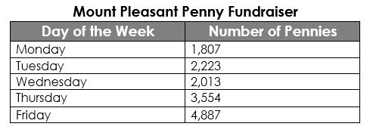

Part A. How many more pennies were collected on Monday and Tuesday than on Thursday?

Part B. Mrs. William’s class collected 1,627 of Friday’s total pennies. How many pennies did the rest of the school collect on Friday?

Part C. The principal said the school collected about 6,000 pennies on Monday, Tuesday and Wednesday. Is this a reasonable estimate? Explain how you know.

*Instructional Task 4*

2,558 + 2,677 = ?

Part A. Write a word problem using the equation shown above.

Part B. Solve the word problem you created in two different ways. Explain your thinking

*Instructional Task 5*

Maya downloaded 856 songs to her music library last month. This month, she downloaded 726 more songs. Then, she deleted 119 songs that she no longer liked.

Part A. How many songs does Maya have in her music library now?

Part B. How many more songs will Maya need to download before she has 3,000 songs in her music library?

Part C. What are two different ways you could solve this problem? Show your thinking.

Instructional Items

*Instructional Item 1*

What is the sum of 1,432 and 2,981?

*Instructional Item 2*

What is the difference of 8,000 and 1,432?

*Instructional Item 3*

Cameron set a goal of collecting 7,000 stickers this year. In January, he collected 895 stickers, in February, he collected 472 stickers, and in March he collected 927 stickers. How many more stickers does he need to collect to meet his goal for the year?

*Instructional Item 4*

Use rounding to estimate the sum of 4,587 and 926. Then, find the actual sum of the two numbers.

*The strategies, tasks and items included in the B1G-M are examples and should not be considered

### MA.3.NSO.2.2

Benchmark

MA.3.NSO.2.2 Explore multiplication of two whole numbers with products from 0 to 144, and related division facts.

Benchmark Clarifications:

*Clarification 1:* Instruction includes equal groups, arrays, area models and equations. *Clarification 2:* Within the benchmark, it is the expectation that one problem can be represented in multiple ways and understanding how the different representations are related to each other.

*Clarification 3:* Factors and divisors are limited to up to 12.

Connecting Benchmarks/Horizontal Alignment

* MA.3.NSO.2.3
* MA.3.NSO.2.4
* MA.3.AR.1.1
* MA.3.AR.1.2
* MA.3.AR.2.1
* MA.3.AR.2.2
* MA.3.AR.3.2
* MA.3.GR.2.2
* MA.3.GR.2.3
* MA.3.GR.2.4
* MA.4. NSO.2.1

Terms from the K-12 Glossary

* Area Model
* Commutative Property of Multiplication
* Dividend
* Divisor
* Equal sign
* Equation
* Expression
* Factors
* Rectangular Array
* Whole Number

Vertical Alignment

|  |  |
| --- | --- |
| **Previous Benchmarks**   * MA.2.AR.3.2 | **Next Benchmarks**   * MA.5.NSO.2.1 * MA.5.NSO.2.2 |

Purpose and Instructional Strategies

The purpose of this benchmark is for students to build conceptual understanding of what

multiplication is and how it relates to division. Because the expectation of this benchmark is at the explore level, instruction focuses on building understanding of multiplication and division facts from 0 to 144 using manipulatives (e.g., counters, place value blocks), visual models (e.g., rectangular arrays, equal groups), discussions, estimation, and drawings (e.g., rectangular arrays, area models) *(MTR.2.1)*.

* Instruction should relate multiplication to repeated addition work that began in Grade 2. In Grade 2, students used repeated addition to find the total number of objects using rectangular arrays and equations (MA.2.AR.3.2).
* Students should explore multiplication and division through word problems, writing expressions and creating or drawing models that match the problems’ contexts *(MTR.2.1, MTR.3.1)*.
* In division, students should see examples of sharing, or partitive division (where the number of groups are given and students determine the number in each group), as well as measurement, or quotative division (where the number in each group is given and students determine the number of groups).
* Instruction should relate division facts to known multiplication facts (e.g., fact families). Fact families can be explored through arrays and equal groups *(MTR.5.1*).

Common Misconceptions or Errors

* Students may have difficulty relating word problems and real-world scenarios to models, expressions and equations. For example, students may not differentiate the number of groups versus number in each group in multiplication, which then impacts their models, expressions and equations.
* Students may be confused by measurement (or quotative) division, when the amount in each group is given and the number of equal-sized groups is found.

Strategies to Support Tiered Instruction

* Instruction includes demonstrating the use of counters, arrays and skip counting to model groups of objects, including the use of real-world scenarios to support students’ understanding of the number of groups versus the size of each group. Students represent their models with equations to reinforce the concept of multiplication.
* For example, a farmer is planting rows of sunflowers. He plants 6 rows with 5 sunflowers in each row. How many sunflowers does he plant?

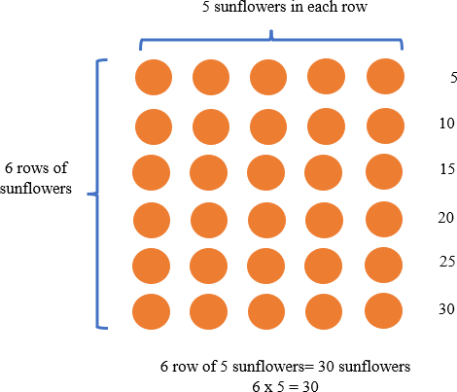

* For example, there are 3 tables in the library. There are 4 students sitting at each table. How many students are sitting at tables in the library?

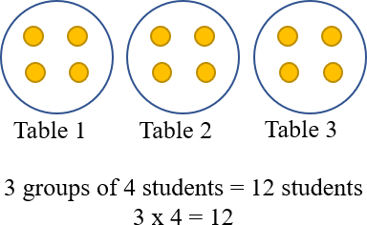

* Instruction includes demonstrating the use of counters and arrays to model division problems where the amount in each group is given and the number of equal-sized groups is found (quotative division). The teacher provides real-world scenarios to represent the number of objects in each group to find the number of equal-sized groups. Students form a group based on the context of the problem, continuing to form groups of that size until the total is reached. Students can skip count to keep track of how many counters they have used, representing their models with equations to reinforce the concept of division.
* For example, Renee is setting up chairs in the library. She is placing 24 chairs into rows. If she places 6 chairs in each row, how many rows of chairs will she have?

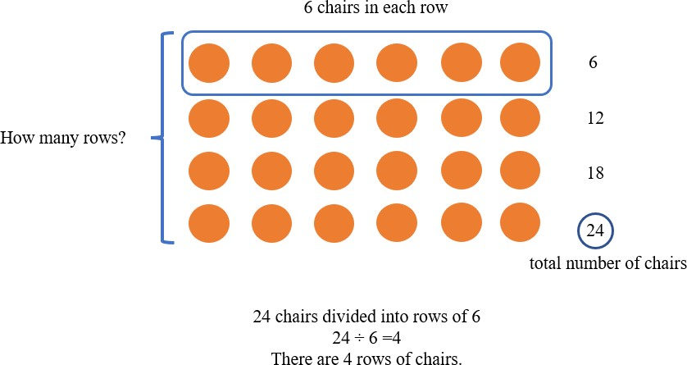

* + For example, there are 15 students working on an art project. The art teacher divides them into groups of 3 students to work on the project. How many groups are there?

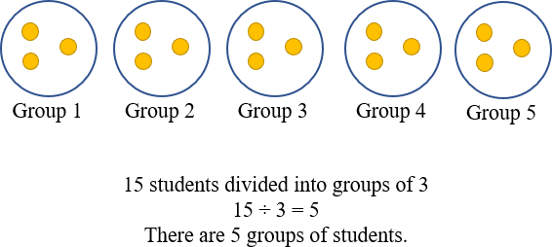

Instructional Tasks

*Instructional Task 1*

Build $12×9$ with place value blocks or counters.

Part A. How would you solve for the product? What strategy did you use to solve the problem?

Part B. Now build $9×12$ with place value block or counters. What is the product of $9×12$? How did you see it?

Part C. Draw a model for $9×12$ or solve using a different strategy.

*Instructional Task 2*

There are 32 photos that need to be organized into a photo album. What are all the possible ways to display the photos on the pages of the album? Each page must have an equal number of photos. Use manipulatives, models, or equations to help you figure out all the possible combinations.

*Instructional Task 3*

Tina has 4 shelves on her bookshelf. Each row has 6 books. How many books are on Tina’s bookshelf in all? Draw a model and write an equation to represent your answer

*Instructional Task 4*

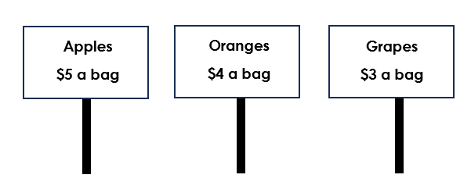

Mateo goes to the grocery store with his dad to buy some fruit. The prices of the fruit are shown above.

Part A. Mateo’s dad buys 6 bags of grapes. Write an equation that represents how many grapes he bought.

Part B. Mateo’s dad also buys 4 bags of apples and 5 bags of oranges. Did he spend more money on apples or oranges? Explain how you know.

Part C. Mateo sees his friend Jeremy at the grocery store. Jeremy’s mom buys 7 bags of grapes and 5 bags of apples. How much more does she spend on apples than grapes? How do you know?

*Enrichment Task 1*

There are 24 cans of soup to organize on shelves at the grocery store. The store wants an

equal number of cans on each shelf. What are all the possible ways they could organize the

cans? Use manipulatives and complete the chart to show your thinking.

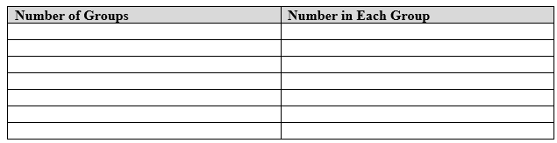

Instructional Items

*Instructional Item 1*

What expression equals 7 x 6?

a. 6 + 6 + 6 + 6

b. 6 + 6 + 6 + 6 + 6

c. 6 + 6 + 6 + 6 + 6 + 6

d. 6 + 6 + 6 + 6 + 6 + 6 + 6

*Instructional Item 2*

Elizabeth has 28 pairs of earrings that she wants to put into her jewelry organizer. Each drawer of the organizer holds 4 pairs of earrings. How many drawers will she need to organize all of her earrings?

*Instructional Item 3*

If 72 eggs are packaged twelve eggs to a carton, how many cartons will we need to package all the eggs? Solve using an equation, model or other strategy.

*Instructional Item 4*

A total of 56 chairs are in the cafeteria for an assembly. The principal arranges the chairs into 8 rows with the same number of chairs in each. Which equation shows the quotient as the number of chairs that will be in each row?

|  |  |  |  |  |
| --- | --- | --- | --- | --- |
| a. 56 | ÷ | 8 | = | 7 |
| b. 56 | ÷ | 8 | = | 48 |
| c. 56 | ÷ | 8 | = | 64 |
| d. 56 | ÷ | 8 | = | 6 |

The strategies, tasks and items included in the B1G-M are examples and should not be considered

### MA.3.NSO.2.3

Benchmark

MA.3.NSO.2.3 Multiply a one-digit whole number by a multiple of 10, up to 90, or a multiple of 100, up to 900, with procedural reliability.

*Example:* The product of 6 and 70 is 420.

*Example:* The product of 6 and 300 is 1,800.

Benchmark Clarifications:

*Clarification 1:* When multiplying one-digit numbers by multiples of 10 or 100, instruction focuses on methods that are based on place value.

Connecting Benchmarks/Horizontal Alignment

* MA.3.NSO.2.2
* MA.3.NSO.2.4
* MA.3.AR.1.1
* MA.3.AR.1.2
* MA.3.GR.2.2
* MA.3.GR.2.4
* MA.4.NSO.2.2

Terms from the K-12 Glossary

* Equation
* Expression
* Factors
* Whole Number

Vertical Alignment

|  |  |
| --- | --- |
| **Previous Benchmarks**   * MA.2.NSO.2.2 | **Next Benchmarks**   * MA.4.NSO.2.3 * MA.5.NSO.2.1 |

Purpose and Instructional Strategies

The purpose of this benchmark is for students to use place value reasoning to multiply single-

digit factors (0-9) by multiples of 10 up to 90 (10, 20, 30, 40, 50, 60, 70, 80, 90) and multiples of 100 up to 900 (100, 200, 300, 400, 500, 600, 700, 800, 900). Because the expectation of this benchmark is at the procedural reliability level, students should develop accurate, reliable methods for multiplication that align with their understanding and learning style.

* Instruction connects known facts of one-digit factors (e.g. 6 × 7), to then apply to products of one-digit numbers and multiples of 10 or 100 (e.g., 6 × 70, 60 × 7, 6 × 700, 600 × 7) *(MTR.5.1)*.
* Teachers can use place value representations (e.g., pictures, diagrams, base-ten blocks, place value chips) to show relationships between known facts and multiplying one-digit factors by multiples of 10 or 100. For example, 3 × 4 can be interpreted as 3 groups of 4 *ones*, or 12 *ones*. 3 × 40 can be represented as 3 groups of 4 *tens*, or 12 *tens*. 12 *tens* is equal to **120 *ones***. 3 × 400 can be represented as 3 groups of 4 *hundreds*, or 12 *hundreds*. 12 *hundreds* is equal to 120 *tens* or **1,200 *ones*** *(MTR.5.1)*.This standard lays the foundation for multi-digit multiplication. For benchmark MA.3.AR.1.1, students use the distributive property to multiply 34 × 8 as (30 × 8) + (4 × 8). This benchmark (MA.3.NSO.2.3) helps students reason that 30 × 8 is the same as 3 tens × 8 or 24 *tens* or 240 *ones*.
* Instruction should not focus on “adding zeroes to the end” when multiplying one-digit factors by multiples of 10 and 100. For example, 7 × 50 should not be reduced to “7 × 5 with one zero at the end.” This trick does not focus on place value methods, as Clarification #1 of the benchmark requires.

Common Misconceptions or Errors

* Students can quickly jump to the conclusion that they can “count zeroes” to determine the number of zeroes in the product (e.g., the product of 7 × 500 will have two zeroes because 500 has two zeroes). This can confuse students when the products of the known facts already end in zero (e.g., using 5 × 8 = 40 to multiply 5 × 80). Students who rely on this trick will often indicate that 5 × 80 = 40 because they see only one zero in the factors.

Strategies to Support Tiered Instruction

* Instruction includes opportunities to connect grouping numbers by multiples in different ways.
* For example, students may place the following facts on the hundreds chart:

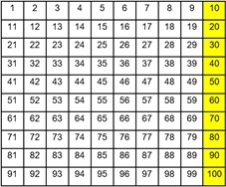1 × 10, 2 × 10, 3 × 10, 4 × 10, 5 × 10, 6 × 10, 7 × 10, 8 × 10 and 9 × 10. The teacher asks students what patterns they notice?

* Instruction includes opportunities to use a number line. Students skip count by multiples on the number line. This will support a conceptual understanding of what is happening with the numbers, instead of focusing on the “zero trick.”

2 × 200 = 400

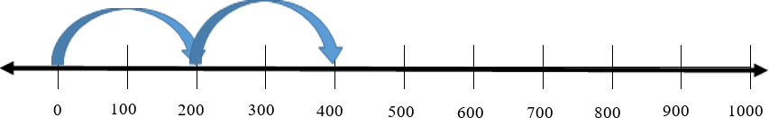

* Instruction includes opportunities to connect grouping numbers by multiples.
  + For example, students use manipulatives to show that 5 groups of 20 is 100 and 5 groups of 200 is 1,000. Teacher should be explicit about the multiples and not point out the zeros trick

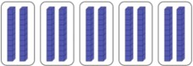

5 × 20 = 100

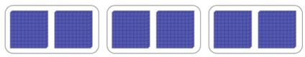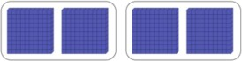

5 × 200 = 1,000

Instructional Tasks

*Instructional Task 1*

Aurora listened to music for 6 days in a row. Each day she listened for 50 minutes. How many minutes did she listen to music in all? Show how you know in two different ways using models, equations, number lines, or other strategies.

*Instructional Task 2*

The Johnson family is planning a wedding for 40 people. They need to purchase enough room decorations, flowers and party favors so that they can have one party favor, one flower and one room decoration for each of their guests. Below are the different choices for each category. Every guest will receive the same items, so you only need to choose one from each category.

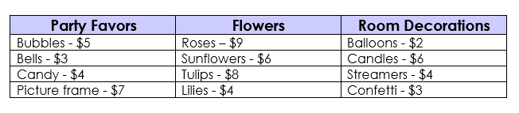

Part A. Choose one party favor, one type of flower, and one room decoration for your guests. How much will it cost to purchase these items for your 40 guests?

Part B. Oh no! Ten of your guests could not make it. How much will the items cost for 10 less guests?

Part C. How much more will it cost to buy all your guests roses than it will to buy them lilies?

*Instructional Task 3*

There are 300 students going on the field trip to the zoo from Eastside

Elementary School. There are 3 times as many students going to the zoo from Westside Elementary School.

Part A. How many total students are going on the field trip to the zoo from Eastside Elementary School and Westside Elementary School?

Part B. Southside Elementary School decides to go to the zoo that day too! They have 4 times as many students as Eastside Elementary School and Westside Elementary School combined. How many students will attend the zoo field trip from Southside Elementary School?

*Instructional Task 4*

The table below shows the costs for entry at the Sunnyland Amusement Park

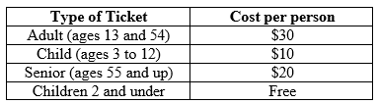

1. How much does entry cost for nine adults? Write an equation to show the total cost?
2. Write an expression that shows the total cost for one senior and one 2-year-old child to attend Sunnyland Amusement Park
3. The Suarez Family purchases 2 adult tickets, 1 senior ticket and 1 ticket for their 6-year-old daughter. Write an equation to show the total cost of entry for the family.
4. Which cost of entry is less expensive, 2 seniors or 3 children? Explain how you know using words, a picture or equations

*Enrichment Task 1*

A banker is organizing money into equal stacks to help him count it faster. He has 8 stacks of twenty-dollar bills with 10 in each stack. He also has 8 stacks of one-hundred-dollar bills with 5 in each stack. How much does he have total in twenty-dollar bills? How much does he have total in hundred-dollar bills? How much money does he have altogether.

Instructional Items

*Instructional Item 1*

Write two different equations using a one-digit whole number and a multiple of 10 that show a product of 120.

_____ × _____ = 120 _____ × _____ = 120

*Instructional Item 2*

Write two different equations using a one-digit whole number and a multiple of 100 that show a product of 2,400.

_____ × _____ = 2,400 _____ × _____ = 2,400

*Instructional Item 3*

Select all the following expressions that equal 1,800.

1. 30 $×$ 6
2. 2 $×900$
3. 600 $×$ 3
4. 9 $×$ 20
5. 60 $×$ 3
6. 9 $×$ 200

*Instructional Item 4*

Reginald and Veronica are having a push-up competition during P.E. class. Reginald said that he did 7 sets of 20 push-ups and that he is the winner. Veronica said that she completed 6 sets of 30 push-ups and that this makes her the winner. Who won the competition? How do you know?

*The strategies, tasks and items included in the B1G-M are examples and should not be considered

### MA.3.NSO.2.4 & MA.4.NSO.2.1

Benchmark

MA.3.NSO.2.4 Multiply two whole numbers from 0 to 12 and divide using related facts with procedural reliability.

*Example:* The product of 5 and 6 is 30.

*Example:* The quotient of 27 and 9 is 3.

Benchmark Clarifications:

*Clarification 1:* Instruction focuses on helping a student choose a method they can use reliably.

Benchmark

MA.4.NSO.2.1 Multiply two whole numbers from 0 to 12 and divide using related facts with procedural reliability.

Connecting Benchmarks/Horizontal Alignment

* MA.3.NSO.2.2
* MA.3.NSO.2.3
* MA.3.AR.2.2
* MA.3.AR.3.3
* MA.3.GR.2.4
* MA.4.NSO.2.1
* MA.4.NSO.2.2
* MA.4.AR.2.1

Terms from the K-12 Glossary

* Associative property of multiplication
* Commutative property of multiplication
* Distributive property of multiplication
* Dividend
* Divisor
* Equation
* Expression
* Factor

Vertical Alignment

|  |  |
| --- | --- |
| **Previous Benchmarks**   * MA.2.AR.3.2 | **Next Benchmarks**   * MA.4.NSO.2.3 * MA.4.NSO.2.4 * MA.4.FR.2.4 |

Purpose and Instructional Strategies

The purpose of this benchmark is for students to utilize skills from the exploration stage of

multiplication and division (MA.3.NSO.2.2) to develop an accurate, reliable method that aligns with the student’s understanding and learning style. Procedural fluency of multiplication facts with factors up to 12 and their related division facts is not expected until Grade 4 *(MTR.2.1, MTR.3.1)*.

* This benchmark provides the opportunity for students to generalize patterns they see within the tools used during the exploration stage (e.g., rectangular arrays, equal groups) to then identify multiplication and related division facts *(MTR.4.1)*.
* Instruction that builds procedural reliability should connect multiplication understanding with the properties of multiplication (commutative, associative and distributive). The patterns students recognize help them relate facts to one another, and to use the related facts to find the products and quotients of unknown facts. In this benchmark, students should be able to explain how they know facts and how they can find products of unknown facts *(MTR.5.1)*. For example, students should recognize that 4 × 6 and 6 × 4 have the same product of 24 and identify this pattern as evidence of the commutative property of multiplication. This can also be discovered through arrays for multiplication using objects or drawings, where students can observe that the arrays contain the same total number of squares, but the orientation of the array has just rotated so the rows and columns are switched as shown below *(MTR.5.1)*.

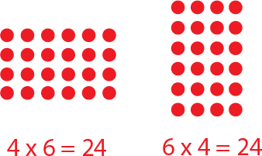

* + To help reach automaticity of multiplication and related division facts, these related concepts should be considered to be foundational.
    - Multiplication by zeroes and ones
    - Doubles (2s facts)
    - Double and Double Again (4s)
    - Doubling three times (8s)
    - Tens facts (relating to place value, $5×10$ is 5 tens or 50)
    - Five facts (half of tens or connect to the analog clock)
    - Skip counting (counting groups of __ and knowing how many groups have been counted)
    - Square numbers (the physical and visual representation of these facts makes a square; e.g., $3×3$)
    - Nines (10 groups less 1 group; e.g., $9×3$ is 10 groups of 3 minus 1 group of 3 so $30-3=27$)
    - Decomposing into known facts ( $6×7$ is a double - $6×6$- plus one more group of 6)
    - Elevens (10 groups and 1 group more; e.g., $11×5$ is 10 groups of 5 plus 1 group of 5 so $50+5=55$)
    - Decomposing using the Distributive Property $(12×6=\left(10×6\right)+\left(2×6\right)=\left(60\right)+(12)=72$

Throughout K-5 instruction, it is not recommended to use timed fact fluency assessments to learn and practice facts.

Common Misconceptions or Errors

* This benchmark does not support students’ memorization of multiplication and division facts. Memorization does not indicate work toward multiplication and division fact fluency. Students should be able to explain how they know multiplication and division facts, and how they can find products and quotients of unknown facts.

Strategies to Support Tiered Instruction

* Instruction includes opportunities to experience the properties of multiplication and division. Students use and apply properties to build procedural fluency. Students should understand that multiplication and division both involve grouping equal sets of numbers or objects.
  + For example, the teacher shows students an array of 8 × 6 = 48 and has them describe what they see with rows and columns. This learning can be connected to the concept of “groups of” objects, 8 groups of 6 is the same as 8 jumps of 6 on the number line?

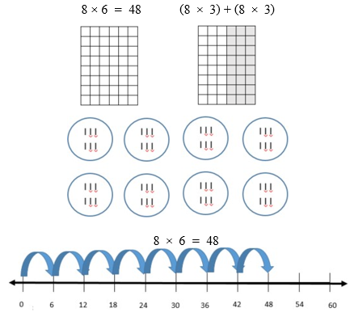

* Teacher provides opportunities to build and manipulate what a multiplication fact looks like and then relates how it looks as division.
  + For example, students model 3 × 4 as 3 rows of 4 with counters.

The teacher then relates the multiplication model to division by separating the rows into groups. 12 = 3 groups of 4 counters or 12 divided by 3 = 4.

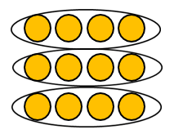

* Instruction includes building strategies and conceptual understanding to recall facts to find unknown multiplication facts by using known facts.
  + For example, if students do not know the product for $9×12$ have them use a known fact such as $10×12$. The known fact of $10×12=120$ can be used to find the product of $9×12$ by subtracting one more group of 12 from the product of 120 to find the product of 108.
  + For example, if students do not know the product for $6×7$ have them use a known fact such as $5×7$. The known fact of $5×7=35$ can be used to find the product of $6×7$ by adding one more group of 7 to the product of 35 to find the product of 42.
* Instruction includes building strategies and conceptual understanding to recall facts to find unknown division facts by using known multiplication facts.
  + For example, if students do not know the quotient for $121÷11$ have them think about how many groups of 11 equal 121. Have students write the problem as a missing factor problem $×11=121$__ to help use multiplication facts to find the quotient. Students can also use known multiplication facts to solve: 10 groups of 11 is 110 and one more group of 11 equals 121 so $121÷11$ equals 11.

For example, if students do not know the quotient for $45÷5$ have them think about how many groups of 5 equal 45. Have students write the problem as a missing factor problem $×5=45$___ to help use known multiplication facts to find the quotient

Instructional Tasks

*Instructional Task 1*

Part A. Show how to find the product of 6 × 7 in two different ways.

Part B. Identify the related division facts from your equation in Part A.

*Instructional Task 2*

Explain how the 2s facts, 4s facts, and 8s facts for multiplication are related.

*Enrichment Task 1*

A student is struggling with their 7s facts. Create a tutorial guide or video to help explain

how they might use friendlier facts to help them with their 7s

Instructional Items

*Instructional Item 1*

What is the product of 11 and 4?

*Instructional Item 2*

Provide two division facts that have a quotient of 8.

*Instructional Item 3*

Select all the true equations.

$11=132÷11$

$7×12=84$

$56=7×7$

$49÷7=7$

$6×11=66$

*The strategies, tasks and items included in the B1G-M are examples and should not be considered

**MA.4.NSO.1** Understand place value for multi-digit numbers

MA.4.NSO.1.2

See Benchmark MA.3.NSO.1.1

MA.4.NSO.1.3

See Benchmark MA.3.NSO.1.3

MA.4.NSO.1.4

See Benchmark MA.3.NSO.1.4

**MA.4.NSO.2** Build an understanding of operations with multi-digit numbers including decimals.

MA.4.NSO.2.1

See Benchmark MA.3.NSO.2.4

### MA.4.NSO.2.2

Benchmark

MA.4.NSO.2.2 Multiply two whole numbers, up to three digits by up to two digits, with procedural reliability.

Benchmark Clarifications:

*Clarification 1:* Instruction focuses on helping a student choose a method they can use reliably.

*Clarification 2:* Instruction includes the use of models or equations based on place value and the distributive property.

Connecting Benchmarks/Horizontal Alignment

* MA.3.NSO.2.2
* MA.3.NSO.2.3
* MA.3.NSO.2.4
* MA.4.NSO.2.3
* MA.4.AR.1.1
* MA.4.GR.2.1
* MA.4.GR.2.2
* MA.4.M.1.2
* MA.4.M.2.1

Terms from the K-12 Glossary

* Area Model
* Distributive Property
* Expression
* Equation
* Factor

Vertical Alignment

|  |  |
| --- | --- |
| **Previous Benchmarks**   * MA.2.NSO.2.2 * MA.2.AR.2.3 | **Next Benchmarks**   * MA.5.NSO.2.1 |

Purpose and Instructional Strategies

The purpose of this benchmark is for students to choose a reliable method for multiplying 3-digit numbers by 2-digit numbers. It builds on the understanding of multiplication and division (MA.3.NSO.2.2, MA.3.NSO.2.3, MA.3.NSO.2.4), and the automaticity in the Grade 3 Accelerated Course (MA.4.NSO.2.1) and prepares for procedural fluency (MA.4.NSO.2.3 and MA.5.NSO.2.1) in the Grade 4 or Grade 4 Accelerated Course.

* For instruction, students may use a variety of strategies when multiplying whole numbers and use words and diagrams to explain their thinking *(MTR.2.1)*. Strategies can include using base-ten blocks, area models, partitioning, compensation strategies and a standard algorithm.
* Using place value strategies enables students to develop procedural reliability with multiplication and transfer that understanding to division. Procedural reliability expects students to utilize skills from the exploration stage to develop an accurate, reliable method that aligns with their understanding and learning style.
* The area model shows students how they can use place value strategies and the Distributive property to find products with multi-digit factors.

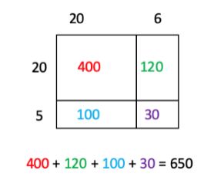 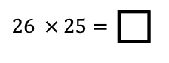



* Additionally, students can use their understanding of base-ten blocks along with place value strategies to create an area model with pictorials.

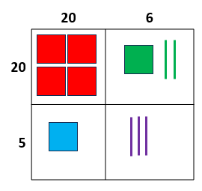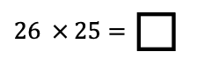

400 + 120 + 100 + 30 = 650

* The distributive property can also be used without the organizational structure of the area model.
  + For example, when solving the problem $43×72$, students can show their understanding by setting up the following expression: $(40×70)+(40×2)+(3×70)+(3×2)$. Instruction includes helping students understand what each partial product represents and how they are related to using the area model.

Common Misconceptions or Errors

* Students that are taught a standard algorithm without any conceptual understanding will often make mistakes. For students to understand a standard algorithm or any other method, they need to be able to explain the process of the method they chose and why it works. This explanation may include pictures, properties of multiplication, decomposition, etc.

Strategies to Support Tiered Instruction

* Instruction includes explaining mathematical reasoning while solving multiplication problems. Instruction also includes determining if a method was used correctly by reviewing the reasonableness of solutions.
  + For example, students determine $5×137$ using an area model and place value understanding.

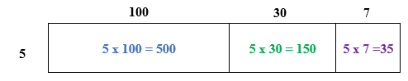 C:\Users\mooreje\AppData\Local\Microsoft\Windows\INetCache\Content.MSO\D796B49C.tmp

* + For example, students solve $5×137$ using partitioning and place value understanding.

* + For example, students determine $4×43$ using base-ten blocks and place value understanding.

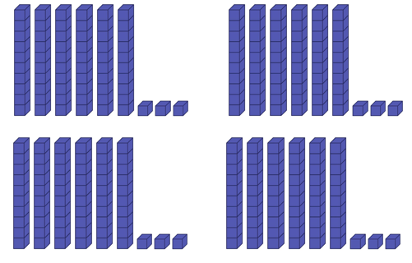

$16 tens+12 ones$

$160+12$

160

+ 12

172

* + For example, students determine $4×43$ using partitioning and place value understanding.

$4×40=160$

172

$4×3=12$

Instructional Tasks

*Instructional Task 1*

Paul orders tomatoes for The Produce Shop. Each box has 24 tomatoes in it. If Paul orders 32 boxes of tomatoes, how many tomatoes will The Produce Shop have to sell? Use a strategy of your choice to find the number of tomatoes The Produce Shop must sell. Explain your thinking and why your method works.

*Instructional Task 2*

Select four cards from the set of cards below.



Part A. Use your cards to create a three-digit number and a one-digit number. Find the product of your three-digit and one-digit numbers.

Part B. Use your cards to create a two-digit number and another two-digit number. Find the product of your two-digit numbers.

Part C. How are your two products similar? How are they different?

*Instructional Task 3*

Part A. How can you use the product of $75 ×8$ to help you find the product of $750 ×8$?

Part B: Explain the relationship between the two products from Part A using the words “ten times greater and “ten times less.”

*Enrichment Task 1*

A grocery store received a shipment of 247 boxes of canned goods. Each box holds 12 cans. How many total cans were delivered in the shipment?

Part A. Before solving, make a reasonable estimate of the number of canned goods.

Part B. Solve to find the total number of canned goods. Compare your answer to your estimate. How do you know your answer is reasonable?

Part C. Another student solved this same problem and made a mistake. He thought the answer was 811. Discuss whether that is a reasonable answer and what you think his mistake was.

Instructional Items

*Instructional Item 1*

The product of $57$ and $92$ is $_______.$

$627$

$4,644$

$5,234$

1. 5,244

*Instructional Item 2*

Which expressions have a product of 2,128? Select all that apply.

$56 ×38$

$532 ×4$

$44×52$

$276×8$

$28×76$

*Instructional Item 3*

Select all the partial products when solving 12 x 46.

1. 10
2. 12
3. 46
4. 60
5. 80
6. 400

*Enrichment Item 1*

Find the product of 976 x 84

*The strategies, tasks and items included in the B1G-M are examples and should not be considered

### MA.4.NSO.2.5

Benchmark

MA.4.NSO.2.5 Explore the multiplication and division of multi-digit whole numbers using estimation, rounding and place value.

*Example:* The product of 215 and 460 can be estimated as being between 80,000 and 125,000 because it is bigger than $200×400$ but smaller than $250×500$.

*Example:* The quotient of 1,380 and 27 can be estimated as 50 because 27 is close to 30 and 1,380 is close to 1,500. 1,500 divided by 30 is the same as $150 tens$ divided by $3 tens$ which is $5 tens$, or 50.

Benchmark Clarifications:

*Clarification 1:* Instruction focuses on previous understanding of multiplication with multiples

of 10 and 100 and seeing division as a missing factor problem.

*Clarification 2:* Estimating quotients builds the foundation for division using a standard

algorithm.

*Clarification 3:* When estimating the division of whole numbers, dividends are limited to up to

four digits and divisors are limited to up to two digits.

Connecting Benchmarks/Horizontal Alignment

* MA.3.NSO.1.4
* MA.3.NSO.2.2
* MA.4.NSO.1.2
* MA.4.NSO.1.3
* MA.4.NSO.1.4
* MA.4.M.1.2
* MA.4.GR.2.1

MA.4.GR.2.2Terms from the K-12 Glossary

* Expression
* Equation
* Factor

Vertical Alignment

|  |  |
| --- | --- |
| **Previous Benchmarks**   * MA.3.NSO.1.4 * MA.3.NSO.2.2 | **Next Benchmarks**   * MA.4.NSO.1.1 * MA.4.AR.1.1 * MA.4.M.2.1 * MA.5.NSO.2.4 |

Purpose and Instructional Strategies

The purpose of this benchmark is to give students authentic opportunities to estimate in multiplication and division. This work builds on students rounding to the nearest 10 or 100 without performing operations (MA.3.NSO.1.4).

* When students find exact solutions of multiplication and division problems, they should use mental math and computation strategies to determine if their solution is reasonable *(MTR.6.1)*.
* Instruction of this benchmark focuses on number sense to help students develop procedural reliability. Students should have practice estimating multiplication and division equations using strategies based on place value and the properties of operations.
* Estimation is often about getting useful answers that need not be exact.
* Models that help students explore multiplication and division of multi-digit numbers include base ten representations (e.g., blocks) and place value mats.
* Students need to be able to explain their reasoning.



Common Misconceptions or Errors

* Some students may not understand how an approximate answer can be useful.
* Students may obsess over whether they got the same estimate as someone else. This can be resolved when the teacher explains that both estimates are useful and acceptable.

Strategies to Support Tiered Instruction

* Instruction includes relating estimation strategies to real world situations.
  + For example, an art teacher has 10 classes with the following numbers of students, 21, 25, 18, 27, 23, 27, 30, 28, 30, 26. He wants to buy 12 pencils for each student. Discuss with students why a suitable estimate could be $12×10×30$.

Instructional Tasks

*Instructional Task 1*

Mrs. Diaz bought 50 packages of crayons to give to her art class. Each package contains 8 individual crayons. She wants to give an equal number of crayons to each of the 22 students in the class.

Part A: One student estimated that each student in Mrs. Diaz’ class would get 10 crayons. Do you think this is a good estimate? Why or why not?

Part B: Use estimation to determine about how many crayons each student will get. Write your answer below and explain your reasoning.

Part C: (*Enrichment Task*) If Mrs. Diaz had 5 more students join her class, how would that change the estimate for the number of crayons each student would get? Explain how you estimated.

*Instructional Task 2*

A pet store owner has 3,330 goldfish. She sells 92 of them. She places the remaining goldfish in equal groups among her goldfish bowls. Each goldfish bowl holds 80 goldfish.

**Part A.** Which is the closest estimate for the number of bowls the pet store owner needs for the remaining goldfish?

1. 20
2. 30
3. 40
4. 160

Part B. How many bowls does the pet store owner need for the remaining goldfish?

Instructional Items

*Instructional Item 1*

Marianela bought 33 packages of pink erasers and 25 packages of glow-in-the-dark erasers for the school store. Packages of pink erasers cost $12 each and packages of glow-in-the-dark erasers cost $19 each. Marianela says she spent about $850, is her answer reasonable? Explain.

1. Yes, because $(30 × \$10) + (25 × \$20) = \$800$.
2. Yes, because $(30 × 25) + (\$10 × \$20) = \$950$.
3. No, because $(30 × 30) + (\$10 × \$20) = \$1,100$.
4. No, because $(30 + 30) × (\$10 × \$20) = \$1,200$.

*Instructional Item 2*

Which equations can be used to estimate the quotient $2,734 ÷56$? Select all that apply.

$2,500 ÷50=50$

$5,500 ÷50=110$

$1,000 ÷50=20$

$300÷60=50$

$3,000÷60=50$

*Instructional Item 3*

Select the reasonable estimate for the product of $462 ×357.$

1. 12,000
2. 20,000
3. 160,000
4. 250,000

*The strategies, tasks and items included in the B1G-M are examples and should not be considered

## Fractions

**MA.3.FR.1** *Understand fractions as numbers and represent fractions.*

### MA.3.FR.1.1

Benchmark

MA.3.FR.1.1 Represent and interpret unit fractions in the form $\frac{1}{n}$ as the quantity one part when a whole is partitioned into $n$ equal parts.

*Example: $\frac{1}{4}$* can be represented as $\frac{1}{4}$ of a pie (parts of a shape), as 1 out of 4 trees (parts of

a set) or as $\frac{1}{4}$ on the number line.

Benchmark Clarifications:

*Clarification 1*: This benchmark emphasizes conceptual understanding through the use of manipulatives or visual models.

*Clarification 2:* Instruction focuses on representing a unit fraction as part of a whole, part of a set, a point on a number line, a visual model or in fractional notation.

*Clarification 3:* Denominators are limited to 2, 3, 4, 5, 6, 8, 10 and 12.

Connecting Benchmarks/Horizontal Alignment

* MA.3.FR.1.2
* MA.3.FR.1.3
* MA.3.FR.2.1
* MA.3.FR.2.2

Terms from the K-12 Glossary

* Number line

Vertical Alignment

|  |  |
| --- | --- |
| **Previous Benchmarks**   * MA.2.FR.1.1 * MA.2.FR.1.2 * MA.2.M.2.1 | **Next Benchmarks**   * MA.4.FR.2.1 * MA.4.FR.2.2 |

Purpose and Instructional Strategies

The purpose of this benchmark is for students to understand that unit fractions are the foundation

for all fractions. The purpose is also for students to understand that fractions are numbers. This benchmark continues instruction of fractions from Grade 2, where students partitioned circles and rectangles into two, three or four equal-sized parts (MA.2.FR.1.1 and MA.2.FR.1.2).

* To activate prior knowledge in Grade 3, instruction should:
  + relates how unit fractions build fractions to how whole-number units build whole numbers, and
  + shows models with non-equal parts as non-examples *(MTR.2.1)*.
* Unit fractions are defined as one part when a whole is partitioned in any number of equal parts. It is in this benchmark that students conclude that the greater a unit fraction’s denominator, the greater its number of parts.
* Instruction should demonstrate how to represent unit fractions using manipulatives (e.g., fraction strips, circles, relationship rods), visual area models (e.g., partitioned shapes), on a number line, and as one object in a set of objects *(MTR.2.1, MTR.5.1)*.
* Denominators are limited in Grade 3 to facilitate the visualizing and reasoning required while students plot, compare and identify equivalence in fractions.

Common Misconceptions or Errors

* Students can misconceive the difference between the meaning of numerators and denominators in fractions. For this reason, it is important for teachers and students to represent unit fractions in multiple ways to understand how they relate to a whole. Representations can be modeled together (e.g., fraction strips side-by-side with number lines, or relationship rods side-by-side with number lines) to help build student understanding.
* Students can misconceive that the smaller the denominator, the smaller the piece, or the larger the denominator, the larger the piece. This is due to thinking and reasoning where students worked with whole numbers (the smaller a number, the less it is, or the larger a number, the more it is). To correct this misconception, have students utilize different models, such as fraction bars and number lines, which would provide students opportunities to compare unit fractions and to reason about their sizes.
* Students can misconceive that all shapes can be partitioned the same way. To assist with this misconception, have students practice with partitioning shapes other than circles, squares or rectangles to prevent students from over generalizing that all shapes can be divided the same way.

Strategies to Support Tiered Instruction

* Teacher represents unit fractions in multiple ways to show understanding of how they

relate to a whole. Representations are modeled together (e.g., fraction strips side-by-side with number lines, or relationship rods side-by-side with number lines) to help build understanding.

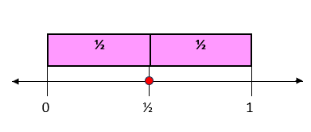

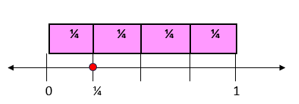

* Instruction includes partitioning shapes into different denominators.
  + For example, students compare what they notice about partitioning a rectangle into halves verses fourths. The teacher asks students, “What do you notice about the pieces? How can we write what one piece of the rectangle is worth with a fraction?” Instruction includes the vocabulary of numerator and denominator.

Graphic to explain example Graphic to explain example  half

Graphic to explain example 

fourths

* Instruction includes shapes other than circles and rectangles. Items like pattern blocks allow students to partition shapes like hexagons and rhombi into equal sized pieces. This prevents students from over-generalizing that all shapes can be divided the same way.
* Instruction includes folding and/or cutting premade shapes into different amounts. Students benefit from beginning with halves and fourths, folding the paper in half, and then folding those halves into halves to make fourths.
  + For example, the teacher asks students, “What do you notice about the shapes? About the size? We now have 4 pieces, do we have more than we did before?” Conversation includes the size of the pieces and how that relates to the denominator.

Instructional Tasks

*Instructional Task 1*

Mrs. Asbel wants to paint a mural on her classroom wall. She creates six equal sections in her mural.

Part A. Use manipulatives to create a visual model of the mural.

Part B. What fraction represents each section of the mural?

*Instructional Task 2*

Madison wants to divide a pan of brownies into 12 equal pieces.

Part A. Show three different ways that Madison can divide her pan of brownies into 12 equal pieces.

Part B. One piece of brownie would represent what fraction?

*Instructional Task 3*

Students at River Valley Elementary School are building a vegetable garden. Here is a picture of the garden so far:

Part A. Show how you would divide the vegetable garden into eight equal parts.

Part B. Explain how you know that the parts you made in Part A are equal.

Part C. Shade in one part of the vegetable garden. What fraction does this equal?

*Instructional Task 4*

Terry wants to show the unit fraction $\frac{1}{8}$ using an area model, a number line, and as a set.

Part A. Into how many equal parts should Terry partition his area model? How many of those parts should be shaded? Explain in words.

Part B. Represent $\frac{1}{8}$ using the number line below.

Part C. Draw a model that represents $\frac{1}{8}$ of a set of juice boxes.

*Enrichment Task 1*

What numbers could be on this number line?

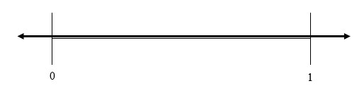

Instructional Items

*Instructional Item 1*

Each model shown has been shaded to represent a fraction. Which model shows $\frac{1}{4}$ shaded?

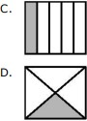

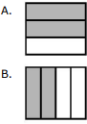

*Instructional Item 2*

Write the fraction that is shown on the number line.

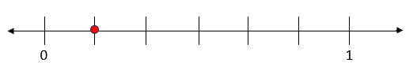

*Instructional Item 3*

Select all of the following that show $\frac{1}{8}$.

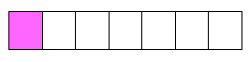

a.

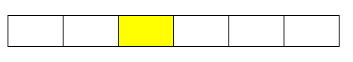

b.

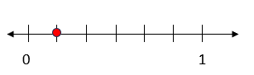

c.

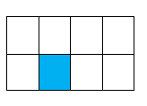

d.

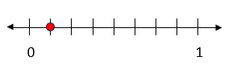

e.

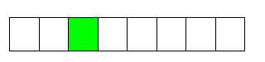 f.

*Instructional Item 4*

Jackson is helping hang his school flag outside the building. The flag has five equal-sized sections on it, each in a different color. Which fraction model represents one section of the school flag?



a.

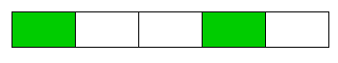

b.

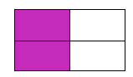

c.

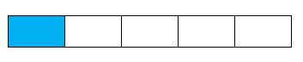

d.

*Enrichment Item 1*

Select all the items that show the unit fraction $\frac{1}{6}$.

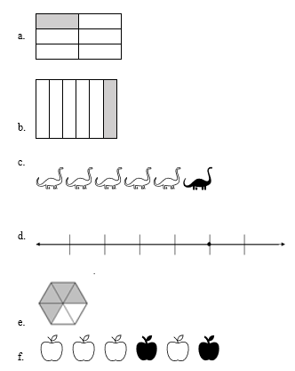

*The strategies, tasks and items included in the B1G-M are examples and should not be considered comprehensive.

### 

### MA.3.FR.1.2 & MA.4.FR.2.1

Benchmark (Grade 3)

MA.3.FR.1.2 Represent and interpret fractions, including fractions greater than one, in the form of $\frac{m}{n}$ as the result of adding the unit fraction $\frac{1}{n}$ to itself *m* times.

*Example: $\frac{9}{8}$* can be represented as $\frac{1}{8}$ + $\frac{1}{8}$ + $\frac{1}{8}$ + $\frac{1}{8}$ + $\frac{1}{8}$ + $\frac{1}{8}$ + $\frac{1}{8}$ + $\frac{1}{8}$ + $\frac{1}{8}$.

Benchmark Clarifications:

*Clarification 1:* Instruction emphasizes conceptual understanding through the use of manipulatives or visual models, including circle graphs, to represent fractions.

*Clarification 2:* Denominators are limited to 2, 3, 4, 5, 6, 8, 10 and 12.

Benchmark

MA.4.FR.2.1 Decompose a fraction, including mixed numbers and fractions greater than one, into a sum of fractions with the same denominator in multiple ways. Demonstrate each decomposition with objects, drawings and equations.

*Example: $\frac{9}{8}$* can be decomposed as $\frac{8}{8}$ + $\frac{1}{8}$ or as $\frac{3}{8}$ + $\frac{3}{8}$ + $\frac{3}{8}$.

Benchmark Clarifications:

*Clarification 1:* Denominators are limited to 2, 3, 4, 5, 6, 8, 10, 12, 16 and 100.

Connecting Benchmarks/Horizontal Alignment

* MA.3.FR.1.1
* MA.3.FR.1.3
* MA.3.FR.2.1
* MA.3.FR.2.2
* MA.4.FR.1.3
* MA.4.AR.1.2

Terms from the K-12 Glossary

* Expression
* Number line

Vertical Alignment

|  |  |
| --- | --- |
| **Previous Benchmarks**   * MA.2.FR.1.1 * MA.2.FR.1.2 | **Next Benchmarks**   * MA.5.FR.2.1 |

Purpose and Instructional Strategies

The purpose of these benchmarks is for students to think conceptually about fractions as they plot, compare, order and determine equivalence as well as develop the counting strategies and additive reasoning required to add and subtract fractions in the Grade 3 Accelerated course *(MTR.2.1, MTR.5.1)*. Decomposing fractions becomes the foundation for students to make sense of adding and subtracting fractions, much like decomposing whole numbers provided the foundation for adding and subtracting whole numbers in the primary grades.

* During instruction, teachers should have students practice representing fractions using manipulatives (e.g., fraction strips, circles, relationship rods), visual area models (e.g., partitioned figures) and on a number line. Manipulatives, visual models and number lines must extend beyond 1 so that students can represent fractions greater than *one (MTR.2.1, MTR.5.1)*.
* These benchmarks build understanding that all fractions, including fractions equal to and greater than one, decompose as the sum of unit fractions. In understanding fractions are numbers, students make connections about whole number operations that will be crucial for them to perform operations with fractions in the Grade 3 Accelerated course. For

example, understanding fractions as numbers allows students to reason that $\frac{2}{3}$ + $\frac{2}{3}$ = $\frac{4}{3}$

because we are adding together a total of 4 parts that are each one-third in size *(MTR.5.1)*.

* During instruction, students should also show multiple ways to decompose a fraction into equivalent addition expressions with the support of models (e.g., objects, drawings and equations).

Common Misconceptions or Errors

* Students may have difficulty decomposing mixed numbers and fractions greater than one. They may have a misunderstanding of flexible fraction representations (e.g., $\frac{4}{4}$ is equivalent to 1) or may not realize that fractions equal to and greater than 1 can also be represented as the sum of unit fractions (eg., $\frac{5}{2}$ = $\frac{1}{2}$ + $\frac{1}{2}$ + $\frac{1}{2}$ + $\frac{1}{2}$ + $\frac{1}{2}$). Flexible representations of models (e.g., rectangular area models that align with number lines) help students connect understanding of fractions and how they are decomposed into unit fractions.

Strategies to Support Tiered Instruction

* Instruction includes modeling how fractions are decomposed. Using fraction circles, students build $\frac{4}{4}$ and then see that there are 4 pieces that make up the whole circle.
* 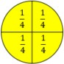For Example.

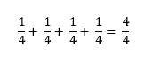

* Instruction includes more than one model so that students can experience and connect fractions in multiple ways. Flexible representations of models (e.g., rectangular area models that align with number lines) help students connect understanding of fractions and how they are decomposed into unit fractions.
  + 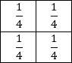For Example:

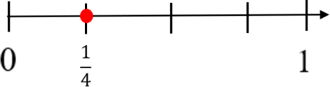

* + Students then apply this understanding to fractions greater than one. Using fraction circles, students build $\frac{8}{4}$ and then see that there are 8 pieces that make up two whole circles.
  + Example:

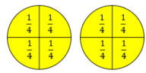

$\frac{1}{4}+ \frac{1}{4}+ \frac{1}{4}+ \frac{1}{4}+ \frac{1}{4} + \frac{1}{4} + \frac{1}{4} + \frac{1}{4}= \frac{8}{4}$

* Instruction includes folding and/or cutting pre-made shapes into halves. Students physically bend the paper into halves and then label the pieces. Instruction includes relating the pieces back to the numerator and denominator and then connecting it to the equation. Using multiple shapes with the same denominators will solidify basic fraction understanding. Instruction should progress with other denominators.
  + Example:

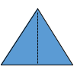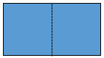

$\frac{1}{2}$ $\frac{1}{2}$ $\frac{1}{2}$ $\frac{1}{2}$

$\frac{1}{2}+ \frac{1}{2}= \frac{2}{2}$ $\frac{1}{2}+ \frac{1}{2}= \frac{2}{2}$

* Instruction includes fraction tiles or fraction kits to physically place and see equivalent fractions of a model.
  + Example:

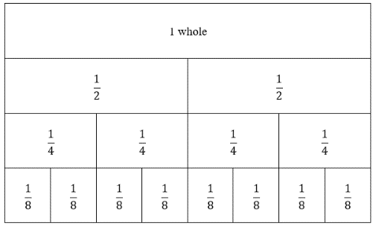

$$\frac{1}{2}=\frac{1}{4}+\frac{1}{4}$$

* The teacher provides instruction that models how fractions can be decomposed in multiple ways.
  + For example, using the same fraction tiles as above, students decompose $\frac{1}{2}$ in multiple ways with the understanding that the value does not change: $\frac{1}{2}=\frac{1}{8}+\frac{1}{8}+\frac{1}{8}+\frac{1}{8}$ or $\frac{1}{2}=\frac{1}{8}+\frac{1}{8}+\frac{2}{8}$ or $\frac{1}{2}=\frac{1}{8}+\frac{3}{8}$.

Instructional Tasks

*Instructional Task 1*

Part A: Part A: How many one-fifth sized parts are added together to equal 1 whole? Prove your thinking with a visual model or number line.

Part B: How many one-fifth sized parts are added together to equal 2 wholes? Prove your thinking with a visual model or number line.

*Instructional Task 2*

Part A: Use a visual fraction model to show one way to decompose $\frac{5}{9}$. Make sure to label each fraction part in the model, and write an equation to show how you decomposed $\frac{5}{9}$.

Part B: Show how you could decompose $\frac{5}{9}$ in a different way using a visual fraction model. Again, make sure to label each fraction part in the model, and write an equation to show how you decomposed $\frac{5}{9}$.

*Enrichment Task 1*

Part A: Show how you could decompose 3 wholes into sixths using a number line, or a visual model such as a post-it note (where each post-it note represents 1 whole.) How many sixths would there be in 3 wholes?

Part B: Represent the total number of sixths in 3 wholes in an equation. Create 2 additional equations that represent the total number of sixths in 3 wholes.

Part C: What if instead of sixths, you were asked to find the total number of eighths in 3 wholes? How would your equations change?

Instructional Items

*Instructional Item 1*

Represent the fraction $\frac{9}{5}$ as the sum of unit fractions.

*Instructional Item 2*

Which of the following expressions models $\frac{7}{4}$?

$\frac{1}{4} + \frac{1}{4} + \frac{1}{4} + \frac{1}{4}$

$\frac{1}{7} + \frac{1}{7} + \frac{1}{7} + \frac{1}{7}$

$\frac{1}{4}+ \frac{1}{4}+ \frac{1}{4}+ \frac{1}{4}+ \frac{1}{4} + \frac{1}{4} + \frac{1}{4}$

$\frac{1}{7}+ \frac{1}{7}+ \frac{1}{7}+ \frac{1}{7}+ \frac{1}{7} + \frac{1}{7} + \frac{1}{7}$

*Enrichment Item 1*

Decompose the fraction $\frac{8}{7}$ in as many ways as possible. How will you know when you found all possible number combinations?

*The strategies, tasks and items included in the B1G-M are examples and should not be considered comprehensive.

### MA.3.FR.1.3

Benchmark

MA.3.FR.1.3 Read and write fractions, including fractions greater than one, using standard form, numeral-word form and word form.

*Example:* The fraction $\frac{4}{3}$ written in word form is four-thirds and in numeral-word form is

4 thirds.

Benchmark Clarifications:

*Clarification 1:* Instruction focuses on making connections to reading and writing numbers to develop the understanding that fractions are numbers and to support algebraic thinking in later grades.

*Clarification 2:* Denominators are limited to 2, 3, 4, 5, 6, 8, 10 and 12.

Connecting Benchmarks/Horizontal Alignment

* MA.3.FR.1.1
* MA.3.FR.1.2
* MA.3.FR.2.1
* MA.3.FR.2.2
* MA.4.FR.1.1
* MA.4.FR.1.2
* MA.4.FR.2.1
* MA.4.FR.2.2
* MA.3.NSO.1.1
* MA.4.NSO.1.2

Terms from the K-12 Glossary

Vertical Alignment

|  |  |
| --- | --- |
| **Previous Benchmarks**   * MA.2.NSO.1.1 * MA.2.FR.1.1 | **Next Benchmarks** |

Purpose and Instructional Strategies

The purpose of this benchmark is for students to describe fractions in different ways.

* This benchmark builds precise vocabulary for describing fractions. When students describe $\frac{4}{3}$ as 4 thirds, they build understanding that the fraction represents 4 parts that are each one-third in size *(MTR.2.1)*.
* It is also the expectation of this benchmark that students represent fractions greater than one as mixed numbers in word and numeral-word form *(MTR.2.1)*.
* Instruction includes modeling and expecting precise vocabulary from students to describe fractions *(MTR.4.1*.).

Common Misconceptions or Errors

* Students can misinterpret fractions as two numbers that are being compared (e.g., reading “1 over 2” instead of one-half). The use of precise vocabulary helps them understand that a fraction is a representation of one number.
* Students can misinterpret that a fraction always models part of one whole. Exceptions to this misconception are fractions greater than one or fractions represented on number lines and in sets of objects.

Strategies to Support Tiered Instruction

* Instruction includes opportunities for practice in naming fractions correctly in multiple ways. Students use a chart to correctly name fractions. To increase appropriate terminology for naming fractions, students use visual representations with the naming of the fractional parts, as well as build fractions with models and utilize number lines. 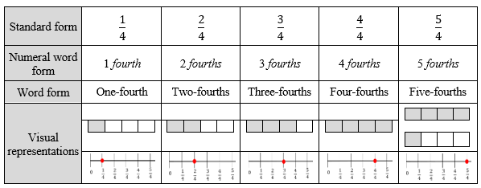
* For example, students model of build .

Rectangle divided into 4 sections, with 3 sections shaded. 

* + Teacher asks, "How can we describe this fraction model?" while guiding students to the understanding that $\frac{3}{4}$ is 3 fourths or 3 of the $\frac{1}{4}$ pieces. The use of precise vocabulary helps them understand that the same number can be represented by different visual models and different verbal expressions.
* Instruction includes opportunities to practice naming fractions correctly in multiple ways with concrete materials and models.
  + For example, students partition a shape or paper into halves. The teacher asks “What do you notice about the pieces? What do we call each piece? How can we write what one piece of the shape is worth with a fraction?” Instruction involves the vocabulary of numerator and denominator. Students are prompted to use the language of *one half* and then connect that to the standard form. The use of precise vocabulary helps students understand that a fraction is a representation of one number.

Instructional Tasks

*Instructional Task 1*

Part A. Reynaldo says that the fraction $\frac{8}{10}$ is written as 8 *tenths*. Jonathon says that the fraction $\frac{8}{10}$ is written as 10 *eighths*. Who is correct?

Part B. What is another way to represent $\frac{8}{10}$? Draw a model or write an equation.

*Instructional Task 2*

Show $2\frac{2}{3}$ in the following forms

Part A. Standard form.

Part B. Word form

Part C. Numeral-word form

Part D. With a visual model

*Instructional Task 3*

Build or model the fraction $\frac{5}{6}$.

Part A. Create the word form of this fraction.

Part B. Explain how this fraction is different fraction $\frac{6}{5}$.

*Enrichment Task 1*

Students play the game Go Fish, using cards that represent various fractions in various word, numeral-word, standard and visual forms. Students will be dealt out five cards and will have to call on another player to find a match to their fraction. For example, a student with the fraction card depicting *six thirds* will say to the other player “I have the fraction *six thirds*, do you have this fraction in another form?” For the card to be a match, the other play would have to have a card depicting six thirds in one of its other forms (see example).

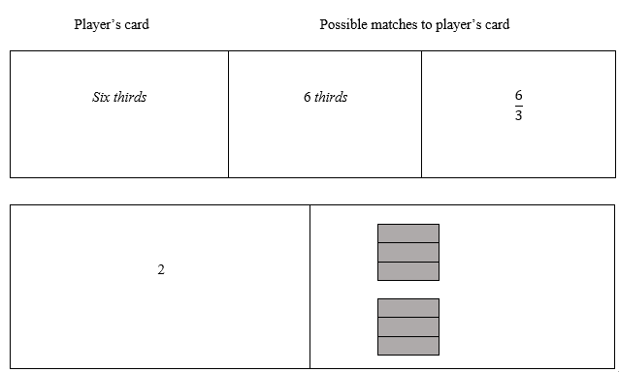

Instructional Items

*Instructional Item 1*

Select all the ways to represent $\frac{8}{3}$.

1. Eight thirds
2. 8 *thirds*
3. 3 *eighths*
$2\frac{2}{3}$

4. Three and two *thirds*

*Instructional Item 2*

Which of the following is the correct way to write $\frac{9}{4}$?

1. Four-*ninths*
2. Four-*fourths*
3. Nine-*fourths*
4. Nine-*ninths*

*Enrichment Item 1*

Select all the ways to represent $\frac{7}{4}$.

1. *Four sevenths*
2. *7 fourths*
3. *One and three fourths*
4. *Seven fourths*
5. *4 sevenths*
6. *One and seven fourths*

*The strategies, tasks and items included in the B1G-M are examples and should not be considered comprehensive.

### **MA.3.FR.2** Order and compare fractions and identify equivalent fractions.

### MA.3.FR.2.1 & MA.4.FR.1.4

Benchmark

MA.3.FR.2.1 Plot, order and compare fractional numbers with the same numerator or the same denominator.

*Example:* The fraction $\frac{3}{2}$ is to the right of the fraction $\frac{3}{3}$ on a number line so $\frac{3}{2}$ is greater

than $\frac{3}{3}$.

Benchmark Clarifications:

*Clarification 1:* Instruction includes making connections between using a ruler and plotting and ordering fractions on a number line.

*Clarification 2:* When comparing fractions, instruction includes an appropriately scaled number line and using reasoning about their size.

*Clarification 3:* Fractions include fractions greater than one, including mixed numbers, with denominators limited to 2, 3, 4, 5, 6, 8, 10 and 12.

Benchmark

MA.4.FR.1.4 Plot, order and compare fractions, including mixed numbers and fractions greater than one, with different numerators and different denominators.

*Example: $1\frac{2}{3}>1\frac{1}{4}$*  because $\frac{2}{3}$ is greater than $\frac{1}{2}$ and $\frac{1}{2}$ is greater than $\frac{1}{4}$.

Benchmark Clarifications:

*Clarification 1:* When comparing fractions, instruction includes using an appropriately scaled number line and using reasoning about their size.

*Clarification 2*: Instruction includes using benchmark quantities, such as 0, $\frac{1}{4}$, $\frac{1}{2}$, $\frac{3}{4}$ and 1, to compare fractions.

*Clarification 3*: Denominators are limited to 2, 3, 4, 5, 6, 8, 10, 12, 16 and 100.

*Clarification 4*: Within this benchmark, the expectation is to use symbols ($<$, $>$ or $=$).

Connecting Benchmarks/Horizontal Alignment

* MA.3.FR.2.2
* MA.3.NSO.1.3
* MA.4.M.1.1
* MA.3.DP.1.1
* MA.4.DP.1.2

Terms from the K-12 Glossary

* Number line

Vertical Alignment

|  |  |
| --- | --- |
| **Previous Benchmarks**   * MA.2.NSO.1.3 | **Next Benchmarks**   * MA.5.NSO.1.4 |

Purpose and Instructional Strategies

The purpose of this benchmark is for students to plot and order fractions with the same

numerator (e.g., $\frac{3}{4},$ $\frac{3}{2},$ $\frac{3}{8}$) or use fractions with the same denominator (e.g., $\frac{3,}{5}$ $\frac{10}{5}$, $\frac{7}{5}$) to compare them by their location on a number line. Then students will work on comparing fractions with different numerators and denominators (e.g., $\frac{3}{4},$ $\frac{10}{5},$ $\frac{1}{3}$) to understand the relative size of fractions. Students will plot fractions on the appropriate scaled number line, compare fractions using relational symbols, and order fractions from greatest to least or least to greatest.

* + During instruction, teachers should provide students opportunities to practice using the number line, which will assist students with understanding the difference in size when fractions have the same numerator (the size of the parts) and with comparing fractions with the same denominator (number of parts) *(MTR.2.1)*.
  + Through making a connection to inch rulers, students see that appropriately scaled number lines allow for comparisons of fraction size and will help them measure to the nearest $\frac{1}{16}$ of one inch.
  + Students should also utilize open number lines to practice creating their own appropriately scaled number lines *(MTR.2.1)*.
  + Instruction demonstrates that number lines can model fractional values as intervals that can be counted using unit fractions. For example, $\frac{5}{3}$ on a number line can be represented by 5 jumps of $\frac{1}{3}$ from 0.Second, number lines help students see comparisons of fractions to the same whole. Finally, number lines reinforce Clarification 3 for MA.3.FR.1.3, that fractions are numbers *(MTR.2.1, MTR.5.1)*.
  + Instruction may include helping students extend understanding by generating equivalent fractions with common numerators or common denominators to compare and order fractions.

Instruction may include using benchmark fractions and estimates to reason about the size of fractions when comparing them. Students can compare $\frac{3}{5}$ to $\frac{1}{2}$ by recognizing that 3 (in the numerator) is more than half of 5 (the denominator) so they can reason that $\frac{3}{5}>\frac{1}{2}$.

Common Misconceptions or Errors

* Students can confuse that when numerators are the same in fractions, larger denominators represent smaller pieces, and smaller denominators represent larger pieces.
* The student may mistake the fraction with the larger numerator and denominator as the larger fraction. The student may not pay attention to the relationship between numerator and denominator when estimating.
* When fraction comparisons are made using area models, students may confuse that the size of the whole for each model must be the same size.
* The student may incorrectly judge that a mixed number like $1\frac{3}{4}$ is always greater than an improper fraction like $\frac{17}{4}$ because of the whole number in front.

Strategies to Support Tiered Instruction

* Instruction includes opportunities to use concrete models and drawing of number lines to connect learning with fraction understanding.
* 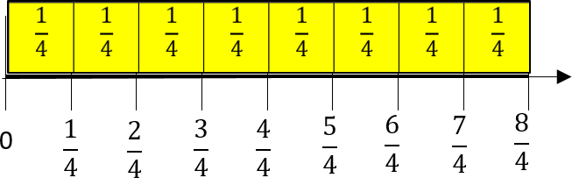For example, students plot fourths on the number line. Utilizing fraction strips or tiles, students can connect fractional parts to the measurement on a number line.
* Conversation includes what students notice about the fraction on the number line. “How many fourths are in three-fourths? What do we notice about the size of $\frac{1}{4}$ compared to $\frac{3}{4}$?” Students have opportunities to describe the distance from the 0 as well as the distance from their benchmark fractions.
* Instruction includes opportunities to use fraction manipulatives, concrete models and drawings. The teacher begins instruction by modeling fractional pieces with their fraction name. It is important that students see that the fractions that they are building and comparing refer to the same size whole.
* For example, students build fractions tiles or models to equal the same size one whole like below.

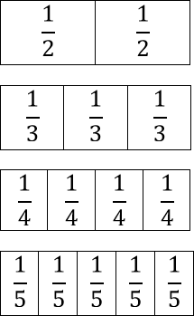



Graphic to explain example 

* Students pull out the unit fraction of each of the fraction models. Conversations include what students notice about the size of each piece and what students notice about the size of the piece compared to the denominators. “Why is $\frac{1}{2}$ larger than $\frac{1}{5}$?”
* Instruction includes models and examples where fractions greater than one whole are represented in a mixed number and as an improper fraction.
* For example, students might think that $\frac{7}{3}$ is greater than $1\frac{1}{4}$ because of the whole number being represented. Instruction includes models to represent fractions that build conceptual understanding of fractions greater than 1.

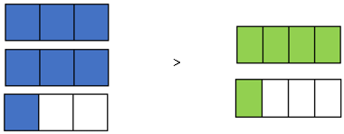

Instructional Tasks

*Instructional Task 1*

Clara says that $\frac{5}{4}$ is greater than $\frac{5}{2}$ because 4 is greater than 2. Prove why she is incorrect using the number line below.

*Instructional Task 2*

Part A. Create a number line to plot the following fractions: $\frac{3}{4}, \frac{7}{4} and \frac{1}{4}$.

Part B. Are any of the fractions you plotted between the whole numbers 1 and 2? How do you know?

*Instructional Task 3*

Use benchmark fractions and the number line below to compare the fractions $\frac{12}{5}$ and $2\frac{7}{8}$.

In the space below the number line, record the results of the comparison using the $<$, $>$ or $=$ symbol.

Blank number line

*Enrichment Task 1*

Draw an open number line for this set of fractions: $\frac{1}{6}$, $\frac{10}{5},$ $\frac{3}{4}$, $\frac{3}{2},$ and $\frac{9}{8}.$ Represent each of the fractions on the number line. Explain how you knew where to plot each fraction.

Instructional Items

*Instructional Item 1*

Order the fractions below from least to greatest.

$$\frac{8}{5}, \frac{8}{3}, \frac{8}{10},\frac{8}{1}$$

*Instructional Item 2*

Compare 7 fourths and 3 fourths using <, = or >.

*Instructional Item 3*

Which point shows $\frac{6}{3}$ plotted correctly?

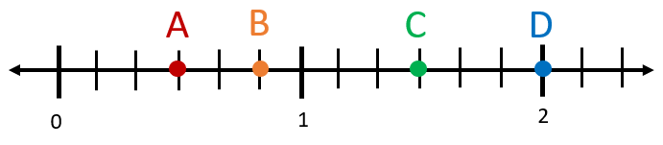

1. Point A
2. Point B
3. Point C
4. Point D

*Instructional Item 4*

Four soccer players started a game with the exact same amount of water in their water bottles. The table shows how much water each soccer player has left at the end of the game. Who has the least amount of water remaining?

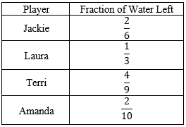

1. Jackie
2. Laura
3. Terri
4. Amanda

*Enrichment Item 1*

Part A: Choose two fractions or mixed numbers from this list: 2 $\frac{1}{3}$, $\frac{2}{8},$ $\frac{8}{3},$ $\frac{5}{7},$ and 1 $\frac{3}{4}$ and complete a comparison using <, >, and =. Then, select two different fractions or mixed numbers from the list and make a second comparison.

Part B: Plot the 4 fractions you chose on an open number line. Explain how you knew where to place each fraction.

*The strategies, tasks and items included in the B1G-M are examples and should not be considered comprehensive.

### MA. 3.FR.2.2 & MA.4.FR.1.3

Benchmark (Grade 3)

MA.3.FR.2.2 Identify equivalent fractions and explain why they are equivalent.

*Example:* The fractions $\frac{1}{1}$ and $\frac{3}{3}$ can be identified as equivalent using number lines.

*Example:* The fractions $\frac{2}{4}$ and $\frac{2}{6}$ can be identified as not equivalent using a visual model

Benchmark Clarifications:

*Clarification 1:* Instruction includes identifying equivalent fractions and explaining why they are equivalent using manipulatives, drawings, and number lines.

*Clarification 2:* Within this benchmark, the expectation is not to generate equivalent fractions.

*Clarification 3:* Fractions are limited to fractions less than or equal to one with denominators of 2, 3, 4, 5, 6, 8, 10 and 12. Number lines must be given and scaled appropriately.

Benchmark (Grade 4)

MA.4.FR.1.3 Identify and generate equivalent fractions, including fractions greater than one. Describe how the numerator and denominator are affected when the equivalent fraction is created.

Benchmark Clarifications:

*Clarification 1:* Instruction includesthe use of manipulatives, visual models, number lines or equations.

*Clarification 2:* Instruction includes recognizing how the numerator and denominator are affected when equivalent fractions are generated.

Connecting Benchmarks/Horizontal Alignment

* MA.3.FR.2.1
* MA.4.FR.1.4
* MA.4.FR.2.1
* MA.4.FR.2.3
* MA.4.M.1.1
* MA.4.M.1.2
* MA.4.DP.1.1
* MA.4.DP.1.2

Terms from the K-12 Glossary

* Number line

Vertical Alignment

|  |  |
| --- | --- |
| **Previous Benchmarks**   * MA.2.FR.1.1 * MA.2.FR.1.2 | **Next Benchmarks**   * MA.5.FR.2.1 |

Purpose and Instructional Strategies

The purpose of these benchmarks is for students to move from identifying equivalent fractions both on appropriately scaled number lines and in area models (while also explaining how the fractions are equivalent) to generating their own equivalent fractions (MTR.2.1, MTR.4.1). This builds the foundation for adding and subtracting fractions with unlike denominators in Grade 5 (MA.5.FR.2.1).

* For instruction, students should use multiple models to develop understanding of equivalent fractions. Students should use area models, set models, number lines and equations to determine and generate equivalent fractions (MTR.2.1).
* Instruction should prioritize tasks that allow for students to reason why fractions are equivalent using the models. (MTR.2.1).
* Instruction should focus on reasoning about how the numerator and denominators are affected when equivalent fractions are generated.
* Reasoning about the size of a fraction using benchmark fractions helps solidify students’ understanding about the size of the fraction.
* This work should also be done with fractions equal to and greater than one.

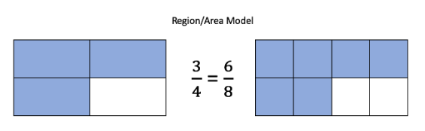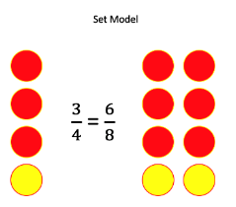

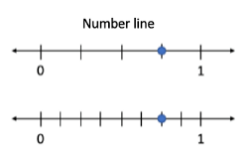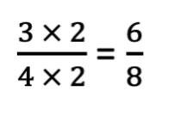

Common Misconceptions or Errors

* Students can confuse that when fractions have the same numerators, larger denominators represent smaller pieces, and smaller denominators represent larger pieces.
* Students think that when generating equivalent fractions, they need to multiply or divide only the numerator or only the denominator, such as changing $\frac{3}{4}$ to $\frac{3}{8}$.

Strategies to Support Tiered Instruction

* Instruction includes partitioning shapes with halves, thirds and fourths and then comparing the pieces used.
* For example, students partition a shape into halves.

Graphic to explain example Graphic to explain example 

=

* + Conversation includes observations about the shape partitioned into 2 equal parts. The teacher models writing the fractional parts $\frac{1}{2 }$ so that students can make the

connection of the denominator representing the number of pieces. Students then practice partitioning shapes into thirds and fourths for this same understanding.

* + Instruction includes opportunities to use concrete models and drawings to solidify understanding of fraction equivalence. Students use models to describe why fractions are equivalent or not equivalent when referring to the same size whole.
    - For example, when looking at $\frac{2}{5}$ and $\frac{4}{10}$, conversation includes that both fraction models are the same size. So, when comparing them, we are comparing the same size whole. Students should be able to see that 2 out of the 5 are shaded in the first model and 4 out of the 10 are shaded in the second mode, making the $\frac{2}{5}$ equal to $\frac{4}{10}$.

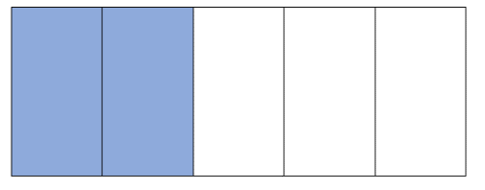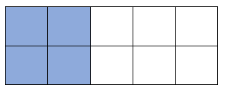

$\frac{2}{5}$ $\frac{4}{10}$

* Instruction includes fraction tiles or fraction kits to physically place and see equivalent fractions of a model. Students line up fraction tiles and begin to make observations about equivalence. One-half is equivalent to 2 one-fourth pieces. Students then notice that those pieces are then equivalent to 4 one-eighth pieces. Once students have this understanding, then they can begin to rename fractions.
  + Example:

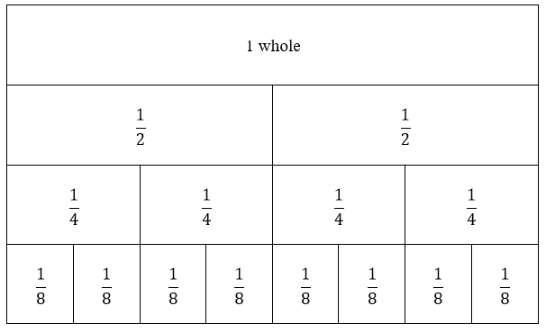

* When students begin exploring equivalent fractions on number lines, teachers can provide number lines that are already scaled and labeled so that students can focus on comparing the locations of equivalent fractions and build generalizations about how to identify them on number lines. Additionally, teachers can have students identify 0 and 1 on each number line so they can identify that the sizes of the wholes are the same. As students build their understanding, teachers can introduce blank number lines for students to then plot fractions and determine when they are equivalent.

Instructional Tasks

*Instructional Task 1*

Plot the fractions $\frac{2}{4}$ and $\frac{1}{2}$. Use your number line to determine whether the fractions are equivalent. Justify your argument in words.

Graphic to explain example 

*Instructional Task 2*

Use a visual model to prove why 6 eighths is equivalent to 3 fourths.

*Instructional Task 3*

The fractions $\frac{3}{4}$ and $\frac{9}{12}$ are equivalent.

Part A. Describe how a **visual model** will show that these fractions are equivalent.

Part B. Describe how a **number line** will show that these fractions are equivalent.

*Instructional Task 4*

Divide the number line below into enough equal sections so that you can locate and label the point $\frac{2}{5}$. Divide the same number line with a different color so that you can locate and label the point $\frac{4}{10}$. Discuss what you have learned.

Blank number line

*Enrichment Task 1*

Four friends try to see how far they can run across the football field in 1 minute. The chart below shows how far each friend made it.

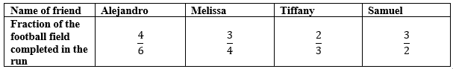

Draw an open number line and place each friend’s fraction on it. Who ran the farthest? Who ran the shortest distance? How do you know?

Instructional Items

*Instructional Item 1*

Use the area models below to determine whether the fractions they represent are equivalent.

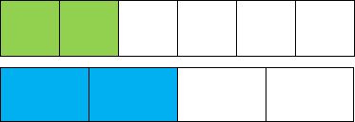

1. The model shows that 2 sixths and 2 fourths are equivalent because the area models

each have 2 shaded parts.

1. The model shows that 2 sixths and 2 fourths are equivalent because the area models

show the size of the shaded parts are equal when the size of each whole is the same.

1. The model shows that 2 sixths and 2 fourths are not equivalent because 2 sixths is

greater than 2 fourths when the size of each whole is the same.

1. The model show that 2 sixths and 2 fourths are not equivalent because the area

models show the size of the shaded parts are not equal when the size of each whole is

the same.

*Instructional Item 2*

1. Select all the fractions that are equivalent to one-half. . $\frac{3}{5}$

$\frac{3}{6}$

$\frac{5}{8}$

$\frac{5}{10}$

$\frac{5}{6}$

*Instructional Item 3*

Write a fraction that is equal to $\frac{3}{4}$ with a denominator 12.

*Instructional Item 4*

Olivia modeled a fraction by shading parts of the rectangle as shown.

Fration for item above.

Ethan draws a rectangle with the same size to model a fraction equivalent to Olivia’s. Which rectangle could Ethan have drawn?

1. 
2. Answer choice B for item above.
3. Answer choice C for item above.
4. 

*Enrichment Item 1*

Select all the values that are equivalent to 2 $\frac{1}{3}$.

$\frac{2}{3}$

$\frac{7}{3}$

$\frac{6}{3}$

$\frac{3}{2}$

$\frac{3}{7}$

1. 1 $\frac{4}{3}$

*The strategies, tasks and items included in the B1G-M are examples and should not be considered comprehensive.

### **MA.4.FR.1** Develop an understanding of the relationship between different fractions and the relationship between fractions and decimals.

### MA.4.FR.1.1

Benchmark

MA.4.FR.1.1 Model and express a fraction, including mixed numbers and fractions greater than one, with the denominator 10 as an equivalent fraction with the denominator 100.

Benchmark Clarifications:

*Clarification 1:* Instruction emphasizes conceptual understanding through the use of manipulatives, visual models, number lines or equations.

Connecting Benchmarks/Horizontal Alignment

* MA.4.NSO.2.6
* MA.4.NSO.2.7
* MA.4.FR.1.2
* MA.4.FR.1.3
* MA.4.FR.2.3

Terms from the K-12 Glossary

Vertical Alignment

|  |  |
| --- | --- |
| **Previous Benchmarks**   * MA.3.FR.2.2 | **Next Benchmarks**   * MA.5.FR.2.1 |

Purpose and Instructional Strategies

The purpose of this benchmark is to have students begin connecting fractions with decimals. This benchmark will connect fractions and decimals by writing equivalent fractions with denominators of 10 or 100 (decimal fractions). Decimal fractions are defined as fractions with denominators of a power of ten.

* For students to have a concrete foundation for future work with decimals (MA.4.NSO.1.5, MA.4.FR.1.2, MA.4.FR.1.3), teachers may provide experiences that allow students to use 10 by 10 grids, base-ten blocks, and other place value models *(MTR.2.1)* to explore the relationship between fractions with denominators of 10 and denominators of 100.
* This work lays the foundation for performing decimal addition and subtraction in MA.4.NSO.2.7.
* This benchmark should be taught in conjunction with MA.4.FR.2.3.

Common Misconceptions or Errors

* Students often confuse decimals such as 0.6 and 0.06. Students need to have conceptual understanding of the visual representations for tenths and hundredths. Students should use models and explain their reasoning to develop their understanding about the connections between fractions and decimals.
* Students may not understand why the denominator remains the same when adding and subtracting fractions with like denominators. Emphasize the use of area and number line models, and present expressions in numeral-word from to help understand that the denominator is the unit.
  + For example, “5 *tenths +* 9 *tenths* is equal to how many *tenths*?”

Strategies to Support Tiered Instruction

* Instruction includes concrete models and drawings to solidify the conceptual understanding of fraction place value.
* For example, students create a model for $\frac{2}{10}$. The teacher then asks students to model a fraction that is equivalent with a denominator of 100 and explain what they notice about the models. Conversation involves connections to the value of the fractions.

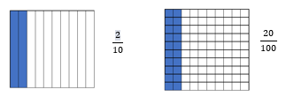



* Instruction includes building fractions and their equivalents with base ten blocks.
  + For example, students build $\frac{2}{10}$“two-tenths” and $\frac{20}{100}$“twenty hundredths” with base ten blocks while using vocabulary that will help students see the decimal connection as well. Students will realize that the numbers have the same value.

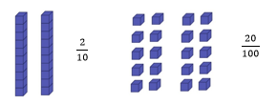 

* Instruction includes opportunities to use concrete models and drawings to solidify understanding of fraction equivalence.
* For example, students use models to describe why fractions are equivalent or not equivalent when referring to the same size whole.

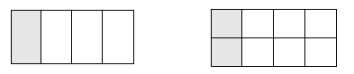

* When looking at $\frac{1}{4}$ and $\frac{2}{8}$, discussion includes that both fraction models are the same size. So, when comparing them, we are comparing the same size whole Students see that 1 out of the 4 are shaded in the first model and 2 out of the 8 are shaded in the second mode, making the $\frac{1}{4}$ equal to $\frac{2}{8}$. Students use this understanding to move into fractions with larger denominators.

Instructional Tasks

*Instructional Task 1*

Shade the models to complete the equivalent fractions.

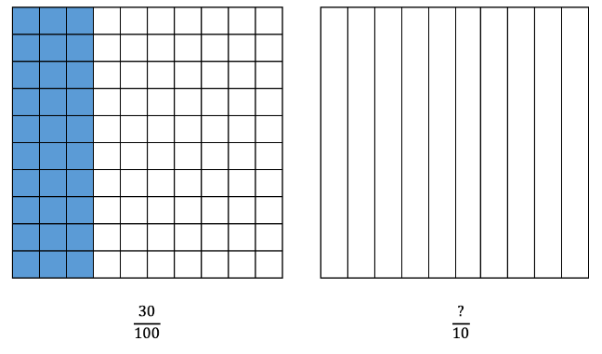 

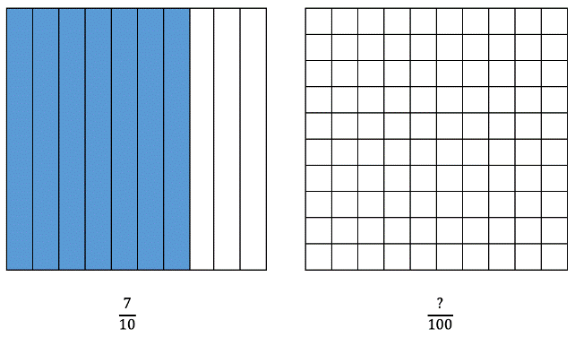 

*Instructional Task 2*

$\frac{3}{10}$ of students in Ms. Moore’s class like broccoli. Express and model this fraction with a denominator of 100.

*Instructional Task 3*

Part A. Draw a model of $\frac{70}{100}$.



Part B. Model and write an equivalent fraction with a denominator of 10.



*Instructional Task 4*

*Enrichment Task 1*

Determine the amount shaded in the model.



$\frac{?}{10}$ $\frac{?}{100}$

Instructional Items

*Instructional Item 1*

An equation is shown. Fill in the missing value for the equation.

$$\frac{6}{10}=\frac{?}{100}$$

*Instructional Item 2*

Which fraction is equivalent to $\frac{12}{10}?$

$\frac{2}{10}$

$\frac{120}{10}$

$\frac{12}{100}$

$\frac{120}{100}$

*Instructional Item 3*

Select all that apply. $7 \frac{20}{100}=$



$\frac{72}{10}$

$\frac{72}{100}$

$7 \frac{2}{10}$

$7 \frac{2}{1}$

$\frac{720}{100}$

*Enrichment Item 1*

An equation is shown. Fill in the missing values for the equation.

$4\frac{63}{10}$ = ? $\frac{?}{100}$

*Enrichment Item 2*

An equation is shown. Fill in the missing values for the equation.

$\frac{39}{10}=$ $\frac{?}{100}$ = ? $\frac{?}{100}$

*The strategies, tasks and items included in the B1G-M are examples and should not be considered comprehensive.

## *MA.4.FR.1.3*

## See Benchmark MA.3.FR.2.2

## *MA.4.FR.1.4*

## See Benchmark MA.3.FR.2.1

## ***MA.4.FR.2*** *Build a foundation of addition, subtraction and multiplication operations with fractions.*

## *MA.4.FR.2.1*

## See Benchmark MA.3.FR.1.2 (insert hyperlink here)

## *MA.4.FR.2.2*

Benchmark

MA.4.FR.2.2 Add and subtract fractions with like denominators, including mixed numbers and fractions greater than one, with procedural reliability.

Benchmark Clarifications:

*Clarification 1:* Instruction includes the use of word form, manipulatives, drawings, the properties of operations or number lines.

*Clarification 2:* Within this benchmark, the expectation is not to simplify or use lowest terms.

*Clarification 3:* Denominators are limited to 2, 3, 4, 5, 6, 8, 10, 12, 16 and 100.

Connecting Benchmarks/Horizontal Alignment

* MA.4.AR.1.

Terms from the K-12 Glossary

* Equation
* Expression

Vertical Alignment

|  |  |
| --- | --- |
| **Previous Benchmarks**   * MA.3.FR.1.1 * MA.3.FR.1.2 | **Next Benchmarks**   * MA.5.FR.2.1 |

Purpose and Instructional Strategies

The purpose of this benchmark is for students to build upon their decomposition of fractions to develop an accurate, reliable method for adding and subtracting fractions with like denominators (including mixed numbers and fractions greater than one) that aligns with their understanding and learning style. Procedural reliability in addition and subtraction of fractions with unlike denominators is expected in grade 5.

* *Clarification 1* states that instruction should include word form (to build vocabulary), manipulatives and drawings (to model), and the properties of operations. Using properties of operations (e.g., commutative property of addition, associative property of addition) allows students to connect prior knowledge about whole number addition and subtraction to fractions. Properties of operations also allow for students to add and subtract fractions flexibly (e.g., students may add by rewriting the expression $1\frac{4}{5}+4\frac{3}{5}$ as $1+4+\frac{4}{5}+\frac{3}{5}$ using the associative property of addition).
* Students need to have experience regrouping a fraction equivalent to 1 as a whole number for addition and subtraction.
  + For example, $\frac{5}{6}+\frac{4}{6}=\frac{9}{6}=\frac{6}{6}+\frac{3}{6}=1\frac{3}{6}$.
* This benchmark should be taught with MA.4.AR.1.2 for students to solve real-world problems while adding and subtracting fractions.

Common Misconceptions or Errors

* Some students may have difficulty understanding that when adding or subtracting fractions with like denominators, the denominator does not change. To help students understand why this happens, addition and subtraction should be accompanied with models to justify solutions.

Strategies to Support Tiered Instruction

* Instruction includes models and drawings demonstrating how when adding and subtracting with like denominators, we are adding and subtracting pieces of the whole. This learning connects to the understanding that fractions can be decomposed into smaller fractions from MA.4.FR.2.1.
  + For example, using a number line, the teacher models solving adding on the number line with guided questioning. Students explain how to use the number line as a model to solve the expression $\frac{3}{8} + \frac{4}{8}= ?$

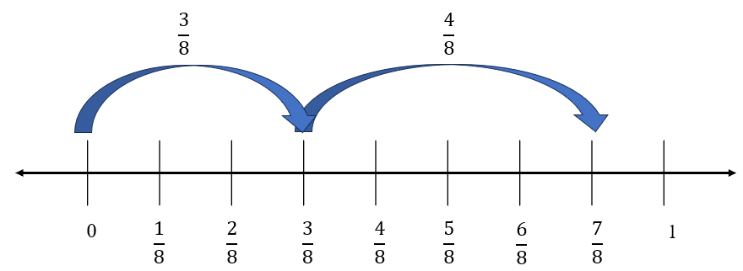

$$\frac{3}{8} + \frac{4}{8}= \frac{7}{8}$$

* Instruction includes the use of fraction bars or fraction strips to model solving expressions with explicit instruction and guided questioning.
  + For example, students explain how to use fraction bars or fraction strips as a model to solve expressions.

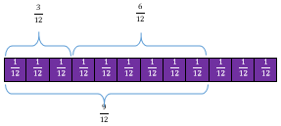

$\frac{3}{12} + \frac{6}{12}= \frac{9}{12 }$

Instructional Tasks

*Instructional Task 1*

Find the sum and explain your method.



$\frac{3}{4}+2\frac{3}{4}=$

$2\frac{3}{10}+1\frac{4}{10}=$

$2\frac{5}{8}-1\frac{3}{8}=$

*Enrichment Task 1 (MTR.3.1., MTR.4.1)*

Find the sum and explain your method.



$\frac{2}{3}+1\frac{2}{3}+2\frac{1}{3}=$

$1\frac{2}{12}+3\frac{4}{12}+\frac{6}{12}=$

$4\frac{5}{10}-2=$

Instructional Items

*Instructional Item 1*

The point on a number line shows the value of the sum of two fractions.

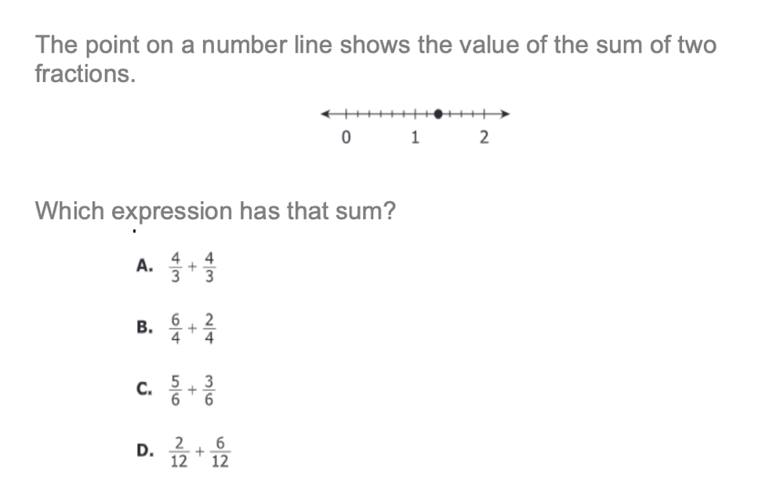

Which expression has that sum?

$\frac{4}{3}+\frac{4}{3}$

$\frac{6}{4}+\frac{2}{4}$

$\frac{5}{6}+\frac{3}{6}$

$\frac{2}{12}+\frac{6}{12}$

*Enrichment Item 1*

Using the visual model or a number line determine the sum of the following expressions:

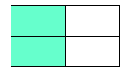*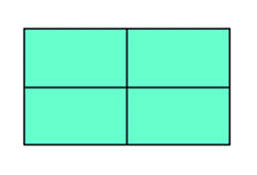Visual model for item above.
*

1. + +
2. +1 +
3. + 1 + +

*The strategies, tasks and items included in the B1G-M are examples and should not be considered comprehensive.

## *MA.4.FR.2.3*

Benchmark

MA.4.FR.2.3 Explore the addition of a fraction with denominator of 10 to a fraction with denominator of 100 using equivalent fractions.

*Example: $\frac{9}{100}+\frac{3}{10}$* is equivalent to $\frac{9}{100}+\frac{30}{100}$ which is equivalent to $\frac{39}{100}$.

Benchmark Clarifications:

*Clarification 1:* Instruction includes the use of visual models.

*Clarification 2:* Within this benchmark, the expectation is not to simplify or use lowest terms.

Connecting Benchmarks/Horizontal Alignment

* MA.4.NSO.2.7
* MA.4.FR.1.1
* MA.4.FR.1.2
* MA.4.FR.1.3

Terms from the K-12 Glossary

Vertical Alignment

|  |  |
| --- | --- |
| **Previous Benchmarks**   * MA.3.FR.1.2 * MA.3.FR.2.2 | **Next Benchmarks**   * MA.5.FR.2.1 |

Purpose and Instructional Strategies

The purpose of this benchmark is to connect fraction addition to decimal addition through decimal fractions. This will be the first opportunity for students to create common denominators to add fractions. This benchmark continues the work of equivalent fractions (MA.3.FR.1.2) by having students rename fractions with denominators of 10 as equivalent fractions with denominators of 100 (MA.4.FR.1.1). Students who can generate equivalent fractions can adapt this new procedure to develop strategies for adding fractions with unlike denominators in Grade 5 (MA.5.FR.2.1).

* Instruction may include students shading decimal grids ( $10×10$ grids) to support their understanding.

34/100 + 4/10 = 74/100

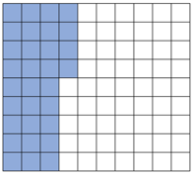 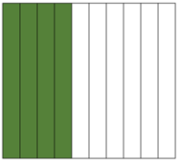 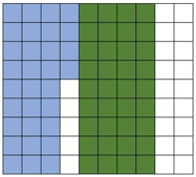

* Subtraction of decimal fractions is not a requirement of grade 4.
* This benchmark should be taught in conjunction with MA.4.FR.1.1.

Common Misconceptions or Errors

* Students often will add the numerators and the denominators without finding the like denominator. Students will need visual models to understand what the like denominator means.

Strategies to Support Tiered Instruction

* Instruction includes opportunities to explore the addition of a fraction with a denominator of 10 to a fraction with a denominator of 100 using visual models to help understand equivalent fractions. Students use visual models to make sense of equivalent fractions when finding like denominators. The teacher provides clarification that students must find the like denominator before adding.
  + For example, the teacher displays the problem $\frac{4}{10}+\frac{23}{100}$ and asks students to share what they notice about this expression. Students identify that the denominators are different. The teacher guides students to shade decimal grids to represent the problem and solve while supporting students as they use the visual models to understand that $\frac{4}{10}$ is equivalent to $\frac{40}{100}$. This is repeated with similar addition problems that have denominators of 10 and 100.

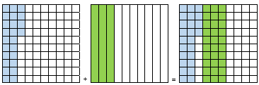

;

* + 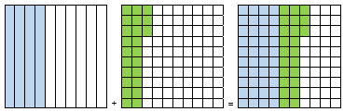For example, the teacher displays the problem $\frac{24}{100}+\frac{3}{10}$, asking students to share what they notice about this expression. Students identify that the denominators are different. The teacher guides students to use place value blocks and shaded decimal grids to represent the problem and solve, having tens rods represent tenths, and ones cubes represent hundredths. Students are supported as they use the visual models to understand that $\frac{3}{10}$ is equivalent to $\frac{30}{100}$. This is repeated with similar addition problems that have denominators of 10 and 100.

**base 10 blocks used to represent equation below.**

;

Instructional Tasks

*Instructional Task 1*

Determine the equivalent fraction.

$$\frac{5}{10} = \frac{? }{100}$$

Use your thinking from above to help you add the following fractions:

$$\frac{31}{100} + \frac{5}{10}=$$

Instructional Items

*Instructional Item 1*

An expression is shown.

$$\frac{3}{10}+\frac{32}{100}$$

What is the value of the expression?

*Enrichment Item 1*

Select all the expressions that will have a sum or difference greater than 3.

$1\frac{3}{10}+\frac{7}{10}+1\frac{6}{10}$

$\frac{8}{10}+1\frac{2}{10}+\frac{2}{10}$

$4\frac{3}{10}-\frac{7}{10}$

$\frac{11}{10}+\frac{18}{10}+1\frac{9}{10}$

$\frac{6}{10}+1\frac{4}{10}+1\frac{1}{10}$

*The strategies, tasks and items included in the B1G-M are examples and should not be considered comprehensive.

## Algebraic Reasoning

**MA.3.AR.1** *Solve multiplication and division problems..*

### MA.3.AR.1.1

Benchmark

MA.3.AR.1.1 Apply the distributive property to multiply a one-digit number and two-digit number. Apply properties of multiplication to find a product of one-digit whole numbers.

Example: The product $4×72$ can be found by rewriting the expression as

$4×(70+2)$ and then using the distributive property to obtain

$\left(4×70\right)+(4×2)$ which is equivalent to 288.

Benchmark Clarifications:

*Clarification 1*: Within this benchmark, the expectation is to apply the associative and commutative properties of multiplication, the distributive property and name the properties. Refer to K-12 Glossary (Appendix C).

*Clarification 2*: Within the benchmark, the expectation is to utilize parentheses.

*Clarification 3*: Multiplication for products of three or more numbers is limited to factors within 12. Refer to Properties of Operations, Equality and Inequality (Appendix D).

Connecting Benchmarks/Horizontal Alignment

* MA.3.NSO.2.3
* MA.3.NSO.2.4
* MA.4.NSO.2.2

Terms from the K-12 Glossary

* Associative Property of Multiplication
* Commutative Property of Multiplication
* Distributive Property
* Expression
* Equation
* Factors

Vertical Alignment

|  |  |
| --- | --- |
| **Previous Benchmarks**   * MA.2.NSO.1.2 | **Next Benchmarks**   * MA.4.NSO.2.3 |

Purpose and Instructional Strategies

The purpose of this benchmark is for students to apply what they have learned about multiplication of one-digit numbers and multiples of ten to then multiply a one-digit number and a two-digit number (MA.3.NSO.2.3).

* Students are introduced to the distributive property of multiplication over addition as a strategy for using products that they know in order to solve products that they do not know. For example, if students are asked to find the product of $6×9$, they might decompose 6 into 4 and 2 and then multiply $4×9$ and $2×9$ to arrive at 36 + 18, which equals 54. Because of the distributive property, students use parentheses to show how to decompose two-digit numbers by the value of its tens and ones or other known facts.. The application of the Commutative and Associative properties of Multiplication allow for two-digit numbers to be decomposed and multiplication expressions reorganized so that the distributive property can work *(MTR.2.1)*.

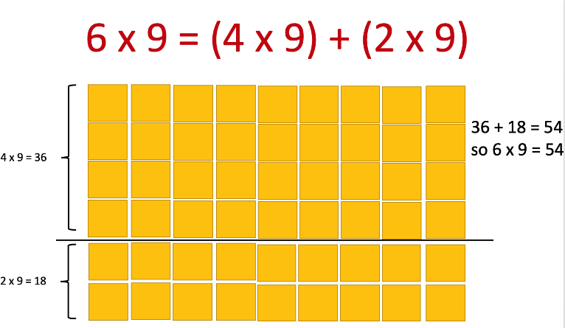

* + During instruction, teachers can model where the properties are applied while multiplying and expect students to explain how they work during explanations of their strategies and solutions.
  + Instruction extends students’ understandings of using the distributive property to multiply one-digit numbers to when one factor is a two-digit number. Two-digit numbers can be decomposed by tens and ones or by decomposing into other known 11s and 12s facts (the former of which will connect students to place value understanding). For example, in the expression $24×7$, students may choose to decompose 24 as 20 + 4 or as 12 +12 before then multiplying each addend by 7 to find the product *(MTR.2.1, MTR.5.1)*
  + Building understanding of the distributive property in Grade 3 will help students decompose larger numbers as they continue to multiply multi-digit numbers with procedural reliability and procedural fluency in Grade 4. Splitting arrays in multiple ways can help students understand the distributive property. They can use a known fact to learn other facts that may cause difficulty *(MTR.2.1, MTR.4.1).*

Common Misconceptions or Errors

* Students can be confused about how to write expressions using the distributive property because they are not relating the equation to what it models. One common mistake that students make is writing an expression 4 × 72 as (4 × 70) × (4 × 2) instead of (4 × 70) + (4 × 2). Instruction should show concrete models (e.g., base ten drawings) along with equations so students can understand the relationship between multiplication and addition while applying the property and writing expressions.

Strategies to Support Tiered Instruction

* Instruction includes opportunities to use concrete models and drawings along with equations to increase understanding of the relationship between multiplication and addition when applying the distributive property and writing equations. The teacher begins by modeling a one-digit number multiplied by a one-digit number, guiding students to decompose one of the factors and use models or drawings to demonstrate the reorganization of the multiplication expression using parentheses. Next, the teacher models multiplication of a one-digit number by a two-digit number, guiding students to decompose the two-digit number into the value of the tens and the ones using models or drawings. The teacher clarifies that the decomposed factor can be represented in expanded form by adding the tens and the ones, repeating with additional one-digit by two-digit multiplication equations.
  + For example, the teacher uses a model or drawing to use the distributive property to solve $3×24$.

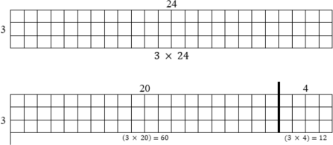

3 × (20 + 4)

(3 × 20) + (3 × 4)

(3 × 20) + (3 × 4) = 60 + 12

(3 × 20) + (3 × 4) = 72

so 3 × 24 = 72

* Teacher provides opportunities to apply the distributive property to solve one-digit by two-digit multiplication equations using base-ten blocks or place value disks. The teacher provides the equation and guides students to decompose the two-digit number into the value of the tens and the ones using manipulatives. If needed, the teacher prompts students to count by 10s and 1s using the base-ten blocks or place value disks
  + For example, the teacher uses base-ten blocks to solve 3 × 24 while asking guiding questions such as “How many tens are in 24?” “How many ones are in 24?” “How would we write 24 in expanded form?”

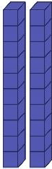

3 × 24

3 × (20 + 4)

(3 × 20) + (3 × 4)

(3 × 20) + (3 × 4) = 60 + 12

(3 × 20) + (3 × 4) = 72

So 3 × 24 = 72

Instructional Tasks

*Instructional Task 1*

In each equation, find the missing value, *n*.

Part A. 4 × 52 = (4 × 50) + (4 × 𝑛)

Part B. 𝑛 × 3 = (20 × 3) + (9 × 3)

Part C. 8 × 36 = (𝑛 × 30) + (𝑛 × 6)

Part D. 48 × 6 = 𝑛

*Instructional Task 2*

Tory tried to use the associative and commutative properties to create the following equations. Using pictures and/or words, explain why Tory is incorrect.

$$4×\left(11+6\right)=\left(4×11\right)+6$$

$$4×\left(11+6\right)=11×\left(4+6\right)$$

*Instructional Task 3*

Julio says that he can use the distributive property to find the product of $24×9$ by rewriting the expression as $\left(12×9\right)+(12×9)$. Mirabel says she can use the distributive property to find the product of by rewriting the expression as $\left(20×9\right)+\left(4×9\right)$. Who is correct? Explain

Instructional Items

*Instructional Item 1*

Which of the following correctly uses the distributive property to multiply 8 × 39?

1. (8 × 30) × (8 × 9) = 96
2. (8 × 30) + (8 × 9) = 296
3. (8 × 30) + (8 × 9) = 45
4. (8 × 30) + (8 × 9) = 312

*Instructional Item 2*

To find its product, an expression is written as $\left(3×40\right)+\left(3×6\right)$. Which expression has the same product?

$3×40$

$3×46$

$6×40$

$6×46$

*Instructional Item 3*

Use the distributive property to find the product of $48×6$

*The strategies, tasks and items included in the B1G-M are examples and should not be considered comprehensive.

### 

### MA.3.AR.1.2

Benchmark

MA.3.AR.1.2 Solve one- and two-step real-world problems involving any of four operations with whole numbers.

Example: A group of students are playing soccer during lunch. How many students are needed to form four teams with eleven players each and to have two referees?

Benchmark Clarifications:

*Clarification 1:* Instruction includes understanding the context of the problem, as well as the quantities within the problem.

*Clarification 2:* Multiplication is limited to factors within 12 and related division facts. Refer to Situations Involving Operations with Numbers (Appendix A).

.

Connecting Benchmarks/Horizontal Alignment

* MA.3.NSO.2.1
* MA.3.NSO.2.2
* MA.3.NSO.2.3
* MA.3.NSO.2.4
* MA.3.AR.2.1
* MA.3.AR.2.2
* MA.3.AR.2.3
* MA.4.AR.1.1

Terms from the K-12 Glossary

* Expression
* Equation

Vertical Alignment

|  |  |
| --- | --- |
| **Previous Benchmarks**   * MA.2.AR.1.1 | **Next Benchmarks**   * MA.4.AR.1.2 |

Purpose and Instructional Strategies

The purpose of this benchmark is for students to apply all four operations to solve one and two- step real-world problems. This benchmark continues the work done in Grade 2 solving real-world problems using addition and subtraction (MA.2.AR.1.1).

* Instruction should facilitate students’ understanding of contexts and quantities within word problems.
* The emphasis on teaching problem-solving strategies should focus on the comprehension of problem contexts and what quantities represent in them. Examples of questions that help students comprehend word problems are:
  + What is happening in the real-world problem?
  + What do you need to find out?
  + What do the quantities represent in the problem?
  + What will the solution represent in the problem? *(MTR.1.1, MTR.4.1, MTR.6.1)*
* Teachers can model answering these questions through rectangular arrays, base-ten blocks, counters and think-alouds. In addition, teachers can help students explore estimation strategies to determine reasonable ranges for solutions (e.g., rounding, finding low and high estimates) and teach problem-solving strategies that build comprehension (e.g., Three Reads) *(MTR.4.1, MTR.5.1, MTR.6.1)*.

Common Misconceptions or Errors

* Students may have difficulty creating effective models (e.g., drawings, equations) that

will help them solve real-world problems. To assist students, provide opportunities for them to estimate solutions and try different models before solving. Beginning instruction by showing problems without their quantities is a strategy for helping students determine what steps and operations will be used to solve.

* Students may also have difficulty identifying when real-world problems require two steps to solve and will complete only one of the steps. Focusing on comprehension of real- world problems helps students determine what step(s) are required to solve.

Strategies to Support Tiered Instruction

* Instruction provides opportunities for students to estimate solutions and try different models before solving.
* Instruction focuses on having students create models (e.g., equations, drawings, manipulatives) to solve real-world problems. The teacher uses guided questioning to support comprehension, considering levels of reading proficiency for students who may struggle with word problems—some students may need to hear the problems read aloud. The teacher provides opportunities to estimate solutions and try different models before solving. Beginning instruction by showing problems without their quantities is a strategy to help students determine what steps and operations will be used to solve.
  + For example, the teacher reads aloud the following problem: “Keisha and Diego are selling pies for a fundraiser. Each pie costs five dollars. If Keisha sells 15 pies and Diego sells 5 pies, how much money did they earn for the fundraiser?”
    - The teacher uses questioning to ensure comprehension (e.g., “What do you need to find out?” “What do the quantities represent in the problem?” “What will the solution represent in the problem?”).
    - The teacher models how to represent this problem using an equation and a drawing.

(15 + 5) × 5

* + 1. × 5

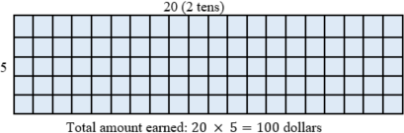

* + As the teacher models the problem using expressions and models, students should be prompted to identify the components of each so they can relate values and visuals back to the real-world situation. (E.g., “What does the expression $\left(15+5\right)$ represent?” “Why is the sum multiplied by 5?” “Could I have multiplied differently using the distributive property?”
    - The teacher repeats with additional two-step problems, guiding students to create appropriate models to support problem-solving
  + For example, the teacher reads aloud the following problem: “Antwan is helping the art teacher get ready for art club. There are a total of 30 paintbrushes. The art teacher asked Antwan to put 6 paintbrushes on each of the 4 tables in the room and then put the rest on the counter. How many paint brushes will he put on the counter?”
    - The teacher uses questioning to ensure comprehension (e.g., “What do you need to find out?” “What do the quantities represent in the problem?” “What will the solution represent in the problem?”).
    - The teacher models the problem using counters, prompting the students to demonstrate each step of the problem while writing the corresponding equations for each step.



6 × 4 = 24

30 – 24 = 6

* + - The teacher repeats this strategy with additional two-step problems, guiding students to create appropriate models using manipulatives to support problem- solving. Some students may benefit from “acting out” the story in the problem to support the problem-solving process.
  + Instruction includes guided practice identifying and completing two steps in a real-world problem. The teacher uses guided questioning to support comprehension considering levels of reading proficiency for students who may struggle with word problems—some students may need to hear the problems read aloud. The teacher uses explicit prompts for each step.
    - For example, the teacher reads aloud the following problem: “Suni is taking piano lessons. Her piano teacher told her to practice for 90 minutes this week. On Monday, she practiced 15 minutes. She practiced 20 minutes on Tuesday and 25 minutes on Wednesday. How much more time does she still need to practice this week?”
  + The teacher uses guided questioning and prompts to help students to identify the steps (e.g., “What do you already know?” “What do you need to find out?” “What do we need to do before we can find out the remaining time she has left to practice?”). Through questioning, the teacher guides students to identify the first step: adding the amount of time Suni has already practiced.
  + The teacher uses a model to represent the problem and an equation to represent the first step.

15 + 20 + 25 = 60

* + - After students complete the first step, the teacher uses questioning to prompt next step (e.g., “What does the sum we just found show us?” “What do you need to find out to solve this problem?” “What should we do next?”). The problem may need to be reread aloud.

15 + 20 + 25 = 60

60 + = 90

90 − 60 = 30 minutes

|  |  |  |  |
| --- | --- | --- | --- |
| Monday | Tuesday | Wednesday | Remaining Time |
| 15 | 20 | 25 | ? |
| Total = 90 minutes | | | |

* + - The teacher repeats with additional two-step problems, guiding students to identify and solve each step.
  + For example, the teacher reads aloud the following problem: Rahim is learning about instruments in music class. He learns that guitars have six strings and mandolins have four strings. If there are three guitars and four mandolins in the classroom, how many strings are there altogether on the guitars and mandolins?
    - The teacher uses guided questioning and prompts to help students to identify the steps (e.g., “What do you already know?” “What do you need to find out?” “What do we need to do before we can find out the remaining time she has left to practice?”). Through questioning, the teacher guides students to identify the first step: Multiplying the number of strings by the number of each instrument.
    - The teacher guides the students to create a model (using manipulatives such as counters) with corresponding equations.

3 × 6 = 18

4× 4 = 16

* + - After students complete the first step, the teacher uses questioning to prompt next step (e.g., “What have we learned about the numbers of strings?” “What do you need to find out to solve this problem?” “What should we do next?”). The problem may need to be reread aloud.

18 + 16 = 34 total strings

* + - The teacher repeats with additional two-step problems, guiding students to identify and solve each step using manipulatives. Some students may benefit from “acting out” the story in the problem to support the problem- solving process.

Instructional Tasks

*Instructional Task 1*

Solve the problem. Oak Hill Elementary third grade students are taking a field trip to the zoo. There are 71 students who paid to attend the field trip. Of those that paid, 8 students cannot go on the day of the trip. There needs to be 7 groups at the zoo and each group must have an equal number of students. How many students will be in each group on the field trip?

*Instructional Task 2*

Rae buys one flower each day for one week (7 days). At the end of the week, she has $12 left. If Rae started the week with $33, how much did she spend each day for a flower?

*Instructional Task 3*

Everglades Elementary School is going on a field trip to the zoo. An additional 6 students are transported by van. Each bus holds 54 students and there are 4 buses. How many students are brought on the field trip in all?

*Instructional Task 4*

Noelle has $592 saved in her piggy bank. This week, she earned an additional $12 for babysitting. If she buys a computer for $390 next week, how much money will she have left*?*

*Enrichment Task 1*

A student is asked to solve a word problem, but the student’s paper was ripped and they

cannot see the question. Come up with 2 possible questions and solutions to the questions

that could be asked using the information remaining on the student’s paper.

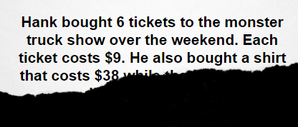

Instructional Items

*Instructional Item 1*

For a school food drive, three students bring in cases of canned goods to donate. Uriel brings 4 cases, Paola brings 6 cases, and Mika brings 5 cases. Each case contains 8 canned goods. How many canned goods in all does the school collect?

*Instructional Item 2*

A bookstore has 8 boxes of books. Each box contains 10 books. On Monday, the bookstore sold 16 books. How many books remain to be sold?

*Instructional Item 3*

At a carnival, Olivia’s family spent $86 in all. They spent $30 on snacks. The rest of the money was spent on tickets to enter the carnival. If there are seven people in Olivia’s family, how much did each ticket cost*.*

*The strategies, tasks and items included in the B1G-M are examples and should not be considered comprehensive.

**MA.3.AR.2** *Develop an understanding of equality and multiplication and division*

### MA.3.AR.2.1

Benchmark

MA.3.AR.2.1 Restate a division problem as a missing factor problem using the relationship between multiplication and division.

Example: The equation 56 ÷ 7 =? can be restated as 7 ×? = 56 to determine the quotient is 8.

Benchmark Clarifications:

*Clarification 1:* Multiplication is limited to factors within 12 and related division facts.

*Clarification 2:* Within this benchmark, the symbolic representation of the missing factor uses any symbol or a letter.

Connecting Benchmarks/Horizontal Alignment

* MA.3.NSO.2.2
* MA.3.NSO.2.4
* MA. 3.AR.1.2
* MA. 4.AR.2.1

Terms from the K-12 Glossary

* Equation
* Factor

Vertical Alignment

|  |  |
| --- | --- |
| **Previous Benchmarks**   * MA.1.AR.2.1, * MA.2.AR.2.1 | **Next Benchmarks**   * MA.4.AR.2.1 |

Purpose and Instructional Strategies

The purpose of this benchmark is to build students’ fluency with division facts by relating them

to known multiplication facts. Division is often more challenging for students than multiplication, so relating division to multiplication helps to determine quotients more efficiently. Students learned a similar strategy when relating subtraction to addition in Grade 1 (MA.1.AR.2.1).

* + Instruction should have students build and use fact families to relate division and multiplication equations. It is important for students to understand that multiplication and division are inverse operations. During instruction, students should have practice with solving and explaining division problems that can also be represented as an unknown factor in multiplication problems *(MTR.3.1, MTR.5.1)*.
  + To help students understand the relationships between division problems and unknown factor problems conceptually (and to build understanding about fact families), teachers can utilize arrays that show 4 related multiplication and division facts. In addition to arrays, instruction of this standard pairs well with MA.3.AR.1.2 while students solve one- and two-step real-world problems. When students translate problem contexts to division equations, this benchmark helps students find solutions *(MTR.3.1, MTR.5.1).*

Common Misconceptions or Errors

* Students may have difficulty understanding that the quotient of a division equation will become a factor in a multiplication equation. Allowing students to use an array model and/or reinforcing fact families may help to clarify the relationship.

Strategies to Support Tiered Instruction

* Instruction includes opportunities to use array models to practice relating multiplication and division as inverse operations. The teacher shows an array model and guides students to identify the factors and the product, having them assist in writing the corresponding equation. The teacher guides students to complete the fact family using prompts as needed, reminding them that multiplication and division are inverse operations. After practicing with several examples, students practice completing fact families without arrays, solving for an unknown factor.
  + For example, students draw an array model to show 3 × 7.

Graphic to explain example 

3 × 7 = 21

7 × 3 = 21

21 ÷ 7 = 3

21 ÷ 3 = 7

* + For example, the students write the fact family and solve for 42 ÷ 6.

42 ÷ 6 = 42 ÷ 6 = 7

42 ÷ = 6 42 ÷ 7 = 6

6 × = 42 6 × 7 = 42

× 6 = 42 7 × 6 = 42

* Teacher provides opportunities to use manipulatives to practice relating multiplication and division as inverse operations. The teacher guides students to develop a model using manipulatives (e.g., counters or base-ten blocks) and uses explicit instruction and questioning to help students to identify the related equation. Additionally, the teacher guides students to complete the fact family using explicit instruction, verbal prompts and nonverbal cues while reminding students that multiplication and division are inverse operations. After practicing with several examples, students practice completing fact families without arrays, solving for an unknown factor with the support of number cards.
  + For example, the teacher uses counters to show an array to represent 4 × 8 and asks guiding questions to help students build the array. With prompting, the teacher guides students to identify the product and write the complete fact family



4 × 8 = 32

8 × 4 = 32

32 ÷ 8 = 4

32 ÷ 4 = 8

* + For example, students use number cards to rearrange equations to create all four parts to the fact family and solve for a missing factor. Students may also write on notecards for this activity. One card should have the multiplication symbol on one side and the division symbol on the other. The teacher uses a blank card for the missing factor until the students solve. Students move each card to a different location to build the entire fact family and record each equation on a sheet of paper or personal white board as they manipulate the cards.

Instructional Tasks

*Instructional Task 1*

Part A. Write a multiplication equation that can be used to find the quotient 48 ÷ 12. Use *n*

to represent the unknown factor.

Part B. What is the quotient?

*Instructional Task 2*

Use the properties of operations to explain why both equations below can be used to find the quotient of 42 and 6.

$6×n=42$

$n×6=42$

*Instructional Task 3*

Yashira wants to find the quotient of $63÷7$ by rewriting it as a multiplication equation. She is not sure if she should use $7× ?= 63$ or $7×63= ?$ to find her answer. Use the properties of operations to justify your answers for the questions below.

Part A. Which equation should Yashira use to find the quotient of 63 and 7? Why?

Part B. Why will the other equation not work?

Instructional Items

*I**nstructional Item 1*

Which of the following equations can be used to find the quotient 72 ÷ 8 ?

a. 8 × ? = 72

b. 72 × 8 = ?

c. 72 − 8 = ?

d. ? + 8 = 72

*The strategies, tasks and items included in the B1G-M are examples and should not be considered comprehensive.

### MA.3.AR.2.2 & MA.4.AR.2.1

Benchmark (Grade 3)

MA.3.AR.2.2 Determine and explain whether an equation involving multiplication or division is true or false.

*Example:* Given the equation 27 ÷ 3 = 3 × 3, it can be determined to be a true equation by dividing the numbers on the left side of the equal sign and multiplying the numbers on the right of the equal sign to see that both sides are equivalent to 9.

Benchmark Clarifications:

*Clarification 1:* Instruction extends the understanding of the meaning of the equal sign to multiplication and division.

*Clarification 2:* Problem types are limited to an equation with three or four terms. The product or quotient can be on either side of the equal sign.

*Clarification 3:* Multiplication is limited to factors within 12 and related division facts.

Benchmark (Grade 4)

MA.4.AR.2.1 Determine and explain whether an equation involving any of the four operations with whole numbers is true or false.

*Example:* Determine and explain whether an equation involving any of the

four operations with whole numbers is true or false.

Benchmark Clarifications:

*Clarification 1:* Multiplication is limited to whole number factors within 12 and related division facts.

Connecting Benchmarks/Horizontal Alignment

* MA.3.NSO.1.3
* MA.3.NSO.2.2
* MA.3.NSO.2.4
* MA.3.AR.1.2
* MA.4.AR.2.1

Terms from the K-12 Glossary

* Equation
* Equal Sign
* Expression

Vertical Alignment

|  |  |
| --- | --- |
| **Previous Benchmarks**   * MA.2.AR.2.1 | **Next Benchmarks**   * MA.4.AR.2.3 |

Purpose and Instructional Strategies

The purpose of this benchmark is to extend the understanding of the meaning of the equal sign in multiplication and division situations. In Grades 1 and 2, students determined and explained when addition and subtraction equations were true or false (MA.1.AR.2.2, MA.2.AR.2.1). In the Accelerated Grade 3 Course, students will determine if equations are true or false for all four operations.

* Instruction should emphasize that the equal sign can be read as “the same as” to show the balance of two expressions. The purpose of this benchmark is to determine if students can connect their understanding of using the four operations fluently *(MTR.3.1)* to the concept of the meaning of the equal sign. This concept builds on the understanding of determining if addition and subtraction equations (MA.2.AR.2.2) and multiplication and division equations (MA.3.AR.2.2) are true and false. In the Grade 3 Accelerated Course, students are expected to determine if equations using any of the four operations are true or false.
* Students will determine if the expression on the left of the equal sign is equivalent to the expression to the right of the equal sign. If these expressions are equivalent, then the equation will be deemed true.
* Students may use comparative relational thinking or estimation, instead of solving, to determine if the equation is true or false.
* When students explain whether an equation is true or false, they should justify by explaining the equivalence of its expressions. (Note: The expectation of this benchmark is not to compare the expressions of a false equation using symbols of inequality, < or >.) *(MTR.4.1, MTR.6.1*).

Common Misconceptions or Errors

* + Many students have difficulty understanding that the equal sign is a relational symbol. They believe that the equal sign makes the expression on the right side of the equation equal to the expression on the left side so that all equations would be true. Instead, an equation with an equal sign can be true or false, depending on whether the expressions on each side of the equal sign are equal to each other or not.

Strategies to Support Tiered Instruction

* Instruction includes opportunities to explore the meaning of the equal sign. The teacher provides clarification that the equal sign means “the same as” rather than “the answer is.” Multiple examples are provided to evaluate equations as true or false using the four operations with the answers on both the left and right side of the equation, beginning by using single numbers on either side of the equal sign to build understanding. The same equations are written in different ways to reinforce the concept.
  + For example, the teacher shows the following equations, asking students if they are true or false statements. Students explain why each equation is true or false, repeating with additional true and false equations using the four operations.

|  |  |  |
| --- | --- | --- |
| Example | True/False | Sample Student Rationale |
| 5 = 5 | True | They are both the same number; five is  the same as five. |
| 9 = 3 | False | Nine and three have different values;  they are not the same. |
| 2 + 11 = 13 | True | When you add two and eleven, the total  has a value of thirteen. |
| 13 = 2 + 11 | True | The value of thirteen is the same as the  value of two and eleven combined. |
| 4 + 2 = 42 | False | The sum of four and two is six, not forty-  two. |
| 25 − 5 = 20 | True | When you take five away from twenty-  five, the difference is twenty. |
| 20 = 25 − 5 | True | The value of twenty is the same as the  difference between twenty-five and five. |
| 20 = 25 + 5 | False | The value of twenty-five plus five is thirty, not twenty. |
| 4 + 1 = 2 + 3 | True | Four plus one has a value of five. Two  plus three also has a value of five. |
| 2 × 3 = 8 − 2 | True | Two times three has a value of six. Eight  minus two also has a value of six. |
| $$63 ÷ 7=3×3$$ | True | The quotient of 63 and 7 is nine. The product of 3 and 3 is also nine. |
| $$42 ÷ 6=2×4$$ | False | The quotient of 42 and 6 is 7. The product of 2 and 4 is 8. |

* Teacher provides opportunities to explore the meaning of the equal sign using visual representations (e.g., counters, drawings, base-ten blocks) on a table to represent equations. The teacher provides clarification that the equal sign means “the same as” rather than “the answer is.” Multiple examples are provided for students to evaluate equations as true or false using the four operations with the answers on both the left and right side of the equation, beginning by using single numbers on either side of the equal sign to build understanding. The same equations are written in different ways to reinforce the concept.
  + For example, the teacher shows the following equations. Students use counters, drawings, or base-ten blocks on a t-chart to represent the equation. The teacher asks students if they are true or false statements and has them explain why each equation is true or false, repeating with additional true and false equations using the four operations

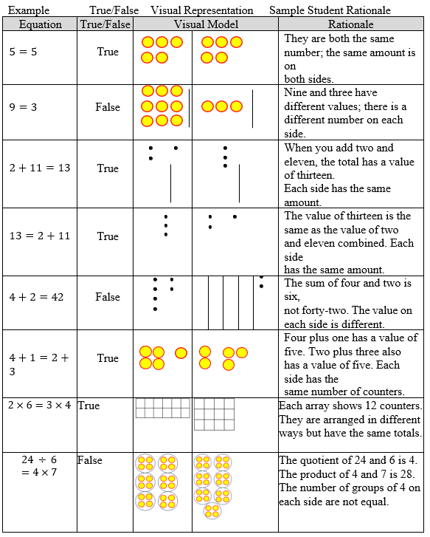

Instructional Tasks

*Instructional Task 1*

Two equations are below. One equation is true, and the other equation is false. Choose one of the equations and explain why it is true or false.

2 × 3 = 4 × 6 2 × 12 = 4 × 6

*Enrichment Task 1*

*Using the numbers shown, create a true equation and a false equation.*

*True Equation False Equation*

$______×_____=______÷______$ $______×_____=______÷______$

*2, 3, 4, 7, 8, 9, 12, 16, 24 2, 3, 4, 7, 8, 9, 12, 16, 24*

Instructional Items

*Instructional Item 1*

Which of the following describes the equation 16 ÷ 2 = 36 ÷ 9?

1. This equation is true because the expressions on each side have a quotient of 8.
2. The equation is true because the expressions on each side have a quotient of 4.
3. This equation is false because the expressions on each side have a quotient of 8.
4. This equation is false because the quotient on the left is 8 and the quotient on the right is 4.

*Instructional Item 2*

Determine whether the equation below is true or false.

$$86 + 58 = 144 ÷ 12$$

*The strategies, tasks and items included in the B1G-M are examples and should not be considered comprehensive.

### MA.3.AR.2.3

Benchmark

MA.3.AR.2.3 Determine the unknown whole number in a multiplication or division equation, relating three whole numbers, with the unknown in any position.

Benchmark Clarifications:

*Clarification 1:* Instruction extends the development of algebraic thinking skills where the symbolic representation of the unknown uses any symbol or a letter.

*Clarification 2:* Problems include the unknown on either side of the equal sign.

*Clarification 3:* Multiplication is limited to factors within 12 and related division facts. Refer to Situations Involving Operations with Numbers (Appendix A).

Connecting Benchmarks/Horizontal Alignment

* MA.3.NSO.2.2
* MA.3.NSO.2.4
* MA.3.AR.1.2
* MA.4.AR.2.2

Terms from the K-12 Glossary

* Equation
* Expression

Vertical Alignment

|  |  |
| --- | --- |
| **Previous Benchmarks**   * MA.2.AR.2.2 | **Next Benchmarks**   * MA.5.AR.2.1 * MA.5.AR.2.4 |

Purpose and Instructional Strategies

The purpose of this benchmark is for students to find an unknown value represented by a symbol or letter in a multiplication or division equation, continuing the work from Grade 2, where students found unknown values in addition and subtraction equations.

* Instruction that emphasizes the relationship between related facts in a fact family helps students use known values to solve for unknown values. For example, a fact family could be used to help students determine the unknown value in the equation 72 ÷ ? = 9 *(MTR.5.1)*.

72 ÷ ? = 9

72 ÷ 9 =?

9 × ? = 72

? × 9 = 72

* Students can use any of these related facts to determine that the unknown value is 8. Teachers should encourage students to use such equations to justify their solutions *(MTR.6.1)*.
* In the primary grades, students used fact families to find missing addends and understand the relationship between addition and subtraction.
* Understanding and using related facts to solve for unknown values is an important algebraic understanding for using inverse operations to solve equations in future mathematics courses *(MTR.5.1)*.

Common Misconceptions or Errors

* + By Grade 3, many students expect the solutions of equations to be an expression on the right side of the equal sign. When students determine unknown values in multiplication or division equations, give examples with the product or quotient on the left side.

Strategies to Support Tiered Instruction

* Instruction includes opportunities to explore the meaning of the equal sign within the context of multiplication and division. The teacher provides clarification that the equal sign means “the same as” rather than “the answer is,” supporting the understanding that the product and quotient can be on either the left or the right side of the equal sign and that both expressions have the same value.

Multiple examples are provided for students to solve for the unknown with the product or quotient on both the left and right side of the equation. The teacher uses the same equations written in different ways to reinforce the concept.

* + For example, the teacher shows the following equations, asking students to solve for the unknown. Students explain why each equation is true after solving, repeating with additional examples.

|  |  |  |
| --- | --- | --- |
| Example | Unknown | Sample Student Rationale |
| 3 × 5 = ? | 15 | Three groups of five is the same as fifteen. If I count by fives three times, I get fifteen. |
| 15 = × 5 | 3 | When I count by fives, I count three times  before I get to fifteen. |
| 4 = 24 ÷ | 6 | If I sort twenty-four into four equal groups,  there are six in each group. |
| ÷ 4 = 6 | 24 | Four groups of six in each group is twenty- four. If I count by fours, six times, I get twenty-four and multiplication and division  are inverse operations. |

* Teacher provides opportunities to explore the meaning of the equal sign within the context of multiplication and division using visual representations (e.g., counters, drawings, base-ten blocks) to represent the equations. The teacher provides clarification that the equal sign means “the same as” rather than “the answer is,” supporting the understanding that the product and quotient can be on either the left or the right side of the equal sign and that both expressions have the same value. Multiple examples are provided for students to solve for the unknown with the product or quotient on both the left and right side of the equation, using the same equations written in different ways to reinforce the concept.
  + For example, the teacher shows the following equations, asking students to solve for the unknown and explain why each equation is true after solving. Students use counters, drawings, or base-ten blocks to represent the equation, repeating with additional operations.

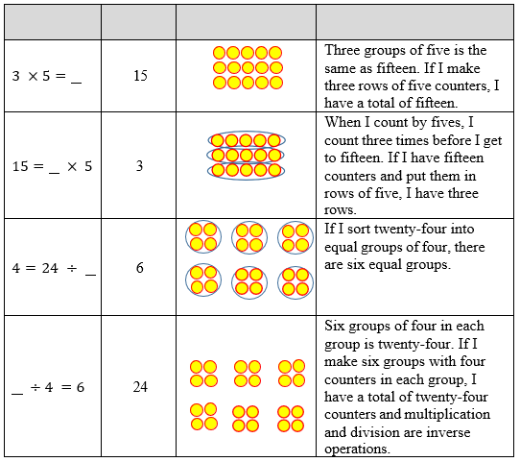

Instructional Tasks

*Instructional Task 1*

Sam is having trouble deciding whether the value of n that makes the equation below true is

4 or 36. Which number is correct? Show your thinking using an equation or visual model.

3 = 𝑛 ÷ 12

.

*Instructional Task 2*

How could Wendy use $6×7=42$ to help her find the value of the unknown number in the equation below?

$7× ?=42$

Instructional Items

*Instructional Item 1*

What value of 𝑛 makes the equation below true?

𝑛 ÷ 6 = 5

*Instructional Item 2*

What is the value of the unknown number in the equation 7 × 𝑛 = 56?

*Instructional Item 3*

What is the value of the unknown number in the equation below?

$132÷n=11$

*The strategies, tasks and items included in the B1G-M are examples and should not be considered comprehensive.

### **MA.3.AR.3** Identify numerical patterns, including multiplicative patterns

### MA. 3.AR.3.1

Benchmark

MA.3.AR.3.1 Determine and explain whether a whole number from 1 to 1,000 is even or odd.

Benchmark Clarifications:

*Clarification 1:* Instruction includes determining and explaining using place value and recognizing patterns.

Connecting Benchmarks/Horizontal Alignment

* MA.3.NSO.2.2/2.4
* MA.4.AR.3.1

Terms from the K-12 Glossary

Vertical Alignment

|  |  |
| --- | --- |
| **Previous Benchmarks**   * MA.2.AR.3.1 | **Next Benchmarks**  MA.4.AR.3.1 |

Purpose and Instructional Strategies

The purpose of this benchmark is for students to relate odd and even numbers to factors and multiples. In Grade 2, students learn to represent an even number using two equal groups or two equal addends and as odd number as two equal groups or two equal addends with one left over (MA.2.AR.3.1). In Grade 3, instruction extends to use patterns to generalize whether any number is odd or even *(MTR.2.1, MTR.5.1)*.

* Instruction connects multiples of 2 to the patterns that the ones digit in any even number is 0, 2, 4, 6, or 8. By teaching this benchmark with MA.3.AR.3.2, students can see that multiples of 2 can form any even number. If a number is not a multiple of 2, then the number is odd *(MTR.5.1)*.
* Building students’ understandings of multiples will help them explore factors and divisibility with prime and composite numbers in Grade 4.

Common Misconceptions or Errors

* + Students may confuse that the ones digit indicates whether it is even because it indicates if the number is a multiple of 2. For example, students may look at the number 883 is even because the digit 8 in the hundreds and tens places are even.

Strategies to Support Tiered Instruction

Instruction includes opportunities to practice identifying if multi-digit numbers are even or odd by using a place-value chart. The teacher explains that even numbers can be represented by two equal groups or two equal addends and that odd numbers can be represented by two equal groups or two equal addends with one left over while modeling using visual representations with several examples (e.g., drawings, tally marks).

* For example, the teacher uses visual representations to identify numbers are even or odd by sorting into two equal groups using drawings or tally marks and enters numbers into a place value chart while asking “What do you notice about the digits in the ones place?” Students should explain that even numbers all have digits in the ones place that are multiples of 2 (0, 2, 4, 6 or 8). Additional examples are used in the place-value chart to practice identifying if numbers are even or odd by looking at the digits in the ones place.

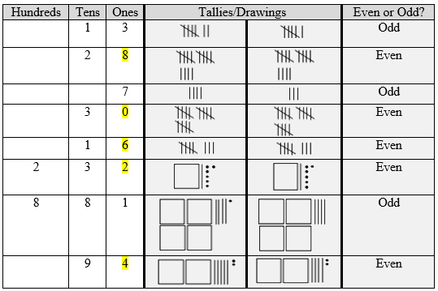

* For example, students use counters to identify if numbers are even or odd by sorting into two equal groups and enter numbers into a place value chart.

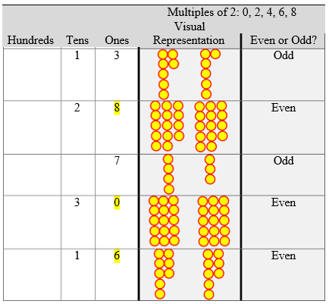

* As in the previous example, the students use counters by sorting into two equal groups. The teacher asks, “How many total counters are there, and what is the digit in the ones place?” Students should explain that even numbers all have digits in the ones place that are multiples of 2 (0, 2, 4, 6, or 8). Additional examples are used in the place-value chart to practice identifying if numbers are even or odd by looking at the digits in the ones place

Instructional Tasks

*Instructional Task 1*

Is the number 461 even or odd? Explain how you know.

*Instructional Task 2*

Kylie sees a pattern that whenever she multiplies a number by 2, the product is even. Explain why this is true using words, equations, or a visual model.

*Enrichment Task 1*

Part A: All of the multiples of 4, 6, and 8 are even. Explain using operations of multiplication how this connects back to the understanding that all even numbers can be divided into 2 equal groups with none left over.

Part B: Write out the multiples of 3, 5, and 7. Which multiples are even and which are odd? Explain the pattern to occurs

Instructional Items

*Instructional Item 1*

Determine whether the numbers are even or odd in the table below.

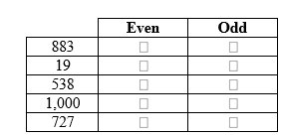

*Instructional Item 2*

Which place value in the number 3,480 indicates whether the number is even or odd?

1. 3 *thousands*
2. 4 *hundreds*
3. 8 *tens*
4. 0 *ones*

*\*The strategies, tasks and items included in the B1G-M are examples and should not be considered comprehensive.*

### 

### MA.3.AR.3.2

Benchmark

MA.3.AR.3.2 Determine whether a whole number from 1 to 144 is a multiple of a given one- digit number.

Benchmark Clarifications:

*Clarification 1:* Instruction includes determining if a number is a multiple of a given number by using multiplication or division.

Connecting Benchmarks/Horizontal Alignment

* MA.3.NSO.2.2
* MA.3.NSO.2.4
* MA.4.NSO.2.1
* MA.4.AR.3.1

Terms from the K-12 Glossary

Vertical Alignment

|  |  |
| --- | --- |
| **Previous Benchmarks**   * MA.2.AR.3.2 | **Next Benchmarks**   * MA.4.AR.3.1 |

Purpose and Instructional Strategies

The purpose of this benchmark is for students to determine whether a whole number is a multiple of a given one-digit number (e.g., Is 45 a multiple of 5?). Understanding of multiples extends what students learned in Grade 2 about skip-counting (e.g., skip-counting by 2s results in multiples of 2). Building a strong foundational understanding of multiples prepares students for relating multiples and factors to prime and composite numbers in Grade 4 (MA.4.AR.3.1).

* Understanding of multiples extends from multiplication by expecting students to understand that the products of the given one-digit number and other factors create multiples of that one-digit number. For example, the products of $5×1, 5×2, 5×3,…$ are multiples of 5 (5, 10, 15,…). Understanding of multiples extends from division in that if a given whole number from 1 to 144 is divisible by a given-one- digit number (divisor), then that divisor is a multiple of the number (e.g., 45 is divisible by 5, therefore 45 is a multiple of 5) *(MTR.5.1)*.
* The focus of instruction should be on the vocabulary of multiples as it relates to multiplication and division. Students should first have a strong understanding of how multiplication and division relate before developing their knowledge of multiples. Instruction can include real-world applications (e.g., Can 45 cookies be placed into 5 bags with an equal number in each bag?) *(MTR.4.1, MTR.5.1)*.

Common Misconceptions or Errors

* + When listing multiples of numbers, students may not list the number itself. It is important to emphasize that the smallest multiple is the number itself. Having students write multiples of a number by consecutive factors beginning with one.

Strategies to Support Tiered Instruction

* Instruction includes opportunities to write multiples of a number by consecutive factors beginning with the factor,1.
* Instruction includes opportunities to connect finding multiples to skip counting.
  + For example, to find the multiples of 8, students can generate lists of multiples beginning with 1 × 8. Their generated list should include each of the counting numbers through 12 × 8. Students model generating multiples with counters. The teacher asks students to make one group of 8, having them record how many counters there are in an equation (1 × 8 = 8). Next, students add another group of 8, recording the number of counters in an equation (2 × 8 = 16). Students add more groups of 8 while recording the number of counters they have in an equation. Students should make all multiples of 8 through 12 × 8 = 96. When students have created their multiples, they record the products in a horizontal list in order from 1 × 8 = 8 to 12 × 8 = 96 and explain the connection between the products in their equations and the multiples in their list.

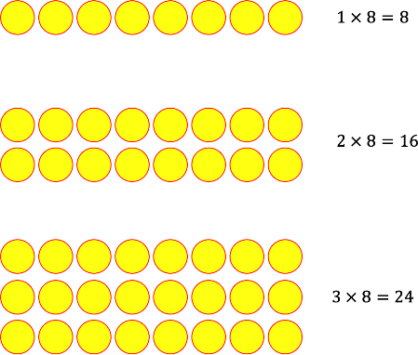

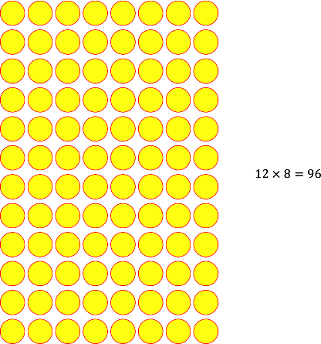

Multiples of 8: 8, 16, 24, 32, 40, 48, 56, 64, 72, 80, 88, 96

Instructional Tasks

*Instructional Task 1*

Use a visual model or write an equation to show whether 27 is a multiple of 3.

*Instructional Task 2*

Use a visual model or write an equation to show whether 36 is a multiple of 8.

*Instructional Task 3*

Penelope says that when she counts by 6s, the numbers are also multiples of 3.

6, 12, 18, 24,…

Is she correct or incorrect? Explain.

*Enrichment Task 2*

An office building has office numbers that are all multiples of 8. The office numbers stop at

80. Grant works in an office that has a number that is also a multiple of 12. What are all the

possible office numbers that Grant could work in?

Instructional Items

*Instructional Item 1*

Select all the numbers below that are multiples of 8.

|  |  |
| --- | --- |
| a. | 28 |
| b. | 56 |
| c. | 18 |
| d. | 24 |
| e. | 30 |

*Instructional Item 2*

Which number is NOT a multiple of 3?

1. 30
2. 32
3. 33
4. 36

*\*The strategies, tasks and items included in the B1G-M are examples and should not be considered comprehensive.*

### MA.3.AR.3.3 & MA.4.AR.3.2

Benchmark (Grade 3)

MA.3.AR.3.3 Identify, create and extend numerical patterns.

*Example:* Bailey collects 6 baseball cards every day. This generates the pattern 6, 12, 18, … How many baseball cards will Bailey have at the end of the sixth day?

Benchmark Clarifications:

*Clarification 1:* The expectation is to use ordinal numbers (1st, 2nd, 3rd, …) to describe the position of a number within a sequence.

*Clarification 2:* Problem types include patterns involving addition, subtraction, multiplication or division of whole numbers.

Benchmark (Grade 4)

MA.4.AR.3.2 Generate, describe and extend a numerical pattern that follows a given rule.

*Example:* Generate a pattern of four numbers that follows the rule of adding 14 starting at 5.

Benchmark Clarifications:

*Clarification 1:* Instruction includes patterns within a mathematical or real-world context.

Connecting Benchmarks/Horizontal Alignment

* MA.3.NSO.2.2
* MA.3.NSO.2.4
* MA.4.AR.3.2
* MA.4.NSO.2.2
* MA.4.FR.2.2

Terms from the K-12 Glossary

Vertical Alignment

|  |  |
| --- | --- |
| **Previous Benchmarks**   * MA.K.NSO.1.3 | **Next Benchmarks**   * MA.4.M.2.2 * MA.5.AR.3.1 * MA.5.AR.3.2 |

Purpose and Instructional Strategies

The purpose of this benchmark is for students to identify, create and extend numerical patterns using all four operations. In the Grade 3 Accelerated Course, students build on this understanding to generate numerical patterns that follow a given rule with one step (MA.4.AR.3.2). Understanding of ordinal numbers from Kindergarten is the foundation for describing the sequence of numbers in a pattern.

* A pattern is a sequence that repeats the same rule over and over. Patterns and rules are related. A rule dictates what that pattern will look like.
* “Identifying” a numerical pattern requires students to determine when a pattern exists in a sequence of numbers, and to potentially determine a rule that can be used to find each term in the sequence. For example, students may be asked whether a pattern exists in the numbers 20, 17, 14, 11,... and to discuss possible rules used to determine the next term.
* “Creating” a numerical pattern requires students to write a pattern given a rule and starting value. For example, students may be asked to write the first five terms of a sequence that begins with 500 and then create each successive term by subtracting 35 from the previous term.
* Finally, “extending” asks students to identify a future term in a sequence when provided with a rule. For example, students may be asked to find the next three terms in which each term is multiplied by 2 to get the next term 2: 1, 2, , , *(MTR.2.1, MTR.5.1)*.
* Instruction of this standard can begin by relating patterns to skip-counting to explore patterns in sequences of numbers and look for relationships in the patterns and be able to describe and make generalizations. When exploring patterns, teachers should allow for students to describe pattern rules flexibly. For example, in the pattern 6, 12, 18,…, one student may describe the pattern’s rule as “add 6.” Another student may describe the rule as, “add 7, then subtract 1” or “list the multiples of 6.” Classroom discussion could compare these rules *(MTR.2.1, MTR.4.1)*.
* Instruction should be limited to whole numbers and operations that are appropriate for Students in the Grade 3 Accelerated Course.
* As students use numerical patterns, they will reinforce facts and develop fluency with operations *(MTR.5.1)*.
* Students need multiple opportunities creating and extending number patterns.
* Students investigate different patterns to find rules, identify features in the patterns and justify the reason for those features.
* Students should look for relationships in the patterns they create and be able to describe and generalize.
* This foundation for identifying and using patterns extends into Grades 4 and 5 to build algebraic thinking for functions in middle and high school.

Common Misconceptions or Errors

* + Students can confuse a term’s number and its value in the sequence. For example, in the pattern 6, 12, 18,…, students can struggle to understand that even though 12 is the 2nd term, 6 is being added to it to find the value of the 3rd term (18). Encourage students to use precise vocabulary while describing patterns to address this confusion.
  + Students often make mistakes due to lack of fluency with the four operations which hinders them from being able to extend the pattern according to the rule.

Strategies to Support Tiered Instruction

* Instruction includes explicit vocabulary instruction regarding patterns (first term, second term, third term…, rule, value, etc.). Instruction also includes relating the pattern to skip counting where appropriate.
  + Example.

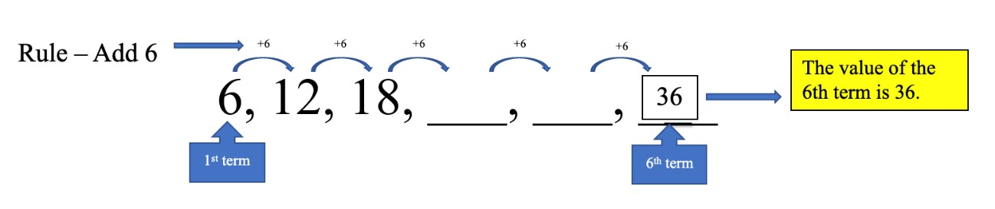

* + For example, a 100 chart may be a referent that can be used for arithmetic patterns. The teacher makes connections between the rule and counting on the 100s chart.

Rule – Add 6 Value of the 6th Term – 34

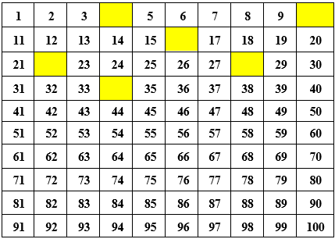

* Instruction includes students drawing quick pictures of the numbers represented or using two-color counters or square tiles to model their patterns to aid students in seeing how the rule affects the terms and to make accurate calculations.
  + Example:

The pattern begins with 4.

The Rule is Add 7.

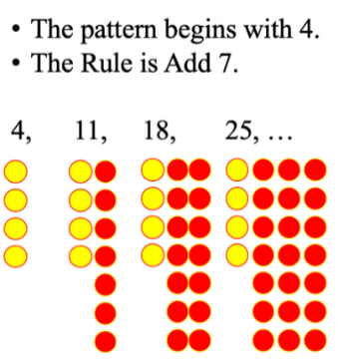

Instructional Tasks

*Instructional Task 1*

Part A. Write a pattern that shows the first 10 multiples of 6.

Part B. What do you notice about the ones digits of the pattern’s numbers?

Part C. What would you expect the ones digit of the 12th multiple to be? Explain how you know using the pattern you.

*Instructional Task 2*

The first term of a pattern is an odd number. The rule is add 13. Will the 4th term be odd or even? Based on the pattern described, will the 4th term always be odd or even? Explain your reasoning.

*Instructional Task 3*

Part A: Find the areas of the squares shown in which the side lengths start at 1 and increase by 1 each time: ($1×1$) ($2×2$) ($3×3$) ($4×4$), etc.

Extend the pattern up to 10 terms.

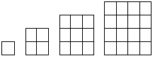

Part B: Find the perimeters of the squares shown in which the side lengths start at 1 and increase by 1 each time: ($1×1$) ($2×2$) ($3×3$) ($4×4$), etc.

Extend the pattern up to 10 terms.

Instructional Items

*Instructional Item 1*

What are the fourth and fifth terms of the sequence below that follows the rule “subtract 4”?

34, 30, 26, ,

*Instructional Item 2*

The first term in a pattern is 6. The pattern follows the rule “add 4.”

Which of the numbers below is a term in the pattern?

1. 1
2. 8
3. 14
4. 16

*\*The strategies, tasks and items included in the B1G-M are examples and should not be considered comprehensive.*

***MA.4.AR.1*** *Represent and solve problems involving the four operations with whole numbers and fractions*

### MA.4.AR.1.2

Benchmark

MA.4.AR.1.2 Solve real-world problems involving addition and subtraction of fractions with like denominators, including mixed numbers and fractions greater than one.

*Example:* Megan is making pies and uses the equation $1\frac{3}{4}+3\frac{1}{4}=x$ when baking. Describe a situation that can represent this equation.

*Example:* Clay is running a 10K race. So far, he has run $6\frac{1}{5}$ kilometers. How many kilometers does he have remaining?

Benchmark Clarifications:

*Clarification 1:* Problems include creating real-world situations based on an equation or representing a real-world problem with a visual model or equation.

*Clarification 2:* Fractions within problems must reference the same whole.

*Clarification 3:* Within this benchmark, the expectation is not to simplify or use lowest terms.

*Clarification 4:* Denominators limited to 2, 3, 4, 5, 6, 8, 10, 12, 16 and 100.

Connecting Benchmarks/Horizontal Alignment

* MA.4.FR.1.3
* MA.4.FR.2.2
* MA.4.M.2.1
* MA.4.DP.1.3

Terms from the K-12 Glossary

* Equation

Vertical Alignment

|  |  |
| --- | --- |
| **Previous Benchmarks**   * MA.3.FR.1.2 | **Next Benchmarks**   * MA.5.AR.1.2 |

Purpose and Instructional Strategies

The purpose of this benchmark is to connect procedures for adding and subtracting fractions with like denominators (MA.4.FR.2.2) to real world situations. This builds on composing and decomposing fractions (MA.4.FR.2.1) to connect to addition and subtraction of fractions.

* Instruction should include providing students with the opportunity to recognize models or equations based on a real-world situation.
* Models may include fraction bars, fraction circles and relationship rods.
* Instruction should include allowing students to create real-world situations based on models or equations.
* Instruction should include having students connect adding and subtracting procedures to real-world situations.

Common Misconceptions or Errors

* + Students tend to have trouble with addition and subtraction because much instruction focuses only on procedures. Students need to know how to treat the numerator and denominator when following the procedures to add and subtract. It is important for students to use models so they make sense of equations and real-world problems when they solve them.

Strategies to Support Tiered Instruction

* Instruction includes opportunities to engage in teacher-directed practice using visual representations to solve real-world problems involving addition and subtraction of fractions with like denominators. Students use models or equations based on real-world situations with an emphasis on how to treat the numerator and denominator when adding and subtracting.
  + For example, the teacher displays and reads the following problem: “Sara read $\frac{2}{8}$ of her book on Friday. On Saturday, she read $\frac{3}{8}$ of her book. How much of her book did she read on both days combined?” Using a number line, the teacher models solving this problem with explicit instruction and guided questioning. Students explain how to use the number line as a model to solve this question. Have students use an equation to represent the problem. This is repeated with similar real-world problems.

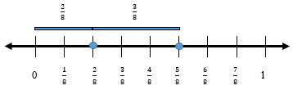

* + For example, the teacher displays and reads the following problem: “Jamal has a raised bed garden in his backyard. He planted tomatoes in $\frac{5}{12}$ of his garden and zucchini in $\frac{3}{12}$ of his garden. What fraction of his garden contains tomatoes and zucchini?” Using fraction bars or fraction strips, the teacher models solving this problem with explicit instruction and guided questioning. Students explain how to use fraction bars or fraction strips as a model to solve this question and create an equation to represent the problem. This is repeated with similar real-world problems.

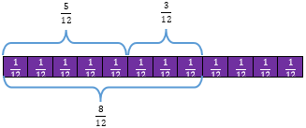

$\frac{5}{12} + \frac{3}{12}= \frac{8}{12}$

Instructional Tasks

*Instructional Task 1*

Solve the following problem. Anna Marie has $\frac{3}{4}$ of a medium cheese pizza. Kent gives her $\frac{3}{4}$ of a medium pepperoni pizza. How much pizza does Anna Marie have now?

*Enrichment Task 1 (MTR.4.1)*

Using the following number line, write a real-world story problem that would match the model.

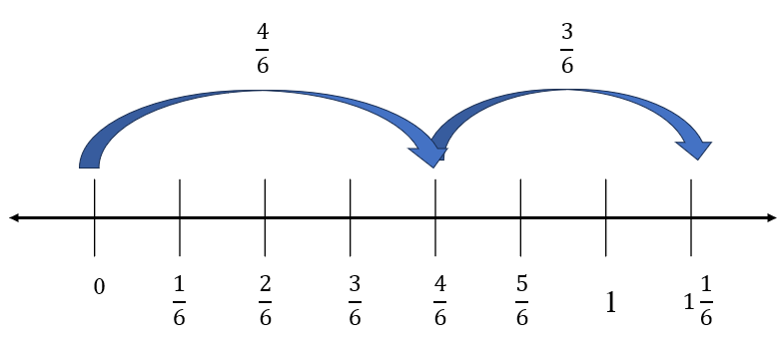

Instructional Items

*Instructional Item 1*

Jose was completing an exercise program. $\frac{8}{12}$ of the exercise program was sit-ups. The rest of the exercise program was pull-ups. What fraction of the exercise program was pull-ups?

*Enrichment Item 1*

Mrs. Alvarez was taking her class to the science museum with two other classes. Of all the people that attended the class trip, $\frac{6}{8}$ of the people were children, $\frac{1}{8}$ of the people were family members of the children, and $\frac{1}{8}$ of the people were teachers. Mrs. Alvarez says that if you add up the fractions of all the people on the trip, the answer should be 1 $\frac{1}{8}$. Her students think she is incorrect. Explain who you think is correct and how you know

*The strategies, tasks and items included in the B1G-M are examples and should not be considered comprehensive.

***MA.4.AR.2*** *Demonstrate an understanding of equality and operations with whole numbers.*

### MA.4.AR.2.1

See Benchmark MA.3.AR.2.2

### MA.4.AR.2.2

Benchmark

MA.4.AR.2.2 Given a mathematical or real-world context, write an equation involving multiplication or division to determine the unknown whole number with the unknown in any position.

*Example:* The equation $96=8×t$ can be used to determine the cost of each movie ticket at the movie theatre if a total of $96 was spent on 8 equally priced tickets. Then each ticket costs $12.

Benchmark Clarifications:

*Clarification 1:* Instruction extends the development of algebraic thinking skills where the symbolic representation of the unknown uses a letter.

*Clarification 2:* Problems include the unknown on either side of the equal sign.

*Clarification 3:* Multiplication is limited to factors within 12 and related division facts.

Connecting Benchmarks/Horizontal Alignment

* MA.3.AR.2.3

MA.4.NSO.2.1

Terms from the K-12 Glossary

* Equation

Vertical Alignment

|  |  |
| --- | --- |
| **Previous Benchmarks**   * MA.3.AR.2.3 | **Next Benchmarks**   * MA.5.AR. 2.1 * MA.5.AR.2.4 |

Purpose and Instructional Strategies

The purpose of this benchmark is for students to continue connecting real world situations to multiplication and division by writing equations to represent these situations and using the relationship between multiplication and division to solve problems. This connects the work from grade 3 of determining the value of the unknown number in multiplication and division equations that are given (MA.3.AR.2.3).

* Instruction of this benchmark should emphasize helping students to see the relationship between multiplication and division (MA.4.NSO.2.1) when solving for an unknown in any position in an equation.
* Success with this benchmark will facilitate automaticity with multiplication and division facts (MA.4.NSO.2.1).
* Within this benchmark, students may use multiplicative comparison (e.g., 50 is 5 times as many as 10).
* Using a bar or tape diagram can be helpful for students to model the real-world situations presented (see example below).

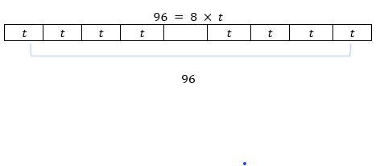

Common Misconceptions or Errors

* + Even though many students know their multiplication and related division facts with automaticity, students without a firm conceptual understanding of multiplication and division may have difficulty problem solving with multiplication and division and writing equations to model situations. Provide opportunities for students to explain their models and justify solutions.

Strategies to Support Tiered Instruction

* Instruction includes opportunities to connect real world situations to multiplication and division by writing equations to represent these situations and using the relationship between multiplication and division to solve problems. The teacher emphasizes the inverse relationship between multiplication and division, reinforcing conceptual understanding of multiplication and division by having students use drawings, models, and equations to solve real world problems.
  + For example, the teacher displays and reads the following problem aloud: “Enrique has 63 baseball cards, which is 9 times as many as Damion. How many baseball cards does Damion have?” The teacher guides students to use a drawing, such as a bar model, to solve and to write an equation. Through prompting and questioning, students explain their models and justify their solutions. This is repeated with multiple examples of real-world problems.

$$63=9×d$$

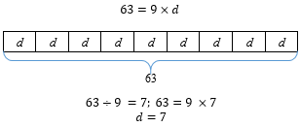

$$63÷9=7;63=9×7$$

$$d=7$$

* The teacher provides opportunities to connect real-world examples to multiplication and division using the relationship between multiplication and division to solve problems using hands-on models and manipulatives. The teacher emphasizes the inverse relationship between multiplication and division, reinforcing conceptual understanding of multiplication and division by having students use manipulatives and equations to solve real world problems. Through prompting and questioning, students explain their models and justify their solutions.
  + For example, the teacher displays and reads the following problem aloud: “Sabrina hiked 48 miles in the month of May. Andre hiked 8 miles in the same month. How many times more miles did Sabrina hike than Andre?” The teacher guides students to use manipulatives, such as counters or base-ten blocks, to model the problem by showing equal groups, reminding students that multiplication and division are inverse operations. Through prompting and questioning, students explain their models and justify their solutions and write an equation. This is repeated with multiple examples of real-world problems.

**Model of equation above.**

Instructional Tasks

*Instructional Task 1*

A typical Dalmatian weighs 54 pounds and a typical Yorkshire terrier weighs 9 pounds.

Write an equation to model this situation. Use your equation to determine how many more times does the typical Dalmatian weigh than the typical Yorkshire terrier?

Instructional Items

*Instructional Item 1*

Shernice has 84 comic books which is 12 times as many as Cindy.

Which equation below represents how many comic books, *c*, Cindy has?

$84 = 12 + c$

$84 = 12 x c$

$c = 12 + 84$

$c = 12 x 84$

*The strategies, tasks and items included in the B1G-M are examples and should not be considered comprehensive.

***MA.4.AR.3*** *Recognize numerical patterns, including patterns that follow a given rule.*

### MA.4.AR.3.1

Benchmark

MA.4.AR.3.1 Determine factor pairs for a whole number from 0 to 144. Determine whether a whole number from 0 to 144 is prime, composite or neither.

Benchmark Clarifications:

*Clarification 1:* Instruction includes the connection to the relationship between multiplication and division and patterns with divisibility rules.

*Clarification 2:* The numbers 0 and 1 are neither prime nor composite.

Connecting Benchmarks/Horizontal Alignment

* MA.3.AR.3.1
* MA.3.AR.3.2
* MA.4.NSO.2.1

Terms from the K-12 Glossary

* Composite Number
* Factors
* Prime Number

Vertical Alignment

|  |  |
| --- | --- |
| **Previous Benchmarks**   * MA.3.AR.3.1 | **Next Benchmarks**   * MA.6.NSO.3.4 |

Purpose and Instructional Strategies

The purpose of this benchmark is for students to begin understanding of factors of whole numbers which sets the foundation for determining prime factorization in grade 6 (MA.6.NSO.3.4).

* This benchmark also refers to prime and composite numbers. Prime numbers have exactly two factors, the number one and the number itself (e.g., the number 13 has the factors of 1 and 13 only so it is a prime number). Composite numbers have more than two factors.
  + For example, 14 has the factors of 1, 2, 7 and 14. Since this number has more factors than 1 and 14, it is a composite number.
* Instruction may allow students to use divisibility rules to determine the factors of a number.
  + All numbers are divisible by 1.
  + All even numbers are divisible by 2.
  + A number is divisible by 3 if the sum of the digits is divisible by 3.
  + A number is divisible by 4 if the 2-digit number in the tens and ones places is divisible by 4.
  + A number is divisible by 5 if the number in the ones place is a 0 or 5.
  + A number is divisible by 6 if it is an even number and the sum of the digits is divisible by 3.
  + A number is divisible by 9 if the sum of the digits is divisible by 9.
* Students should use models (arrays) to determine why a number would be prime or composite.

Common Misconceptions or Errors

* Students may think of the number 1 as a prime number. It is neither prime nor composite.
* Students may also think that all odd numbers are prime.
  + Some students may think that larger numbers have more factors. Have students share all factor pairs and how they found the factors.

Strategies to Support Tiered Instruction

* Instruction includes opportunities to identify the factor pairs of whole numbers from 0-144 with teacher guidance. Students also determine if the number is prime, composite or neither. The teacher refers to the divisibility rules shown above in “Purpose and Instructional Strategies” to support students as they determine the factors of the given number. Students use manipulatives and models (e.g., counters and arrays) to identify factors of the given number.
* For example, the teacher displays the following number: 48. Students draw arrays to determine the factors of 48 (1, 2, 3, 4, 6, 8, 12, 16, 24, 48). Students may use multiplication and skip counting to check factor pairs (e.g., 5 can be ruled out as a factor because $5×9=45$ and $5 ×10=50$). The teacher asks students if 48 is prime, composite, or neither (composite). This is repeated with additional whole numbers from 0-144.

48

1

24

2

16

3

12

4

8

6

* For example, the teacher displays the following number: 32. Students are provided 32 counters and use them to create arrays to determine the factors of 32 (1, 2, 4, 8, 16, 32). Students may use multiplication and skip counting to check factor pairs (e.g., 5 can be ruled out as a factor because $5×6=30$ and $5 ×7=35$). Students may explore using counters to rule out additional numbers as factors (e.g., if you make 6 rows with a total of 32 counters, there will not be an even number in each row). The teacher asks students if 32 is prime, composite, or neither (composite). This is repeated with additional whole numbers from 0-144.

16

2

32

1

8

4

Instructional Tasks

*Instructional Task 1*

Find all the factors for 20 and 30. What factors are in both lists? What is the largest factor

that is a prime number?

*Enrichment Task 1*

Find all the factors for the numbers between 20 and 30. What is the greatest prime number in this set of factors? What is the least prime number in this set of factors?

Instructional Items

*Instructional Item 1*

Select all the statements that are true about the number $84$.

1. $42$ is a factor of $84$.
2. $84$ is a composite number.
3. $84$ has exactly $4$ distinct factor pairs.
4. The prime factors of $84$ are $2$, $6$ and $7$.
5. $84$ can be written as the product $2 × 2 × 3 × 7$.

*The strategies, tasks and items included in the B1G-M are examples and should not be considered comprehensive.

### MA.4.AR.3.2

See Benchmark MA.3.AR.3.3

Measurement

**MA.3.M.1** *Measure attributes of objects and solve problems involving measurement.*

### MA.3.M.1.1

Benchmark

MA. 3.M.1.1 Select and use appropriate tools to measure the length of an object, the volume of liquid within a beaker and temperature.

Benchmark Clarifications:

*Clarification 1:* Instruction focuses on identifying measurement on a linear scale, making the connection to the number line.

*Clarification 2:* When measuring the length, limited to the nearest centimeter and half or quarter inch.

*Clarification 3:* When measuring the temperature, limited to the nearest degree.

*Clarification 4:* When measuring the volume of liquid, limited to nearest milliliter and half or quarter cup.

Connecting Benchmarks/Horizontal Alignment

* MA.3.FR.1.1/1.2
* MA.3.FR.2.1/2.2
* MA.3.GR.1.2
* MA.3.GR.2.3/2.4

Terms from the K-12 Glossary

Vertical Alignment

|  |  |
| --- | --- |
| **Previous Benchmarks**   * MA.2.M.1.1/1.2 | **Next Benchmarks**   * MA.4.M.1.1 |

Purpose and Instructional Strategies

The purpose of this benchmark is for students to choose appropriate tools to measure length, liquid volume, and temperature. In this Grade 3Accelerated course, students continue to build their understanding of measuring lengths from Grades 1 and 2. Also in the Grade 3 Accelerated course, they also measure liquid volume and temperature.

* Instruction should connect students’ understandings about number lines and rulers to tools that measure liquid volume and temperature. This will help students make sense of measuring units (including half and quarter) with different tools *(MTR.1.1, MTR.2.1)*.
* To make instruction meaningful for students, this benchmark should be taught with MA.3.M.1.2 so students can choose appropriate tools when given problems in real-world contexts.
* Instruction should model and allow students to interact with hands-on activities to choose tools and measure appropriately.

Common Misconceptions or Errors

* Students who struggle to identify benchmarks on number lines can also struggle to measure units of length, liquid volume, and temperature. To assist students, teachers should allow students to measure often and provide feedback. Students can also complete error and reasoning analysis activities to identify this common measurement difficulty.

Strategies to Support Tiered Instruction

* + Instruction includes opportunities to measure often and provide feedback. Use error and reasoning analysis activities to address common measurement difficulties.
  + Instruction includes opportunities to find the locations of points on number lines. Number lines should be represented vertically and horizontally. Instruction includes whole number values and fractions, including fractions greater than one.
* 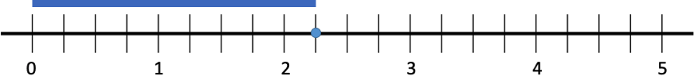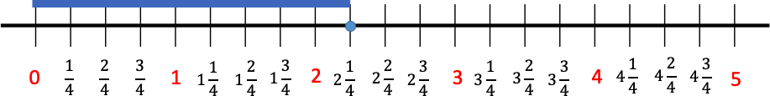For example, number lines should be included with benchmarks instead of every number in the sequence included. The blue line below extends from the 0 mark on the number line to the first hashmark beyond 2. The dot plotted on the number line identifies the end of the blue line. Since each whole number interval is partitioned into four equal parts, the first hashmark beyond 2 is represented as $2\frac{1}{4}$.
  + For example, number lines can also have all numbers included to represent the values between the benchmarks values between the benchmarks.

Instructional Tasks

*Instructional Task 1*

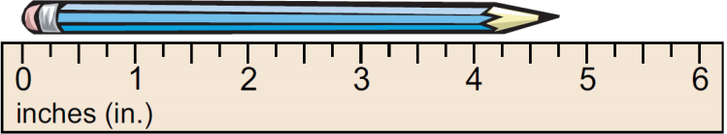Jonah measures the length of his pencil.

Part A. What is the length of his pencil, in inches?

Part B. Why is a ruler an appropriate tool for Jonah to measure the pencil’s length

*Enrichment Task 1*

Tiana measures the length of a sticky note.

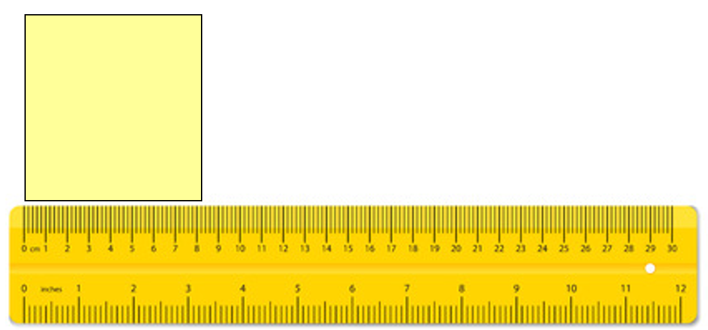

Part A: What is the length of her pencil, in centimeters?

Part B: If Tiana decides to measure her pencil in inches instead of centimeters, will the number of inches be greater or less than the number of centimeters? Explain your thinking.

Instructional Items

*Instructional Item 1*

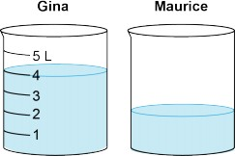Gina and Maurice have same-sized containers filled with different amounts of water, as shown. Gina’s container has 4 liters of water. About how much water, in liters, does Maurice’s container have.

*Instructional Item 2*

Rinaldo wants to determine which bottle has the greatest volume.





Which tools can Rinaldo use to determine which bottle has the greatest volume?

1. A ruler
2. A measuring cup
3. A thermometer
4. A beaker

*The strategies, tasks and items included in the B1G-M are examples and should not be considered comprehensive.

### MA.3.M.1.2

Benchmark

MA.3.M.1.2 Solve real-world problems involving any of the four operations with whole- number lengths, masses, weights, temperatures or liquid volumes.

*Example:* Ms. Johnson’s class is having a party. Eight students each brought in a 2-liter bottle of soda for the party. How many liters of soda did the class have for the party?

Benchmark Clarifications:

*Clarification 1:* Within this benchmark, it is the expectation that responses include appropriate units.

*Clarification 2:* Problem types are not expected to include measurement conversions.

*Clarification 3:* Instruction includes the comparison of attributes measured in the same units. *Clarification 4:* Units are limited to yards, feet, inches; meters, centimeters; pounds, ounces; kilograms, grams; degrees Fahrenheit, degrees Celsius; gallons, quarts, pints, cups; and liters, milliliters.

Connecting Benchmarks/Horizontal Alignment

* MA.3.FR.1.1/1.2
* MA.3.FR.2.1/2.2
* MA.3.AR.1.2
* MA.3.GR.1.2
* MA.3.GR.2.3/2.4

Terms from the K-12 Glossary

Vertical Alignment

|  |  |
| --- | --- |
| **Previous Benchmarks**   * MA.2.M.1.3 | **Next Benchmarks**   * MA.4.M.1.2 |

Purpose and Instructional Strategies

The purpose of this benchmark is for students to apply what they have learned about measurement to solve real-world problems. This work extends from the Grade 2 expectation to solve one- and two-step real-world measurement problems involving addition and subtraction of lengths given in the same units (MA.2.M.1.3). This work extends to the Grade 4 Accelerated course expectation to solve two-step real-world problems involving distances and intervals of time using any combination of the four operations (MA.4.M.2.1).

* When solving real-world problems, instruction can facilitate students’ understandings of contexts and quantities *(MTR.4.1, MTR.5.1, MTR.7.1)*.
* Recommendations for helping students comprehend and solve real-world problems can be found in this document for benchmark MA.3.AR.1.2.

Common Misconceptions or Errors

* Students who struggle to identify benchmarks on number lines can also struggle to measure units of length, liquid volume, and temperature. Allow students to measure often and receive feedback. Students can also use error and reasoning analysis activities to identify this common measurement difficulty.
* Students may have difficulty creating effective models (e.g., drawings, equations) that will help them solve real-world problems. To assist students, provide opportunities for them to estimate solutions and try different models before solving. Beginning instruction by showing problems without their quantities is a strategy for helping students determine what steps and operations will be used to solve.
  + Students can struggle to identify when real-world problems require two steps to solve and will complete only one of the steps. Focusing on comprehension of real-world problems helps students determine what step(s) are required to solve.

Strategies to Support Tiered Instruction

* Instruction includes providing opportunities to estimate solutions and try different models before solving. Instruction begins by showing problems without their quantities to determine what steps and operations will be used to solve. Teaching problem-solving strategies builds comprehension of problem contexts and what quantities represent in them.
  + For example, “For a science experiment in Mr. Thomas’s class, each student needs ***some*** milliliters of water. If there are ***some*** students in Mr. Thomas’s class, how many milliliters will be needed in all?” Students will notice that the quantities have been removed from the problem. This will help them to determine what the quantities represent and which operation to choose to solve the problem. The numberless word problem may also be written as students × milliliters of water = milliliters needed in all.
* Teacher encourages exploration of estimation strategies to determine reasonable ranges for solutions (e.g., rounding, finding low and high estimates) and teach problem-solving strategies that build comprehension?
  + For example, the 3-Reads Protocol is a close reading strategy for solving problems that focuses on comprehension of the word problem.
    - The problem is read 3 times, each for a different purpose.
      * What is the problem, context, or story about?
      * What are we trying to find out?
      * What information is important in the problem?

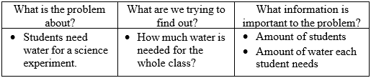

* Instruction includes opportunities to measure often and provide feedback. Use error and reasoning analysis activities to address common measurement difficulties.
* Instruction includes opportunities to find the locations of points on number lines. Number lines represented both vertically and horizontally will help students build measurement skills. Instruction includes whole number values and fractions, including fractions greater than one.
  + For example, number lines should be included with benchmarks instead of every number in the sequence included. The blue line below extends from the 0 mark on the number line to the first hashmark beyond 2. The dot plotted on the number line identifies the end of the blue line. Since each whole number interval is partitioned into four equal parts, the first hashmark beyond 2 is represented as $2\frac{1}{4}$
  + For example, number lines can also have all numbers included to represent the values between the benchmarks.
  + For example, teaching problem-solving strategies can focus on the comprehension of problem contexts and what quantities represent in them.
* Instruction includes an emphasis on teaching problem-solving strategies, focusing on the comprehension of problem contexts and what quantities represent in them.
  + For example, questions that help students comprehend word problems are:
    - What is happening in the real-world problem?
    - What do you need to find out?
    - What do the quantities represent in the problem?
    - What will the solution represent in the problem?
  + For example, “For a science experiment in Mr. Thomas’s class, each student needs 8 milliliters of water. If there are 23 students in Mr. Thomas’s class, how many milliliters will be needed in all

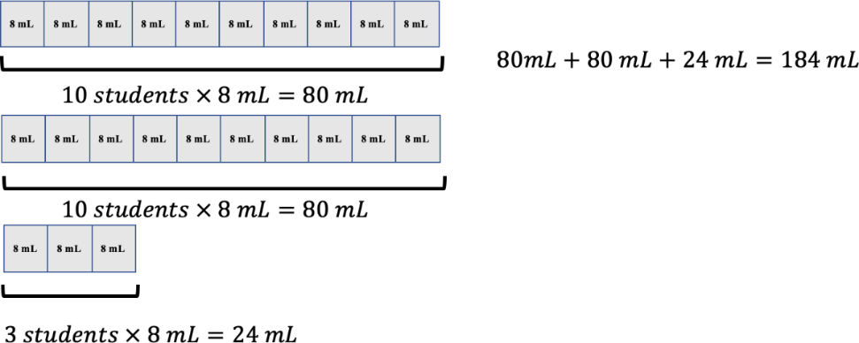

Instructional Tasks

*Instructional Task 1*

Each year, the Tallahassee Pumpkin Festival hosts a contest to find the largest pumpkin grown that season. The winner of the competition has the greatest mass, in grams. The masses of the contest entries are in the table below.

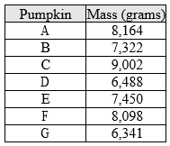

Part A. Which pumpkin won the contest?

Part B. What is the difference of the mass, in grams, between the first and second place winning pumpkins?

*Instructional Task 2*

The high temperatures on April 3 in Detroit, Michigan and Gainesville, Florida are shown below.

A close-up of 2 thermometers



Part A. Which city was warmer on April 3? Explain how you know.

Part B. How much warmer was that city, in degrees Fahrenheit, than the other one? Write an equation to model how you found your answer.

*Instructional Task 3*

Part A. Measure the lengths of three different objects at your desk to the nearest quarter inch. Each should have a different length.

Part B. Plot the three lengths on a number line.

Part C. Write the lengths in ascending order.

Part D. Compare the lengths of two of your objects using.

*Enrichment Task 1*

The average December high and low temperatures for four Florida cities are listed in the table.

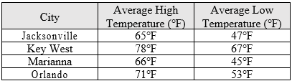

Part A: Which city has the greatest difference between the average high and low temperatures for December?

Part B: Which cities have the same difference between the average high and low temperatures for December?

*Enrichment Item 2*

Leah has 56 inches of thread that she is using to make necklaces. She cuts off 2 inches of thread. If she wants to make 6 necklaces with the remaining thread, how long will each necklace be?

Instructional Items

*Instructional Item 1*

For a science experiment in Mr. Thomas’s class, each student needs 8 milliliters of water. If there are 23 students in Mr. Thomas’s class, how many milliliters will be needed in all?

*Instructional Item 2*

Beau is 8 years old and 49 inches tall. Carter is 13 years old and 57 inches tall. Determine who the taller student is and by how many inches.

*Instructional Item 3*

Dr. Parker’s fruit punch recipe is made with 300 milliliters of cranberry juice, 80 milliliters of lime juice, 250 milliliters of pineapple juice, and 75 milliliters of club soda. Dr. Parker mixes all the ingredients into a large pitcher. What is the total volume of the fruit punch in the pitcher, in milliliters?

*\*The strategies, tasks and items included in the B1G-M are examples and should not be considered comprehensive.*

### **MA.3.M.2** Tell and write time and solve problems involving time.

### MA.3.M.2.1

Benchmark

MA.3.M.2.1 Using analog and digital clocks tell and write time to the nearest minute using a.m. and p.m. appropriately.

Benchmark Clarifications:

*Clarification 1:* Within this benchmark, the expectation is not to understand military time.

Connecting Benchmarks/Horizontal Alignment

* MA.3.M.1.1

Terms from the K-12 Glossary

Vertical Alignment

|  |  |
| --- | --- |
| **Previous Benchmarks**   * MA.2.M.2.1 | **Next Benchmarks**   * MA.4.M.2.1 |

Purpose and Instructional Strategies

The purpose of this benchmark is for students to tell time to the nearest minute, using a.m. and p.m. appropriately. In Grade 2, students tell and write time on analog and digital clocks to the nearest five minutes, including using language that expressions fractional parts of an hour (e.g., “half of,” “half past,” “quarter of,” “quarter after,” and “quarter til”). Students also bring understanding about a.m. and p.m. from Grade 2, and they also related partitioned circles to number lines with the purpose of helping them count by 5s.

* Instruction can connect how students can count by fives and ones to identify the exact time on an analog clock. For example, if the time on an analog clock shows 3:19, students can demonstrate that they can use the minute hand to count by 5s to land at the 3 on the clock (15 minutes after the hour), and then count ahead 4 more minutes to represent 19 minutes. Students could also count by 5s to get to the 4 on the clock (20 minutes after the hour), and then count back one to get to 3:19. During instruction, allowing students opportunities to use flexible strategies for telling time will build understanding and continue to connect telling time to using number lines *(MTR.4.1, MTR.5.1)*.
* Manipulatives that help students tell and write time are Judy clocks, virtual clocks, and number lines (that can be folded as a circle around a clock and unfolded to show a linear representation) *(MTR.2.1)*. It is important to note that when using number lines during instruction, students can be given the opportunities to determine the intervals and size of jumps on their number line. This approach also connects to measuring lengths (MA.3.M.1.1).

Common Misconceptions or Errors

* Students can misrepresent the location of the hour hand when expressing a given time on an analog clock. For example, when representing the hour hand for 3:19, students can be unsure where the hour hand is located between the 3 and 4. Model reasoning with students that the hour hand would be less than halfway between 3 and 4 because 3:19 is before 3:30 when the hour hand would be in the middle. Allow for classroom discussions that encourage students to justify the location of hour hands between benchmarks when representing analog time.

Strategies to Support Tiered Instruction

* Instruction includes classroom discussions that encourage students to justify the location of hour hands between benchmarks when representing analog time.
* Instruction includes how the hour hand moves around the clock. Instruction includes using a one-handed (hour hand only) clock. As students receive given times from the teacher, they can reason the location of the hour hand for that given time.
  + For example, the teacher models where the hour hand of the clock would be if the time is 2:37, reasoning for the students so they understand that they point the hour hand slightly more than halfway between the 2 and the 3 on the clock because 2:37 is just past 2:30.

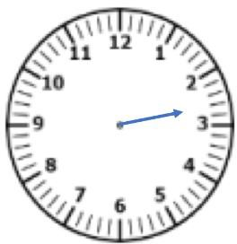

* Instruction includes understanding that the hour hand moves around the clock. Instruction includes using a geared manipulative clock. This clock will demonstrate the relationship between the minute hand and hour hand moving around the clock.
  + For example, the teacher moves the hands on the clock so the hour hand is slightly more than half-way between the 2 and the 3 asking, “What time do you think it is on the clock?” (The clock reads approximately 2:37.) The teacher allows for classroom discussions that encourage students to justify the location of the hour hand between benchmarks when representing analog time.

Instructional Tasks

*Instructional Task 1*

Show the same time represented on the digital clock

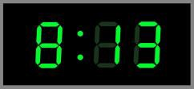

on the analog clock below.

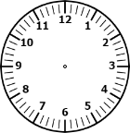

Explain how you know where the hour hand is located on the analog clock.

*Instructional Task 2 (MTR.3.1)*

Show the same time represented on the analog log clock on the digital clock.

A clock with blue hands

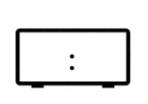

*Enrichment Task 1*

Rebekah thinks that both Clock A and Clock B show the same time.

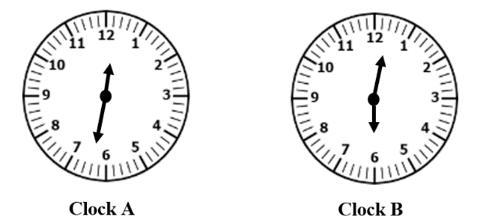

What is Rebekah’s error? How would you explain to Rebekah that each clock shows a different time?

Instructional Items

*Instructional Item 1*

Alex goes to the grocery store in the morning at the time shown.

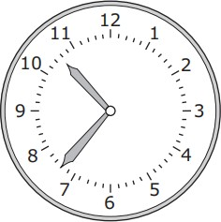

What time does Alex go to the grocery store? Write the time on the line and circle a.m. or p.m.

_______________a.m./p.m

*Instructional Item 2*

Roxy got home from the gym at 6:39 p.m. Which analog clock represents the same time?

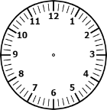

*Enrichment Item 1*

Tara usually leaves for school between 7:46 and 7:53. Which clocks show a possible time that Tara leaves for school?

d.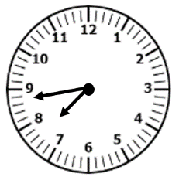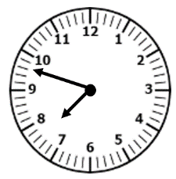

a.

b.e.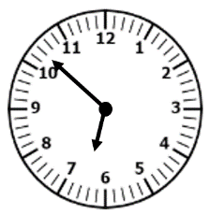

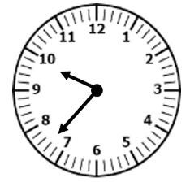

b.

c.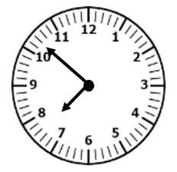

c.

*\*The strategies, tasks and items included in the B1G-M are examples and should not be considered comprehensive.*

### MA.3.M.2.2

Benchmark

MA.3.M.2.2 Solve one- and two-step real-world problems involving elapsed time.

*Example:* A bus picks up Kimberly at 6:45 a.m. and arrives at school at 8:15 a.m. How long was her bus ride?

Benchmark Clarifications:

*Clarification 1:* Within this benchmark, the expectation is not to include crossing between a.m. and p.m.

Connecting Benchmarks/Horizontal Alignment

* MA.3.NSO.2.2
* MA. 3.AR.1.

Terms from the K-12 Glossary

Vertical Alignment

|  |  |
| --- | --- |
| **Previous Benchmarks**   * MA.2.M.2.1 | **Next Benchmarks**  MA. 4.M.2.1 |

Purpose and Instructional Strategies

The purpose of this benchmark is for students to apply their understanding of telling and writing time to solve one- and two-step real-world problems involving elapsed time. This is the first grade level where students are expected to determine elapsed time. Elapsed time can be represented within a single hour (e.g., determining when a half-hour gym class would end if it began at 8:10 a.m.) or crossing into the next hour (e.g., determining when a half-hour gym class will end if it began at 8:45 a.m.). Elapsed time problems should not include crossing between a.m. and p.m. When solving problems with elapsed time, students may see different problem types. Students may see result unknown problems (e.g., determining when an activity ends, given the starting time and length of activity), change unknown problems (e.g. determining the length of an activity, given the starting and end times), or start unknown problems (e.g., determining the starting time, given the length of the activity and ending time) *(MTR.2.1, MTR.7.1).*

* A great way for students to work with elapsed time problems is to use number lines. It is important to note that when using number lines during instruction, students be given the opportunities to determine the intervals and size of jumps on their number line. Students could use pre-marked number lines (intervals every 5 or 15 minutes) or open number lines (intervals determined by students). Open number lines encourage students to jump from one point on the line to another any way they choose, allowing them to calculate flexibly. Students can compare their open number line strategies with one another, and then make connections between them during classroom discussions.
* 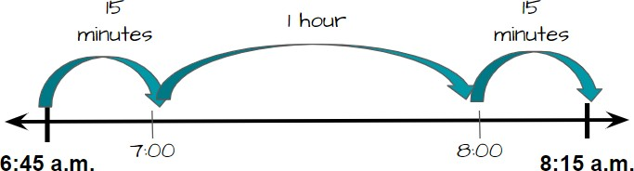In real-world elapsed time problems, students use open number lines to represent solutions in many ways. Two open number lines that represent the benchmark’s example are below.
  + In this example, the student counted up to benchmark hours, then an addition 15 minutes to jump to 8:15 a.m. The student would reason that the elapsed time is the sum of the jumps, or 1 hour and 30 minutes.

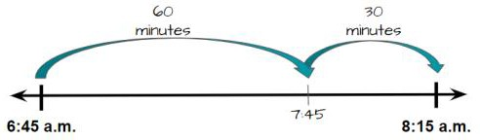

* + In this example, the student jumped 60 minutes to 7:45 a.m., and then another 30 minutes to 8:15 a.m. In this example, the student would represent the answer as 60 minutes + 30 minutes, or 90 minutes.
  + Notice that both the answers of 1 hour and 30 minutes and 90 minutes are acceptable. Students’ solutions may be expressed as hours and minutes or minutes only. Conversion from minutes to hours or hours to minutes is not expected in Grade 3, so students may see both as correct *(MTR.2.1, MTR.5.1).*
* In addition to number lines, Judy clocks provide a great visual to help students identify elapsed time and can be used to help students solve real-world problems *(MTR.2.1)*.
* Elapsed time problems can involve multiplication and division. For example, if Petra starts running laps at 9:55 a.m. and runs 6 laps at 2 minutes per lap, what time does she finish?

Common Misconceptions or Errors

* Students can confuse when time crosses the hour because it does not follow the familiar base ten pattern. For example, students can misinterpret that the elapsed time between 9:55 a.m. and 10:05 a.m. and state that the elapsed time is 50 minutes because they have found the difference from 55 to 105. The use of number lines and clocks side-by-side help students build understanding about how elapsed time is calculated.

Strategies to Support Tiered Instruction

* Instruction includes the use of number lines and clocks side-by-side to help students build understanding about how elapsed time is calculated.
* Instruction includes using a number line and counting by ones to demonstrate what happens when time crosses the hour because it does not follow the familiar base ten pattern.
  + For example, use a number line to find the elapsed time between 9:55 a.m. and 10:05 a.m. and explain what happens when time crosses the hour at 10:00 a.m..

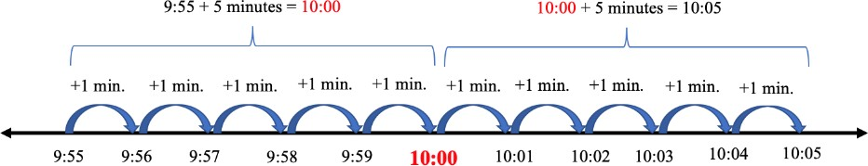

* Instruction includes using a geared manipulative clock.
  + 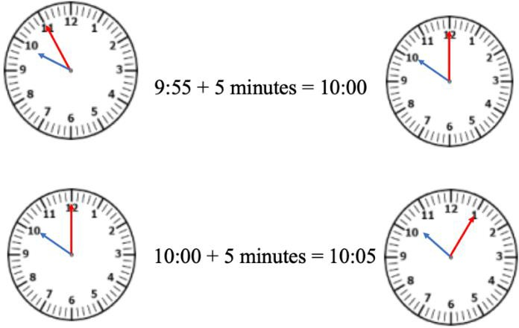For example, the teacher uses a geared manipulative clock model how to find the elapsed time between 9:55 a.m. and 10:05 a.m. Students can move the minute of the hand one minute at a time from 9:55 to 10:00. After each minute, the teacher asks students to record what time it is. The teacher can have students pay special attention to what happens when the minute hand moves from 9:59 to the next minute.

Instructional Tasks

*Instructional Task 1*

Recess began at the time shown on Clock A. Recess ended at the time shown on Clock B.

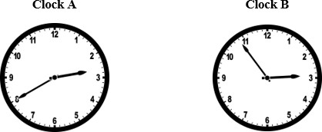

How many minutes were spent at recess?

*Instructional Task 1*

Anthony began reading at the time shown on Clock A. He stopped at the time shown on Clock B.

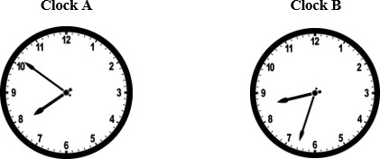

How many minutes did Anthony spend reading?

*Instructional Task 3*

A movie runs for 2 hours, 15 minutes. The movie ends at 2:30 p.m. What time did the movie start?

number line from 11:00 to 2:30

*Enrichment Task 1*

Gillian is practicing for an upcoming 10K race. Once she begins running, she will drink water every 9 minutes. Gillian stops to drink water for the first time at 8:07 a.m.

Part A: What time did Gillian start running?

Part B: At what time will Gillian stop to drink water for the fifth time?

Instructional Items

*Instructional Item 1*

Each week, Victor attends violin lessons that last 55 minutes. If the lesson begins at 4:30 p.m., what time will it end?

*Instructional Item 2*

Robert wants to arrive at the football stadium at 4:00 p.m. He first has to pick up his friend who lives 25 minutes from his house, then he will have another 20 minutes to drive to the stadium. At what time should he leave?

*Enrichment Item 2*

Jordan finished his homework at 4:12 p.m. He spent 22 minutes on his reading homework, 19 minutes on his math homework and 15 minutes on his science homework. If Jordan did not take any breaks while completing his homework, what time did he begin?

*\*The strategies, tasks and items included in the B1G-M are examples and should not be considered comprehensive.*

Geometric Reasoning

**MA.3.GR.1** *Describe and identify relationships between lines and classify quadrilaterals.*

### MA.3.GR.1.1 & MA.4.GR.1.1

Benchmark (Grade 3)

MA.3.GR.1.1 Describe and draw points, lines, line segments, rays, intersecting lines, perpendicular lines and parallel lines. Identify these in two-dimensional figures.

Benchmark Clarifications:

*Clarification 1:* Instruction includes mathematical and real-world context for identifying points, lines, line segments, rays, intersecting lines, perpendicular lines and parallel lines.

*Clarification 2:* When working with perpendicular lines, right angles can be called square angles or square corners.

Benchmark (Grade 4)

MA.4.GR.1.1 Informally explore angles as an attribute of two-dimensional figures. Identify and classify angles as acute, right, obtuse, straight or reflex.

Benchmark Clarifications:

*Clarification 1:* Instruction includes classifying angles using benchmark angles of 90° and 180° in two-dimensional figures.

*Clarification 2:* When identifying angles, the expectation includes two-dimensional figures and real-world pictures.

Connecting Benchmarks/Horizontal Alignment

* MA.3.GR.2.4
* MA.3.DP.1.1
* MA.4.GR.1.2
* MA.4.GR.1.3

Terms from the K-12 Glossary

* Acute angle
* Angle
* Line
* Obtuse angle
* Parallelogram
* Rectangle
* Reflex angle
* Right angle
* Square
* Straight angle
* Triangle

Vertical Alignment

|  |  |
| --- | --- |
| **Previous Benchmarks**   * MA.2.GR.1.1 | **Next Benchmarks**   * + MA.5.GR.1.1 |

Purpose and Instructional Strategies

The purpose of this benchmark is to build important vocabulary that allows students to describe

and draw points, lines, line segments, rays, intersecting lines, perpendicular lines and parallel lines, and to identify examples in two-dimensional figures represented in mathematical and real- world contexts. In Grade 2, students were expected to identify and draw two-dimensional figures based on their defining attributes. In Grade 3, students can describe and draw geometric figures using more formal vocabulary developed in this benchmark. Therefore, instruction of this benchmark relies heavily on vocabulary development for students to internalize definitions and make connections between the concepts. In Grade 4, students will explore and draw angles beyond square angles.

* In mathematical contexts, students find evidence of points, lines, line segments, rays, intersecting lines, perpendicular lines and parallel lines in models of two-dimensional figures (e.g., quadrilaterals, triangles). In real-world contexts, students identify evidence of these geometric attributes in real-life images (e.g., aerial views of city maps, photos of objects) *(MTR.4.1, MTR.7.1)*.
* This vocabulary development will be necessary as students identify and draw quadrilaterals based on their defining attributes (MA.3.GR.1.2). It will also be beneficial in other areas as students begin to read, draw and understand graphs and diagrams.
* Instruction may consider activities that encourage student discussions rich in mathematical reasoning opportunities. Mathematical discussions and reasoning activities give students the practice necessary to use the vocabulary and internalize it in meaningful ways. An example of a mathematical reasoning activity that builds vocabulary understanding is in the instructional task below *(MTR.4.1)*.
* Two additional notes about instruction of this benchmark:
* Images of figures used in instruction should not include hatch marks.
* 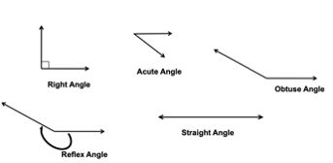Because formal instruction of angle measurements does not begin until Grade 4, students can refer to right angles in perpendicular lines as “square angles” or “square corners.”

Common Misconceptions or Errors

* Students can confuse some pairs of intersecting lines as perpendicular. Encourage students to justify their thinking whenever they reason about geometric concepts. For example, students can use the corners of a standard sheet of paper as a comparison to determine whether a pair of intersecting lines is perpendicular.
* Students may struggle to identify examples of points, lines, line segments, rays, intersecting lines, perpendicular lines and parallel lines and acute, obtuse, reflex, right and straight angles in real-world examples. Classroom instruction should include many examples for students to explore.
* Students believe a wide angle with short sides may seem smaller than a narrow angle with long sides. Students can compare two angles by tracing one and placing it over the other. Students will then realize that the length of the sides does not determine whether one angle is larger or smaller than another angle. The measure of the angle does not change.

Strategies to Support Tiered Instruction

* Instruction provides opportunities to justify thinking when reasoning about geometric concepts.
  + For example, the teacher demonstrates how to use the corners of a standard sheet of paper as a comparison to determine whether a pair of intersecting lines is perpendicular.
* Instruction includes the use of key vocabulary, referencing definitions for terms such as intersecting lines, right angle, and perpendicular lines. The teacher draws examples of intersecting lines that are both perpendicular and not perpendicular and has students explain which they are and justify their reasoning.
  + For example, teachers provide key vocabulary as shown below for students to reference. The teacher will then draw sets of lines, some that do not intersect, some that intersect but do not create right angles, and other sets that do create right angles. Students determine which pairs of intersecting lines can be classified as perpendicular and explain why.

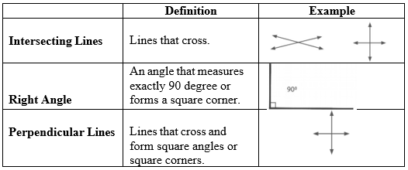

* The teacher provides a tool such as a square tile or the corner of a piece of paper to identify intersecting lines that create right angles and classify those as perpendicular lines and those that do not form right angles as intersecting but not perpendicular. Students use the tool to draw some of their own intersecting lines that would be examples of both
  + For example, the teacher may provide students with a graphic organizer like the one shown below and a set of cards with pairs of lines (examples shown below). The students use the tool to sort the cards into perpendicular and not perpendicular and draw at least one pair of their own lines for each category.

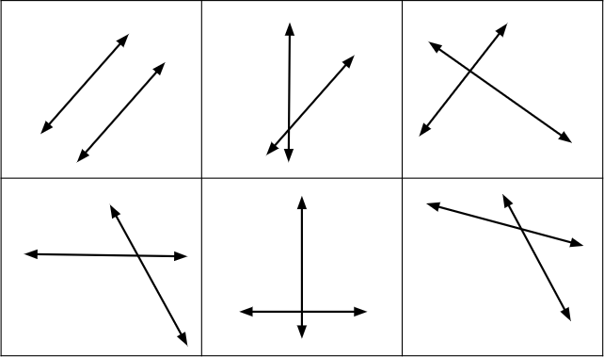

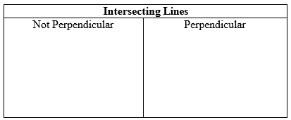

* Instruction includes real-world examples of points, lines, line segments, rays, intersecting lines, perpendicular lines, and parallel lines. The teacher provides images of real-world examples that include geometric figures. Students identify the geometric figure in the example.
  + For example, the teacher provides an image of railroad tracks to represent parallel lines, a speed sign to represent perpendicular lines, a balance beam to represent a line segment, and other common images.
* Instruction includes providing a graphic organizer and several examples of each type of angle (acute, right, obtuse, straight and reflex). The graphic organizer will have angles labeled on them for the students to use to help them classify the figures provided.
* For example, the teacher provides a graphic organizer similar to the one shown below. Along with the graphic organizer, the teacher provides examples of various angles to classify.

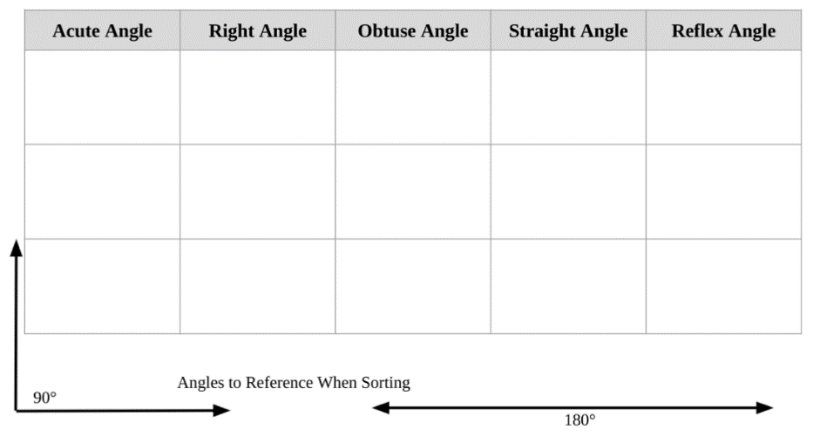

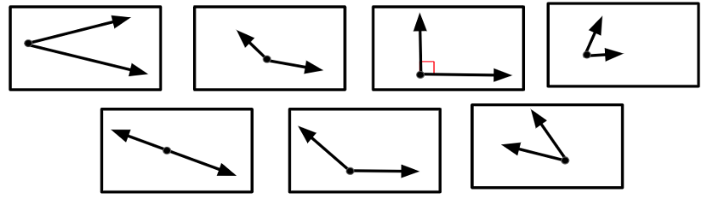

* Instruction includes providing a right angle and a straight angle printed on a clear transparency or sheet protector. Students lay the angles over angle examples provided by the teacher to help them classify the angles as less than 90 degrees (acute angle), greater than 90 degrees (obtuse angle), exactly 90 degrees (right angle), exactly 180 degrees (straight angle), or greater than 180 degrees (reflex angle). Students trace one angle and place it over the other to compare them.
  + For example, the teacher may provide the student with a clear transparency with a right angle printed on it. The teacher provides sample angles and asks students to place the transparency over the angles. The students sort the angles into greater than 90 degrees, less than 90 degrees, and equal to 90 degrees. The teacher will then provide a straight angle printed on a transparency and have students use that to classify the angles that were sorted as greater than 90 degrees into an additional grouping. Students will determine if the angles are equal to 180 degrees or greater than 180 degrees.

Instructional Tasks

*Instructional Task 1*

Are intersecting lines always, sometimes or never parallel? Show your thinking.

*Instructional Task 2*

Using the following figure, answer the questions below.

Part A: What types of angles do you see in this figure?

Part B: What kinds of lines do you see in this figure?

Part C: Where would I see a figure like this in the world around me? Give an example

*Instructional Task 3 (MTR.4.1)*

Part A: Draw and label an example of 3 objects that have a right angle.

Part B: Draw and label an example of 3 objects that have an acute angle.

Part C: Draw and label an example of 3 objects that have an obtuse angle.

Part D: Is it possible to find an object with a reflex angle? Why or why not?

*Enrichment Task 1*

Which figure doesn’t belong? Pick one figure and use attributes of the figure(s) to defend your answer.

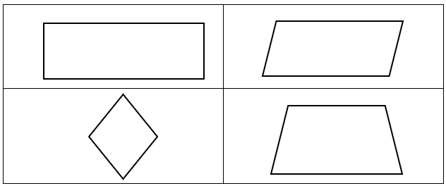

Instructional Items

*Instructional Item 1*

Which of the following figures show perpendicular lines?

II.

III.

* + - 1. I only
      2. II only
      3. II and III
      4. I, II and III

*Instructional Item 2*

Which statement correctly describes the figure?

1. 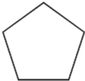 It has 5 acute angles.
2. 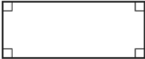 It has 4 obtuse angles.
3. 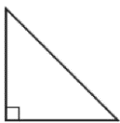 It has 1 right angle and 2 acute angles.
4. 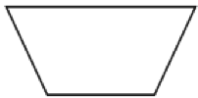 It has 2 right angles and 2 obtuse angles

*Enrichment Item 1*

Use the following polygons to answer the questions.

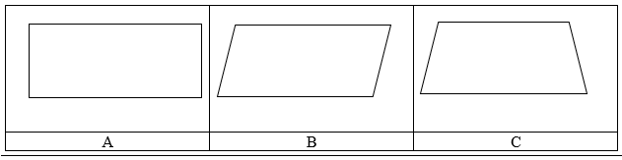

Part A: Which polygon(s) has/have two sets of parallel lines? __________________

Part B: Which polygon(s) has/have right angles? ___________________

Part C: Which polygon(s) has/have acute angles? ___________________

Part D: Which polygon(s) has perpendicular lines? _____________________

Part E: Which polygon(s) has/have angles greater than ${90}^{0}$? _________________

*The strategies, tasks and items included in the B1G-M are examples and should not be considered comprehensive.

### MA.3.GR.1.2

Benchmark

MA.3.GR.1.2 Identify and draw quadrilaterals based on their defining attributes. Quadrilaterals include parallelograms, rhombi, rectangles, squares and trapezoids.

Connecting Benchmarks/Horizontal Alignment

* MA.3.M.1.1
* MA.3.M.1.2
* MA.3.GR.1.1

Terms from the K-12 Glossary

* Line
* Parallelogram
* Rectangle
* Square
* Triangle
* Rhombus

Vertical Alignment

|  |  |
| --- | --- |
| **Previous Benchmarks**   * MA.2.GR.1.1 | **Next Benchmarks**   * MA.4.GR.1.1 |

Purpose and Instructional Strategies

The purpose of this benchmark is to provide opportunities for students to apply their formalized definitions of geometric attributes when identifying and drawing quadrilaterals *(MTR.5.1)*. With the support of vocabulary developed about geometric attributes in benchmark MA.3.GR.1.1, the goal of this benchmark is for students to identify and draw quadrilaterals based on them. In Grade 2, students started to explore and draw quadrilaterals in less formal ways.

* This benchmark gives students opportunities to build vocabulary around examples of quadrilaterals (e.g., parallelograms, rhombi, rectangles, squares, and trapezoids) based on the attributes that define them. Understanding quadrilaterals will help them make comparisons to non-quadrilaterals *(MTR.4.1)*.
* In Grade 4, students will classify types of angles and identify them in two-dimensional figures. In Grade 5, prior learning about quadrilaterals and triangles is synthesized for students to classify these figures based on their attributes.
* Instruction may include highlighting measurement as an attribute to help categorize quadrilaterals.

Common Misconceptions or Errors

* Students can confuse some pairs of intersecting lines as perpendicular. Encourage students to justify their thinking whenever they reason about geometric concepts. For example, students can use the corners of a standard sheet of paper as a comparison to determine whether a pair of intersecting lines is perpendicular.
* Some students may assume all quadrilaterals must have attributes of squares, rhombi, rectangles, and trapezoids. During instruction, it is important for students to determine that a figure lacking further defining attributes (such as a kite) can still be a quadrilateral.

Strategies to Support Tiered Instruction

* Instruction includes real-world examples of points, lines, line segments, rays, intersecting lines, perpendicular lines, and parallel lines. The teacher provides images of real-world examples that include geometric figures. Students identify the geometric figure in the example.
  + For example, the teacher provides an image of railroad tracks to represent parallel lines, a speed sign to represent perpendicular lines, a balance beam to represent a line segment, and other common images.
* Instruction includes real-world examples of points, lines, line segments, rays, intersecting lines, perpendicular lines, and parallel lines. The teacher points out items in the classroom that are examples of the geometric terms listed above and has students identify which term is represented by the item.
  + For example, if the teacher points out a poster with the number one or the letter l on it, students will say it represents a line segment. If the teacher points out the window, students will say the top and bottom of the window shows parallel lines, while the corners of the window show perpendicular lines.
  + For example, students find their own examples within the classroom and explain which geometric term they notice in the figure.
* Graphic to explain example Teacher provides students with key vocabulary from the glossary to identify right angles to help them identify perpendicular sides in figures. The teacher also provides a tool such as a square tile or the corner of a standard sheet of paper to help students find right angles. Students then match quadrilaterals that contain this attribute.
  + For example, the teacher provides a vocabulary card or vocabulary information from the glossary for a right angle, similar to the example shown below. Students then use the tool provided to locate right angles and identify which quadrilaterals contain that attribute when provided images of parallelograms, rhombi, rectangles, squares, and trapezoids.

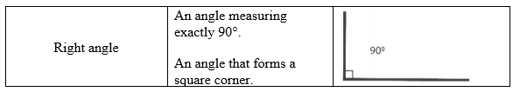

* Teacher provides a graphic organizer to help students identify given attributes in figures. Students place the figures under the correct columns and identify quadrilaterals that do not contain any of the attributes stated.
  + For example, the teacher provides sample figures and students draw them in or place the figure cards in the correct columns of the graphic organizer (some figures will fit in more than one column).

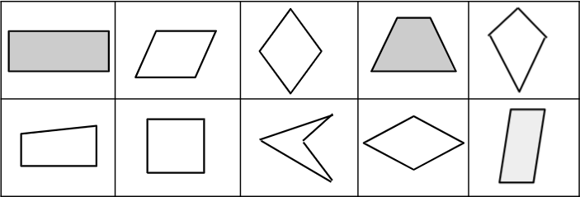

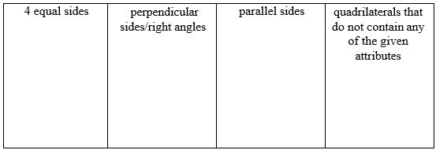

* Teacher provides figures that can be classified as quadrilaterals and those that are not (figures may include: triangles, squares, pentagons, hexagons, square, rectangles, parallelograms, trapezoids, and other quadrilaterals such as a kite). Students sort the figures into two groups, quadrilaterals and non-quadrilaterals and justify their reasoning by explaining how they used the number of sides each figure has to determine their placement.
  + For example, students will add figures to the chart shown below and explain why the figure belongs in that category

Instructional Tasks

*Instructional Task 1*

Draw an example of a quadrilateral that does not have any defining attributes of a square (except that it has 4 straight sides and 4 vertices). Then explain how you know.

*Instructional Task 2*

Draw an example of a quadrilateral with 4 equal sides and no right angles. If your quadrilateral can be classified as another figure, explain.

*Enrichment Task 1 (MTR.4.1)*

Part A: Draw and name a quadrilateral that has 2 obtuse sides, at least one set of parallel lines and no angles that measure 90 degrees.

Part B: Draw and name a second quadrilateral that has the exact same attributes (2 obtuse sides, at least one set of parallel lines and no angles that measure 90 degrees.) Explain how your two quadrilaterals are different.

Instructional Items

*Instructional Item 1*

Which of the following quadrilaterals always have 2 sets of parallel sides? Select all that apply.

1. Square
2. Rectangle
3. Rhombus
4. Parallelogram
5. Trapezoid

*Instructional Item 2*

Which of the following quadrilaterals always have perpendicular sides? Select all that apply.

1. Square
2. Rectangle
3. Rhombus
4. Parallelogram
5. Trapezoid

*Instructional Item 3*

Which of the following quadrilaterals is NOT a parallelogram.

1. b.

c. d.

*Enrichment Item 1*

Using the clues below, solve the riddle.

What figure am I?

Clue 1: I have four sides.

Clue 2: I have two sets of parallel sides.

Clue 3: I have no perpendicular lines.

Clue 4: I have two acute angles.

Clue 5: I have four equal sides

*The strategies, tasks and items included in the B1G-M are examples and should not be considered comprehensive.

### MA.3.GR.1.3

Benchmark

MA.3.GR.1.3 Draw line(s) of symmetry in a two-dimensional figure and identify line- symmetric two-dimensional figures.

Benchmark Clarifications:

*Clarification 1:* Instruction develops the understanding that there could be no line of symmetry, exactly one line of symmetry or more than one line of symmetry.

*Clarification 2:* Instruction includes folding paper along a line of symmetry so that both halves match exactly to confirm line-symmetric figures.

Connecting Benchmarks/Horizontal Alignment

* MA.3.FR.1.1
* MA.3AR.3.2

Terms from the K-12 Glossary

* Line of Symmetry

Vertical Alignment

|  |  |
| --- | --- |
| **Previous Benchmarks**   * MA.2.GR.1.3 | **Next Benchmarks**   * MA.6.GR.1.1 * MA.8.GR.2.1 |

Purpose and Instructional Strategies

The purpose of this benchmark is for students to draw lines of symmetry and identify line- symmetric figures. In Grade 2, students identify lines of symmetry in a two-dimensional figure by partitioning (e.g., folding) it and matching its halves. Students in the Grade 3 Accelerated course develop the understanding that a figure can have no lines of symmetry, exactly 1 line of symmetry, or more than 1 line of symmetry.

* Instruction includes encouraging students to partition figures and match their halves to identify line(s) of symmetry. Upon identifying a line of symmetry, students should recognize that each side of the line of symmetry is the same as one-half of the figure*(MTR.2.1)*.
* Instruction can also ask students to build generalizations about which two-dimensional figures are line symmetric and why. For example, students could argue that all squares share similar defining attributes and only differ in size, therefore all squares will be line- symmetric *(MTR.2.1, MTR.4.1)*.
* Instruction includes having students identify the number of lines of symmetry in a figure.
* Instruction builds a foundation for exploring reflections in middle school.

Common Misconceptions or Errors

* Students can miss identifying all lines of symmetry in line-symmetric figures. Encourage classroom discussions and have students justify their arguments about lines of symmetry using their partitioned representations.

Strategies to Support Tiered Instruction

* Teacher provides figures that have at least one line of symmetry and tells how many lines of symmetry the figure has. Students draw lines to show where the lines of symmetry would be.
  + For example, the teacher provides students with images similar to those shown below and has students draw the number of lines of symmetry given and explain how they know the lines they draw are lines of symmetry.

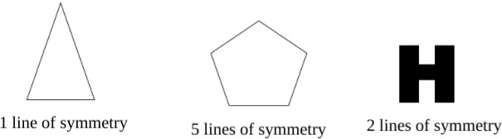

* Teacher provides a figure partitioned in different ways with dotted lines. Students fold the image along the dotted line and determine if it is a line of symmetry (do the two sides match).
  + For example, the teacher gives a triangle like the one shown below. Students fold along the dotted lines and determine if it shows a line of symmetry or not.

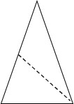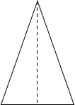

Instructional Tasks

*Instructional Task 1*

Mika says that the uppercase letter H below has 1 line of symmetry. Errol says that the uppercase letter H has 2 lines of symmetry. Who is correct? Show your thinking.

*Instructional Task 2*

Determine if the figure below has 0 lines of symmetry, 1 line of symmetry, or more than 1 line of symmetry. Explain your thinking.

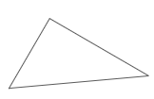

*Enrichment Task 1*

Draw diagrams of the following:

Part A: Draw a diagram of a house that has one line of symmetry.

Part B: Draw a diagram of a school that has two lines of symmetry.

Part C: Draw a diagram of a supermarket that has zero lines of symmetry.

*Enrichment Task 2*

Draw a quadrilateral that has both of the following attributes:

Part A: The quadrilateral has two lines of symmetry and at least one right angle.

Part B: The quadrilateral has one line of symmetry and exactly two acute angles.

Part C: The quadrilateral has one line of symmetry and exactly two obtuse angles

Instructional Items

*Instructional Item 1*

Select all the figures that have at least one line of symmetry.



a.



b.



c.



d.



e.

*Instructional Item 2*

How many lines of symmetry does the following figure have?



*Instructional Item 3*

A figure is shown.



How many lines of symmetry does the figure have?

*Instructional Item 4*

Draw the lines of symmetry on the figure below.

*Instructional Item 5*

In which figure is the line of symmetry NOT drawn correctly?

a. A white circle with a dotted line
in center b. A triangle with a dotted line


c. A white square with a cut out line

 d. A hexagon with a dotted line




*Enrichment Item 1*

Draw three different figures that have exactly four lines of symmetry.

*The strategies, tasks and items included in the B1G-M are examples and should not be considered comprehensive.

**MA.3.GR.2** *Solve problems involving the perimeter and area of rectangles.*

### MA.3.GR.2.1

Benchmark

MA.3.GR.2.1 Explore area as an attribute of a two-dimensional figure by covering the figure with unit squares without gaps or overlaps. Find areas of rectangles by counting unit squares.

Benchmark Clarifications:

*Clarification 1:* Instruction emphasizes the conceptual understanding that area is an attribute that can be measured for a two-dimensional figure. The measurement unit for area is the area of a unit square, which is a square with side length of 1 unit.

*Clarification 2:* Two-dimensional figures cannot exceed 12 units by 12 units and responses include the appropriate units in word form (e.g., square centimeter or sq.cm.).

Connecting Benchmarks/Horizontal Alignment

* MA.3.NSO.2.2

Terms from the K-12 Glossary

* Rectangular Array

Vertical Alignment

|  |  |
| --- | --- |
| **Previous Benchmarks**   * MA.2.AR.3.2 * MA.2.GR.2.1 | **Next Benchmarks**   * MA.4.GR.2.1/2.2 |

Purpose and Instructional Strategies

The purpose of this benchmark is to provide the foundation for students to understand area measurement. In Grades 1 and 2, students learned about linear measurement using number lines, rulers and calculating perimeter. In Grade 3, students build on their knowledge of measurement and multiplicative reasoning to explore and understand area measurement. Instruction emphasizes that area is a two-dimensional measurement, therefore it is measured in units that are also two-dimensional – unit squares with side lengths that measure one unit. Area is calculated using unit squares that cover a shape without gaps or overlap *(MTR.5.1)*.

* The expectation of this benchmark is for students to calculate area of rectangles by **counting** unit squares *(MTR.2.1)*.
* Instruction allows for students to draw conclusions about connections to arrays and to determine more efficient counting strategies for calculation, leading to the use of a multiplication formula in MA.3.GR.2.2 *(MTR.4.1, MTR.5.1)*.
* Students have previous experience with calculating the perimeter of rectangles but do not have experience with calculating the area. Explain that the perimeter of a rectangle is the sum of the side lengths of the rectangle and that area of a rectangle is the measure, in square units, of the inside region of the rectangle. Demonstrate with a real-world example such as a bulletin board. To determine the length of border needed, we would calculate the perimeter of the bulletin board and to determine the amount of paper needed to cover the bulletin board, we would calculate the area.

Common Misconceptions or Errors

* Students may miscount unit squares when they are laid out in a figure. Encourage students to mark unit squares as they are counted.
* Students can confuse why area is measured in “square units.” Use this exploratory benchmark for students to relate area measurement to the counting of squares. This benchmark provides the opportunity for students to build vocabulary necessary for area measurement.

Strategies to Support Tiered Instruction

* Instruction includes modeling how to number the unit square tiles, so students don’t miscount when finding area.
  + 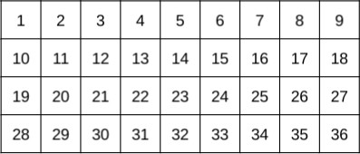For example, the teacher provides students with figures created with squares and has them number each square as they count.
* Instruction includes creating figures with no gaps or overlaps that have a given area. Students mark each unit square with a number as they count to check that the area of the figure they create has the correct area.
  + 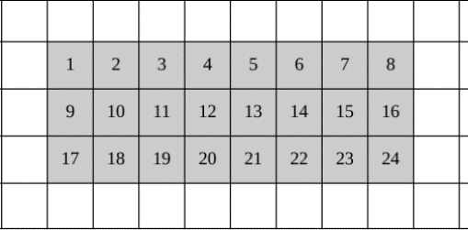For example, the teacher provides students with grid paper and asks them to create a figure with an area of 24 square units. Students count and label 24 connected squares on the grid paper and then shade in the entire figure (see example below).
* Instruction includes measuring the area of given figures by covering them with 1-inch square tiles, leaving no gaps or overlaps. Students count the total number of squares it takes to completely cover the figure and explain how that number represents the area in square units of the figure.
  + For example, the teacher provides a sheet with figures that can be covered perfectly using the square tiles. Students tile the figure and count the square tiles to identify the area.
* Instruction includes students creating their own figures by connecting square tiles with no gaps or overlaps and counting the tiles.
  + For example, the teacher provides a set of 1-inch tiles and asks students to build a figure with an area of 18 square inches. After students have created the figure, they will count and number each tile to ensure they have an area of 18 square inches

Instructional Tasks

*Instructional Task 1*

Kendra used unit squares with 1-centimeter side lengths to find the area of the rectangle below. She started, but then stopped for a lunch break.

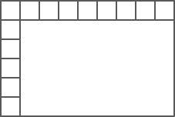

1. What is the area of Kendra’s figure?
2. Explain how you counted.

*Instructional Task 2*

Alex put the tiles shown on the floor.

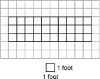

Part A. What is the area in square feet of the portion that Alex has covered?

Part B. What is the area in square feet of the entire floor?

Part C. The area of Alex’s floor is 30 square feet. Select all the floors that could be Alex’s.

*A group of squares with the same number

*

*Enrichment Task 1*

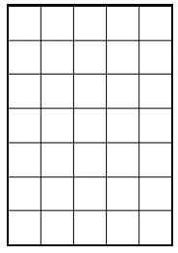Craig is creating a model of a building. He drew a rectangle for the model and used unit squares with 1-inch side lengths to find the area.

Part A: What is the area of Craig’s rectangle?

Part B: What do you notice about the side lengths of the rectangle and the area of the rectangle? Why do you think this is true?

Instructional Items

*Instructional Item 1*

Count the shaded unit squares. Then write the area.

*A grid with a square in the middle


*

*Instructional Item 2*

What is the area of the rectangle?

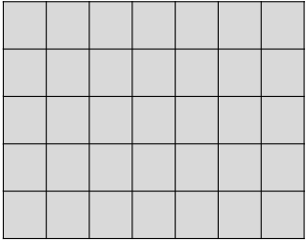

a. 34 square units

b. 25 square units

c. 36 square units

d. 35 square units

*The strategies, tasks and items included in the B1G-M are examples and should not be considered comprehensive.

### MA.3.GR.2.2

Benchmark

MA.3.GR.2.2 Find the area of a rectangle with whole-number side lengths using a visual model and a multiplication formula.

Benchmark Clarifications:

*Clarification 1:* Instruction includes covering the figure with unit squares, a rectangular array or applying a formula.

*Clarification 2:* Two-dimensional figures cannot exceed 12 units by 12 units and responses include the appropriate units in word form.

Connecting Benchmarks/Horizontal Alignment

* MA.3.NSO.2.2/2.3/2.4

Terms from the K-12 Glossary

* Rectangular Array

Vertical Alignment

|  |  |
| --- | --- |
| **Previous Benchmarks**   * MA.2.AR.3.2 * MA.2.GR.2.2 | **Next Benchmarks**   * MA.4.GR.2.1/2.2 |

Purpose and Instructional Strategies

The purpose of this benchmark is for students to calculate the area of rectangles presented visually as arrays or by using a multiplication formula and is connected to MA.3.GR.2.1. *(MTR.5.1)*.

* The benchmark MA.3.GR.2.1 expects students to calculate the area of rectangles by counting unit squares that covered them with no gaps or overlaps. As students count, they will likely connect their calculations to rectangular arrays and connect understanding that multiplication is a more efficient strategy for calculating than counting or adding unit squares.
* Instruction may encourage students to discover a multiplication formula based on patterns they have observed through practice and classroom discussions. This will make a multiplication formula more meaningful for students conceptually *(MTR.5.1)*. Teachers can help students formalize the formula into an equation, like 𝐴 = 𝑙 × 𝑤. In this benchmark, memorization of a multiplication formula is the goal *(MTR.3.1)*.
* Instruction includes making connections between the meaning of multiplication as seen in arrays and finding the area of a rectangle. The area of a rectangle, or the amount of square units covering the rectangle, is the product of the number of rows and the number of columns.

Common Misconceptions or Errors

* When using a formula, students may be confused about which dimension to label the length and width in a rectangle. Instruction can emphasize connections to the commutative property of multiplication to emphasize that the order in which dimensions are multiplied will not change the rectangle’s area, and therefore the length and width can be labeled flexibly.

Strategies to Support Tiered Instruction

* Instruction includes the teacher modeling how to draw in rows and columns to cover a figure based on the side lengths given. Students then count the total number of square units that make up the figure and write a multiplication equation to represent it. Teachers help students make the connection to the commutative property of multiplication by having them create and compare figures with the same factors for their rows and columns, just switched. Emphasize that the order in which dimensions are multiplied will not change the rectangle’s area, and therefore the length and width can be labeled flexibly.
  + For example, when provided with a figure with the dimensions of 4 x 8, students draw in the rows and columns as shown by the dotted lines. The teacher then asks students to do the same for an image with the dimensions 8 x 4and has them compare the area of the two figures.

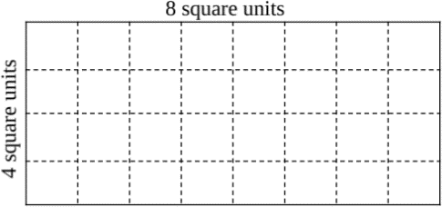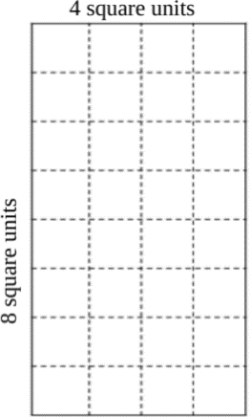

* Teacher provides dimensions for a given rectangle and students use square tiles to build the figure in two ways. Students then count the number of tiles in each row and in each column and create a multiplication expression. Next, the students count the total number of tiles used to make the figure and recognize that as the area of the figure.
  + For example, the teacher asks students to create a rectangle with a length of 5 and a width of 7. Students use the square tiles to create two rectangles applying the commutative property of multiplication and writing multiplication equations to match. Then, students count the total number of tiles to check that the area they found for their equation is correct.

Instructional Tasks

*Instructional Task 1*

***Kendra used unit squares with 1-centimeter side lengths to find the area of the rectangle below. She started, but then stopped for a lunch break.***

**

Part A. Write two equations that can be used to find the area of Kendra’s rectangle.

Part B. What is the area of Kendra’s rectangle?

Part C. Which has greater area, the rectangle above or a square with side lengths of 8 centimeters? Explain.

*Instructional Task 2*

Mya wants to plant tulips in the garden below but first she must figure out how many square feet the garden is. What is the area of the garden in square feet?

*A grid of blue squares

*

.

*Enrichment Task 1*

Mateo sketched the rectangle below.

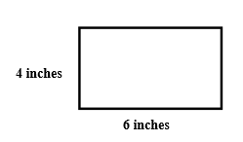

Mateo wants to sketch a second rectangle that has the same area but different side lengths.

Part A: Determine a possible length and width for Mateo’s second rectangle.

Part B: Explain how both rectangles can have different side lengths and the same area.

Instructional Items

*Instructional Item 1*

The rectangle below is composed of unit squares. Which equations can be used to find the area of the rectangle?

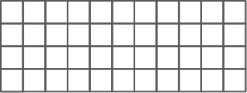

1. 𝐴 = 4 × 10
2. 𝐴 = 10 × 4
3. 𝐴 = 4 + 11
4. 𝐴 = 4 × 11
5. 𝐴 = 11 + 11 + 11 + 11
6. 𝐴 = 11 × 4

*Instructional Item 2*

What is the area of the rectangle below?

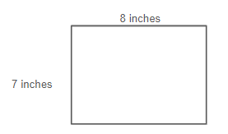

*Instructional Item 3*

What is the area of the rectangle below?

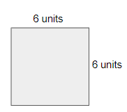

*Enrichment Item 1*

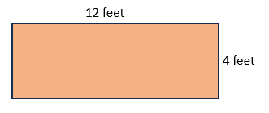A teacher is covering a chalkboard with red paper. The chalkboard is shown below.

*The strategies, tasks and items included in the B1G-M are examples and should not be considered comprehensive.

### MA.3.GR.2.3

Benchmark

MA.3.GR.2.3 Solve mathematical and real-world problems involving the perimeter and area of rectangles with whole-number side lengths using a visual model and a formula.

Benchmark Clarifications:

*Clarification 1:* Within this benchmark, the expectation is not to find unknown side lengths.

*Clarification 2:* Two-dimensional figures cannot exceed 12 units by 12 units and responses include the appropriate units in word form.

Connecting Benchmarks/Horizontal Alignment

* MA.3.NSO.2.2
* MA.3.NSO.2.4
* MA.3.AR.1.2
* MA.3.M.1.1
* MA.3.M.1.2
* MA.4.NSO.2.2
* MA.4.NSO.2.3
* MA.4.NSO.2.4
* MA.4.NSO.2.5
* MA.4.AR.1.1

Terms from the K-12 Glossary

* Perimeter
* Rectangle

Vertical Alignment

|  |  |
| --- | --- |
| **Previous Benchmarks**   * MA.2.GR.1.1/1.2 | **Next Benchmarks**   * MA.5.GR.2.1 |

Purpose and Instructional Strategies

The purpose of MA.3.GR.2.3 is for students to solve mathematical and real-world problems using the perimeter and area of rectangles using a visual model and/or a formula for each. The purpose of MA.4.GR.2.1 is for students to connect perimeter and area problems to algebraic concepts to find the measures of unknown side lengths. This new idea builds from solving area and perimeter problems with whole number side lengths when using models and formulas and will form the foundation for problems involving fractional and decimal side lengths in the Grade 4 Accelerated course (MA.5.GR.2.1).

* In the provided mathematical and real-world problems, instruction should include cases where students use a ruler to measure lengths before determining its perimeter and/or area *(MTR.3.1)*.
* Mathematical problems include visual models of rectangles, while examples of real- world problems could include photos or classroom objects (e.g., measuring the area of one face on a tissue box). Students will not be expected to find unknown side lengths until Grade 4 *(MTR.7.1)*.
* This benchmark gives students the chance to measure perimeter and area together and understand their differences – perimeter as a one-dimensional length measurement and area as a two-dimensional measurement. (Note: Though students explored and measured perimeter in Grade 2, they were not expected to determine a formula.) *(MTR.5.1)*
* As recommended for MA.3.GR.2.2 for a multiplication formula for area, classroom instruction should include activities that allow students to build formulas for perimeter based on patterns they observe (e.g., 𝑃 = 𝑙 + 𝑙 + 𝑤 + 𝑤, 𝑃 = 2𝑙 + 2𝑤) before expecting them to memorize. Student-created formulas will build conceptual understanding around a formula before memorizing it *(MTR.4.1)*.
* During instruction, students should use a letter (variable) to represent the missing side length and have experiences solving for unknowns in perimeter situations with a given area and vice-versa.
* Instruction includes having students use the fact that opposite sides in rectangles and squares are equal when solving problems involving area and perimeter.

Common Misconceptions or Errors

* Students may confuse area and perimeter and use incorrect formulas to find measurements. During instruction, the teacher should continue to emphasize the difference between perimeter as a one-dimensional measurement of length and area as a two-dimensional measurement that covers a figure with unit squares. The teacher can use visuals to show the perimeter (e.g., yarn, string stretched around the rectangle) and area (e.g., square counters, square-shaped sticky notes, square-shaped crackers covering it) to help students differentiate between the measurements. Instruction should also focus on naming the units properly.

Strategies to Support Tiered Instruction

* Instruction includes opportunities to explore both area and perimeter of given figures and make connections to the formulas to find each. The teacher provides students with dimensions for a figure that has whole number side lengths that can be measured using inches or centimeters. Students use a ruler to measure the side lengths and place tick marks for each whole number unit. Students then label each side length and use the formula for perimeter to calculate. Next, students use the formula for area to find the area and then use the tick marks made when measuring to draw in the rows and columns to check their work.
  + For example, the teacher asks students to draw a figure with a length of 3 inches and a width of 6 inches. Students use a ruler to draw the figure and place tick marks along each side for each inch. Students then use the formula to find the perimeter (P = 3 + 3 + 6 + 6 ). Next, students use the tick marks made when measuring to draw in the rows and columns to cover the figure with square inches and then use the formula to find area (A = 3 × 6 ).

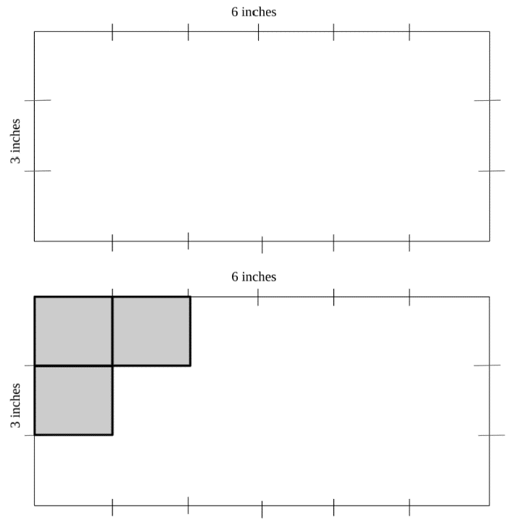

* Teacher provides a figure that has whole number side lengths that can be measured using inches. Students use a visual representation such as string or yarn to measure the distance around the figure and then measure the length of the string to make the connection to perimeter being a one-dimensional measurement. Students then use a different visual representation such as 1-inch tiles or square sticky notes to cover the figure to find the area and make the connection to area being a two-dimensional measurement.
  + For example, the teacher provides an image like the example below. Students use a piece of string to measure the distance around the figure and then use a tape measure to measure the length of the string. Or students can use the string to measure the 2 sides, then add the 2 lengths and multiply by 2 to determine the perimeter. Students will then use square tiles to cover the image to determine the area.

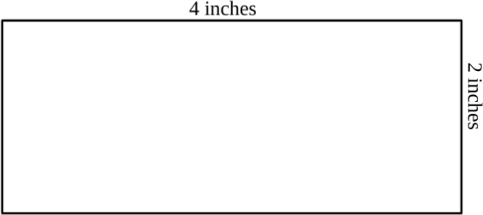

* Teacher provides students with images created using square tiles. Student count and labels the side lengths based on the tiles, then write equations to show how they would find the area and how they would find the perimeter.
  + 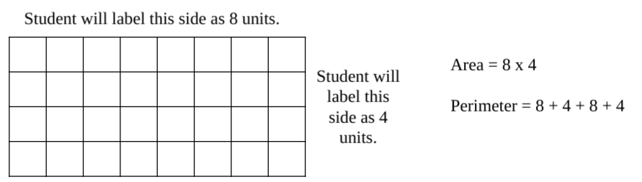For example: When provided with an image like the one shown below, students label each side length based on the number of tiles and write an equation for perimeter and then count the units around the outside of the figure to confirm their solution. Students multiply the length and width to find area and then count the number of squares that make up the figure to confirm their solution

Instructional Tasks

*Instructional Task 1 (MTR.7.1)*

The perimeter of the patio below is 98 square feet.

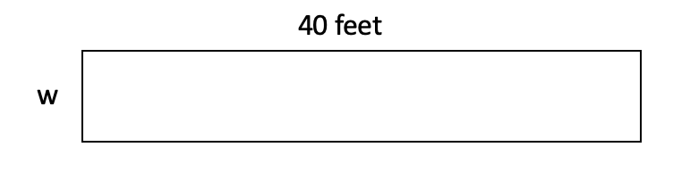

What is the area of the patio?

*Enrichment Task 1*

Part A: Find the whole number length and whole number width of every rectangle with an area of 18 square feet. Record the length, width and perimeter of each rectangle in the table.

|  |  |  |  |
| --- | --- | --- | --- |
| Area | Length | Width | Perimeter |
| 18 sq. ft. |  |  |  |
| 18 sq. ft. |  |  |  |
| 18 sq. ft. |  |  |  |
| 18 sq. ft. |  |  |  |
| 18 sq. ft. |  |  |  |
| 18 sq. ft. |  |  |  |

Part B: How do different length and width measurements change the perimeter of each rectangle? Why do you think this happens.

Instructional Items

*Instructional Item 1*

Which of the following rectangles has a perimeter of 24 inches and an area of 36 square inches?

* + 1. 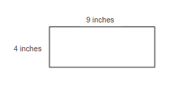
    2. 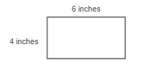
    3. 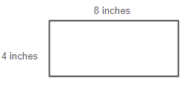

*Instructional Item 2*

A rectangle is 12 centimeters long and 9 centimeters wide. What is the area of the rectangle?

*Instructional Item 3*

The length of a large window is 6 feet. If the area of the window is 24 square feet, what is the width of the window?

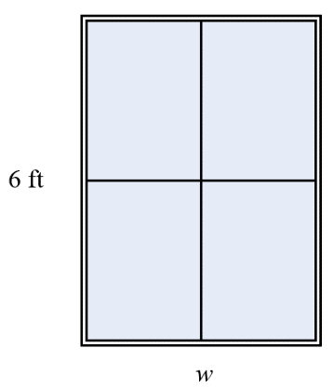

*Instructional Item 4*

A soccer field with its dimensions is shown.

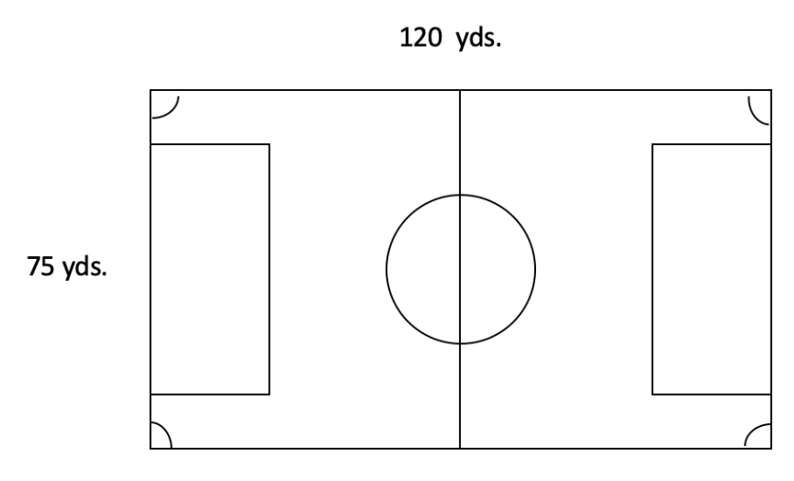

Which equation can be used to find the area of the soccer field?

$75 yards + 120 yards = A yards$

$75 yards + 75 yards + 120 yards + 120 yards = A yards$

$75 yards × 120 yards = A square yards$

$75 yards × 120 yards × 75 yards × 120 yards = A square yards$

*The strategies, tasks and items included in the B1G-M are examples and should not be considered comprehensive.

### MA.3.GR.2.4

Benchmark

MA.3.GR.2.4 Solve mathematical and real-world problems involving the perimeter and area of composite figures composed of non-overlapping rectangles with whole- number side lengths.

*Example:* A pool is comprised of two non-overlapping rectangles in the shape of an “L”. The area for a cover of the pool can be found by adding the areas of the two non-overlapping rectangles.

Benchmark Clarifications:

*Clarification 1:* Composite figures must be composed of non-overlapping rectangles.

*Clarification 2:* Each rectangle within the composite figure cannot exceed 12 units by 12 units and responses include the appropriate units in word form.

Connecting Benchmarks/Horizontal Alignment

* MA.3.NSO.2.2
* MA.3.NSO.2.4
* MA.3.AR.1.2
* MA.3.M.1.1
* MA.3.M.1.2

Terms from the K-12 Glossary

* Composite Figure
* Perimeter
* Rectangle

Vertical Alignment

|  |  |
| --- | --- |
| **Previous Benchmarks**   * MA.2.GR.2.2 | **Next Benchmarks**   * MA.4.GR.2.1 |

Purpose and Instructional Strategies

The purpose of this benchmark is for students to solve mathematical and real-world problems involving the perimeter and area of composite figures with whole-number side lengths. This benchmark builds on the work with perimeter done in Grade 2. The area of each rectangle in a composite figure is expected to be within the appropriate multiplication limits for Grade 3 – up to 12 units by 12 units. All side lengths of composite figures should be given, though cases can be provided where students are expected to use a ruler to measure before finding a composite figure’s perimeter and/or area.

* Students have previous experience with decomposing larger rectangles into smaller rectangles to find individual areas. When students utilized the distributive property in area models to multiply 2-digit factors by a 1-digit factors, students decomposed (broke apart) the 2-digit number as the sum of its tens and ones. Students learned that the product was the sum of smaller rectangles’ areas. Students likely used area models to build fluency within12 x 12 as well. During instruction of this benchmark, instruction includes having students make connections to their previous learning as they begin decomposing the composite figures *(MTR.2.1, MTR.5.1)*.
* Instruction of measuring area of composite figures includes opportunities for students to justify how they decompose their composite figures into 2 or more rectangles before calculating. As students share the different ways they decompose their figures, they identify that any correct decomposition will yield the correct calculation *(MTR.2.1, MTR.2.1, MTR.3.1)*.

Common Misconceptions or Errors

* Students can confuse the side lengths when determining area calculations once a composite figure has been decomposed. For example, a potential way to decompose the figure from the task below is seen on the right. A student may not yet understand that once decomposed in this way, the length of 14 centimeters on the right side of the figure is now the sum of 5 centimeters + 9 centimeters. The student may continue to multiply by 14 centimeters to find the areas of each rectangle instead. Likewise, they may multiply 5 centimeters by 6 centimeters (instead of 9 centimeters) to find the area of the upper rectangle. During instruction, encourage students to label how side lengths change once a composite figure has been decomposed.

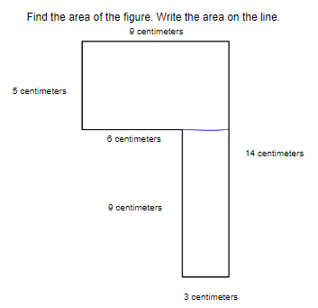

* Students may add all sides of the parts of the figure once it is decomposed to determine the perimeter of the composite figure. For example in the figure shown, the student may find the perimeter to be (9 centimeters + 9 centimeters + 5 centimeters + 5 centimeters) + (9 centimeters + 9 centimeters = 3 centimeters + 3 centimeters) = 52 centimeters, when the correct answer is 9 centimeters + 14 centimeters + 3 centimeters + 9 centimeters + 6 centimeters + 5 centimeters = 46 centimeters.

Strategies to Support Tiered Instruction

* Instruction includes decomposing figures in multiple ways, finding the area of each individual rectangle and then finding the sum of the two rectangles.
  + For example, the teacher provides students with a composite figure and asks them to decompose the figure into two rectangles. Students draw and label the two rectangles as separate parts to show their understanding of how the side lengths have changed once the figure was decomposed. Then, students find the area of each individual rectangle. By drawing the two separate rectangles, students identify which measurements to use due to the decomposing of the figures. One example of how the figure can be decomposed is shown. Students may come up with other ways.

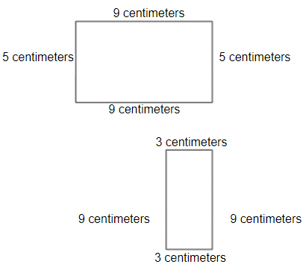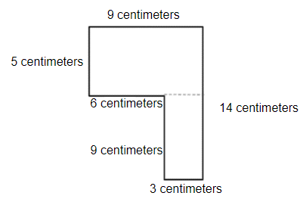

* Teacher provides composite figures created with unit squares. Students cut the figures to decompose them into two separate rectangles and label the dimensions for each figure. Students then find the sum of the area of the two rectangles.
  + For example, teacher provides students with figures similar to the one below. Students determine how they can decompose them into two rectangles (there could be more than one way). Students then cut the figure apart to show the two rectangles and write multiplication equations to represent the area of each part. Finally, students find the sum of the two areas and determine if the area is the same as the whole figure.
  + Students can find the perimeters of the two separate rectangles and then determine if the sum of the two perimeters is the same as the perimeter of the composite figure.

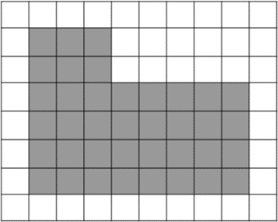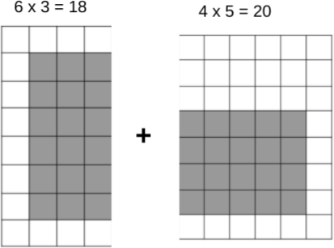

Instructional Tasks

*Instructional Task 1*

diagram for instructional task 1


Part A. Find the perimeter.

Part B. Find the area.

*Instructional Task 2*

Angie and her friends are heading to a fall festival and want to walk through the corn maze. Determine the perimeter and area of the corn maze.

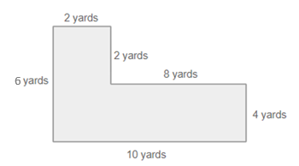

*Enrichment Task 1*

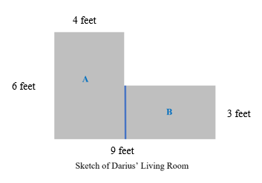Darius created a sketch of his living room as shown below.



Darius decomposed the sketch of his living room in two different ways.

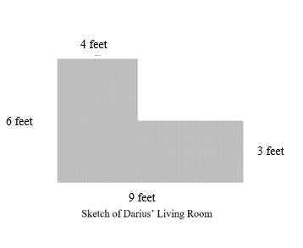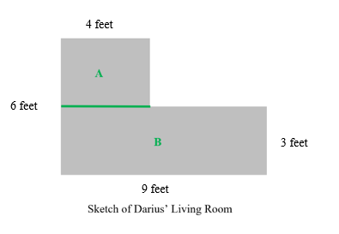

What is the area of Rectangle A? What is the area of Rectangle A?

What is the area of Rectangle B? What is the area of Rectangle B?

What is the total area of the living room? What is the total area of the living room?

Instructional Items

*Instructional Item 1*

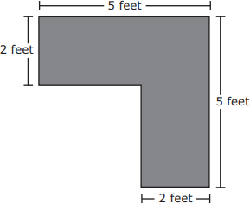A drawing of the top of a desk is shown.

What is the area of the top of the desk?

1. 14 square feet
2. 16 square feet
3. 20 square feet
4. 25 square feet

*Instructional Item 2*

Find the perimeter of the following figure.

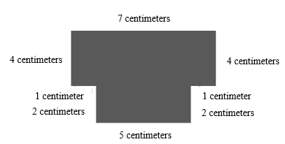

*Instructional Item 3*

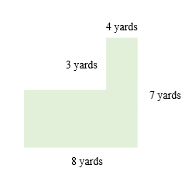A drawing of a field is shown.

What is the perimeter of the field?

|  |  |
| --- | --- |
| a. | 20 yards |
| b. | 30 yards |
| c. | 35 yards |
| d. | 38 yards |

*Enrichment Item 1*

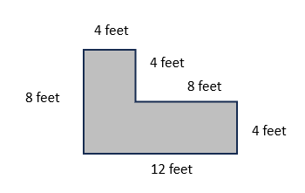A living room floor plan is shown. A home designer is calculating the cost of covering the floor with carpet and placing baseboards around the perimeter of the room. He measures the area and perimeter of the room.

Part A. What is the area, in square feet, of the living room?

Part B. What is the perimeter of the room?

1. 24 feet
2. 40 feet
3. 64 feet
4. 96 feet

*The strategies, tasks and items included in the B1G-M are examples and should not be considered comprehensive.

## ***MA.4.GR.1*** *Draw, classify and measure angles*

### MA.4.GR.1.1

See Benchmark MA.3.GR.1.1

### MA.4.GR.1.2

Benchmark

MA.4.GR.1.2 Estimate angle measures. Using a protractor, measure angles in whole-number degrees and draw angles of specified measure in whole-number degrees. Demonstrate that angle measure is additive.

Benchmark Clarifications:

*Clarification 1:* Instruction includes measuring given angles and drawing angles using protractors.

*Clarification* 2*:* Instruction includes estimating angle measures using benchmark angles (30°, 45°, 60°, 90° and 180°).

*Clarification 3:* Instruction focuses on the understanding that angles can be decomposed into non-overlapping angles whose measures sum to the measure of the original angle.

Connecting Benchmarks/Horizontal Alignment

* MA.4.GR.1.1
* MA.4.GR.1.2

Terms from the K-12 Glossary

* Acute angle
* Angle
* Obtuse angle
* Right angle

Vertical Alignment

|  |  |
| --- | --- |
| **Previous Benchmarks**   * MA.3.GR.1.1 * MA.3.GR.1.2 | **Next Benchmarks**   * MA.5.GR.1.1 |

Purpose and Instructional Strategies

The purpose of this benchmark is to build understanding that angles can be measured. Students have experience identifying acute, obtuse, and right angles (MA.4.GR.1.1). Through instruction in this benchmark, students will attach precise measurements to their informal understanding of the angles they have explored.

* Students will also estimate angle measures based on their growing familiarity of the size of angles according to the benchmark angles $30°$, $45°$, $60°$, $90°$ and $180°$.
* Instruction should allow students to draw angles of all sizes, including situations where they must make angles that are larger than their protractor or their piece of paper. This will ensure that students have an understanding that the angle measure does not change even if the length of the rays do.
* Instruction should use explicit and direct instruction to show students how to use a protractor (standard or circle) to measure and draw angles. Using circle protractors helps students explore reflex angles.
* Instructional time should also be spent decomposing angles into smaller angles so that students build understanding that angle measures are additive.

Common Misconceptions or Errors

* Students may have difficulty using a protractor to measure. To assist students with this misconception, they may:
* use the centimeter ruler or inch ruler instead of the baseline when measuring the angles.
* measure the length of each ray and find the sum of the lengths.
* not correctly line up the angle to be measured on the protractor.

Strategies to Support Tiered Instruction

* Instruction includes using a right angle, 90 degrees measure, as a benchmark to estimate angle measures prior to measuring with a protractor. The teacher provides students with a right angle to overlap with the angles they are measuring as a way to compare their size.
  + For example, when given an angle, students will determine if the angle is 90 degrees, greater than 90 degrees, or less than 90 degrees. Students then measure the angle using a protractor and determine if their measurement makes sense based on their estimate.
* The teacher provides angles that have a baseline ray labeled so that students know which ray to line up with the baseline on the protractor and begin their measurement from. Students explain how they will use the protractor to measure the angle (which set of numbers they will use to measure and how they know where to stop measuring).
  + For example, the teacher provides an angle similar to the one shown below. Students line up the baseline of the protractor with the ray on the angle that is labeled as the baseline. Students will start measuring with the set of numbers that begins with 0 at the end of the ray and follow the measurements around to the point where the other ray intersects with the protractor.

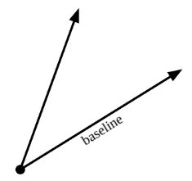

Instructional Tasks

*Instructional Task 1*

Use a protractor to find the measure of each indicated angle.

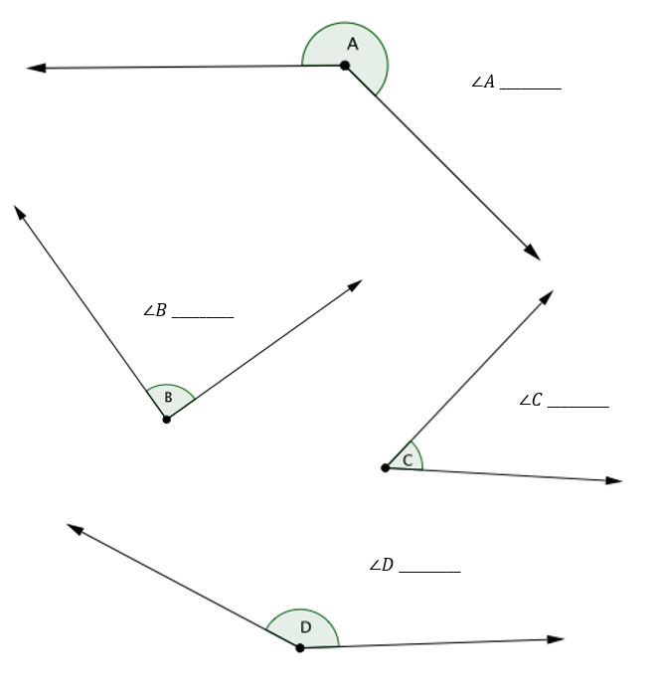

*Instructional Task 2*

If you decomposed this angle into two smaller angles, what could be the measurement of each of the two smaller angles?

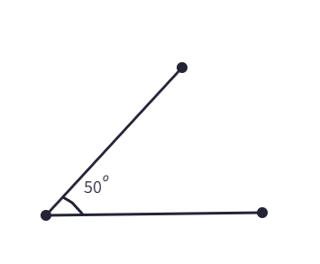

*Enrichment Task 1*

Complete the following tasks using a protractor.

Part A: Draw an angle that measures ${100}^{o}$.

Part B: Using a red marker or pencil, divide your ${100}^{o}$ angle into two smaller angles. What are the measures of your two smaller angles?

Part C: Using a blue marker or pencil, divide your ${100}^{o}$ angle into two different smaller angles. What are the measures of your new angles?

Part D: Using a black marker or pencil, divide your ${100}^{o}$ angle into a right angle and another angle. What is the measure of your second angle.

*Enrichment Task 2*

Use the face of a clock and a protractor to determine the measurement of these angles:

Part A: 1:30 to 2:00

Part B: 11:45 to 12:00

Part C: 7:00 to 7:10

Part D: 5:15 to 5:20

Instructional Items

*Instructional Item 1*

Which angles when added together make a right angle?

1. 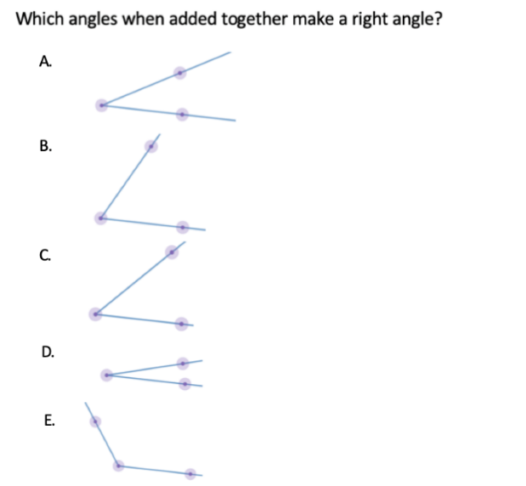
2. 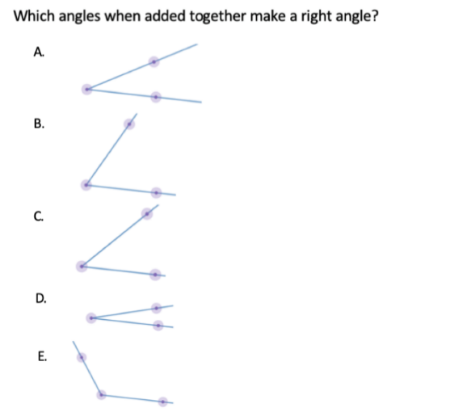
3. 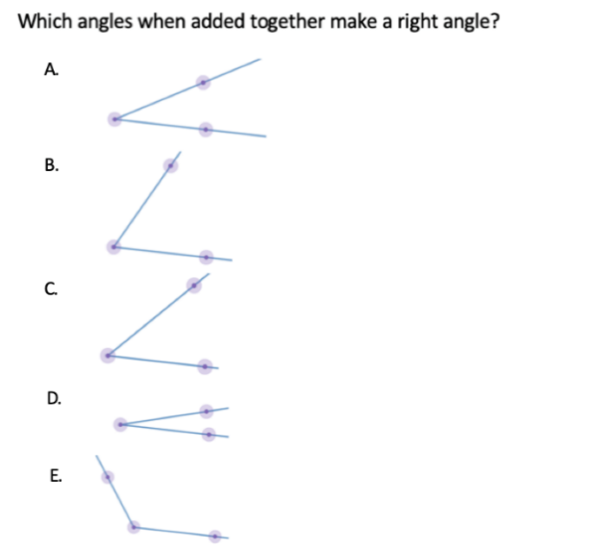
4. 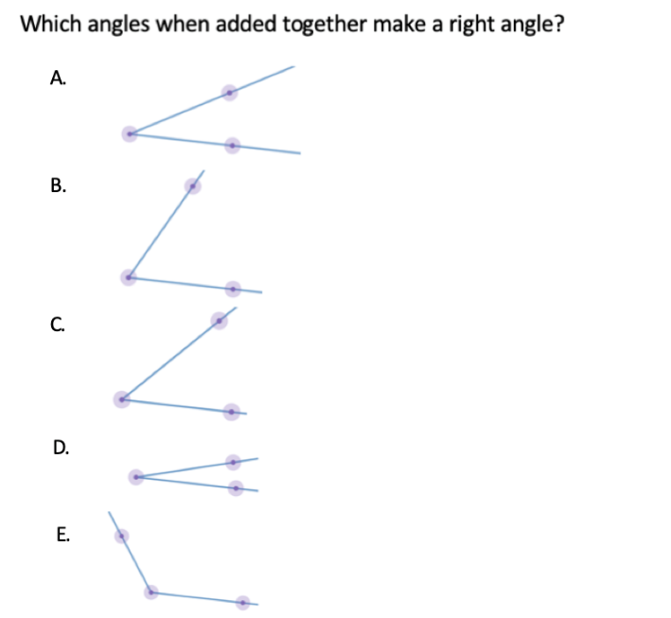
5. 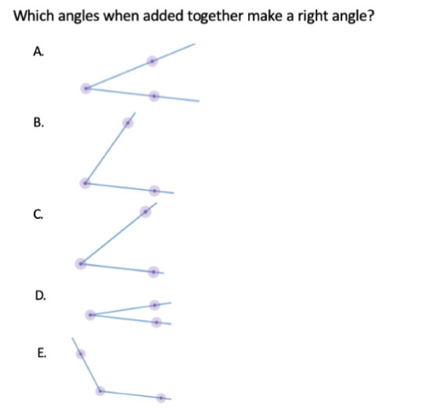

*Instructional Item 2*

Draw an angle that measures 70 $°$

Enrichment Item 1

What two angles could add together to equal the measurement of the angle created by the hands of a clock as it moves from 6:00 to 6:30?

*The strategies, tasks and items included in the B1G-M are examples and should not be considered comprehensive.

### MA.4.GR.1.3

Benchmark

MA.4.GR.1.3 Solve real-world and mathematical problems involving unknown whole-number angle measures. Write an equation to represent the unknown.

*Example:* A 60 $°$ angle is decomposed into two angles, one of which is 25 $°$. What is the measure of the other angle?

Benchmark Clarifications:

*Clarification 1:* Instruction includes the connection to angle measure as being additive.

Connecting Benchmarks/Horizontal Alignment

* MA.4.GR.1.2
* MA.4.AR.1.1
* MA.4.AR.2.2

Terms from the K-12 Glossary

* Angle
* Circle
* Right angle

Straight angle

Vertical Alignment

|  |  |
| --- | --- |
| **Previous Benchmarks**   * MA.3.GR.1.1 | **Next Benchmarks**   * MA.8.GR.1.4 * MA.8.GR.1.5 |

Purpose and Instructional Strategies

The purpose of this benchmark is to extend student thinking about angle measures beyond right angles that were taught earlier in the Grade 3 Accelerated course (MA.3.GR.1.1) and introducing the idea that angle measures are additive (MA.4.GR.1.2). Students will use this idea to find a missing angle measure.

* For instruction, students should use protractors to draw angles that add up to make right angles, straight angles and circles.
* With the knowledge that angle measures are additive, students can solve interesting and challenging problems with all four operations to find the measurements of unknown angles on a diagram in real world and mathematical problems.
* Students can use a protractor to ensure that they develop understanding of benchmark angles (e.g., $30°$, $45°$, $60°$, $90°$ and 18 $0°$).

Common Misconceptions or Errors

* Students may make errors when writing equations used to solve angle measurement problems. During instruction, expect students to justify their equations and solutions.
* Students may not understand that straight lines, even if intersected, measure $180°$.

Strategies to Support Tiered Instruction

* Instruction teacher provides a right angle, straight angle, or circle and asks students to use the protractor to divide the angle into two angles and specify their measurements. The teacher has students write an equation to show that the sum of the two angles is equivalent to the angle they started with and explain their equation.
  + For example, when provided with a straight angle, students divide the angle into a 45-degree angle and a 135-degree angle as show below. Students label each angle and explain the equation 13 $5°$ + $45°$ = 180 $°$ knowing that a straight angle measures 180-degrees.

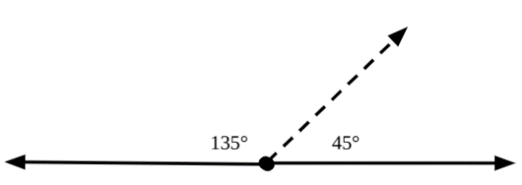

* Instruction includes matching equations with given angle images containing angle measures. Students explain the equations and how they know they match the image selected.
  + For example, when provided images similar to those shown below, students match the equation from a list of equations provided and explain how they know the equation matches.

|  |  |
| --- | --- |
|  |  |
| illustration of example above. | illustration of example above. |

* The teacher provides images that contain missing angle measures. Students identify straight angles in the image and use their understanding that straight angles measure 180-degrees to help them find the missing angle measure.
  + For example, when provided with the image below, students highlight or trace over the straight angle and label as 180-degrees. Students then write an equation using this information and the angle measure provided to help them solve for the unknown angle.

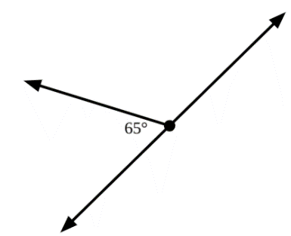

* Instruction includes identifying straight angles as measuring 180-degrees.
  + For example, when provided images similar to the one shown below, students highlight straight angles and label them as 180-degrees. In this example, students identify both straight angles, highlighting them with different colors and explain that both have a measure of 180-degrees.

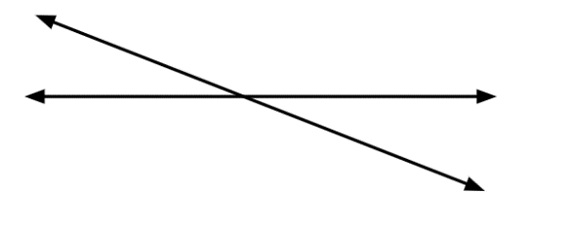

Instructional Tasks

*Instructional Task 1*

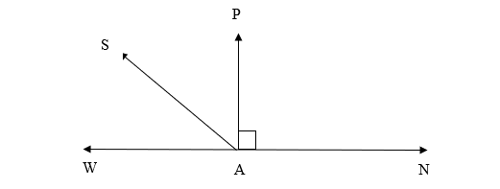

If $∠$ WAS and $∠$ SAP are equal, what would the measure of each of the angles be?

*Enrichment Task 1*

Two straight lines, $AC$ and $BD$, intersect at point $E$. Using the given angle $∠AEB$, find the measure of the other 3 angles.

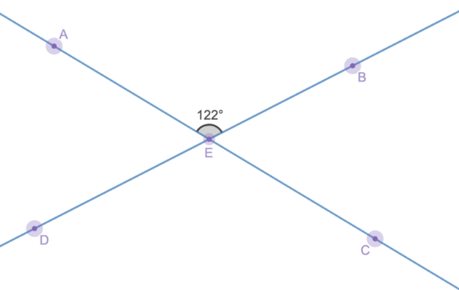

Instructional Items

*Instructional Item 1*

Carlos is adding angles together to create a $150°$ angle. Select all the angle measures that Carlos can use to create a $150°$ angle.

$50° +100°$

$45° +95°$

$50° +90°$

$50° +20° +20°$

$50° +50° +50°$

*Enrichment Item 1*

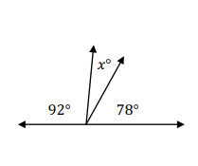

Part A: Determine the missing angle.

Part B: Write an equation that can be used to represent the unknown angle.

*The strategies, tasks and items included in the B1G-M are examples and should not be considered comprehensive.

## ***MA.4.GR.2*** *Solve problems involving the perimeter and area of rectangles*

### MA.4.GR.2.1

### See Benchmark MA.3.GR.2.3

### MA.4.GR.2.2

Benchmark

MA.4.GR.2.2 Solve problems involving rectangles with the same perimeter and different areas or with the same area and different perimeters.

*Example:* Possible dimensions of a rectangle with an area of 24 square feet include 6 feet by 4 feet or 8 feet by 3 feet. This can be found by cutting a rectangle into unit squares and rearranging them

Benchmark Clarifications:

*Clarification 1:* Instruction extends the development of algebraic thinking where the symbolic representation of the unknown uses a letter.

*Clarification 2:* Problems involving multiplication are limited to products of up to 3 digits by 2 digits. Problems involving division are limited to up to 4 digits divided by 1 digit.

*Clarification 3:* Responses include the appropriate units in word form.

Connecting Benchmarks/Horizontal Alignment

* MA.4.NSO.2.2
* MA.4.NSO.2.3
* MA.4.NSO.2.4
* MA.4.NSO.2.5
* MA.4.AR.1.1

Terms from the K-12 Glossary

* Perimeter

Vertical Alignment

|  |  |
| --- | --- |
| **Previous Benchmarks**   * MA.3.GR.2.3 | **Next Benchmarks**   * MA.5.GR.2.1 |

Purpose and Instructional Strategies

The purpose of this benchmark is for students to understand the relationship between perimeter and area. Students will explore situations where the multiple figures have the same area and different perimeters and same perimeters and different areas during the Grade 3 Accelerated course. This benchmark supports the perimeter and area work in MA.3.GR.2.3 and MA.4.GR.2.1.

* Instruction will help students begin to generalize that when working with rectangles with the same area, squares will have the smallest perimeter and the longer one side is, the greater the perimeter is going to be.

Common Misconceptions or Errors

* Students may believe that a rectangle with a large perimeter must also have a large area.

Strategies to Support Tiered Instruction

* Instruction includes comparing figures with the same perimeter but different areas and the same area but different perimeters.
  + For example, students find the area and perimeter for figures created using grid paper making the connection that not all figures with a large perimeter have a large area.

|  |  |
| --- | --- |
| Perimeter = 15 + 15 + 10 + 10 = 50 units  Area = 15 x 10 = 150 square units | Perimeter = 20 + 20 + 5 + 5 = 50 units  Area = 20 x 5 = 100 square units |
| Illustration for example above. | Illustration for example above. |

* Instruction includes providing several square tiles that can be arranged to make rectangular figures in many ways. Students build figures with the same area and calculate the perimeter.
  + For example, students use 36 tiles to make a figure that is 2 tiles by 18 tiles. They would calculate Area = $2 × 18 =36$ square units, and then calculate Perimeter = $2 + 2 + 18 + 18 = 40$ units. Students would then rearrange the tiles to create a rectangle that is 6 tiles by 6 tiles. They would calculate the Area $=6×6=$ 26 square units, and Perimeter as $6 + 6 + 6 + 6 = 24$ units. Students compare the area and perimeter of both figures and make the connection that the area of a figure does not determine the perimeter.

Instructional Tasks

*Instructional Task 1*

Steve has 600 feet of fencing. He is trying to figure out how to build his fence so that he has a rectangle with the greatest square footage inside the fence.

Part A: What are the dimensions of the fence he can build with the greatest area inside?

Part B: What is the area inside his fence.

*Enrichment Task 1*

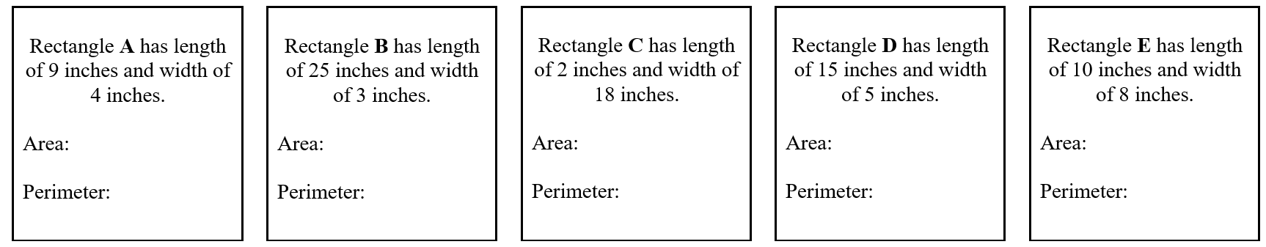Have students calculate the area and perimeter for each of the rectangles described on the cards below.

Part A: Have students order the rectangles based on their area, from least to greatest. Ask: What do you notice about the rectangles with the greatest areas?

Part B: Next, have students order the rectangles based on their perimeters. Ask: What do you notice about the rectangles with the greatest perimeters? How is this similar to the rectangles with the greatest areas.

Instructional Items

*Instructional Item 1*

Skylar built a rectangular table for her doll house. The area of the table is 105 square inches and the side lengths are whole-number inches. What are some possible perimeters of the table?

1. 26 inches
2. 44 inches
3. 52 inches
4. 76 inches
5. 210 inches

*Instructional Item 2*

Three rectangles are shown below.

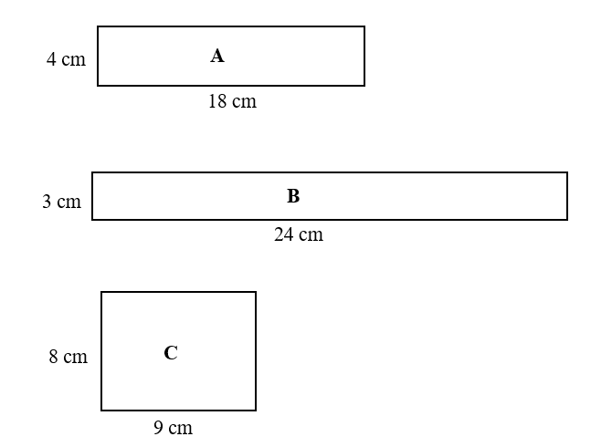

Which statements correctly describes the area and perimeter of the rectangles?

1. All of the rectangles have the same perimeters and different areas.
2. Figure A has the least perimeter because it has the shortest side length.
3. Figure B has the greatest perimeter because it has the shortest side length.
4. All of the rectangles have the same areas and different perimeters.
5. Figure B has the greatest perimeter because it has the longest length.

*The strategies, tasks and items included in the B1G-M are examples and should not be considered comprehensive.

## **Data Analysis & Probability**

**MA. 3.DP.1** *Collect, represent and interpret numerical and categorical data.*

### **MA.3.DP.1.1**

Benchmark

MA.3.DP.1.1 Collect and represent numerical and categorical data with whole-number values using tables, scaled pictographs, scaled bar graphs or line plots. Use appropriate titles, labels and units

Benchmark Clarifications:

*Clarification 1:* Within this benchmark, the expectation is to complete a representation or construct a representation from a data set.

*Clarification 2:* Instruction includes the connection between multiplication and the number of data points represented by a bar in scaled bar graph or a scaled column in a pictograph.

*Clarification 3:* Data displays are represented both horizontally and vertically.

Connecting Benchmarks/Horizontal Alignment

* MA.3.NSO.2.2/2.4
* MA.3.GR.1.1

Terms from the K-12 Glossary

* Bar Graph
* Categorical Data
* Whole Number

Vertical Alignment

|  |  |
| --- | --- |
| **Previous Benchmarks**   * MA.2.DP.1.1 | **Next Benchmarks**   * MA.4.DP.1.1 |

Purpose and Instructional Strategies

The purpose of this benchmark is for students to represent numerical and categorical data using tables, scaled pictographs, scaled bar graphs or line plots, using appropriate titles, tables and units. Though there are many skills included in this benchmark, students bring background knowledge from Grades 1 and 2 when they collected, categorized and represented data in tables, pictographs and bar graphs. In Grade 2, students were expected to represent data with appropriate titles, labels and units.

* Before instruction begins, teachers can provide students with opportunities of reading and solving problems using scaled graphs before being asked to draw one. These skills will assist students with determining what they already know. This will save instructional time that can be focused on the Grade 3 extensions explained in the next paragraph *(MTR.3.1)*.
* Instruction may include opportunities for students to collect and display their own numerical and categorical data *(MTR.7.1)*.
* In Grade 3, two extensions of previous understandings about collecting and representing data occur. First, categorical data represented in pictographs and bar graphs are scaled. Students use their understanding of multiplication to read the data representations appropriately. Second, students represent numerical data in line plots, which shows the frequency of data on a number line *(MTR.2.1)*.
* During instruction, it is important to remind students that scales on graphs begin with 0.
* Because the expectation is to represent data with whole-number values, number lines do not need to be partitioned into fractional parts. Students will represent fractional values beginning in Grade 4.
* During instruction, it is important that students have the opportunity to display data horizontally and vertically. Their work with MA.3.GR.1.1 will be beneficial in making graphs that are accurate representations.

Common Misconceptions or Errors

* Students may confuse which types of data (categorical or numerical) can be displayed with a data representation. In Grades 1 and 2, students graphed frequency of categorical data in pictographs and bar graphs. Representing frequency in numerical data graphed via line plots is a new expectation in Grade 3. During instruction, expect students to justify the representations they choose based on the data collected.
* Students tend to count each square as one for intervals on bar graphs that are not single units.

Strategies to Support Tiered Instruction

* Instruction includes how to decide which way to display data (numerical vs. categorical).

The teacher provides examples of when to use pictographs and bar graphs, and when to use line plots.

* + For example, students measure the lengths of pencils to the nearest $\frac{1}{2}$ inch. Because the students are finding a numerical measurement, this data would be graphed on a line plot.
* Instruction includes how to decide which way to display their data (numerical vs. categorical). The teacher provides examples of when to use pictographs and bar graphs, and when to use a line plot. Also, the teacher provides instruction regarding how numerical data refers to data that is in the form of numbers and categorical data is a type of data that is divided into groups.
  + For example, categorical data could be favorite colors, types of pets at home or hair color. Types of numerical data could be ages of students, numbers of siblings at home or the results of the measurement of objects.
* Instruction includes opportunities to count the correct intervals on a scaled bar graph. The teacher provides instruction for identifying the scale and showing students how to read the bars according to the scale.

Instructional Tasks

*Instructional Task 1*

The data below shows the ages of students in an art class and their favorite colors.

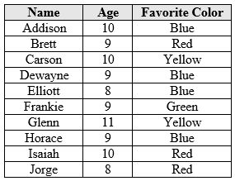

Part A. Represent the ages of the students in the art class using a line plot.

Part B. Represent the favorite colors of the students in an art class using a scaled pictograph.

*Instructional Task 2*

Survey your classmates about their favorite color. Collect the data in a table and represent your data in a pictograph, bar graph or line plot.

Instructional Items

*Instructional Item 1*

Rebecca surveyed the ages of kids visiting a movie theater and displayed the data using a line plot. The customers’ ages are below. Which line plot correctly displays the data that Rebecca collected?

5, 11, 9, 5, 6, 5, 9, 9, 8, 10, 6, 11, 9, 5

**Ages of Kids Visiting a Movie Theater**

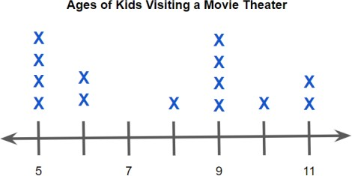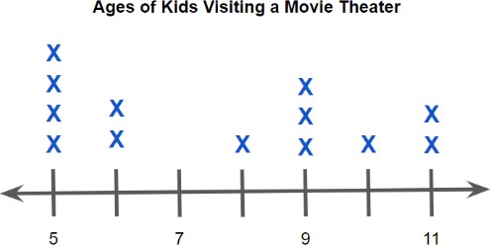

A.

C.

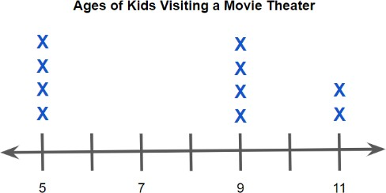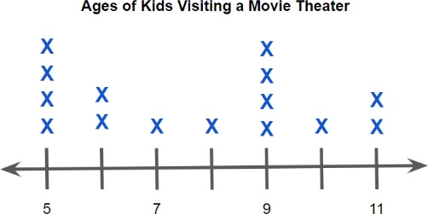

B. D.

*Instructional Item 2*

Matthew surveyed his classmates' favorite animals and displayed the data using a pictograph. The favorite animals are displayed below. Which pictograph correctly displays the data Matthew collected?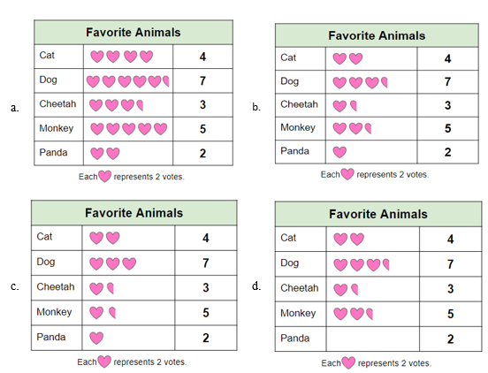

*The strategies, tasks and items included in the B1G-M are examples and should not be considered comprehensive.

### MA.3.DP.1.2

Benchmark

MA.3.DP.1.2 Interpret data with whole-number values represented with tables, scaled pictographs, circle graphs, scaled bar graphs or line plots by solving one- and two-step problems

Benchmark Clarifications:

*Clarification 1:* Problems include the use of data in informal comparisons between two data sets in the same units.

*Clarification 2:* Data displays can be represented both horizontally and vertically.

*Clarification 3:* Circle graphs are limited to showing the total values in each category.

Connecting Benchmarks/Horizontal Alignment

* MA.3.NSO.2.2/2.4

Terms from the K-12 Glossary

* Bar Graph
* Categorical Data
* Circle Graph
* Whole Number

Vertical Alignment

|  |  |
| --- | --- |
| **Previous Benchmarks**   * MA.2.DP.1.2 | **Next Benchmarks**   * MA.4.DP.1.3 |

Purpose and Instructional Strategies

The purpose of this benchmark is for students to interpret data displayed in scaled pictographs, circle graphs, scaled bar graphs and line plots. Like MA.3.DP.1.1, the purpose of this benchmark builds on data interpretation skills from Grades 1 and 2. In Grade 1, students interpreted data represented with tally marks and pictographs, and in Grade 2, students also interpreted data represented in pictographs and bar graphs. Additionally, students solved addition and subtraction problems using the data representations.

* In Grade 3, students will interpret categorical data represented in scaled pictographs and bar graphs, whole-number numerical data represented in line plots, and whole-number category totals in circle graphs (e.g., instead of percentages). To interpret the represented data, they will solve one- and two-step problems from a given data set or compare two data sets in the same units *(MTR.5.1)*.
* Instruction can include opportunities for students to interpret their own numerical and categorical data *(MTR.7.1)*.
* Students could use addition, subtraction, multiplication or division to solve the problems. This benchmark is most often taught with MA.3.DP.1.1 (collecting and representing data) *(MTR.2.1, MTR.4.1, MTR.5.1*).

Common Misconceptions or Errors

* Students may confuse the values in scaled pictographs and bar graphs. Utilizing a given key when determining frequency of each category will help build this skill.

Strategies to Support Tiered Instruction

* Instruction includes opportunities to determine the values in a scaled pictograph, pointing

out the importance of paying close attention to the key of the pictograph. The key outlines how much each of the pictures on the graph will represent. Students connect multiplication strategies to this concept. Instruction includes opportunities to practice counting by 2s, 5s and 10s, to be successful with this benchmark. To help students see the connection between the key and what each picture represents, a bar diagram may be helpful.

* + Instruction includes opportunities to determine the values in a scaled pictograph, pointing out the importance of paying close attention to the key of the pictograph. The key outlines how much each of the pictures on the graph will represent. Students connect multiplication strategies to this concept. Instruction includes opportunities to practice counting by 2s, 5s and 10s, to be successful with this benchmark. To help students see the connection between the key and what each picture represents, a bar diagram may be helpful.

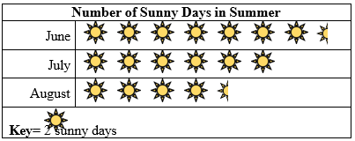

* + 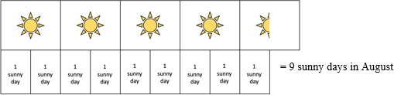For example, students use the key for the pictograph and a bar model to determine the number of sunny days in August.

Instructional Tasks

*Instructional Task 1 (MTR.4.1, MTR.8.1)*

The pictographs show favorite subjects in Grade 3 and Grade 4 at Palm Elementary School.

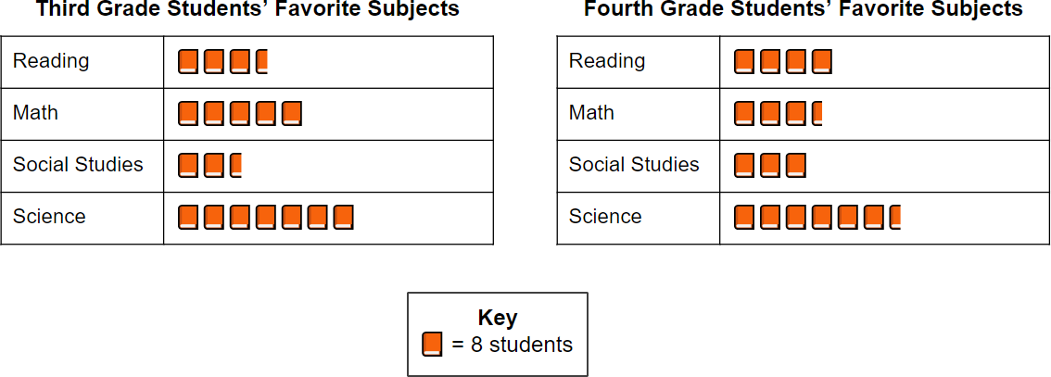

Part A. Write an equation that shows how many fourth graders chose reading as their favorite subject.

Part B. How many third graders chose social studies as their favorite subject?

Part C. How many more students prefer math in Grade 3 than Grade 4?

*Instructional Task 2*

Grade 3 students at Sunshine Elementary were surveyed after their class party to see how many donuts they ate. The results are shown in the line plot below.

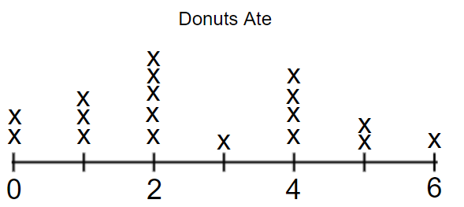

Part A. How many total donuts did the class eat?

Part B. How many students ate less than 3 donuts?

*Enrichment Task 1*

750 students at Palm Elementary School voted for their favorite Fine Arts program. The

graph below shows all the data, except the number that voted for Music.

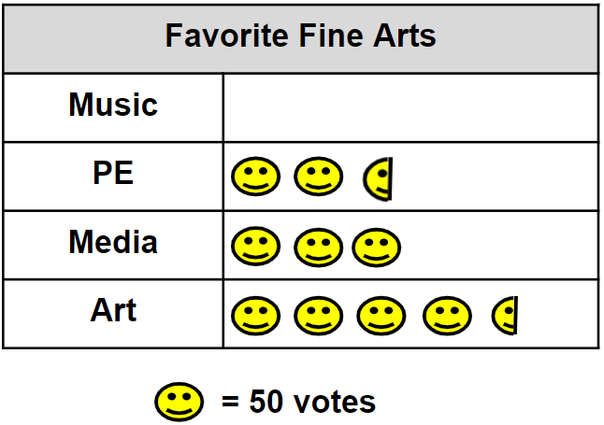

Part A: Write and solve an equation to show how many students voted for each of the Fine Arts Shown.

Part B: Write and solve an equation to determine how many votes are missing for Music.

Part C: Draw in the missing images for Music.

Part D: Write three questions that could be asked based on the data.

Instructional Items

Instructional Item 1

John surveys his classmates about their favorite foods, as shown in the bar graph. How many more classmates chose pizza as their favorite food than classmates who chose salad?

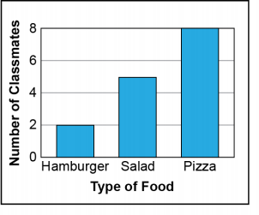

Instructional Item 2

Molly surveys her class about their favorite ice cream flavors, as shown in the circle graph. How many students picked a favorite ice cream flavor other than vanilla?

Mint - 7 students



Vanilla - 11 students

Strawberry - 4 students

Chocolate - 8 students

Instructional Item 3

Andre surveys students in Grade 4 about their favorite types of shoes, as shown in the pictograph. How many more people like sneakers more than flip flops?

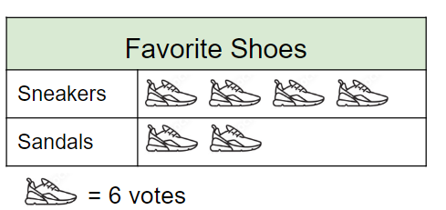

*The strategies, tasks and items included in the B1G-M are examples and should not be considered comprehensive.