# Grade 3 B.E.S.T. Instructional Guide for Mathematics

The B.E.S.T. Instructional Guide for Mathematics (B1G-M) is intended to assist educators with planning for student learning and instruction aligned to Florida’s Benchmarks for Excellent Student Thinking (B.E.S.T.) Standards. This guide is designed to aid high-quality instruction through the identification of components that support the learning and teaching of the B.E.S.T. Mathematics Standards and Benchmarks. The B1G-M includes an analysis of information related to the B.E.S.T. Standards for Mathematics within this specific mathematics course, the instructional emphasis and aligned resources. This document is posted on the [B.E.S.T. Standards for Mathematics webpage](https://www.fldoe.org/academics/standards/subject-areas/math-science/mathematics/bestmath.stml) of the Florida Department of Education’s website and will continue to undergo edits as needed.

## Structural Framework and Intentional Design of the B.E.S.T. Standards for Mathematics

Florida’s B.E.S.T. Standards for Mathematics were built on the following.

* The coding scheme for the standards and benchmarks was changed to be consistent with other content areas. The new coding scheme is structured as follows:

Content.GradeLevel.Strand.Standard.Benchmark.

* Strands were streamlined to be more consistent throughout.
* The standards and benchmarks were written to be clear and concise to ensure that they are easily understood by all stakeholders.
* The benchmarks were written to allow teachers to meet students’ individual skills, knowledge and ability.
* The benchmarks were written to allow students the flexibility to solve problems using a method or strategy that is accurate, generalizable and efficient depending on the content (i.e., the numbers, expressions or equations).
* The benchmarks were written to allow for student discovery (i.e., exploring) of strategies rather than the teaching, naming and assessing of each strategy individually.
* The benchmarks were written to support multiple pathways for success in career and college for students.
* The benchmarks should not be taught in isolation but should be combined purposefully.
* The benchmarks may be addressed at multiple points throughout the year, with the intention of gaining mastery by the end of the year.
* Appropriate progression of content within and across strands was developed for each grade level and across grade levels.
* There is an intentional balance of conceptual understanding and procedural fluency with the application of accurate real-world context intertwined within mathematical concepts for relevance.
* The use of other content areas, like science and the arts, within real-world problems should be accurate, relevant, authentic and reflect grade-level appropriateness.

## Components of the B.E.S.T. Instructional Guide for Mathematics

The following table is an example of the layout for each benchmark and includes the defining attributes for each component. It is important to note that instruction should not be limited to the possible connecting benchmarks, related terms, strategies or examples provided. To do so would strip the intention of an educator meeting students’ individual skills, knowledge and abilities.

Benchmark

focal point for instruction within lesson or task

This section includes the benchmark as identified in the [B.E.S.T. Standards for Mathematics](https://www.cpalms.org/uploads/docs/standards/BEST/MA/MathBESTStandardsFinal.pdf). The benchmark, also referred to as the Benchmark of Focus, is the focal point for student learning and instruction. The benchmark, and its related example(s) and clarification(s), can also be found in the course description. The 9-12 benchmarks may be included in multiple courses; select the example(s) or clarification(s) as appropriate for the identified course.

Connecting Benchmarks/Horizontal Alignment

in other standards within the grade level or course

This section includes a list of connecting benchmarks that relate horizontally to the Benchmark of Focus. Horizontal alignment is the intentional progression of content within a grade level or course linking skills within and across strands. Connecting benchmarks are benchmarks that either make a mathematical connection or include prerequisite skills. The information included in this section is not a comprehensive list, and educators are encouraged to find other connecting benchmarks. Additionally, this list will not include benchmarks from the same standard since benchmarks within the same standard already have an inherent connection.

Terms from the K-12 Glossary

This section includes terms from Appendix C: K-12 Glossary, found within the B.E.S.T. Standards for Mathematics document, which are relevant to the identified Benchmark of Focus. The terms included in this section should not be viewed as a comprehensive vocabulary list, but instead should be considered during instruction or act as a reference for educators.

Vertical Alignment

across grade levels or courses

This section includes a list of related benchmarks that connect vertically to the Benchmark of Focus. Vertical alignment is the intentional progression of content from one year to the next, spanning across multiple grade levels. Benchmarks listed in this section make mathematical connections from prior grade levels or courses in future grade levels or courses within and across strands. If the Benchmark of Focus is a new concept or skill, it may not have any previous benchmarks listed. Likewise, if the Benchmark of Focus is a mathematical skill or concept that is finalized in learning and does not have any direct connection to future grade levels or courses, it may not have any future benchmarks listed. The information included in this section is not a comprehensive list, and educators are encouraged to find other benchmarks within a vertical progression.

Purpose and Instructional Strategies

This section includes further narrative for instruction of the benchmark and vertical alignment. Additionally, this section may also include the following:

* explanations and details for the benchmark;
* vocabulary not provided within Appendix C;
* possible instructional strategies and teaching methods; and
* strategies to embed potentially related Mathematical Thinking and Reasoning Standards (MTRs).

Common Misconceptions or Errors

This section will include common student misconceptions or errors and may include strategies to address the identified misconception or error. Recognition of these misconceptions and errors enables educators to identify them in the classroom and make efforts to correct the misconception or error. This corrective effort in the classroom can also be a form of formative assessment within instruction.

**Strategies** to Support Tiered Instruction

The instructional strategies in this section address the common misconceptions and errors listed within the above section that can be a barrier to successfully learning the benchmark. All instruction and intervention at Tiers 2 and 3 are intended to support students to be successful with Tier 1 instruction. Strategies that support tiered instruction are intended to assist teachers in planning across any tier of support and should not be considered exclusive or inclusive of other instructional strategies that may support student learning with the B.E.S.T. Mathematics Standards. For more information about tiered instruction, please see the Effective Tiered Instruction for Mathematics: ALL Means ALL document.

Instructional Tasks

demonstrate the depth of the benchmark and the connection to the related benchmarks

This section will include example instructional tasks, which may be open-ended and are intended to demonstrate the depth of the benchmark. Some instructional tasks include integration of the Mathematical Thinking and Reasoning Standards (MTRs) and related benchmark(s). Enrichment tasks may be included to make connections to benchmarks in later grade levels or courses. Tasks may require extended time, additional materials and collaboration.

Instructional Items

demonstrate the focus of the benchmark

This section will include example instructional items which may be used as evidence to demonstrate the students’ understanding of the benchmark. Items may highlight one or more parts of the benchmark.

*The strategies, tasks and items included in the B1G-M are examples and should not be considered comprehensive.

# Mathematical Thinking and Reasoning Standards

MTRs: Because Math Matters

Florida students are expected to engage with mathematics through the Mathematical Thinking and Reasoning Standards (MTRs) by utilizing their language as a self-monitoring tool in the classroom, promoting deeper learning and understanding of mathematics. The MTRs are standards which should be used as a lens when planning for student learning and instruction of the B.E.S.T. Standards for Mathematics.

## Structural Framework and Intentional Design of the Mathematical Thinking and Reasoning Standards

The Mathematical Thinking and Reasoning Standards (MTRs) are built on the following.

* The MTRs have the same coding scheme as the standards and benchmarks; however, they are written at the standard level because there are no benchmarks.
* In order to fulfill Florida’s unique coding scheme, the 5th place (benchmark) will always be a “1” for the MTRs.
* The B.E.S.T. Standards for Mathematics should be taught through the lens of the MTRs.
* At least one of the MTRs should be authentically and appropriately embedded throughout every lesson based on the expectation of the benchmark(s).
* The bulleted language of the MTRs were written for students to use as self-monitoring tools during daily instruction.
* The clarifications of the MTRs were written for teachers to use as a guide to inform their instructional practices.
* The MTRs ensure that students stay engaged, persevere in tasks, share their thinking, balance conceptual understanding and procedures, assess their solutions, make connections to previous learning and extended knowledge, and apply mathematical concepts to real-world applications.
* The MTRs should not stand alone as a separate focus for instruction but should be combined purposefully.
* The MTRs will be addressed at multiple points throughout the year, with the intention of gaining mastery of mathematical skills by the end of the year and building upon these skills as they continue in their K-12 education.

MA.K12.MTR.1.1 Actively participate in effortful learning both individually and collectively.

Mathematicians who participate in effortful learning both individually and with others:

* Analyze the problem in a way that makes sense given the task.
* Ask questions that will help with solving the task.
* Build perseverance by modifying methods as needed while solving a challenging task.
* Stay engaged and maintain a positive mindset when working to solve tasks.
* Help and support each other when attempting a new method or approach.

Clarifications:

Teachers who encourage students to participate actively in effortful learning both individually and with others:

* Cultivate a community of growth mindset learners.
* Foster perseverance in students by choosing tasks that are challenging.
* Develop students’ ability to analyze and problem solve.
* Recognize students’ effort when solving challenging problems.

MA.K12.MTR.2.1 Demonstrate understanding by representing problems in multiple ways.

Mathematicians who demonstrate understanding by representing problems in multiple ways:

* Build understanding through modeling and using manipulatives.
* Represent solutions to problems in multiple ways using objects, drawings, tables, graphs and equations.
* Progress from modeling problems with objects and drawings to using algorithms and equations.
* Express connections between concepts and representations.
* Choose a representation based on the given context or purpose.

Clarifications:

Teachers who encourage students to demonstrate understanding by representing problems in multiple ways:

* Help students make connections between concepts and representations.
* Provide opportunities for students to use manipulatives when investigating concepts.
* Guide students from concrete to pictorial to abstract representations as understanding progresses.
* Show students that various representations can have different purposes and can be useful in different situations.

MA.K12.MTR. 3.1 Complete tasks with mathematical fluency.

Mathematicians who complete tasks with mathematical fluency:

* Select efficient and appropriate methods for solving problems within the given context.
* Maintain flexibility and accuracy while performing procedures and mental calculations.
* Complete tasks accurately and with confidence.
* Adapt procedures to apply them to a new context.
* Use feedback to improve efficiency when performing calculations.

Clarifications:

Teachers who encourage students to complete tasks with mathematical fluency:

* Provide students with the flexibility to solve problems by selecting a procedure that allows them to solve efficiently and accurately.
* Offer multiple opportunities for students to practice efficient and generalizable methods.
* Provide opportunities for students to reflect on the method they used and determine if a more efficient method could have been used.

MA.K12.MTR.4.1 Engage in discussions that reflect on the mathematical thinking of self and others.

Mathematicians who engage in discussions that reflect on the mathematical thinking of self and others:

* Communicate mathematical ideas, vocabulary and methods effectively.
* Analyze the mathematical thinking of others.
* Compare the efficiency of a method to those expressed by others.
* Recognize errors and suggest how to correctly solve the task.
* Justify results by explaining methods and processes.
* Construct possible arguments based on evidence.

Clarifications:

Teachers who encourage students to engage in discussions that reflect on the mathematical thinking of self and others:

* Establish a culture in which students ask questions of the teacher and their peers, and error is an opportunity for learning.
* Create opportunities for students to discuss their thinking with peers.
* Select, sequence and present student work to advance and deepen understanding of correct and increasingly efficient methods.
* Develop students’ ability to justify methods and compare their responses to the responses of their peers.

MA.K12.MTR.5.1 Use patterns and structure to help understand and connect mathematical concepts.

Mathematicians who use patterns and structure to help understand and connect mathematical concepts:

* Focus on relevant details within a problem.
* Create plans and procedures to logically order events, steps or ideas to solve problems.
* Decompose a complex problem into manageable parts.
* Relate previously learned concepts to new concepts.
* Look for similarities among problems.
* Connect solutions of problems to more complicated large-scale situations.

Clarifications:

Teachers who encourage students to use patterns and structure to help understand and connect mathematical concepts:

* Help students recognize the patterns in the world around them and connect these patterns to mathematical concepts.
* Support students to develop generalizations based on the similarities found among problems.
* Provide opportunities for students to create plans and procedures to solve problems.
* Develop students’ ability to construct relationships between their current understanding and more sophisticated ways of thinking.

MA.K12.MTR.6.1 Assess the reasonableness of solutions.

Mathematicians who assess the reasonableness of solutions:

* Estimate to discover possible solutions.
* Use benchmark quantities to determine if a solution makes sense.
* Check calculations when solving problems.
* Verify possible solutions by explaining the methods used.
* Evaluate results based on the given context.

Clarifications:

Teachers who encourage students to assess the reasonableness of solutions:

* Have students estimate or predict solutions prior to solving.
* Prompt students to continually ask, “Does this solution make sense? How do you know?”
* Reinforce that students check their work as they progress within and after a task.
* Strengthen students’ ability to verify solutions through justifications.

MA.K12.MTR.7.1 Apply mathematics to real-world contexts.

Mathematicians who apply mathematics to real-world contexts:

* Connect mathematical concepts to everyday experiences.
* Use models and methods to understand, represent and solve problems.
* Perform investigations to gather data or determine if a method is appropriate.
* Redesign models and methods to improve accuracy or efficiency.

Clarifications:

Teachers who encourage students to apply mathematics to real-world contexts:

* Provide opportunities for students to create models, both concrete and abstract, and perform investigations.
* Challenge students to question the accuracy of their models and methods.
* Support students as they validate conclusions by comparing them to the given situation.
* Indicate how various concepts can be applied to other disciplines.

## Examples of Teacher and Student Moves for the MTRs

Below are examples that demonstrate the embedding of the MTRs within the mathematics classroom. The provided teacher and student moves are examples of how some MTRs could be incorporated into student learning and instruction. The information included in this table is not a comprehensive list, and educators are encouraged to incorporate other teacher and student moves that support the MTRs.

| **MTR** | **Student Moves** | **Teacher Moves** |
| --- | --- | --- |
| MA.K12.MTR.1.1  *Actively participate in effortful learning both individually and collectively.* | * Students engage in the task through individual analysis, student-to-teacher interaction and student-to-student interaction. * Students ask task-appropriate questions to self, the teacher and to other students. *(MTR.4.1)* * Students have a positive productive struggle exhibiting growth mindset, even when making a mistake. * Students stay engaged in the task to a purposeful conclusion while modifying methods, when necessary, in solving a problem through self-analysis and perseverance. | * Teacher provides flexible options (i.e., differentiated, challenging tasks that allow students to actively pursue a solution both individually and in groups) so that all students have the opportunity to access and engage with instruction, as well as demonstrate their learning. * Teacher creates a physical environment that supports a growth mindset and will ensure positive student engagement and collaboration. * Teacher provides constructive, encouraging feedback to students that recognizes their efforts and the value of analysis and revision. * Teacher provides appropriate time for student processing, productive struggle and reflection. * Teacher uses data and questions to focus students on their thinking; help students determine their sources of struggle and to build understanding. * Teacher encourages students to ask appropriate questions of other students and of the teacher including questions that examine accuracy. *(MTR.4.1)* |
| MA.K12.MTR.2.1  *Demonstrate understanding by representing problems in multiple ways.* | * Students represent problems concretely using objects, models and manipulatives. * Students represent problems pictorially using drawings, models, tables and graphs. * Students represent problems abstractly using numerical or algebraic expressions and equations. * Students make connections and select among different representations and methods for the same problem, as appropriate to different situations or context. *(MTR.3.1)* | * Teacher provides students with objects, models, manipulatives, appropriate technology and real-world situations. *(MTR.7.1)* * Teacher encourages students to use drawings, models, tables, expressions, equations and graphs to represent problems and solutions. * Teacher questions students about making connections between different representations and methods and challenges students to choose one that is most appropriate to the context. *(MTR.3.1)* * Teacher encourages students to explain their different representations and methods to each other. *(MTR.4.1)* * Teacher provides opportunities for students to choose appropriate methods and to use mathematical technology. |
| MA.K12.MTR.3.1  *Complete tasks with mathematical fluency.* | * Students complete tasks with flexibility, efficiency and accuracy. * Students use feedback from peers and teachers to reflect on and revise methods used. * Students build confidence through practice in a variety of contexts and problems. *(MTR.1.1)* | * Teacher provides tasks and opportunities to explore and share different methods to solve problems. *(MTR.1.1)* * Teacher provides opportunities for students to choose methods and reflect (i.e., through error analysis, revision, summarizing methods or writing) on the efficiency and accuracy of the method(s) chosen. * Teacher asks questions and gives feedback to focus student thinking to build efficiency of accurate methods. * Teacher offers multiple opportunities to practice generalizable methods. |
| MA.K12.MTR.4.1  *Engage in discussions that reflect on the mathematical thinking of self and others.* | * Students use content specific language to communicate and justify mathematical ideas and chosen methods. * Students use discussions and reflections to recognize errors and revise their thinking. * Students use discussions to analyze the mathematical thinking of others. * Students identify errors within their own work and then determine possible reasons and potential corrections. * When working in small groups, students recognize errors of their peers and offers suggestions. | * Teacher provides students with opportunities (through open-ended tasks, questions and class structure) to make sense of their thinking. *(MTR.1.1)* * Teacher uses precise mathematical language, both written and abstract, and encourages students to revise their language through discussion. * Teacher creates opportunities for students to discuss and reflect on their choice of methods, their errors and revisions and their justifications. * Teachers select, sequence and present student work to elicit discussion about different methods and representations. *(MTR.2.1, MTR.3.1)* |
| MA.K12.MTR.5.1 *Use patterns and structure to help understand and connect mathematical concepts.* | * Students identify relevant details in a problem in order to create plans and decompose problems into manageable parts. * Students find similarities and common structures, or patterns, between problems in order to solve related and more complex problems using prior knowledge. | * Teacher asks questions to help students construct relationships between familiar and unfamiliar problems and to transfer this relationship to solve other problems. *(MTR.1.1)* * Teacher provides students opportunities to connect prior and current understanding to new concepts. * Teacher provides opportunities for students to discuss and develop generalizations about a mathematical concept. *(MTR.3.1, MTR.4.1)* * Teacher allows students to develop an appropriate sequence of steps in solving problems. * Teacher provides opportunities for students to reflect during problem solving to make connections to problems in other contexts, noticing structure and making improvements to their process. |
| MA.K12.MTR.6.1 *Assess the reasonableness of solutions.* | * Students estimate a solution, including using benchmark quantities in place of the original numbers in a problem. * Students monitor calculations, procedures and intermediate results during the process of solving problems. * Students verify and check if solutions are viable, or reasonable, within the context or situation. *(MTR.7.1)* * Students reflect on the accuracy of their estimations and their solutions. | * Teacher provides opportunities for students to estimate or predict solutions prior to solving. * Teacher encourages students to compare results to estimations and revise if necessary for future situations. *(MTR.5.1)* * Teacher prompts students to self-monitor by continually asking, “Does this solution or intermediate result make sense? How do you know?” * Teacher encourages students to provide explanations and justifications for results to self and others. *(MTR.4.1)* |
| MA.K12.MTR.7.1 *Apply mathematics to real-world contexts.* | * Students connect mathematical concepts to everyday experiences. * Students use mathematical models and methods to understand, represent and solve real-world problems. * Students investigate, research and gather data to determine if a mathematical model is appropriate for a given situation from the world around them. * Students re-design models and methods to improve accuracy or efficiency. | * Teacher provides real-world context to help students build understanding of abstract mathematical ideas. * Teacher encourages students to assess the validity and accuracy of mathematical models and situations in real-world context, and to revise those models if necessary. * Teacher provides opportunities for students to investigate, research and gather data to determine if a mathematical model is appropriate for a given situation from the world around them. * Teacher provides opportunities for students to apply concepts to other content areas. |

# Grade 3 Areas of Emphasis

In grade 3, instructional time will emphasize four areas:

1. adding and subtracting multi-digit whole numbers, including using a standard algorithm;
2. building an understanding of multiplication and division, the relationship between them and the connection to area of rectangles;
3. developing an understanding of fractions; and
4. extending geometric reasoning to lines and attributes of quadrilaterals.

The purpose of the areas of emphasis is not to guide specific units of learning and instruction, but rather provide insight on major mathematical topics that will be covered within this mathematics course. In addition to its purpose, the areas of emphasis are built on the following:

* Supports the intentional horizontal progression within the strands and across the strands in this grade level or course.
* Student learning and instruction should not focus on the stated areas of emphasis as individual units.
* Areas of emphasis are addressed within standards and benchmarks throughout the course so that students are making connections throughout the school year.
* Some benchmarks can be organized within more than one area.
* Supports the communication of the major mathematical topics to all stakeholders.
* Benchmarks within the areas of emphasis should not be taught within the order in which they appear. To do so would strip the progression of mathematical ideas and miss the opportunity to enhance horizontal progressions within the grade level or course.

The table below shows how the benchmarks within this mathematics course are embedded within the areas of emphasis.

| **Number Sense and Operations** | **Addition and Subtraction Fluency** | **Building Understanding of Multiplication and Division** | **Building Understanding of Fractions** | **Geometric Reasoning with Lines and Quadrilaterals** |
| --- | --- | --- | --- | --- |
| MA.3.NSO.1.1 | X |  |  |  |
| MA.3.NSO.1.2 | X |  |  |  |
| MA.3.NSO.1.3 | X |  |  |  |
| MA.3.NSO.1.4 | X |  |  |  |
| MA.3.NSO.2.1 | X | X |  |  |
| MA.3.NSO.2.2 |  | X |  |  |
| MA.3.NSO.2.3 |  | X |  |  |
| MA.3.NSO.2.4 |  | X |  |  |

| **Fractions** | **Addition and Subtraction Fluency** | **Building Understanding of Multiplication and Division** | **Building Understanding of Fractions** | **Geometric Reasoning with Lines and Quadrilaterals** |
| --- | --- | --- | --- | --- |
| MA.3.FR.1.1 |  |  | X |  |
| MA.3.FR.1.2 |  |  | X |  |
| MA.3.FR.1.3 |  |  | X |  |
| MA.3.FR.2.1 |  |  | X |  |
| MA.3.FR.2.2 |  |  | X |  |

|  |  |  |  |  |
| --- | --- | --- | --- | --- |
| **Algebraic Reasoning** | **Addition and Subtraction Fluency** | **Building Understanding of Multiplication and Division** | **Building Understanding of Fractions** | **Geometric Reasoning with Lines and Quadrilaterals** |
| MA.3.AR.1.1 |  | X |  |  |
| MA.3.AR.1.2 | X | X |  |  |
| MA.3.AR.2.1 |  | X |  |  |
| MA.3.AR.2.2 |  | X |  |  |
| MA.3.AR.2.3 |  | X |  |  |
| MA.3.AR.3.1 |  | X |  |  |
| MA.3.AR.3.2 |  | X |  |  |
| MA.3.AR.3.3 |  | X |  |  |

|  |  |  |  |  |
| --- | --- | --- | --- | --- |
| **Measurement** | **Addition and Subtraction Fluency** | **Building Understanding of Multiplication and Division** | **Building Understanding of Fractions** | **Geometric Reasoning with Lines and Quadrilaterals** |
| MA.3.M.1.1 |  |  | X |  |
| MA.3.M.1.2 | X | X |  |  |
| MA.3.M.2.1 | X |  |  |  |
| MA.3.M.2.2 | X |  |  |  |

|  |  |  |  |  |
| --- | --- | --- | --- | --- |
| **Geometric Reasoning** | **Addition and Subtraction Fluency** | **Building Understanding of Multiplication and Division** | **Building Understanding of Fractions** | **Geometric Reasoning with Lines and Quadrilaterals** |
| MA.3.GR.1.1 |  |  |  | X |
| MA.3.GR.1.2 |  |  |  | X |
| MA.3.GR.1.3 |  |  |  | X |
| MA.3.GR.2.1 | X |  |  | X |
| MA.3.GR.2.2 |  | X |  | X |
| MA.3.GR.2.3 | X | X |  | X |
| MA.3.GR.2.4 | X | X |  | X |

|  |  |  |  |  |
| --- | --- | --- | --- | --- |
| **Data Analysis & Probability** | **Addition and Subtraction Fluency** | **Building Understanding of Multiplication and Division** | **Building Understanding of Fractions** | **Geometric Reasoning with Lines and Quadrilaterals** |
| MA.3.DP.1.1 |  | X |  |  |
| MA.3.DP.1.2 |  | X |  |  |

## Number Sense and Operations

**MA. 3.NSO.1** *Understand the place value of four-digit numbers.*

### **MA.3.NSO.1.1**

Benchmark

MA.3.NSO.1.1 Read and write numbers from 0 to 10,000 using standard form, expanded form and word form.

*Example:* The number two thousand five hundred thirty written in standard form is 2,530 and in expanded form is 2,000 + 500 + 30.

Connecting Benchmarks/Horizontal Alignment

* MA.3.NSO.1.2
* MA.3.NSO.1.3

Terms from the K-12 Glossary

* Expression
* Whole number

Vertical Alignment

|  |  |
| --- | --- |
| **Previous Benchmarks**   * MA.2.NSO.1.1 * MA.2.NSO.1.2 | **Next Benchmarks**   * MA.4.NSO.1.2 |
|  |  |

Purpose and Instructional Strategies

The purpose of this benchmark is for students to express numbers in standard form, expanded form and word form. This work extends from the Grade 2 expectation to read and write numbers within 1,000 using standard form, expanded form and word form (MA.2.NSO.2.1). Students will expand on this work in Grade 4 as they will read and write numbers up to 1,000,000 in standard form, expanded form and word form (MA.4.NSO.1.2).

* Students learn to express multi-digit whole numbers using the place value of digits to name them in words. For example, two thousand, five hundred thirty is named for the 2 in the *thousands* place, the 5 in the *hundreds* place, and the 3 in the *tens* place.
* Students express multi-digit whole numbers by decomposing them by place value and showing them as an addition expression with the value of each nonzero digit. For example, 2,530 is decomposed as 2,000 + 500 + 30.
* Students should have ample practice expressing numbers orally in standard form to reinforce the connection between how to say the number correctly and the value of the number.
* Decomposing numbers in expanded form helps students understand how addition and subtraction algorithms work, as well as helps them use the distributive property when multiplying multi-digit numbers *(MTR.2.1)*.
* Throughout instruction, teachers can ensure students have practice with problems that include both vertical and horizontal forms, including opportunities for students to apply the commutative and associative properties. This will provide students opportunities to explain their thinking and show their work by using place-value strategies and algorithms, in addition to verifying that their answer is reasonable *(MTR.3.1, MTR.6.1)*.
* Decomposing numbers flexibly helps students reason through multiplication and division strategies. Multiple representations of the number *(MTR.2.1)* allow for opportunities to apply the commutative and associative properties. This will allow students to explain their thinking and show their work using place-value strategies and algorithms, in addition to verifying that their answer is reasonable.

Common Misconceptions or Errors

* When the value of a digit in a multi-digit whole number is 0, students can misunderstand that it represents 0 of that place value.
* For example, in the number 2,530, there are 0 *ones*. In the number 1,008, there are 0 *hundreds* and 0 *tens.*
* Students may have misconceptions when translating word form to standard form. Numbers like one thousand often do not cause a problem; however, a number like three thousand four can cause problems for students. Many students will understand the 3,000 and the 4 but then instead of placing the 4 in the ones place, students will write the numbers as they hear them, 3,004, not understanding that this number represents more than 3,004.

Strategies to Support Tiered Instruction

* Instruction includes using models and writing three- and four-digit numbers with a zero in various place values. A place value chart and models such as base-ten blocks or place value disks can be used to help students understand that when the value of a digit in a multi-digit whole number is 0, it represents a 0 of that place value.
* For example, in the number 1,030 there are 0 *hundreds* (beyond the ten *hundreds* represented by the 1 in the *thousands* place) and 0 *ones* (beyond the *ones* represented by the other digits.

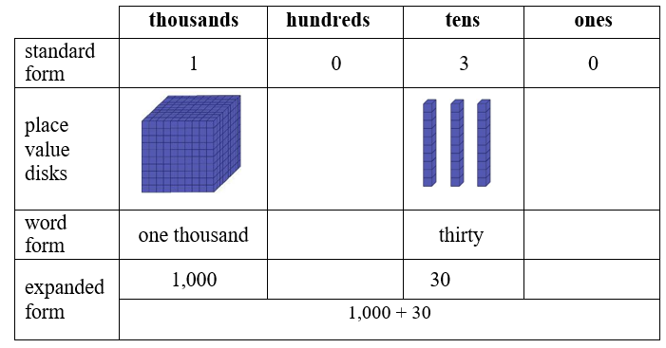

* For example, in the number 203, there are 0 *tens.*

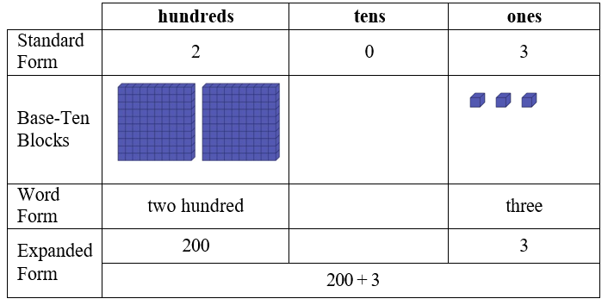

Instructional Tasks

*Instructional Task 1*

Henry says that the number 9,300 is read as nine thousand three. Noelle says that 9,300 is read as nine thousand thirty. Do you agree with either Henry or Noelle? Why or why not? Use expanded form to prove your thinking.

*Instructional Task 2*

What number has 5 *hundreds*, 6 *ones*, 8 *thousands* and 4 *tens*.

*Instructional Task 3 (MTR.3.1, MTR.8.1)*

Using the digits 6, 0, 7 and 8, create a 4-digit number and write it in standard form, expanded form, and word form. Then, using the same four digits, create a different 4-digit number and write the new number in standard form, expanded form, and word form.

Instructional Items

*Instructional Item 1*

Which shows three thousand seventy-nine in expanded form?

1. 300 + 70 + 9
2. 3,000 + 70 + 9
3. 3,000 + 70 + 90
4. 3,000 + 700 + 90

Instructional Item 2

What is the number 9,811 in word form?

Instructional Item 3

Select all the ways that show 4,805.

1. 4,000 + 80 + 5
2. four thousand, eight hundred five
3. 4,000 + 800 + 5
4. 4,000 + 800 + 50
5. four thousand, eighty-five
6. four thousand, eight hundred fifty

Instructional Item 4

Select the correct form of each number by filling in the corresponding circle

A table with numbers represented in different forms.


*The strategies, tasks and items included in the B1G-M are examples and should not be considered comprehensive.

### MA.3.NSO.1.2

Benchmark

MA.3.NSO.1.2 Compose and decompose four-digit numbers in multiple ways using thousands, hundreds, tens and ones. Demonstrate each composition or decomposition using objects, drawings and expressions or equations.

*Example:* The number 5,783 can be expressed as 5 *thousands* + 7 *hundreds* + 8 *tens* + 3 *ones* or as 56 *hundreds* + 183 *ones*.

Connecting Benchmarks/Horizontal Alignment

* MA.3.NSO.1.1
* MA.3.NSO.2.1

Terms from the K-12 Glossary

* Expression
* Whole numbers
* Equal sign
* Equation

Vertical Alignment

|  |  |
| --- | --- |
| **Previous Benchmarks**   * MA.2.NSO.1.1 * MA.2.NSO.1.2 | **Next Benchmarks**   * MA.4.NSO.1.1 * MA.4.NSO.1.2 |

Purpose and Instructional Strategies

The purpose of this benchmark is for students to identify ways numbers can be written flexibly

using decomposition and that number sense and computational understanding is built on a firm understanding of place value. This work extends from the Grade 2 expectation to compose and decompose three-digit numbers in multiple ways using hundreds, tens and ones (MA.2.NSO.1.2). The work also extends to the Grade 3 expectation to add and subtract multi-digit whole numbers including using a standard algorithm with procedural fluency (MA.3.NSO.2.1).

* Allow students to explore the relationship between adjacent place values as they are composing and decomposing numbers in multiple ways. For example, 1,243 can be expressed as *1 thousand + 2 hundreds + 4 tens + 3 ones* or *12 hundreds + 4 tens + 3 ones.* One thousand is 10 times greater than one hundred, so when we decompose the one thousand into 10 *hundreds* when expressing 1,243 we now have *12 hundreds.* Multiple representations of multi-digit whole numbers allow students to identify opportunities for regrouping while adding and subtracting. For example, when subtracting 5,783 – 892, we can represent 5,783 as 5 *thousands* + 6 *hundreds* + 18 *tens* + 3 *ones* by regrouping 1 hundred as 10 tens, allowing us to subtract 9 tens (*MTR.2.1, MTR.3.1*).
* Students should use objects (e.g., manipulatives such as base ten blocks), drawings, and expressions or equations side-by-side to compare and contrast the representations. Model for students to demonstrate how multiple representations relate to the original number. For example, use base ten blocks to show how in the number 5,783, 1 hundred can be regrouped as 10 tens to express it as 5 *thousands* + 6 *hundreds* + 18 *tens* + 3 *ones*. Then, ask students how the two representations are the same *(MTR.2.1)*.
* Allow students to decompose numbers in as many ways as possible with objects, manipulatives, expressions and equations. Have students compare and contrast the representations shared *(MTR.4.1)*.
* Students should see examples of numbers within 10,000 where zero is a digit and make sense of its value.
* Flexibility of place value is a prerequisite for conceptual understanding of a standard algorithm for addition and subtraction with regrouping (MA.3.NSO.2.1).

Common Misconceptions or Errors

* Students can misunderstand the value of 5 in 57. They may see the 5 as representing 5, not 50 or 5 *tens*. Students need practice with representing two and three-digit numbers with manipulatives that group (base ten blocks) and those that do NOT group, such as counters, etc.
* Students can misunderstand that when decomposing a number in multiple ways, the value of the number does not change. 879 is the same as 87 *tens* + 9 *ones* and 8 *hundreds* + 79 *ones*.

Strategies to Support Tiered Instruction

* Instruction includes decomposing numbers using manipulatives that group (such as base ten blocks) and those that do not group (such as counters). When decomposing a number, students focus on the value of each digit based on its place value. To reinforce this concept, students may count by units based on the place value.
* For example, decompose 362 using base ten blocks and explain the value of each digit.

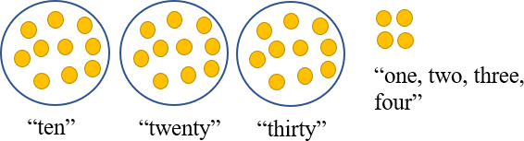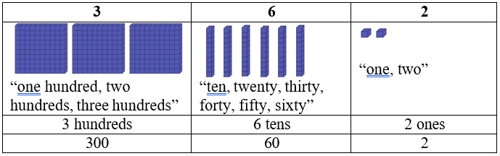

* For example, represent 34 using counters and explain the value of each digit. Students group 10 ones as a group of ten and focus on the value of each digit based on its place value. To reinforce this concept, students count by units based on the place value
* Teacher provides opportunities to decompose numbers in multiple ways using manipulatives and a chart to organize their thinking and asks students to name/identify the different ways to name the values (regrouping the hundreds into tens and the tens into the ones, e.g., 36 *tens* and 2 *ones* or 3 *hundreds* and 62 *ones*, etc.)
  + For example, students decompose 362 in multiple ways using hundreds, tens, and ones.

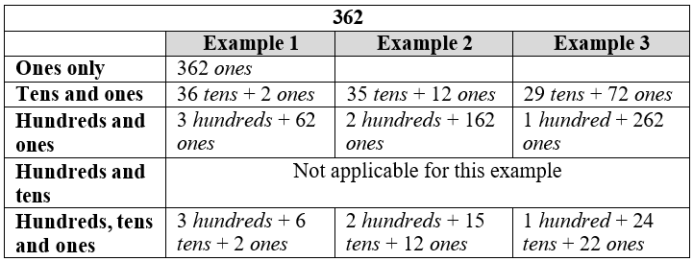

* For example, students decompose 34 in multiple ways using tens and ones

|  |  |  |  |
| --- | --- | --- | --- |
| **34** | | | |
|  | **Example 1** | **Example 2** | **Example 3** |
| **Tens** | 3 *tens* + 4 *ones*  3 tens  Graphic to explain example 3 ones | 2 *tens* + 14 *ones* | 1 *tens* + 24 *ones* |
| **and** |
| **ones** |

Instructional Tasks

*Instructional Task 1*

Part A. Express the number 5,783 using only thousands and ones.

Part B. Express the number 5,783 using only hundreds and ones.

Part C. Express the number 5,783 using only tens and ones.

*Instructional Task 2*

Decompose the following number in two different ways: 6,905.

*Instructional Task 3*

Determine what number is shown below.

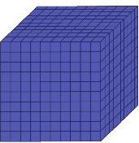   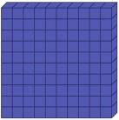      Graphic to explain example  Graphic to explain example  Graphic to explain example 



Instructional Items

*Instructional Item 1*

Select all the ways that express the number 8,709.

1. 8,000 + 600 + 19
2. 8,000 + 700 + 19
3. 879 *ones*
4. 8 *thousands* + 6 *hundreds* + 10 *tens* + 9 *ones*

*Instructional Item 2*

4,851 = 3 *thousands* + _______ *hundreds* + 5 *tens* + 1

*Instructional Item 3*

What is the value of this expression?

71 *hundreds* + 53 *ones*

*Instructional Item 4*

How many total hundreds are in the number 9,844?

1. 9
2. 98
3. 984
4. 9,844

*The strategies, tasks and items included in the B1G-M are examples and should not be considered comprehensive.

### **MA.3.NSO.1.3**

Benchmark

MA.3.NSO.1.3 Plot, order and compare whole numbers up to 10,000.

*Example:* The numbers 3,475; 4,743 and 4,753 can be arranged in ascending order as 3,475; 4,743 and 4,753.

Benchmark Clarifications:

*Clarification 1:* When comparing numbers, instruction includes using an appropriately scaled number line and using place values of the thousands, hundreds, tens and ones digits.

*Clarification 2:* Number lines, scaled by 50s, 100s or 1,000s, must be provided and can be a representation of any range of numbers.

*Clarification 3:* Within this benchmark, the expectation is to use symbols (<, > or =).

Connecting Benchmarks/Horizontal Alignment

* MA.3.NSO.1.1
* MA.3.NSO.1.2
* MA.3.AR.2.2
* MA.3.FR.2.1

Terms from the K-12 Glossary

* Number Line
* Whole Number
* Equal sign
* Equation
* Expression

Vertical Alignment

|  |  |
| --- | --- |
| **Previous Benchmarks**   * MA.2.NSO.1.3 | **Next Benchmarks**   * MA.4.NSO.1.3 |

Purpose and Instructional Strategies

* The purpose of this benchmark is for students to compare two numbers by examining the place value~~s~~ of thousands, hundreds, tens and ones in each number. This work extends from the Grade 2 expectation to plot, order and compare up to 1,000 (MA.2.NSO.1.2). Students will expand on this work in Grade 4 when they plot, order and compare multi-digit whole numbers up to 1,000,000 (MA.4.NSO.1.3).
* Instruction should use the terms greater than, less than and equal to, as well as the corresponding symbols (>, <, and =). Students should use place value strategies and scaled number lines (horizontal and vertical) to justify how they compare numbers and explain their reasoning. Instruction should not rely on tricks for determining the direction of the inequality symbols. Students should read entire statements (e.g., read 7,309 > 7,039, “7,309 is greater than 7,039” and vice versa) *(MTR.2.1, MTR.3)*.
* Students should understand the meaning of the ≠ symbol through instruction. It is recommended that students use = and ≠ symbols first. Once students have determined that numbers are not equal, then they can determine “how” they are not equal, with the understanding now that the number is either greater than (>) or less than (<). If students cannot determine if amounts are ≠ or = then they will struggle with > or <. This will build understanding of statements of inequality and help students determine differences between inequalities and equations *(MTR.6.1)*
* Students should practice putting sets of whole numbers with values up to 10,000 in ascending and descending order. For example, have students put the following set of numbers (5,881; 4,367; 6,777 and 1,004) in ascending order (1,004; 4,367; 5,881 and 6,777) or in descending order (6,777; 5,881; 4,367 and 1,004).

Common Misconceptions or Errors

* Often students think of these relational symbols as operational symbols instead. To address this misconception, allow students to practice using the number line and/or base-ten blocks to see the relationship between one number and the other.

Strategies to Support Tiered Instruction

* Instruction includes use of a number line, base-ten blocks, place value charts and relational symbols to demonstrate the relationship between one number and the other.
* Graphic to explain example For example, the teacher uses a number line and relational symbols to compare 487 and 623, labeling the endpoints of the number line 0 and 1,000. The teacher asks students to place 487 and 623 on the number line, discussing the placement of the numbers and distance from zero. Next, the teacher uses the number line to demonstrate that 487 is closer to zero than 623 so 487 < 623 and that 623 is farther from zero so 623 > 487. Then, the teacher explains that 487 and 623 are not the same point on the number line so 487 ≠ 623 and asks students to identify numbers that are greater than... and less than...Finally, the teacher repeats with two four-digit numbers (number line endpoints of 0 and 10,000) and discusses the placement of the other numbers on the number line and if their values are greater than or less than other numbers.
  + For example, the teacher uses base-ten blocks, a place value chart and relational symbols to compare 274 and 312. The teacher has students represent 274 and 312 using base-ten blocks and a place value chart and asks students to compare these numbers, beginning with the greatest place value. Next, the teacher explains that the number 274 has 2 hundreds and the number 312 has 3 hundreds so 274 < 312 and 312 > 274 and that 274 and 312 have different digits in the hundreds place so 274 ≠ 312.

|  |  |  |
| --- | --- | --- |
| **Hundreds** | **Tens** | **Ones** |
| **2**  **Graphic to explain example Graphic to explain example** | **7**  Graphic to explain example Graphic to explain example Graphic to explain example Graphic to explain example Graphic to explain example Graphic to explain example Graphic to explain example | **4**  Graphic to explain example Graphic to explain example Graphic to explain example Graphic to explain example |
| **3**  **Graphic to explain example Graphic to explain example Graphic to explain example** | 1  Graphic to explain example | **2**  Graphic to explain example Graphic to explain example |

Instructional Tasks

*Instructional Task 1 (MTR.3.1, MTR.7.1)*

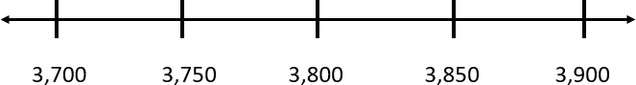 Plot the numbers 3,790, 3,890, 3,799, 3,809 on the number line below.

Choose two values from the list and compare them using >, <, or =.

Choose a number between 3,799 and 3,809 and plot it on the number line.

Use evidence from your number line to justify which number is greatest.

*Instructional Task 2*

The students at Imaginary Elementary School participated in a school-wide Read-a-Thon.

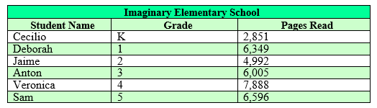The top reader from each grade level is listed below along with the number of pages they read during the contest.

Which student read the least pages of books? How do you know?

Deborah says she read more books than Sam and Anton? Is she correct? Put their three book totals in ascending order to prove if she is correct or not.

*Instructional Task 3*

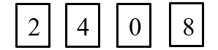

Jacob is playing a game with his friend. He flips over the four number cards above.

Create four different numbers using each of the number cards above only once. Zero cannot be used in the thousands place.

Using the number line below, plot the four numbers you created.

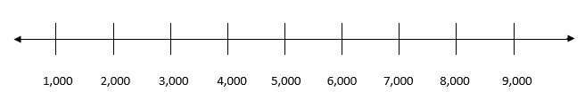

What is the greatest number Jacob could create with the four number cards above?

*Instructional Task 4*

The Grade 3 classes were having a competition to see which class could collect the most can tabs. Here are the total can tabs that each class collected.

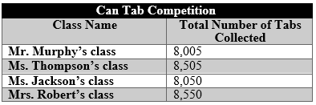

Which class collected the most can tabs? Put the number of can tabs in descending order to determine the class winner.

Compare the number of can tabs collected by Mr. Thompson’s class with the number of can tabs collected in Mr. Robert’s class using >, <, or =.

Instructional Items

*Instructional Item 1*

Put the following numbers in order from greatest to least: 2,847; 2,478; 2,748; and 2,487.

1. 2,478; 2,487; 2,748; 2,847
2. 2,478; 2,487; 2,847; 2,748
3. 2,847; 2,748; 2,487; 2,478
4. 2,847; 2,487; 2,748; 2,478

*Instructional Item 2*

Which of the following correctly compares 6,909 and 6,099?

1. 6,909 < 6,099, because the value of the 9 in the tens place of 6,099 is greater than the value of the 0 in the tens place of 6,909.
2. 6,909 > 6,099, because the value of the 9 in the tens place of 6,099 is greater than the value of the 0 in the tens place of 6,909
3. 6,909 < 6,099, because the value of the 9 in the hundreds place of 6,909 is greater than the value of the 0 in the hundreds place of 6,099
4. 6,909 > 6,099, because the value of the 9 in the hundreds place of 6,909 is greater than the value of the 0 in the hundreds place of 6,099.

*Instructional Item 3*

Select all the following correct comparisons.

1. 8,227 < 3,454
2. 6,742 > 6,231
3. 4,404 = 4,404
4. 3,864 > 5,279
5. 1,835 < 3,901
6. 9,067 < 8,067

*Instructional Item 4*

Which point is located at number 1,045 on the number line?

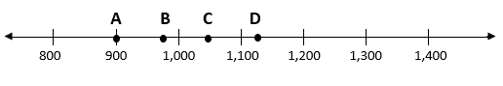

1. Point A
2. Point B
3. Point C
4. Point D

*The strategies, tasks and items included in the B1G-M are examples and should not be considered

### MA.3.NSO.1.4

Benchmark

MA.3.NSO.1.4 Round whole numbers from 0 to 1,000 to the nearest 10 or 100.

*Example:* The number 775 is rounded to 780 when rounded to the nearest 10.

*Example:* The number 745 is rounded to 700 when rounded to the nearest 100.

Connecting Benchmarks/Horizontal Alignment

* MA.3.NSO.1.3
* MA.3.NSO.2.1
* MA.3.AR.1.2
* MA.3.M.1.2

Terms from the K-12 Glossary

* Number Line
* Whole Number

Vertical Alignment

|  |  |
| --- | --- |
| **Previous Benchmarks**   * MA.2.NSO.1.4 | **Next Benchmarks**   * MA.4.NSO.1.4 |

Purpose and Instructional Strategies

The purpose of this benchmark is for students to use place value understanding to explain and

reason about rounding. It is important for students to have numerous experiences using a number line, a place-value chart and a hundred chart to support their work with rounding to assist with their understanding of knowing when and why to round numbers providing opportunities to investigate and explore place value *(MTR.2.1)*. This benchmark continues instruction of rounding from Grade 2, where students rounded numbers from 0 to 100 to the nearest 10 (MA.2.NSO.1.4).

* Instruction of rounding includes place value representations (e.g., base-ten blocks) and number lines (both horizontal and vertical) *(MTR.2.1)*.
* Students should identify benchmarks based on place value to justify rounding. For example, when rounding 643 to the nearest ten, students should use place value to determine that 643 falls between the benchmark tens, 640 and 650. Between 640 and 650, a number line shows that 643 is closer to 640 than 650. When rounding 643 to the nearest hundred, students should use place value to determine that 643 is between the benchmark hundreds, 600 and 700. Between 600 and 700, 643 is closer to 600 than 700 *(MTR.2.1, MTR.3.1)*.
* During instruction, have students practice identifying possible answers and halfway points. In addition to understanding that, by rule, if a number is exactly at the halfway point of two possible answers, the number is rounded up. For example, students learn the convention that when the value to the right of the rounded place value is 5, they round up to the greater of the two benchmark values. For example, when rounding 765 to the nearest ten, 765 is the same distance between 760 and 770. The rounding convention tells us to round up to 770 *(MTR.2.1, MTR.3.1)*.
* Rounding numbers is a skill that helps students estimate reasonable solutions when adding and subtracting. It also helps students estimate reasonable solutions when multiplying and dividing larger numbers in Grade 4 (MA.NSO.2.5). Instruction of rounding skills should be taught within the context of estimating while adding or subtracting. Rounding numbers in an expression should be done before performing operations to estimate reasonable sums or differences. Rounding sums and differences should not be done after students have already performed operations.
* Instruction focuses on place value understanding or the use of number lines, not tricks for rounding such as mnemonics, rhymes or songs.

Common Misconceptions or Errors

* Students can confuse the place value to which they are rounding. For example, students mistakenly round 923 to 900 when rounding to the nearest ten because they observe 2 tens and round to 900, instead of using the ones value of 3 to help them determine that 923 is closest to 920. The use of benchmark numbers and number lines help students understand rounding conceptually.
* Students assume numbers that are already located at benchmarks cannot be rounded. For example, students think that 920 cannot be rounded to the nearest ten.
* It is imperative for students to develop a conceptual understanding of rounding, such as what the benchmarks are, using place value understanding to round numbers without instruction of mnemonics, rhymes or songs.

Strategies to Support Tiered Instruction

* Instruction includes using number lines, benchmark numbers and place value understanding to round numbers to the nearest ten and hundred. To develop a conceptual understanding of rounding, such as what the benchmarks are, students use place value understanding to round numbers without instruction using mnemonics, rhymes or songs.
  + Graphic to explain example For example, students round 439 to the nearest hundred using a number line and place value understanding. The teacher explains that the endpoints of our number line will be represented using hundreds, because we are rounding to the nearest hundred. The teacher then explains that there are 4 *hundreds* in the number 439 and one more hundred would be 5 hundreds and represents these endpoints on the number line as 4 *hundreds* (400) and 5 *hundreds* (500). Next, the teacher explains that the mid-point on the number line can be labeled as 4 *hundreds* and 5 *tens* (450). This midpoint is halfway between 400 and 500. The teachers ask students to plot 439 on the number line and discuss if it is closer to 400 or 500. Then, the teacher explains that 439 rounds to 400 because it is 61 units away from 500 and only 39 units away from 400 and that a number rounds to the closest benchmark number.

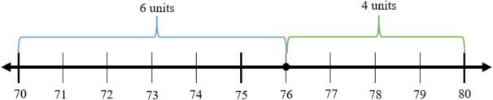

* + For example, students round 76 to the nearest ten using a number line and place value understanding. The teacher explains that the endpoints of the number line will be represented using tens, because we are rounding to the nearest ten. Then, the teacher explains that there are 7 *tens* in the number 76 and one more ten would be 8 *tens* and represents these endpoints on the number line as 7 *tens* (70) and 8 *tens* (80). The mid-point on the number line can be labeled as 7 *tens* and 5 *ones* (75). This midpoint is halfway between 70 and 80 or 5 units from 70 and 5 units from 80. The teacher asks students to plot 76 on the number line and discuss if it is closer to 70 or 80. Then, the teacher explains that 76 rounds to 80 because it is 6 units away from 70 and only 4 units away from 80. Once students master this concept, there should be a discussion about rounding the number 75 where the choice is made to round it up to 80.

Instructional Tasks

*Instructional Task 1 (MTR.3.1, MTR.7.1)*

Part A. Emily is thinking of a mystery number that rounds to 350 when rounded to the nearest ten and 300 when rounded to the nearest hundred. Could Emily’s number be 344? Why or why not?

Part B. Give two numbers that could be Emily’s mystery number. Justify your answer using a number line.

*Instructional Task 2*

Use the following digits to create two different 3-digit numbers. Then, round each of your numbers to the nearest ten and the nearest hundred.

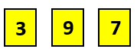

|  |  |  |
| --- | --- | --- |
| **Your numbers** | **Rounded to the Nearest Ten** | **Rounded to the Nearest Hundred** |
|  |  |  |
|  |  |  |

*Instructional Task 3*

Daniel’s mom says she spent about $600 on groceries this month.

Part A. Write five numbers that could round to 600 when rounded to the nearest ten.

Part B. If Daniel’s mom rounded her $600 grocery bill to the nearest ten, what is the least amount Daniel’s mom could have spent on groceries this month?

Part C. If Daniel’s mom rounded her $600 grocery bill to the nearest hundred, what is the most she could have spent on groceries this month?

*Instructional Task 4*

Isabella practices her guitar every week. She tracked how many minutes she practiced each month in her journal. This table lists the total minutes she practiced this school year so far.

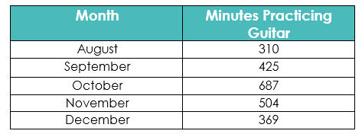

Part A. Isabella put the total minutes from each month in ascending order. In what order did she write the numbers?

Part B. Isabella then rounded each month to the nearest hundred and added the totals together. About how many minutes did Isabella practice this school year so far?

Part C. When Isabella rounded each month to the nearest hundred, she said two months rounded to the same number. Which two months round to the same number

Part D. When Isabella rounded each month to the nearest hundred, she said two months, when rounded, added up to over 1,100. Which two months, when rounded to the nearest hundred, add up to over 1,100?

Instructional Items

*Instructional Item 1*

Identify all the true statements.

a. 302 rounded to the nearest ten is 300.

b. 302 rounded to the nearest ten is 310.

c. 302 rounded to the nearest hundred is 300.

d. 493 rounded to the nearest ten is 500.

e. 493 rounded to the nearest ten is 490.

f. 493 rounded to the nearest hundred is 500

*The strategies, tasks and items included in the B1G-M are examples and should not be considered

### MA.3.NSO.2.1

Benchmark

MA.3.NSO.2.1 Add and subtract multi-digit whole numbers including using a standard algorithm with procedural fluency.

Connecting Benchmarks/Horizontal Alignment

* MA.3.NSO.1.4
* MA.3.AR.1.2
* MA.3.M.1.2

Terms from the K-12 Glossary

* Whole Number
* Equal sign
* Equation
* Expression

Vertical Alignment

|  |  |
| --- | --- |
| **Previous Benchmarks**   * MA.2.NSO.2.1 * MA.2.NSO.2.2 * MA.2.NSO.2.3 * MA.2.NSO.2.4 | **Next Benchmarks**   * MA.4.NSO.2.6 * MA.4.NSO.2.7 |

Purpose and Instructional Strategies

The purpose of this benchmark is for students to add and subtract multi-digit whole numbers

with procedural fluency. Students use skills from the procedural reliability stage in Grade 2 to become fluent with efficient and accurate procedures, including standard algorithms for addition and subtraction. In Grade 2, students added and subtracted multi-digit whole numbers up to 1,000. In Grade 3, the magnitude of numbers increases.

* A standard algorithm is defined as any efficient and accurate procedure that allows students to add and subtract whole numbers. Students’ choices of standard algorithms for addition and subtraction do not need to be the same *(MTR.5.1)*.
* Students should be able to justify their use of a standard algorithm for adding and subtracting by explaining the steps mathematically. Each student should be able to explain when regrouping is needed, and how regrouping is computed using their chosen algorithm. During instruction, teachers and students may work together to relate place value understanding to algorithms *(MTR.3.1, MTR.4.1, MTR.5.1)*.
* Problems include both vertical and horizontal forms, including opportunities for students to apply the commutative and associative properties.
* Instruction of this benchmark should be taught with MA.3.NSO.1.4. Students should use rounding to estimate reasonable solutions of sums and differences before calculating *(MTR.6.1).*

Common Misconceptions or Errors

* Students who learn a standard algorithm without being able to explain why it works using place value understanding often make computational errors and/or cannot determine if their solutions are reasonable. To assist students with this misconception, students should justify the algorithm they choose by checking for reasonableness.
* Students who cannot explain their steps mathematically often have difficulty understanding regrouping. Many computational errors are a result of students not discovering this conceptual understanding while they practiced adding and subtracting with procedural reliability in Grade 2 (MA.2.NSO.2.3 and MA.2.NSO.2.4). Instruction that focuses on learning standard algorithms for addition and subtraction as a series of steps without checking for conceptual understanding will contribute to regrouping errors.

Strategies to Support Tiered Instruction

* Instruction includes guiding students through the process of estimating reasonable values for sums and differences using understanding of place value, addition and subtraction.
  + For example, students make reasonable estimates for the sum of 174 + 253. Instruction includes a prompt such as “Before using an algorithm, we will estimate the sum to make sure that we are using the algorithm correctly and our answer is reasonable. The first addend of 174 is close to the benchmark number 200 and the second addend of 253 is close to the benchmark number 250. So, we can use 200 + 250 = 450 to estimate that our sum should be close to 450.”
* Instruction includes guiding students through the process of explaining and justifying the chosen algorithm and determining if an algorithm was used correctly by reviewing the reasonableness of solutions.
  + 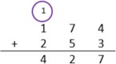For example, students use a standard algorithm to solve 174 + 253 and explain their thinking using a place value visual representation. Instruction includes a prompt such as “Begin by adding in the ones place. 4 ones plus 3 ones is 7 ones. Because the total number of ones is less than 10 ones, it is not necessary to regroup. Next, add in the tens place. 7 *tens* plus 5 *tens* is 12 *tens*. Because I have more than 10 *tens* it is necessary to regroup the 10 *tens* to make one *hundred*. After composing a group of 10 *tens*, there are 2 *tens* remaining. Finally, add 1 *hundred* plus 2 *hundreds*. Add the 1 *hundred* that was regrouped from the tens place. The sum is 427. Our sum of 427 is close to our estimate of 450, which helps us determine that our answer is reasonable.
  + For example, students use a standard algorithm to solve 327 – 174 and explain their thinking using a place value visual representation. Instruction includes prompt such as “Begin subtracting 174 starting in the ones place. 7 *ones* minus 4 *ones* are 3 ones. There are not enough tens to subtract 7 *tens* from 2 *tens*. It is necessary to decompose one *hundred* into 10 *tens*. Now there are 12 *tens*, and there is enough to subtract 7 *tens*. 12 *tens* minus 7 *tens* equals 5 *tens*. Finally, subtract the hundreds: 3 *hundreds* minus 1 *hundred* equals 2 *hundreds*. The difference is 253.”

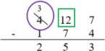

* + For example, students use a standard algorithm and place value blocks to solve 62 – 37 and explain their thinking using a place value visual representation. Instruction includes a prompt such as “Begin subtracting 37 starting in the ones place. There are not enough ones to subtract 7 *ones* from 2 *ones*. It is necessary to decompose one ten into 10 *ones*. Now there are 12 *ones* and there is enough to subtract 7 *ones*. 12 *ones* take away 7 *ones* equals 5 *ones*. Finally, subtract the tens: 5 *tens* minus 3 *tens* is 2 *tens*. The difference is 25.”

|  |  |
| --- | --- |
| **tens** | **ones** |
| Graphic to explain example | |

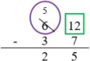



* Teacher provides guidance on using strategies based on place value to add and subtract.
* For example, students use strategies based on place value to solve 174 + 253. Students can decompose each number into expanded form, then add each place value separately (add the ones together, the tens together, and the hundreds together). Then, students can add together the sums of the ones, tens and hundreds to compute the sum.

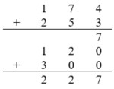Graphic to explain example sum of ones

sum of tens

sum of hundreds

Instructional Tasks

*Instructional Task 1 (MTR.3.1, MTR.7.1)*

Miranda finds 492 seashells during her vacation. She now has 1,045 seashells in her collection. How many seashells did she have in her collection before vacation?

Part A. Solve using a standard algorithm.

Part B. Indicate one step where you needed to regroup while solving and show how you did it using words or a pictorial model.

*Instructional Task 2*

Mount Pleasant Elementary School had a penny fundraiser last week to raise money for families that were affected by the recent storm. The chart below shows how many pennies they raised each day.

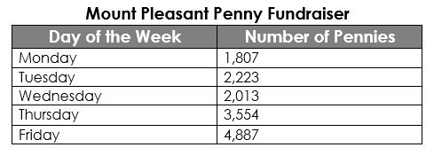

Part A. How many more pennies were collected on Monday and Tuesday than on Thursday?

Part B. Mrs. William’s class collected 1,627 of Friday’s total pennies. How many pennies did the rest of the school collect on Friday?

Part C. The principal said the school collected about 6,000 pennies on Monday, Tuesday and Wednesday. Is this a reasonable estimate? Explain how you know.

*Instructional Task 3*

2,558 + 2,677 = ?

Part A. Write a word problem using the equation shown above.

Part B. Solve the word problem you created in two different ways. Explain your thinking

*Instructional Task 4*

Maya downloaded 856 songs to her music library last month. This month, she downloaded 726 more songs. Then, she deleted 119 songs that she no longer liked.

Part A. How many songs does Maya have in her music library now?

Part B. How many more songs will Maya need to download before she has 3,000 songs in her music library?

Part C. What are two different ways you could solve this problem? Show your thinking.

*Instructional Task 5*

Shay wants to find the sum of 2,417 and 3,568. Explain the steps for finding the sum of 2,417 and 3,568. Be sure to include the words *thousands*, *hundreds*, *tens, ones*, and *sum* in your explanation.

Instructional Items

*Instructional Item 1*

What is the sum of 1,432 and 2,981?

*Instructional Item 2*

What is the difference of 8,000 and 1,432?

*Instructional Item 3*

Cameron set a goal of collecting 7,000 stickers this year. In January, he collected 895 stickers, in February, he collected 472 stickers, and in March he collected 927 stickers. How many more stickers does he need to collect to meet his goal for the year?

*Instructional Item 4*

Use rounding to estimate the sum of 4,587 and 926. Then, find the actual sum of the two numbers.

*The strategies, tasks and items included in the B1G-M are examples and should not be considered

### MA.3.NSO.2.2

Benchmark

MA.3.NSO.2.2 Explore multiplication of two whole numbers with products from 0 to 144, and related division facts.

Benchmark Clarifications:

*Clarification 1:* Instruction includes equal groups, arrays, area models and equations. *Clarification 2:* Within the benchmark, it is the expectation that one problem can be represented in multiple ways and understanding how the different representations are related to each other.

*Clarification 3:* Factors and divisors are limited to up to 12.

Connecting Benchmarks/Horizontal Alignment

* MA.3.NSO.2.3
* MA.3.NSO.2.4
* MA.3.AR.1.1
* MA.3.AR.1.2
* MA.3.AR.2.1
* MA.3.AR.2.2
* MA.3.AR.3.2
* MA.3.GR.2.2
* MA.3.GR.2.3
* MA.3.GR.2.4

Terms from the K-12 Glossary

* Area Model
* Commutative Property of Multiplication
* Dividend
* Divisor
* Equal sign
* Equation
* Expression
* Factors
* Rectangular Array
* Whole Number

Vertical Alignment

|  |  |
| --- | --- |
| **Previous Benchmarks**   * MA.2.AR.3.2 | **Next Benchmarks**   * MA.4.NSO.2.1 |

Purpose and Instructional Strategies

The purpose of this benchmark is for students to build conceptual understanding of what

multiplication is and how it relates to division. Because the expectation of this benchmark is at the explore level, instruction focuses on building understanding of multiplication and division facts from 0 to 144 using manipulatives (e.g., counters, place value blocks), visual models (e.g., rectangular arrays, equal groups), discussions, estimation, and drawings (e.g., rectangular arrays, area models) *(MTR.2.1)*.

* Instruction should relate multiplication to repeated addition work that began in Grade 2. In Grade 2, students used repeated addition to find the total number of objects using rectangular arrays and equations (MA.2.AR.3.2).
* Students should explore multiplication and division through word problems, writing expressions and creating or drawing models that match the problems’ contexts *(MTR.2.1, MTR.3.1)*.
* In division, students should see examples of sharing, or partitive division (where the number of groups are given and students determine the number in each group), as well as measurement, or quotative division (where the number in each group is given and students determine the number of groups).
* Instruction should relate division facts to known multiplication facts (e.g., fact families). Fact families can be explored through arrays and equal groups *(MTR.5.1*).

Common Misconceptions or Errors

* Students may have difficulty relating word problems and real-world scenarios to models, expressions and equations. For example, students may not differentiate the number of groups versus number in each group in multiplication, which then impacts their models, expressions and equations.
* Students may be confused by measurement (or quotative) division, when the amount in each group is given and the number of equal-sized groups is found.

Strategies to Support Tiered Instruction

* Instruction includes demonstrating the use of counters, arrays and skip counting to model groups of objects, including the use of real-world scenarios to support students’ understanding of the number of groups versus the size of each group. Students represent their models with equations to reinforce the concept of multiplication.
* For example, a farmer is planting rows of sunflowers. He plants 6 rows with 5 sunflowers in each row. How many sunflowers does he plant?

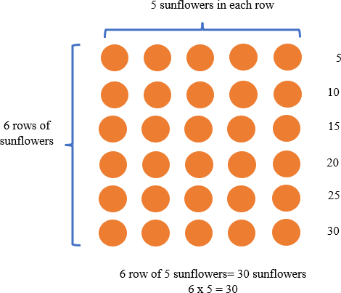

* For example, there are 3 tables in the library. There are 4 students sitting at each table. How many students are sitting at tables in the library?

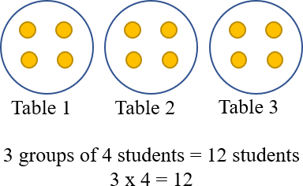

* Instruction includes demonstrating the use of counters and arrays to model division problems where the amount in each group is given and the number of equal-sized groups is found (quotative division). The teacher provides real-world scenarios to represent the number of objects in each group to find the number of equal-sized groups. Students form a group based on the context of the problem, continuing to form groups of that size until the total is reached. Students can skip count to keep track of how many counters they have used, representing their models with equations to reinforce the concept of division.
* For example, Renee is setting up chairs in the library. She is placing 24 chairs into rows. If she places 6 chairs in each row, how many rows of chairs will she have?

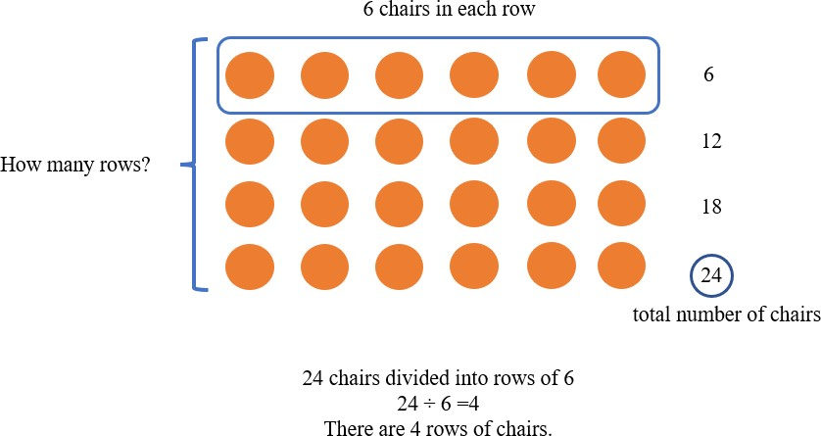

* + For example, there are 15 students working on an art project. The art teacher divides them into groups of 3 students to work on the project. How many groups are there?

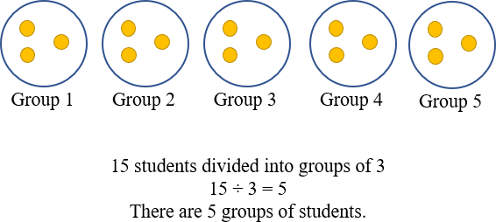

Instructional Tasks

*Instructional Task 1 (MTR.3.1, MTR.7.1)*

Build $12×9$ with place value blocks or counters.

Part A. How would you solve for the product? What strategy did you use to solve the problem?

Part B. Now build $9×12$ with place value block or counters. What is the product of $9×12$? How did you see it?

Part C. Draw a model for $9×12$ or solve using a different strategy.

*Instructional Task 2*

There are 32 photos that need to be organized into a photo album. What are all the possible ways to display the photos on the pages of the album? Each page must have an equal number of photos. Use manipulatives, models, or equations to help you figure out all the possible combinations.

*Instructional Task 3*

Tina has 4 shelves on her bookshelf. Each row has 6 books. How many books are on Tina’s bookshelf in all? Draw a model and write an equation to represent your answer

*Instructional Task 4*

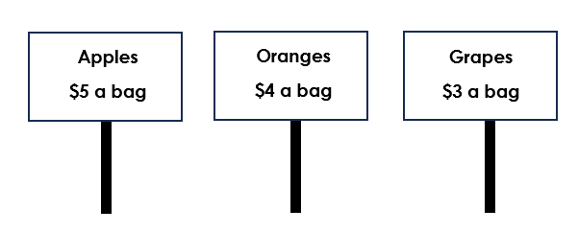

Mateo goes to the grocery store with his dad to buy some fruit. The prices of the fruit are shown above.

Part A. Mateo’s dad buys 6 bags of grapes. Write an equation that represents how many grapes he bought.

Part B. Mateo’s dad also buys 4 bags of apples and 5 bags of oranges. Did he spend more money on apples or oranges? Explain how you know.

Part C. Mateo sees his friend Jeremy at the grocery store. Jeremy’s mom buys 7 bags of grapes and 5 bags of apples. How much more does she spend on apples than grapes? How do you know?

Instructional Items

*Instructional Item 1*

What expression equals 7 x 6?

a. 6 + 6 + 6 + 6

b. 6 + 6 + 6 + 6 + 6

c. 6 + 6 + 6 + 6 + 6 + 6

d. 6 + 6 + 6 + 6 + 6 + 6 + 6

*Instructional Item 2*

Elizabeth has 28 pairs of earrings that she wants to put into her jewelry organizer. Each drawer of the organizer holds 4 pairs of earrings. How many drawers will she need to organize all of her earrings?

*Instructional Item 3*

If 72 eggs are packaged twelve eggs to a carton, how many cartons will we need to package all the eggs? Solve using an equation, model or other strategy.

*Instructional Item 4*

A total of 56 chairs are in the cafeteria for an assembly. The principal arranges the chairs into 8 rows with the same number of chairs in each. Which equation shows the quotient as the number of chairs that will be in each row?

|  |  |  |  |  |
| --- | --- | --- | --- | --- |
| a. 56 | ÷ | 8 | = | 7 |
| b. 56 | ÷ | 8 | = | 48 |
| c. 56 | ÷ | 8 | = | 64 |
| d. 56 | ÷ | 8 | = | 6 |

The strategies, tasks and items included in the B1G-M are examples and should not be considered

### MA.3.NSO.2.3

Benchmark

MA.3.NSO.2.3 Multiply a one-digit whole number by a multiple of 10, up to 90, or a multiple of 100, up to 900, with procedural reliability.

*Example:* The product of 6 and 70 is 420.

*Example:* The product of 6 and 300 is 1,800.

Benchmark Clarifications:

*Clarification 1:* When multiplying one-digit numbers by multiples of 10 or 100, instruction focuses on methods that are based on place value.

Connecting Benchmarks/Horizontal Alignment

* MA.3.NSO.2.2
* MA.3.NSO.2.4
* MA.3.AR.1.1
* MA.3.AR.1.2
* MA.3.GR.2.2
* MA.3.GR.2.4

Terms from the K-12 Glossary

* Equation
* Expression
* Factors
* Whole Number

Vertical Alignment

|  |  |
| --- | --- |
| **Previous Benchmarks**   * MA.2.NSO.2.2 | **Next Benchmarks**   * MA.4.NSO.2.2 * MA.4.NSO.2.3 |

Purpose and Instructional Strategies

The purpose of this benchmark is for students to use place value reasoning to multiply single-

digit factors (0-9) by multiples of 10 up to 90 (10, 20, 30, 40, 50, 60, 70, 80, 90) and multiples of 100 up to 900 (100, 200, 300, 400, 500, 600, 700, 800, 900). Because the expectation of this benchmark is at the procedural reliability level, students should develop accurate, reliable methods for multiplication that align with their understanding and learning style.

* Instruction connects known facts of one-digit factors (e.g. 6 × 7), to then apply to products of one-digit numbers and multiples of 10 or 100 (e.g., 6 × 70, 60 × 7, 6 × 700, 600 × 7) *(MTR.5.1)*.
* Teachers can use place value representations (e.g., pictures, diagrams, base-ten blocks, place value chips) to show relationships between known facts and multiplying one-digit factors by multiples of 10 or 100. For example, 3 × 4 can be interpreted as 3 groups of 4 *ones*, or 12 *ones*. 3 × 40 can be represented as 3 groups of 4 *tens*, or 12 *tens*. 12 *tens* is equal to **120 *ones***. 3 × 400 can be represented as 3 groups of 4 *hundreds*, or 12 *hundreds*. 12 *hundreds* is equal to 120 *tens* or **1,200 *ones*** *(MTR.5.1)*.This standard lays the foundation for multi-digit multiplication. For benchmark MA.3.AR.1.1, students use the distributive property to multiply 34 × 8 as (30 × 8) + (4 × 8). This benchmark (MA.3.NSO.2.3) helps students reason that 30 × 8 is the same as 3 tens × 8 or 24 *tens* or 240 *ones*.
* Instruction should not focus on “adding zeroes to the end” when multiplying one-digit factors by multiples of 10 and 100. For example, 7 × 50 should not be reduced to “7 × 5 with one zero at the end.” This trick does not focus on place value methods, as Clarification #1 of the benchmark requires.

Common Misconceptions or Errors

* Students can quickly jump to the conclusion that they can “count zeroes” to determine the number of zeroes in the product (e.g., the product of 7 × 500 will have two zeroes because 500 has two zeroes). This can confuse students when the products of the known facts already end in zero (e.g., using 5 × 8 = 40 to multiply 5 × 80). Students who rely on this trick will often indicate that 5 × 80 = 40 because they see only one zero in the factors.

Strategies to Support Tiered Instruction

* Instruction includes opportunities to connect grouping numbers by multiples in different ways.
* For example, students may place the following facts on the hundreds chart:

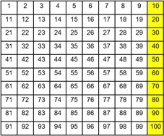1 × 10, 2 × 10, 3 × 10, 4 × 10, 5 × 10, 6 × 10, 7 × 10, 8 × 10 and 9 × 10. The teacher asks students what patterns they notice?

* Instruction includes opportunities to use a number line. Students skip count by multiples on the number line. This will support a conceptual understanding of what is happening with the numbers, instead of focusing on the “zero trick.”

2 × 200 = 400

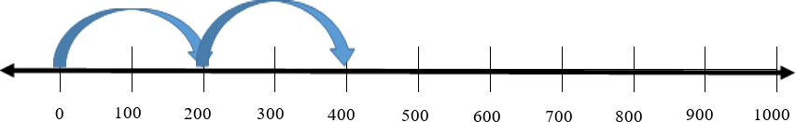

* Instruction includes opportunities to connect grouping numbers by multiples.
  + For example, students use manipulatives to show that 5 groups of 20 is 100 and 5 groups of 200 is 1,000. Teacher should be explicit about the multiples and not point out the zeros trick

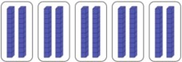

5 × 20 = 100

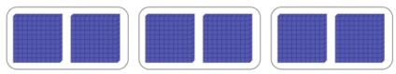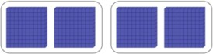

5 × 200 = 1,000

Instructional Tasks

*Instructional Task 1*

Aurora listened to music for 6 days in a row. Each day she listened for 50 minutes. How many minutes did she listen to music in all? Show how you know in two different ways using models, equations, number lines, or other strategies.

*Instructional Task 2*

The Johnson family is planning a wedding for 40 people. They need to purchase enough room decorations, flowers and party favors so that they can have one party favor, one flower and one room decoration for each of their guests. Below are the different choices for each category. Every guest will receive the same items, so you only need to choose one from each category.

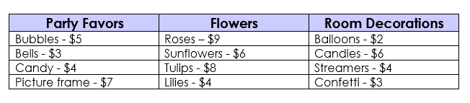

Part A. Choose one party favor, one type of flower, and one room decoration for your guests. How much will it cost to purchase these items for your 40 guests?

Part B. Oh no! Ten of your guests could not make it. How much will the items cost for 10 less guests?

Part C. How much more will it cost to buy all your guests roses than it will to buy them lilies?

*Instructional Task 3*

There are 300 students going on the field trip to the zoo from Eastside Elementary School. There are 3 times as many students going to the zoo from Westside Elementary School.

Part A. How many total students are going on the field trip to the zoo from Eastside Elementary School and Westside Elementary School?

Part B. Southside Elementary School decides to go to the zoo that day too! They have 4 times as many students as Eastside Elementary School and Westside Elementary School combined. How many students will attend the zoo field trip from Southside Elementary School?

*Instructional Task 4*

The table below shows the costs for entry at the Sunnyland Amusement Park.

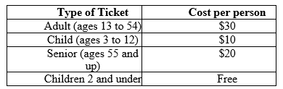

1. How much does entry cost for nine adults? Write an equation to show the total cost?
2. Write an expression that shows the total cost for one senior and one 2-year-old child to attend Sunnyland Amusement Park
3. The Suarez Family purchases 2 adult tickets, 1 senior ticket and 1 ticket for their 6-year-old daughter. Write an equation to show the total cost of entry for the family.
4. Which cost of entry is less expensive, 2 seniors or 3 children? Explain how you know using words, a picture or equations

Instructional Items

*Instructional Item 1*

Write two different equations using a one-digit whole number and a multiple of 10 that show a product of 120.

_____ × _____ = 120 _____ × _____ = 120

*Instructional Item 2*

Write two different equations using a one-digit whole number and a multiple of 100 that show a product of 2,400.

_____ × _____ = 2,400 _____ × _____ = 2,400

*Instructional Item 3*

Select all the following expressions that equal 1,800.

1. 30 $×$ 6
2. 2 $×900$
3. 600 $×$ 3
4. 9 $×$ 20
5. 60 $×$ 3
6. 9 $×$ 200

*Instructional Item 4*

Reginald and Veronica are having a push-up competition during P.E. class. Reginald said that he did 7 sets of 20 push-ups and that he is the winner. Veronica said that she completed 6 sets of 30 push-ups and that this makes her the winner. Who won the competition? How do you know?

*The strategies, tasks and items included in the B1G-M are examples and should not be considered

### MA.3.NSO.2.4

Benchmark

MA.3.NSO.2.4 Multiply two whole numbers from 0 to 12 and divide using related facts with procedural reliability.

*Example:* The product of 5 and 6 is 30.

*Example:* The quotient of 27 and 9 is 3.

Benchmark Clarifications:

*Clarification 1:* Instruction focuses on helping a student choose a method they can use reliably.

Connecting Benchmarks/Horizontal Alignment

* MA.3.NSO.2.2
* MA.3.NSO.2.3
* MA.3.AR.1.2
* MA.3.AR.2.1
* MA.3.AR.2.2
* MA.3.AR.3.3
* MA.3.GR.2.2
* MA.3.GR.2.3
* MA.3.GR.2.4

Terms from the K-12 Glossary

* Area model
* Associative property of multiplication
* Commutative property of multiplication
* Distributive property of multiplication
* Dividend
* Divisor
* Equation
* Expression
* Factor
* Rectangular array

Vertical Alignment

|  |  |
| --- | --- |
| **Previous Benchmarks**   * MA.2.AR.3.2 | **Next Benchmarks**   * MA.4.NSO.2.1 * MA.4.NSO.2.2 * MA.4.NSO.2.3 * MA.4.NSO.2.4 |

Purpose and Instructional Strategies

The purpose of this benchmark is for students to utilize skills from the exploration stage of

multiplication and division (MA.3.NSO.2.2) to develop an accurate, reliable method that aligns with the student’s understanding and learning style. Procedural fluency of multiplication facts with factors up to 12 and their related division facts is not expected until Grade 4 *(MTR.2.1, MTR.3.1)*.

* This benchmark provides the opportunity for students to generalize patterns they see within the tools used during the exploration stage (e.g., rectangular arrays, equal groups) to then identify multiplication and related division facts *(MTR.4.1)*.
* Instruction that builds procedural reliability should connect multiplication understanding with the properties of multiplication (commutative, associative and distributive). The patterns students recognize help them relate facts to one another, and to use the related facts to find the products and quotients of unknown facts. In this benchmark, students should be able to explain how they know facts and how they can find products of unknown facts *(MTR.5.1)*. For example, students should recognize that 4 × 6 and 6 × 4 have the same product of 24 and identify this pattern as evidence of the commutative property of multiplication. This can also be discovered through arrays for multiplication using objects or drawings, where students can observe that the arrays contain the same total number of squares, but the orientation of the array has just rotated so the rows and columns are switched as shown below *(MTR.5.1)*.

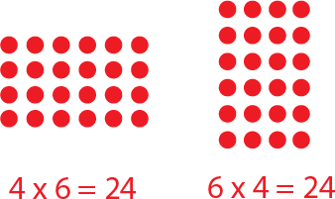

Common Misconceptions or Errors

* This benchmark does not support students’ memorization of multiplication and division facts. Memorization does not indicate work toward multiplication and division fact fluency. Students should be able to explain how they know multiplication and division facts, and how they can find products and quotients of unknown facts.

Strategies to Support Tiered Instruction

* Instruction includes opportunities to experience the properties of multiplication and division. Students use and apply properties to build procedural fluency. Students should understand that multiplication and division both involve grouping equal sets of numbers or objects.
  + For example, the teacher shows students an array of 8 × 6 = 48 and has them describe what they see with rows and columns. This learning can be connected to the concept of “groups of” objects, 8 groups of 6 is the same as 8 jumps of 6 on the number line?

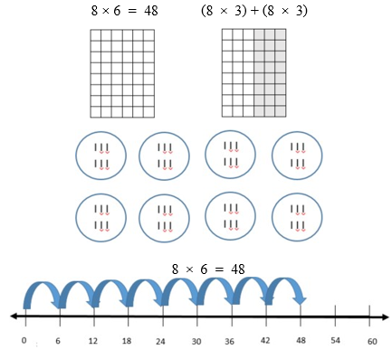

* Teacher provides opportunities to build and manipulate what a multiplication fact looks like and then relates how it looks as division.
  + For example, students model 3 × 4 as 3 rows of 4 with counters.

A group of yellow circles



The teacher then relates the multiplication model to division by separating the rows into groups. 12 = 3 groups of 4 counters or 12 divided by 3 = 4.

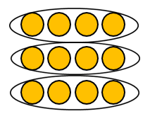

Instructional Tasks

*Instructional Task 1*

Part A. Show how to find the product of 6 × 7 in two different ways.

Part B. Identify the related division facts from your equation in Part A.

*Instructional Task 2*

Use manipulatives or models to help you with this task.

Part A. If there are 36 sides, how many squares are there?

Part B. Write a multiplication or division equation to go with Part A.

*Instructional Task 3*

Use manipulatives, models, or equations to help you with this task.

Part A. Show two different ways to model a quotient of 36.

Part B. Write 2 multiplication or division equations to go with Part A.

*Instructional Task 4*

Anywhere Elementary is ordering popsicles for the third-grade field day. The grocery store allows them three different ways to order them.

**Option 1:**   **Option 2:**   **Option 3:**



*Instructional Task 5*

Which option will be the best one for each of the following teachers to buy? Be sure to tell which options or combinations of options you chose for each teacher as well as how many total popsicles you ordered for each class. Show your thinking (you can use manipulatives, models, expressions, equations, etc.).

|  |  |  |
| --- | --- | --- |
| Mrs. Lopez – 24 students |  |  |
| Mr. Henry – 22 students |  |  |
| Ms. Singe – 20 students |  |  |
| Mrs. Votella – 25 students |  |  |

Instructional Items

*Instructional Item 1*

What is the product of 11 and 4?

*Instructional Item 2*

Provide two division facts that have a quotient of 8.

*Instructional Item 3*

Robert wants to build 8 trains. He has a total of 56 train cars. Select all the different equations that could represent how many train cars each train has.

$8 ×7=56$

$64 ÷8 =8$

$8 ×6 =48$

$56 ÷8=7$

$8 ×8 =64$

$48 ÷8 =6$

*Instructional Item 4*

One bag of potato chips costs $4. How much would 12 bags of potato chips cost?

*The strategies, tasks and items included in the B1G-M are examples and should not be considered

## Fractions

**MA.3.FR.1** *Understand fractions as numbers and represent fractions.*

### MA.3.FR.1.1

Benchmark

MA.3.FR.1.1 Represent and interpret unit fractions in the form $\frac{1}{n}$ as the quantity one part when a whole is partitioned into $n$ equal parts.

*Example: $\frac{1}{4}$* can be represented as $\frac{1}{4}$ of a pie (parts of a shape), as 1 out of 4 trees (parts of

a set) or as $\frac{1}{4}$ on the number line.

Benchmark Clarifications:

*Clarification 1*: This benchmark emphasizes conceptual understanding through the use of manipulatives or visual models.

*Clarification 2:* Instruction focuses on representing a unit fraction as part of a whole, part of a set, a point on a number line, a visual model or in fractional notation.

*Clarification 3:* Denominators are limited to 2, 3, 4, 5, 6, 8, 10 and 12.

Connecting Benchmarks/Horizontal Alignment

* MA.3.FR.1.2
* MA.3.FR.1.3
* MA.3.FR.2.1
* MA.3.FR.2.2

Terms from the K-12 Glossary

* Number line

Vertical Alignment

|  |  |
| --- | --- |
| **Previous Benchmarks**   * MA.2.FR.1.1 * MA.2.FR.1.2 * MA.2.M.2.1 | **Next Benchmarks**   * MA.4.FR.2.1 * MA.4.FR.2.2 |

Purpose and Instructional Strategies

The purpose of this benchmark is for students to understand that unit fractions are the foundation

for all fractions. The purpose is also for students to understand that fractions are numbers. This benchmark continues instruction of fractions from Grade 2, where students partitioned circles and rectangles into two, three or four equal-sized parts (MA.2.FR.1.1 and MA.2.FR.1.2).

* To activate prior knowledge in Grade 3, instruction should:
  + relates how unit fractions build fractions to how whole-number units build whole numbers, and
  + shows models with non-equal parts as non-examples *(MTR.2.1)*.
* Unit fractions are defined as one part when a whole is partitioned in any number of equal parts. It is in this benchmark that students conclude that the greater a unit fraction’s denominator, the greater its number of parts.
* Instruction should demonstrate how to represent unit fractions using manipulatives (e.g., fraction strips, circles, relationship rods), visual area models (e.g., partitioned shapes), on a number line, and as one object in a set of objects *(MTR.2.1, MTR.5.1)*.
* Denominators are limited in Grade 3 to facilitate the visualizing and reasoning required while students plot, compare and identify equivalence in fractions.

Common Misconceptions or Errors

* Students can misconceive the difference between the meaning of numerators and denominators in fractions. For this reason, it is important for teachers and students to represent unit fractions in multiple ways to understand how they relate to a whole. Representations can be modeled together (e.g., fraction strips side-by-side with number lines, or relationship rods side-by-side with number lines) to help build student understanding.
* Students can misconceive that the smaller the denominator, the smaller the piece, or the larger the denominator, the larger the piece. This is due to thinking and reasoning where students worked with whole numbers (the smaller a number, the less it is, or the larger a number, the more it is). To correct this misconception, have students utilize different models, such as fraction bars and number lines, which would provide students opportunities to compare unit fractions and to reason about their sizes.
* Students can misconceive that all shapes can be partitioned the same way. To assist with this misconception, have students practice with partitioning shapes other than circles, squares or rectangles to prevent students from over generalizing that all shapes can be divided the same way.

Strategies to Support Tiered Instruction

* Teacher represents unit fractions in multiple ways to show understanding of how they

relate to a whole. Representations are modeled together (e.g., fraction strips side-by-side with number lines, or relationship rods side-by-side with number lines) to help build understanding.

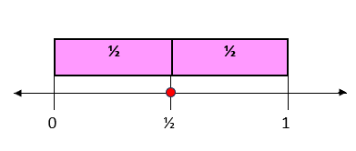

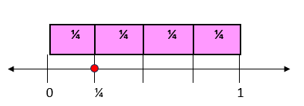

* Instruction includes partitioning shapes into different denominators.
  + For example, students compare what they notice about partitioning a rectangle into halves verses fourths. The teacher asks students, “What do you notice about the pieces? How can we write what one piece of the rectangle is worth with a fraction?” Instruction includes the vocabulary of numerator and denominator.

Graphic to explain example Graphic to explain example  half

Graphic to explain example 

fourths

* Instruction includes shapes other than circles and rectangles. Items like pattern blocks allow students to partition shapes like hexagons and rhombi into equal sized pieces. This prevents students from over-generalizing that all shapes can be divided the same way.
* Instruction includes folding and/or cutting premade shapes into different amounts. Students benefit from beginning with halves and fourths, folding the paper in half, and then folding those halves into halves to make fourths.
  + For example, the teacher asks students, “What do you notice about the shapes? About the size? We now have 4 pieces, do we have more than we did before?” Conversation includes the size of the pieces and how that relates to the denominator.

Instructional Tasks

*Instructional Task 1*

Mrs. Asbel wants to paint a mural on her classroom wall. She creates six equal sections in her mural.

Part A. Use manipulatives to create a visual model of the mural.

Part B. What fraction represents each section of the mural?

*Instructional Task 2*

Madison wants to divide a pan of brownies into 12 equal pieces.

Part A. Show three different ways that Madison can divide her pan of brownies into 12 equal pieces.

Part B. One piece of brownie would represent what fraction?

*Instructional Task 3*

Students at River Valley Elementary School are building a vegetable garden. Here is a picture of the garden so far:

Part A. Show how you would divide the vegetable garden into eight equal parts.

Part B. Explain how you know that the parts you made in Part A are equal.

Part C. Shade in one part of the vegetable garden. What fraction does this equal?

*Instructional Task 4*

Terry wants to show the unit fraction $\frac{1}{8}$ using an area model, a number line, and as a set.

Part A. Into how many equal parts should Terry partition his area model? How many of those parts should be shaded? Explain in words.

Part B. Represent $\frac{1}{8}$ using the number line below.

Part C. Draw a model that represents $\frac{1}{8}$ of a set of juice boxes.

Instructional Items

*Instructional Item 1*

Each model shown has been shaded to represent a fraction. Which model shows $\frac{1}{4}$ shaded?

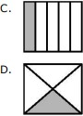

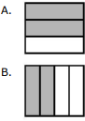

*Instructional Item 2*

Write the fraction that is shown on the number line.

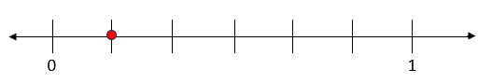

*Instructional Item 3*

Select all of the following that show $\frac{1}{8}$.

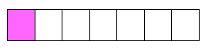

a.

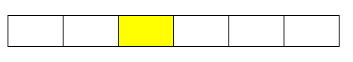

b.

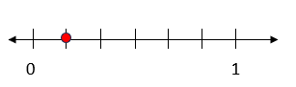

c.

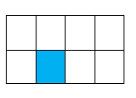

d.

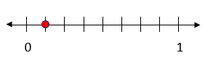

e.

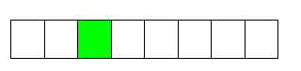 f.

*Instructional Item 4*

Jackson is helping hang his school flag outside the building. The flag has five equal-sized sections on it, each in a different color. Which fraction model represents one section of the school flag?



a.

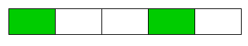

b.

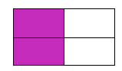

c.

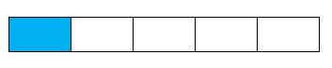

d.

*The strategies, tasks and items included in the B1G-M are examples and should not be considered comprehensive.

### MA.3.FR.1.2

Benchmark

MA.3.FR.1.2 Represent and interpret fractions, including fractions greater than one, in the form of $\frac{m}{n}$ as the result of adding the unit fraction $\frac{1}{n}$ to itself *m* times.

*Example: $\frac{9}{8}$* can be represented as $\frac{1}{8}$ + $\frac{1}{8}$ + $\frac{1}{8}$ + $\frac{1}{8}$ + $\frac{1}{8}$ + $\frac{1}{8}$ + $\frac{1}{8}$ + $\frac{1}{8}$ + $\frac{1}{8}$.

Benchmark Clarifications:

*Clarification 1:* Instruction emphasizes conceptual understanding through the use of manipulatives or visual models, including circle graphs, to represent fractions.

*Clarification 2:* Denominators are limited to 2, 3, 4, 5, 6, 8, 10 and 12.

Connecting Benchmarks/Horizontal Alignment

* MA.3.FR.1.1
* MA.3.FR.1.3
* MA.3.FR.2.1
* MA.3.FR.2.2

Terms from the K-12 Glossary

* Circle Graph
* Expression
* Number line

Vertical Alignment

|  |  |
| --- | --- |
| **Previous Benchmarks**   * MA.2.FR.1.1 * MA.2.FR.1.2 | **Next Benchmarks**   * MA.4.FR.2.1 * MA.4.FR.2.2 |

Purpose and Instructional Strategies

The purpose of this benchmark is for students to think conceptually about fractions as they plot, compare, order and determine equivalence in Grade 3. It also allows students to develop the counting strategies and additive reasoning required to add and subtract fractions in Grade 4 *(MTR.2.1, MTR.5.1)*.

* During instruction, teachers can have students practice representing fractions using manipulatives (e.g., fraction strips, circles, relationship rods), visual area models (e.g., partitioned shapes) and on a number line. Manipulatives, visual models and number lines must extend beyond 1 so that students can represent fractions greater than one *(MTR.2.1, MTR.5.1)*.
* In instruction of MA.3.FR.1.1, students learn that unit fractions are the foundation for all fractions. MA.3.FR.1.2 builds understanding that all fractions, including fractions equal to and greater than one, decompose as the sum of unit fractions.
* In understanding fractions are numbers, students make connections about whole number operations that will allow them to perform operations with fractions in later grades. For example, understanding fractions as numbers allows students to reason that $\frac{2}{3}+ \frac{2}{3}= \frac{4}{3}$ in Grade 4 because we are adding together a total of 4 parts that are each one-third in size. (MTR.5.1).

.

Common Misconceptions or Errors

* Students may not understand that fractions equal to and greater than 1 can also be represented as the sum of unit fractions (e.g., $\frac{5}{2 }= \frac{1}{2}+ \frac{1}{2}+ \frac{1}{2}+ \frac{1}{2}+ \frac{1}{2}$). Flexible representations of

models (e.g. rectangular are models that align with number lines) help students connect understanding of fractions and how they are decomposed into unit fractions.

Strategies to Support Tiered Instruction

* Instruction includes modeling how fractions are decomposed. Using fraction circles, students build $\frac{4}{4}$ and then see that there are 4 pieces that make up the whole circle.
* 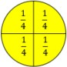For Example.

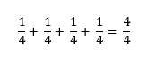

* Instruction includes more than one model so that students can experience and connect fractions in multiple ways. Flexible representations of models (e.g., rectangular area models that align with number lines) help students connect understanding of fractions and how they are decomposed into unit fractions.
  + For Example:



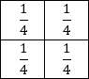

* + Students then apply this understanding to fractions greater than one. Using fraction circles, students build $\frac{8}{4}$ and then see that there are 8 pieces that make up two whole circles.
  + Example:

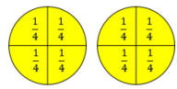

$\frac{1}{4}+ \frac{1}{4}+ \frac{1}{4}+ \frac{1}{4}+ \frac{1}{4} + \frac{1}{4} + \frac{1}{4} + \frac{1}{4}= \frac{8}{4}$

* Instruction includes folding and/or cutting pre-made shapes into halves. Students physically bend the paper into halves and then label the pieces. Instruction includes relating the pieces back to the numerator and denominator and then connecting it to the equation. Using multiple shapes with the same denominators will solidify basic fraction understanding. Instruction should progress with other denominators.
  + Example:

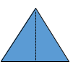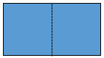

$\frac{1}{2}$ $\frac{1}{2}$ $\frac{1}{2}$ $\frac{1}{2}$

$\frac{1}{2}+ \frac{1}{2}= \frac{2}{2}$ $\frac{1}{2}+ \frac{1}{2}= \frac{2}{2}$

Instructional Tasks

*Instructional Task 1*

Part A: How many one-fifth sized parts are added together to equal 1 whole? Prove your thinking with a visual model or number line.

Part B: How many one-fifth sized parts are added together to equal 2 wholes? Prove your thinking with a visual model or number line?

*Instructional Task 2*

Part A. Model two wholes divided into tenths.

Part B. Write an equation to match your model.

Part C. What would happen to your equation if you added another whole?

Instructional Items

*Instructional Item 1*

Create an equation to represent the total number of one-fourth sized pieces in 3 wholes.

*Instructional Item 2*

Represent the fraction $\frac{8}{3}$ as the sum of unit fractions.

*Instructional Item 3*

Which of the following expressions models $\frac{7}{4}$?

$\frac{1}{4} + \frac{1}{4} + \frac{1}{4} + \frac{1}{4}$

$\frac{1}{7} + \frac{1}{7} + \frac{1}{7} + \frac{1}{7}$

$\frac{1}{4}+ \frac{1}{4}+ \frac{1}{4}+ \frac{1}{4}+ \frac{1}{4} + \frac{1}{4} + \frac{1}{4}$

$\frac{1}{7}+ \frac{1}{7}+ \frac{1}{7}+ \frac{1}{7}+ \frac{1}{7} + \frac{1}{7} + \frac{1}{7}$

*The strategies, tasks and items included in the B1G-M are examples and should not be considered comprehensive.

### MA.3.FR.1.3

Benchmark

MA.3.FR.1.3 Read and write fractions, including fractions greater than one, using standard form, numeral-word form and word form.

*Example:* The fraction $\frac{4}{3}$ written in word form is four-thirds and in numeral-word form is

4 *thirds*.

Benchmark Clarifications:

*Clarification 1:* Instruction focuses on making connections to reading and writing numbers to develop the understanding that fractions are numbers and to support algebraic thinking in later grades.

*Clarification 2:* Denominators are limited to 2, 3, 4, 5, 6, 8, 10 and 12.

Connecting Benchmarks/Horizontal Alignment

* MA.3.FR.1.1
* MA.3.FR.1.2
* MA.3.FR.2.1

Terms from the K-12 Glossary

Vertical Alignment

|  |  |
| --- | --- |
| **Previous Benchmarks**   * MA.2.NSO.1.1 | **Next Benchmarks**   * MA.4.FR.1.1 * MA.4.FR.1.2 |

Purpose and Instructional Strategies

The purpose of this benchmark is for students to describe fractions in different ways.

* This benchmark builds precise vocabulary for describing fractions. When students describe $\frac{4}{3}$ as 4 thirds, they build understanding that the fraction represents 4 parts that are each one-third in size *(MTR.2.1)*.
* It is also the expectation of this benchmark that students represent fractions greater than one as mixed numbers in word and numeral-word form *(MTR.2.1)*.
* Instruction includes modeling and expecting precise vocabulary from students to describe fractions *(MTR.4.1*.).

Common Misconceptions or Errors

* Students can misinterpret fractions as two numbers that are being compared (e.g., reading “1 over 2” instead of one-half). The use of precise vocabulary helps them understand that a fraction is a representation of one number.
* Students can misinterpret that a fraction always models part of one whole. Exceptions to this misconception are fractions greater than one or fractions represented on number lines and in sets of objects.

Strategies to Support Tiered Instruction

* Instruction includes opportunities for practice in naming fractions correctly in multiple ways. Students use a chart to correctly name fractions. To increase appropriate terminology for naming fractions, students use visual representations with the naming of the fractional parts, as well as build fractions with models and utilize number lines. 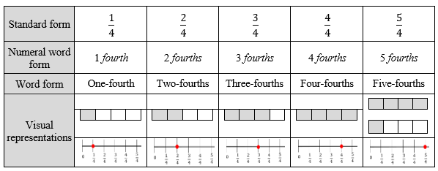
* For example, students model of build .

Rectangle divided into 4 sections, with 3 sections shaded. 

* + Teacher asks, "How can we describe this fraction model?" while guiding students to the understanding that $\frac{3}{4}$ is 3 fourths or 3 of the $\frac{1}{4}$ pieces. The use of precise vocabulary helps them understand that the same number can be represented by different visual models and different verbal expressions.
* Instruction includes opportunities to practice naming fractions correctly in multiple ways with concrete materials and models.
  + For example, students partition a shape or paper into halves. The teacher asks “What do you notice about the pieces? What do we call each piece? How can we write what one piece of the shape is worth with a fraction?” Instruction involves the vocabulary of numerator and denominator. Students are prompted to use the language of *one half* and then connect that to the standard form. The use of precise vocabulary helps students understand that a fraction is a representation of one number.

Instructional Tasks

*Instructional Task 1*

Part A. Reynaldo says that the fraction $\frac{8}{10}$ is written as 8 *tenths*. Jonathon says that the fraction $\frac{8}{10}$ is written as 10 *eighths*. Who is correct?

Part B. What is another way to represent $\frac{8}{10}$? Draw a model or write an equation.

*Instructional Task 2*

Show $2\frac{2}{3}$ in the following forms

Part A. Standard form.

Part B. Word form

Part C. Numeral-word form

Part D. With a visual model

*Instructional Task 3*

Build or model the fraction $\frac{5}{6}$.

Part A. Create the word form of this fraction.

Part B. Explain how this fraction is different fraction $\frac{6}{5}$.

Instructional Items

*Instructional Item 1*

Select all the ways to represent $\frac{8}{3}$.

1. Eight thirds
2. 8 *thirds*
3. 3 *eighths*
$2\frac{2}{3}$

4. Three and two *thirds*

*Instructional Item 2*

Which of the following is the correct way to write $\frac{9}{4}$?

1. Four-*ninths*
2. Four-*fourths*
3. Nine-*fourths*
4. Nine-*ninths*

*The strategies, tasks and items included in the B1G-M are examples and should not be considered comprehensive.

### **MA.3.FR.2** Order and compare fractions and identify equivalent fractions.

### MA.3.FR.2.1

Benchmark

MA.3.FR.2.1 Plot, order and compare fractional numbers with the same numerator or the same denominator.

*Example:* The fraction $\frac{3}{2}$ is to the right of the fraction $\frac{3}{3}$ on a number line so $\frac{3}{2}$ is greater

than $\frac{3}{3}$.

Benchmark Clarifications:

*Clarification 1:* Instruction includes making connections between using a ruler and plotting and ordering fractions on a number line.

*Clarification 2:* When comparing fractions, instruction includes an appropriately scaled number line and using reasoning about their size.

*Clarification 3:* Fractions include fractions greater than one, including mixed numbers, with denominators limited to 2, 3, 4, 5, 6, 8, 10 and 12.

Connecting Benchmarks/Horizontal Alignment

* MA.3.FR.2.2
* MA.3.NSO.1.3

Terms from the K-12 Glossary

* Number line

Vertical Alignment

|  |  |
| --- | --- |
| **Previous Benchmarks**   * MA.2.NSO.1.3 | **Next Benchmarks**   * MA.4.FR.1.4 * MA.4.FR.1.3 |

Purpose and Instructional Strategies

The purpose of this benchmark is for students to plot order and compare fractions with the same

numerator (e.g., $\frac{3}{4}$, $\frac{3}{2}, \frac{3}{8}$) or fractions with the same denominator (e.g., $\frac{3}{5}$, $\frac{10}{5}$, $\frac{7}{5}$) to compare them by their

location on a number line.

* During instruction, teachers can provide students opportunities to practice using the number line, which will assist students with understanding the difference in size when fractions have the same numerator (the size of the parts) and with comparing fractions with the same denominator (number of parts) *(MTR.2.1)*.
* Through making connections to rulers, students see that appropriately scaled number lines allow for comparisons of fraction size. Students should also utilize open number lines to practice creating their own appropriately scaled number lines *(MTR.2.1)*. Instruction demonstrates that number lines can model fractional values as intervals that can be counted using unit fractions. For example, $\frac{5}{3}$ on a number line can be represented by 5 jumps of $\frac{1}{3}$ from 0.. Second, number lines help students see comparisons of fractions to the same whole and will continue as students compare fractions with different numerators and denominators in Grade 4. Finally, number lines reinforce Clarification 3 for MA.3.FR.1.3, that fractions are numbers *(MTR.2.1, MTR.5.1).*

Common Misconceptions or Errors

* Students can confuse that when numerators are the same in fractions, larger denominators represent smaller pieces, and smaller denominators represent larger pieces. Allow students opportunities to partition models and number lines to understand that the size of the piece decreases as the denominator increases.
* When fraction comparisons are made using area models, students may confuse that the size of the whole for each model must be the same size.

Strategies to Support Tiered Instruction

* Instruction includes opportunities to use concrete models and drawing of number lines to connect learning with fraction understanding.
* 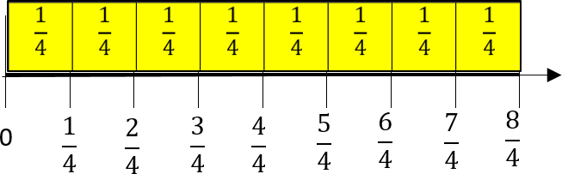For example, students plot fourths on the number line. Utilizing fraction strips or tiles, students can connect fractional parts to the measurement on a number line.
* Conversation includes what students notice about the fraction on the number line. “How many fourths are in three-fourths? What do we notice about the size of $\frac{1}{4}$ compared to $\frac{3}{4}$?” Students have opportunities to describe the distance from the 0 as well as the distance from their benchmark fractions.
* Instruction includes opportunities to use fraction manipulatives, concrete models and drawings. The teacher begins instruction by modeling fractional pieces with their fraction name. It is important that students see that the fractions that they are building and comparing refer to the same size whole.
* For example, students build fractions tiles or models to equal the same size one whole like below.

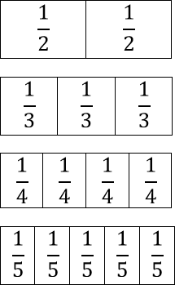



Graphic to explain example 

* Students pull out the unit fraction of each of the fraction models. Conversations include what students notice about the size of each piece and what students notice about the size of the piece compared to the denominators. “Why is $\frac{1}{2}$ larger than $\frac{1}{5}$?”

Instructional Tasks

*Instructional Task 1*

Clara says that $\frac{5}{4}$ is greater than $\frac{5}{2}$ because 4 is greater than 2. Prove why she is incorrect using the number line below.

*Instructional Task 2*

Part A. Create a number line to plot the following fractions: $\frac{5}{4}, \frac{4}{4} and \frac{1}{4}$.

Part B. Are any of the fractions you plotted between the whole numbers 1 and 2? How do you know?

*Instructional Task 3*

Which is greater, $\frac{7}{8}$ or $\frac{7}{10}$? Explain how you know using words or visual model.

Instructional Items

*Instructional Item 1*

Order the fractions below from least to greatest.

$$\frac{8}{5}, \frac{8}{3}, \frac{8}{10},\frac{8}{1}$$

*Instructional Item 2*

Compare 7 fourths and 3 fourths using <, = or >.

*Instructional Item 3*

Which point shows $\frac{6}{3}$ plotted correctly?

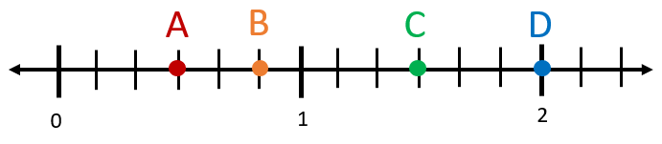

1. Point A
2. Point B
3. Point C
4. Point D

*The strategies, tasks and items included in the B1G-M are examples and should not be considered comprehensive.

### MA.3.FR.2.2

Benchmark

MA.3.FR.2.2 Identify equivalent fractions and explain why they are equivalent.

*Example:* The fractions $\frac{1}{1}$ and $\frac{3}{3}$ can be identified as equivalent using number lines.

*Example:* The fractions $\frac{2}{4}$ and $\frac{2}{6}$ can be identified as not equivalent using a visual model

Benchmark Clarifications:

*Clarification 1:* Instruction includes identifying equivalent fractions and explaining why they are equivalent using manipulatives, drawings, and number lines.

*Clarification 2:* Within this benchmark, the expectation is not to generate equivalent fractions.

*Clarification 3:* Fractions are limited to fractions less than or equal to one with denominators of 2, 3, 4, 5, 6, 8, 10 and 12. Number lines must be given and scaled appropriately.

Connecting Benchmarks/Horizontal Alignment

* MA.3.FR.2.1

Terms from the K-12 Glossary

* Number line

Vertical Alignment

|  |  |
| --- | --- |
| **Previous Benchmarks**   * MA.2.NSO.1.2 | **Next Benchmarks**   * MA.4.FR.1.3 |

Purpose and Instructional Strategies

The purpose of this benchmark is for students to identify equivalent fractions both on appropriately scaled number lines and on area models, and to justify how they know the fractions are equivalent. *(MTR.2.1, MTR.4.1)*.

* + Instruction should prioritize tasks that allow students to reason why fractions are equivalent using models. Students are not expected to generate equivalent fractions until Grade 4 *(MTR.2.1)*.

Common Misconceptions or Errors

* Students may not understand that when numerators are the same in fractions, larger denominators represent smaller pieces, and smaller denominators represent larger pieces.

Strategies to Support Tiered Instruction

* Instruction includes opportunities to use concrete models and drawings to solidify

understanding of fraction equivalence. Students use models to describe why fractions are equivalent or not equivalent when referring to the same size whole.

* For example, when looking at $\frac{2}{8 }$ and $\frac{4}{8 }$ conversation includes that both fraction models are

the same size, so when comparing them we are comparing the same size whole. Students can see that 2 out of the 8 are shaded in the first model and 4 out of the 8 are shaded in

the second model, making the $\frac{4}{8 }$ greater than $\frac{2}{8 }$.

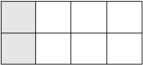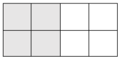

* Instruction includes opportunities to use concrete models and drawings to solidify

understanding of fraction equivalence. Students use models to describe why fractions are equivalent or not equivalent when referring to the same size whole. Instruction includes partitioning shapes with halves, thirds and fourths and then comparing the pieces used.

* For example, students partition a shape into halves.

Graphic to explain example Graphic to explain example 

=

* + Conversation includes observations about the shape partitioned into 2 equal parts. The teacher models writing the fractional parts $\frac{1}{2 }$ so that students can make the
  + connection of the denominator representing the number of pieces. Students then practice partitioning shapes into thirds and fourths for this same understanding.
* When students begin exploring equivalent fractions on number lines, teachers can provide number lines that are already scaled and labeled so that students can focus on comparing the locations of equivalent fractions and build generalizations about how to identify them on number lines. Additionally, teachers can have students identify 0 and 1 on each number line so they can identify that the sizes of the wholes are the same. As students build their understanding, teachers can introduce blank number lines for students to then plot fractions and determine when they are equivalent.

Instructional Tasks

*Instructional Task 1*

Plot the fractions $\frac{2}{4}$ and $\frac{1}{2}$. Use your number line to determine whether the fractions are equivalent. Justify your argument in words.

Graphic to explain example 

*Instructional Task 2*

Use a visual model to prove why 6 eighths is equivalent to 3 fourths.

*Instructional Task 3*

The fractions $\frac{3}{4}$ and $\frac{9}{12}$ are equivalent.

Part A. Describe how a **visual model** will show that these fractions are equivalent.

Part B. Describe how a **number line** will show that these fractions are equivalent.

Instructional Items

*Instructional Item 1*

Use the area models below to determine whether the fractions they represent are equivalent.

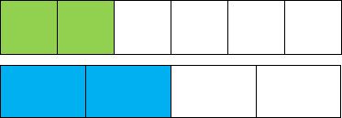

1. The model shows that 2 sixths and 2 fourths are equivalent because the area models

each have 2 shaded parts.

1. The model shows that 2 sixths and 2 fourths are equivalent because the area models

show the size of the shaded parts are equal when the size of each whole is the same.

1. The model shows that 2 sixths and 2 fourths are not equivalent because 2 sixths is

greater than 2 fourths when the size of each whole is the same.

1. The model show that 2 sixths and 2 fourths are not equivalent because the area

models show the size of the shaded parts are not equal when the size of each whole is

the same.

*Instructional Item 2*

1. Select all the fractions that are equivalent to one-half. . $\frac{3}{5}$

$\frac{3}{6}$

$\frac{5}{8}$

$\frac{5}{10}$

$\frac{5}{6}$

*The strategies, tasks and items included in the B1G-M are examples and should not be considered comprehensive.

## Algebraic Reasoning

**MA.3.AR.1** *Solve multiplication and division problems..*

### MA.3.AR.1.1

Benchmark

MA.3.AR.1.1 Apply the distributive property to multiply a one-digit number and two-digit number. Apply properties of multiplication to find a product of one-digit whole numbers.

Example: The product 4 × 72 can be found by rewriting the expression as 4 × (70 + 2) and then using the distributive property to obtain (4 × 70) + (4 × 2) which is equivalent to 288.

Benchmark Clarifications:

*Clarification 1: Within this benchmark, the expectation is to apply the associative and commutative properties of multiplication, the distributive property and name the properties. Refer to K-12 Glossary (Appendix C).*

*Clarification 2: Within the benchmark, the expectation is to utilize parentheses.*

*Clarification 3: Multiplication for products of three or more numbers is limited to factors within 12. Refer to Properties of Operations, Equality and Inequality (Appendix D)*.

Connecting Benchmarks/Horizontal Alignment

* MA.3.NSO.2.3
* MA.3.NSO.2.4

Terms from the K-12 Glossary

* Associative Property of Multiplication
* Commutative Property of Multiplication
* Distributive Property
* Expression
* Equation
* Factors

Vertical Alignment

|  |  |
| --- | --- |
| **Previous Benchmarks**   * MA.2.NSO.1.2 | **Next Benchmarks**   * MA.4.NSO.2.2 * MA.4.NSO.2.3 |

Purpose and Instructional Strategies

The purpose of this benchmark is for students to apply what they have learned about multiplication of one-digit numbers and multiples of ten to then multiply a one-digit number and a two-digit number (MA.3.NSO.2.3).

* Students are introduced to the distributive property of multiplication over addition as a strategy for using products that they know in order to solve products that they do not know. For example, if students are asked to find the product of $6×9$, they might decompose 6 into 4 and 2 and then multiply $4×9$ and $2×9$ to arrive at 36 + 18, which equals 54. Because of the distributive property, students use parentheses to show how to decompose two-digit numbers by the value of its tens and ones or other known facts.. The application of the Commutative and Associative properties of Multiplication allow for two-digit numbers to be decomposed and multiplication expressions reorganized so that the distributive property can work *(MTR.2.1)*.

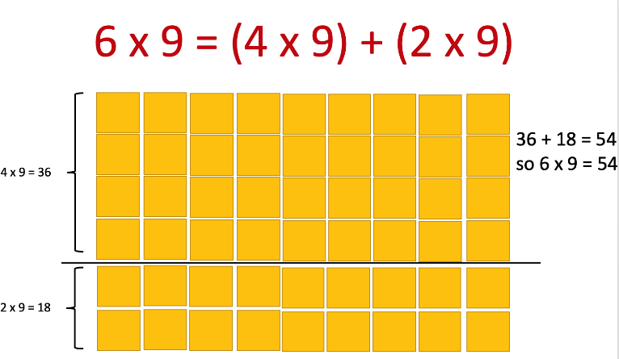

* + During instruction, teachers can model where the properties are applied while multiplying and expect students to explain how they work during explanations of their strategies and solutions.
  + Instruction extends students’ understandings of using the distributive property to multiply one-digit numbers to when one factor is a two-digit number. Two-digit numbers can be decomposed by tens and ones or by decomposing into other known 11s and 12s facts (the former of which will connect students to place value understanding). For example, in the expression $24×7$, students may choose to decompose 24 as 20 + 4 or as 12 +12 before then multiplying each addend by 7 to find the product *(MTR.2.1, MTR.5.1)*
  + Building understanding of the distributive property in Grade 3 will help students decompose larger numbers as they continue to multiply multi-digit numbers with procedural reliability and procedural fluency in Grade 4. Splitting arrays in multiple ways can help students understand the distributive property. They can use a known fact to learn other facts that may cause difficulty *(MTR.2.1, MTR.4.1).*

Common Misconceptions or Errors

* Students can be confused about how to write expressions using the distributive property because they are not relating the equation to what it models. One common mistake that students make is writing an expression 4 × 72 as (4 × 70) × (4 × 2) instead of (4 × 70) + (4 × 2). Instruction should show concrete models (e.g., base ten drawings) along with equations so students can understand the relationship between multiplication and addition while applying the property and writing expressions.

Strategies to Support Tiered Instruction

* Instruction includes opportunities to use concrete models and drawings along with equations to increase understanding of the relationship between multiplication and addition when applying the distributive property and writing equations. The teacher begins by modeling a one-digit number multiplied by a one-digit number, guiding students to decompose one of the factors and use models or drawings to demonstrate the reorganization of the multiplication expression using parentheses. Next, the teacher models multiplication of a one-digit number by a two-digit number, guiding students to decompose the two-digit number into the value of the tens and the ones using models or drawings. The teacher clarifies that the decomposed factor can be represented in expanded form by adding the tens and the ones, repeating with additional one-digit by two-digit multiplication equations.
  + For example, the teacher uses a model or drawing to use the distributive property to solve $3×24$.

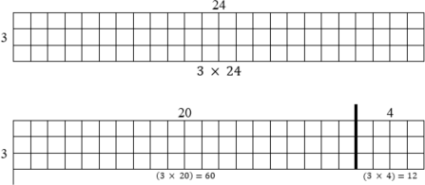

3 × (20 + 4)

(3 × 20) + (3 × 4)

(3 × 20) + (3 × 4) = 60 + 12

(3 × 20) + (3 × 4) = 72

so 3 × 24 = 72

* Teacher provides opportunities to apply the distributive property to solve one-digit by two-digit multiplication equations using base-ten blocks or place value disks. The teacher provides the equation and guides students to decompose the two-digit number into the value of the tens and the ones using manipulatives. If needed, the teacher prompts students to count by 10s and 1s using the base-ten blocks or place value disks
  + For example, the teacher uses base-ten blocks to solve 3 × 24 while asking guiding questions such as “How many tens are in 24?” “How many ones are in 24?” “How would we write 24 in expanded form?”

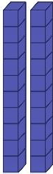

3 × 24

3 × (20 + 4)

(3 × 20) + (3 × 4)

(3 × 20) + (3 × 4) = 60 + 12

(3 × 20) + (3 × 4) = 72

So 3 × 24 = 72

Instructional Tasks

*Instructional Task 1*

In each equation, find the missing value, *n*.

Part A. 4 × 52 = (4 × 50) + (4 × 𝑛)

Part B. 𝑛 × 3 = (20 × 3) + (9 × 3)

Part C. 8 × 36 = (𝑛 × 30) + (𝑛 × 6)

Part D. 48 × 6 = 𝑛

*Instructional Task 2*

Tory tried to use the associative and commutative properties to create the following equations. Using pictures and/or words, explain why Tory is incorrect.

$$4×\left(11+6\right)=\left(4×11\right)+6$$

$$4×\left(11+6\right)=11×\left(4+6\right)$$

*Instructional Task 3*

Julio says that he can use the distributive property to find the product of $24×9$ by rewriting the expression as $\left(12×9\right)+(12×9)$. Mirabel says she can use the distributive property to find the product of by rewriting the expression as $\left(20×9\right)+\left(4×9\right)$. Who is correct? Explain

Instructional Items

*Instructional Item 1*

Which of the following correctly uses the distributive property to multiply 8 × 39?

1. (8 × 30) × (8 × 9) = 96
2. (8 × 30) + (8 × 9) = 296
3. (8 × 30) + (8 × 9) = 45
4. (8 × 30) + (8 × 9) = 312

*Instructional Item 2*

To find its product, an expression is written as $\left(3×40\right)+\left(3×6\right)$. Which expression has the same product?

$3×40$

$3×46$

$6×40$

$6×46$

*Instructional Item 3*

Use the distributive property to find the product of $48×6$

*The strategies, tasks and items included in the B1G-M are examples and should not be considered comprehensive.

### 

### MA.3.AR.1.2

Benchmark

MA.3.AR.1.2 Solve one- and two-step real-world problems involving any of four operations with whole numbers.

Example: A group of students are playing soccer during lunch. How many students are needed to form four teams with eleven players each and to have two referees?

Benchmark Clarifications:

*Clarification 1:* Instruction includes understanding the context of the problem, as well as the quantities within the problem.

*Clarification 2:* Multiplication is limited to factors within 12 and related division facts. Refer to Situations Involving Operations with Numbers (Appendix A).

Connecting Benchmarks/Horizontal Alignment

* MA.3.NSO.2.1
* MA.3.NSO.2.2
* MA.3.NSO.2.3
* MA.3.NSO.2.4
* MA.3.AR.2.1
* MA.3.AR.2.2
* MA.3.AR.2.3

Terms from the K-12 Glossary

* Expression
* Equation

Vertical Alignment

|  |  |
| --- | --- |
| **Previous Benchmarks**   * MA.2.AR.1.1 | **Next Benchmarks**   * MA.4.AR.1.1 * MA.4.AR.1.2 |

Purpose and Instructional Strategies

The purpose of this benchmark is for students to apply all four operations to solve one and two- step real-world problems. This benchmark continues the work done in Grade 2 solving real-world problems using addition and subtraction (MA.2.AR.1.1).

* Instruction should facilitate students’ understanding of contexts and quantities within word problems.
* The emphasis on teaching problem-solving strategies should focus on the comprehension of problem contexts and what quantities represent in them. Examples of questions that help students comprehend word problems are:
  + What is happening in the real-world problem?
  + What do you need to find out?
  + What do the quantities represent in the problem?
  + What will the solution represent in the problem? *(MTR.1.1, MTR.4.1, MTR.6.1)*
* Teachers can model answering these questions through rectangular arrays, base-ten blocks, counters and think-alouds. In addition, teachers can help students explore estimation strategies to determine reasonable ranges for solutions (e.g., rounding, finding low and high estimates) and teach problem-solving strategies that build comprehension (e.g., Three Reads) *(MTR.4.1, MTR.5.1, MTR.6.1)*.

Common Misconceptions or Errors

* Students may have difficulty creating effective models (e.g., drawings, equations) that

will help them solve real-world problems. To assist students, provide opportunities for them to estimate solutions and try different models before solving. Beginning instruction by showing problems without their quantities is a strategy for helping students determine what steps and operations will be used to solve.

* Students may also have difficulty identifying when real-world problems require two steps to solve and will complete only one of the steps. Focusing on comprehension of real- world problems helps students determine what step(s) are required to solve.

Strategies to Support Tiered Instruction

* Instruction provides opportunities for students to estimate solutions and try different models before solving.
* Instruction focuses on having students create models (e.g., equations, drawings, manipulatives) to solve real-world problems. The teacher uses guided questioning to support comprehension, considering levels of reading proficiency for students who may struggle with word problems—some students may need to hear the problems read aloud. The teacher provides opportunities to estimate solutions and try different models before solving. Beginning instruction by showing problems without their quantities is a strategy to help students determine what steps and operations will be used to solve.
  + For example, the teacher reads aloud the following problem: “Keisha and Diego are selling pies for a fundraiser. Each pie costs five dollars. If Keisha sells 15 pies and Diego sells 5 pies, how much money did they earn for the fundraiser?”
    - The teacher uses questioning to ensure comprehension (e.g., “What do you need to find out?” “What do the quantities represent in the problem?” “What will the solution represent in the problem?”).
    - The teacher models how to represent this problem using an equation and a drawing.

(15 + 5) × 5

* + 1. × 5

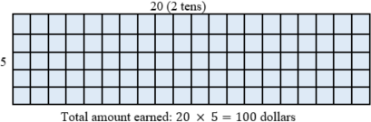

* + - As the teacher models the problem using expressions and models, students should be prompted to identify the components of each so they can relate values and visuals back to the real-world situation. (E.g., “What does the expression $\left(15+5\right)$ represent?” “Why is the sum multiplied by 5?” “Could I have multiplied differently using the distributive property?”
    - The teacher repeats with additional two-step problems, guiding students to create appropriate models to support problem-solving
  + For example, the teacher reads aloud the following problem: “Antwan is helping the art teacher get ready for art club. There are a total of 30 paintbrushes. The art teacher asked Antwan to put 6 paintbrushes on each of the 4 tables in the room and then put the rest on the counter. How many paint brushes will he put on the counter?”
    - The teacher uses questioning to ensure comprehension (e.g., “What do you need to find out?” “What do the quantities represent in the problem?” “What will the solution represent in the problem?”).
    - The teacher models the problem using counters, prompting the students to demonstrate each step of the problem while writing the corresponding equations for each step.



6 × 4 = 24

30 – 24 = 6

* + - The teacher repeats this strategy with additional two-step problems, guiding students to create appropriate models using manipulatives to support problem- solving. Some students may benefit from “acting out” the story in the problem to support the problem-solving process.
  + Instruction includes guided practice identifying and completing two steps in a real-world problem. The teacher uses guided questioning to support comprehension considering levels of reading proficiency for students who may struggle with word problems—some students may need to hear the problems read aloud. The teacher uses explicit prompts for each step.
    - For example, the teacher reads aloud the following problem: “Suni is taking piano lessons. Her piano teacher told her to practice for 90 minutes this week. On Monday, she practiced 15 minutes. She practiced 20 minutes on Tuesday and 25 minutes on Wednesday. How much more time does she still need to practice this week?”
  + The teacher uses guided questioning and prompts to help students to identify the steps (e.g., “What do you already know?” “What do you need to find out?” “What do we need to do before we can find out the remaining time she has left to practice?”). Through questioning, the teacher guides students to identify the first step: adding the amount of time Suni has already practiced.
  + The teacher uses a model to represent the problem and an equation to represent the first step.

15 + 20 + 25 = 60

* + - After students complete the first step, the teacher uses questioning to prompt next step (e.g., “What does the sum we just found show us?” “What do you need to find out to solve this problem?” “What should we do next?”). The problem may need to be reread aloud.

15 + 20 + 25 = 60

60 + = 90

90 − 60 = 30 minutes

|  |  |  |  |
| --- | --- | --- | --- |
| Monday | Tuesday | Wednesday | Remaining Time |
| 15 | 20 | 25 | ? |
| Total = 90 minutes | | | |

* + - The teacher repeats with additional two-step problems, guiding students to identify and solve each step.
  + For example, the teacher reads aloud the following problem: Rahim is learning about instruments in music class. He learns that guitars have six strings and mandolins have four strings. If there are three guitars and four mandolins in the classroom, how many strings are there altogether on the guitars and mandolins?
    - The teacher uses guided questioning and prompts to help students to identify the steps (e.g., “What do you already know?” “What do you need to find out?” “What do we need to do before we can find out the remaining time she has left to practice?”). Through questioning, the teacher guides students to identify the first step: Multiplying the number of strings by the number of each instrument.
    - The teacher guides the students to create a model (using manipulatives such as counters) with corresponding equations.

3 × 6 = 18

4× 4 = 16

* + - After students complete the first step, the teacher uses questioning to prompt next step (e.g., “What have we learned about the numbers of strings?” “What do you need to find out to solve this problem?” “What should we do next?”). The problem may need to be reread aloud.

18 + 16 = 34 total strings

* + - The teacher repeats with additional two-step problems, guiding students to identify and solve each step using manipulatives. Some students may benefit from “acting out” the story in the problem to support the problem- solving process.

Instructional Tasks

*Instructional Task 1*

Solve the problem. Oak Hill Elementary third grade students are taking a field trip to the zoo. There are 71 students who paid to attend the field trip. Of those that paid, 8 students cannot go on the day of the trip. There needs to be 7 groups at the zoo and each group must have an equal number of students. How many students will be in each group on the field trip?

*Instructional Task 2*

Rae buys one flower each day for one week (7 days). At the end of the week, she has $12 left. If Rae started the week with $33, how much did she spend each day for a flower?

*Instructional Task 3*

Everglades Elementary School is going on a field trip to the zoo. An additional 6 students are transported by van. Each bus holds 54 students and there are 4 buses. How many students are brought on the field trip in all?

*Instructional Item 4*

Noelle has $592 saved in her piggy bank. This week, she earned an additional $12 for babysitting. If she buys a computer for $390 next week, how much money will she have left*?*

Instructional Items

*Instructional Item 1*

For a school food drive, three students bring in cases of canned goods to donate. Uriel brings 4 cases, Paola brings 6 cases, and Mika brings 5 cases. Each case contains 8 canned goods. How many canned goods in all does the school collect?

*Instructional Item 2*

A bookstore has 8 boxes of books. Each box contains 10 books. On Monday, the bookstore sold 16 books. How many books remain to be sold?

*Instructional Item 3*

At a carnival, Olivia’s family spent $86 in all. They spent $30 on snacks. The rest of the money was spent on tickets to enter the carnival. If there are seven people in Olivia’s family, how much did each ticket cost*.*

*The strategies, tasks and items included in the B1G-M are examples and should not be considered comprehensive.

**MA.3.AR.2** *Develop an understanding of equality and multiplication and division*

### MA.3.AR.2.1

Benchmark

MA.3.AR.2.1 Restate a division problem as a missing factor problem using the relationship between multiplication and division.

Example: The equation 56 ÷ 7 =? can be restated as 7 ×? = 56 to determine the quotient is 8.

Benchmark Clarifications:

*Clarification 1:* Multiplication is limited to factors within 12 and related division facts.

*Clarification 2:* Within this benchmark, the symbolic representation of the missing factor uses any symbol or a letter.

Connecting Benchmarks/Horizontal Alignment

* MA.3.NSO.2.2
* MA.3.NSO.2.4
* MA.3.AR.1.2

Terms from the K-12 Glossary

* Equation
* Factor

Vertical Alignment

|  |  |
| --- | --- |
| **Previous Benchmarks**   * MA.1.AR.2.1, * MA.2.AR.2.1 | **Next Benchmarks**   * MA.4.AR.2.1 |

Purpose and Instructional Strategies

The purpose of this benchmark is to build students’ fluency with division facts by relating them

to known multiplication facts. Division is often more challenging for students than multiplication, so relating division to multiplication helps to determine quotients more efficiently. Students learned a similar strategy when relating subtraction to addition in Grade 1 (MA.1.AR.2.1).

* + Instruction should have students build and use fact families to relate division and multiplication equations. It is important for students to understand that multiplication and division are inverse operations. During instruction, students should have practice with solving and explaining division problems that can also be represented as an unknown factor in multiplication problems *(MTR.3.1, MTR.5.1)*.
  + To help students understand the relationships between division problems and unknown factor problems conceptually (and to build understanding about fact families), teachers can utilize arrays that show 4 related multiplication and division facts. In addition to arrays, instruction of this standard pairs well with MA.3.AR.1.2 while students solve one- and two-step real-world problems. When students translate problem contexts to division equations, this benchmark helps students find solutions *(MTR.3.1, MTR.5.1).*

Common Misconceptions or Errors

* Students may have difficulty understanding that the quotient of a division equation will become a factor in a multiplication equation. Allowing students to use an array model and/or reinforcing fact families may help to clarify the relationship.

Strategies to Support Tiered Instruction

* Instruction includes opportunities to use array models to practice relating multiplication and division as inverse operations. The teacher shows an array model and guides students to identify the factors and the product, having them assist in writing the corresponding equation. The teacher guides students to complete the fact family using prompts as needed, reminding them that multiplication and division are inverse operations. After practicing with several examples, students practice completing fact families without arrays, solving for an unknown factor.
  + For example, students draw an array model to show 3 × 7.

Graphic to explain example 

3 × 7 = 21

7 × 3 = 21

21 ÷ 7 = 3

21 ÷ 3 = 7

* + For example, the students write the fact family and solve for 42 ÷ 6.

42 ÷ 6 = 42 ÷ 6 = 7

42 ÷ = 6 42 ÷ 7 = 6

6 × = 42 6 × 7 = 42

× 6 = 42 7 × 6 = 42

* Teacher provides opportunities to use manipulatives to practice relating multiplication and division as inverse operations. The teacher guides students to develop a model using manipulatives (e.g., counters or base-ten blocks) and uses explicit instruction and questioning to help students to identify the related equation. Additionally, the teacher guides students to complete the fact family using explicit instruction, verbal prompts and nonverbal cues while reminding students that multiplication and division are inverse operations. After practicing with several examples, students practice completing fact families without arrays, solving for an unknown factor with the support of number cards.
  + For example, the teacher uses counters to show an array to represent 4 × 8 and asks guiding questions to help students build the array. With prompting, the teacher guides students to identify the product and write the complete fact family



4 × 8 = 32

8 × 4 = 32

32 ÷ 8 = 4

32 ÷ 4 = 8

* + For example, students use number cards to rearrange equations to create all four parts to the fact family and solve for a missing factor. Students may also write on notecards for this activity. One card should have the multiplication symbol on one side and the division symbol on the other. The teacher uses a blank card for the missing factor until the students solve. Students move each card to a different location to build the entire fact family and record each equation on a sheet of paper or personal white board as they manipulate the cards.

Instructional Tasks

*Instructional Task 1*

Part A. Write a multiplication equation that can be used to find the quotient 48 ÷ 12. Use *n*

to represent the unknown factor.

Part B. What is the quotient?

*Instructional Task 2*

Use the properties of operations to explain why both equations below can be used to find the quotient of 42 and 6.

$6×n=42$

$n×6=42$

*Instructional Task 3*

Yashira wants to find the quotient of $63÷7$ by rewriting it as a multiplication equation. She is not sure if she should use $7× ?= 63$ or $7×63= ?$ to find her answer. Use the properties of operations to justify your answers for the questions below.

Part A. Which equation should Yashira use to find the quotient of 63 and 7? Why?

Part B. Why will the other equation not work?

Instructional Items

*I**nstructional Item 1*

Which of the following equations can be used to find the quotient 72 ÷ 8 ?

a. 8 × ? = 72

b. 72 × 8 = ?

c. 72 − 8 = ?

d. ? + 8 = 72

*The strategies, tasks and items included in the B1G-M are examples and should not be considered comprehensive.

### MA.3.AR.2.2

Benchmark

MA.3.AR.2.2 Determine and explain whether an equation involving multiplication or division is true or false.

*Example:* Given the equation 27 ÷ 3 = 3 × 3, it can be determined to be a true equation by dividing the numbers on the left side of the equal sign and multiplying the numbers on the right of the equal sign to see that both sides are equivalent to 9.

Benchmark Clarifications:

*Clarification 1:* Instruction extends the understanding of the meaning of the equal sign to multiplication and division.

*Clarification 2:* Problem types are limited to an equation with three or four terms. The product or quotient can be on either side of the equal sign.

*Clarification 3:* Multiplication is limited to factors within 12 and related division facts.

Connecting Benchmarks/Horizontal Alignment

* MA.3.NSO.1.3
* MA.3.NSO.2.2
* MA.3.NSO.2.4
* MA.3.AR.1.2

Terms from the K-12 Glossary

* Equation
* Equal Sign
* Expression

Vertical Alignment

|  |  |
| --- | --- |
| **Previous Benchmarks**   * MA.2.AR.2.1 | **Next Benchmarks**   * MA.4.AR.2.1 |

Purpose and Instructional Strategies

The purpose of this benchmark is to extend the understanding of the meaning of the equal sign in multiplication and division situations. In Grades 1 and 2, students determined and explained when addition and subtraction equations were true or false by comparing the equivalence of the expression on each side of the equal sign *(*MA.1.AR.2.2, MA.2.AR.2.1*)*.

* + Instruction should emphasize that the equal sign can be read as “the same as” to show the balance of two multiplication and/or division expressions. When those expressions are evaluated as the same product or quotient, the equation is balanced, or true. If those expressions evaluate differently, then the equation is not balanced, or false *(MTR.2.1, MTR.5.1)*.
  + When students explain whether an equation is true or false, they should justify by explaining the equivalence of its expressions. (Note: The expectation of this benchmark is not to compare the expressions of a false equation using symbols of inequality, < or

>.) *(MTR.4.1, MTR.6.1*).

Common Misconceptions or Errors

* + By Grade 3, students may grow to expect equation solutions to be represented as the expressions on the right side of the equal sign. When having students evaluate true or false equations with only three terms (e.g., 18 = 3 × 6), instruction includes examples showing products and quotients on the left side.

Strategies to Support Tiered Instruction

* Instruction includes opportunities to explore the meaning of the equal sign. The teacher provides clarification that the equal sign means “the same as” rather than “the answer is.” Multiple examples are provided to evaluate equations as true or false using the four operations with the answers on both the left and right side of the equation, beginning by using single numbers on either side of the equal sign to build understanding. The same equations are written in different ways to reinforce the concept.
  + For example, the teacher shows the following equations, asking students if they are true or false statements. Students explain why each equation is true or false, repeating with additional true and false equations using the four operations.

|  |  |  |
| --- | --- | --- |
| Example | True/False | Sample Student Rationale |
| 5 = 5 | True | They are both the same number; five is  the same as five. |
| 9 = 3 | False | Nine and three have different values;  they are not the same. |
| 2 + 11 = 13 | True | When you add two and eleven, the total  has a value of thirteen. |
| 13 = 2 + 11 | True | The value of thirteen is the same as the  value of two and eleven combined. |
| 4 + 2 = 42 | False | The sum of four and two is six, not forty-  two. |
| 25 − 5 = 20 | True | When you take five away from twenty-  five, the difference is twenty. |
| 20 = 25 − 5 | True | The value of twenty is the same as the  difference between twenty-five and five. |
| 20 = 25 + 5 | False | The value of twenty-five plus five is thirty, not twenty. |
| 4 + 1 = 2 + 3 | True | Four plus one has a value of five. Two  plus three also has a value of five. |
| 2 × 3 = 8 − 2 | True | Two times three has a value of six. Eight  minus two also has a value of six. |
| $$63 ÷ 7=3×3$$ | True | The quotient of 63 and 7 is nine. The product of 3 and 3 is also nine. |
| $$42 ÷ 6=2×4$$ | False | The quotient of 42 and 6 is 7. The product of 2 and 4 is 8. |

* Teacher provides opportunities to explore the meaning of the equal sign using visual representations (e.g., counters, drawings, base-ten blocks) on a table to represent equations. The teacher provides clarification that the equal sign means “the same as” rather than “the answer is.” Multiple examples are provided for students to evaluate equations as true or false using the four operations with the answers on both the left and right side of the equation, beginning by using single numbers on either side of the equal sign to build understanding. The same equations are written in different ways to reinforce the concept.
  + For example, the teacher shows the following equations. Students use counters, drawings, or base-ten blocks on a t-chart to represent the equation. The teacher asks students if they are true or false statements and has them explain why each equation is true or false, repeating with additional true and false equations using the four operations

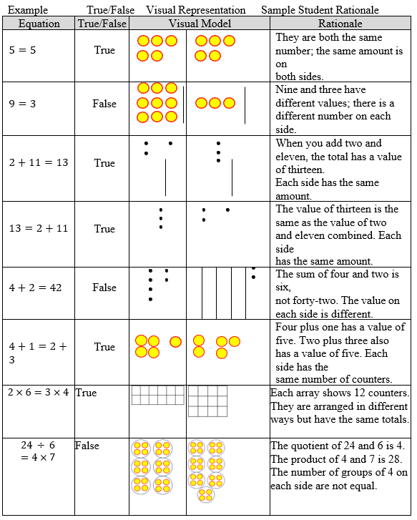

Instructional Tasks

*Instructional Task 1*

Two equations are below. One equation is true, and the other equation is false. Choose one of the equations and explain why it is true or false.

2 × 3 = 4 × 6 2 × 12 = 4 × 6

*Instructional Task 2*

Part A. Use the numbers below to fill in the blanks so that the equations are true. Use all four numbers once in each equation.

2, 3, 8, 12

$×$___ ___ = $×$

$÷$___ ___

___ ___ = $÷$

___ ___

Part B. How could you rewrite each equation so that it is still true?

*Instructional Task 3*

Explain why the equation $7×8=8×7$ is true. Use the properties of operations to justify your answer.

Instructional Items

*Instructional Item 1*

Which of the following describes the equation 16 ÷ 2 = 36 ÷ 9 ?

1. This equation is true because the expressions on each side have a quotient of 8.
2. The equation is true because the expressions on each side have a quotient of 4.
3. This equation is false because the expressions on each side have a quotient of 8.
4. This equation is false because the quotient on the left is 8 and the quotient on the right is 4.

*Instructional Item 2*

Explain why the division equation $50=10÷5$ is true or false. If the equation is false, rewrite it so that it is true.

*Instructional Item 3*

Which value for *n* makes the equation below true?

$$9×4=n×6$$

1. 4
2. 6
3. 7
4. 8

.

*The strategies, tasks and items included in the B1G-M are examples and should not be considered comprehensive.

### MA.3.AR.2.3

Benchmark

MA.3.AR.2.3 Determine the unknown whole number in a multiplication or division equation, relating three whole numbers, with the unknown in any position.

Benchmark Clarifications:

*Clarification 1:* Instruction extends the development of algebraic thinking skills where the symbolic representation of the unknown uses any symbol or a letter.

*Clarification 2:* Problems include the unknown on either side of the equal sign.

*Clarification 3:* Multiplication is limited to factors within 12 and related division facts. Refer to Situations Involving Operations with Numbers (Appendix A).

Connecting Benchmarks/Horizontal Alignment

* MA.3.NSO.2.2/2.4
* MA.3.AR.1.2

Terms from the K-12 Glossary

* Equation
* Expression

Vertical Alignment

|  |  |
| --- | --- |
| **Previous Benchmarks**   * MA.2.AR.2.2 | **Next Benchmarks**   * MA.4.AR.2.2 |

Purpose and Instructional Strategies

The purpose of this benchmark is for students to find an unknown value represented by a symbol or letter in a multiplication or division equation, continuing the work from Grade 2, where students found unknown values in addition and subtraction equations.

* Instruction that emphasizes the relationship between related facts in a fact family helps students use known values to solve for unknown values. For example, a fact family could be used to help students determine the unknown value in the equation 72 ÷ ? = 9 *(MTR.5.1)*.

72 ÷ ? = 9

72 ÷ 9 =?

9 × ? = 72

? × 9 = 72

* Students can use any of these related facts to determine that the unknown value is 8. Teachers should encourage students to use such equations to justify their solutions *(MTR.6.1)*.
* In the primary grades, students used fact families to find missing addends and understand the relationship between addition and subtraction.
* Understanding and using related facts to solve for unknown values is an important algebraic understanding for using inverse operations to solve equations in future mathematics courses *(MTR.5.1*.

Common Misconceptions or Errors

* + By Grade 3, many students expect the solutions of equations to be an expression on the right side of the equal sign. When students determine unknown values in multiplication or division equations, give examples with the product or quotient on the left side.

Strategies to Support Tiered Instruction

* Instruction includes opportunities to explore the meaning of the equal sign within the context of multiplication and division. The teacher provides clarification that the equal sign means “the same as” rather than “the answer is,” supporting the understanding that the product and quotient can be on either the left or the right side of the equal sign and that both expressions have the same value.

Multiple examples are provided for students to solve for the unknown with the product or quotient on both the left and right side of the equation. The teacher uses the same equations written in different ways to reinforce the concept.

* + For example, the teacher shows the following equations, asking students to solve for the unknown. Students explain why each equation is true after solving, repeating with additional examples.

|  |  |  |
| --- | --- | --- |
| Example | Unknown | Sample Student Rationale |
| 3 × 5 = ? | 15 | Three groups of five is the same as fifteen. If I count by fives three times, I get fifteen. |
| 15 = × 5 | 3 | When I count by fives, I count three times  before I get to fifteen. |
| 4 = 24 ÷ | 6 | If I sort twenty-four into four equal groups,  there are six in each group. |
| ÷ 4 = 6 | 24 | Four groups of six in each group is twenty- four. If I count by fours, six times, I get twenty-four and multiplication and division  are inverse operations. |

* Teacher provides opportunities to explore the meaning of the equal sign within the context of multiplication and division using visual representations (e.g., counters, drawings, base-ten blocks) to represent the equations. The teacher provides clarification that the equal sign means “the same as” rather than “the answer is,” supporting the understanding that the product and quotient can be on either the left or the right side of the equal sign and that both expressions have the same value. Multiple examples are provided for students to solve for the unknown with the product or quotient on both the left and right side of the equation, using the same equations written in different ways to reinforce the concept.
  + For example, the teacher shows the following equations, asking students to solve for the unknown and explain why each equation is true after solving. Students use counters, drawings, or base-ten blocks to represent the equation, repeating with additional operations.

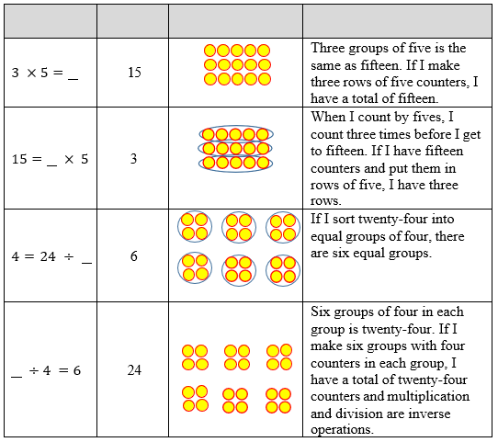

Instructional Tasks

*Instructional Task 1*

Sam is having trouble deciding whether the value of n that makes the equation below true is

4 or 36. Which number is correct? Show your thinking using an equation or visual model.

3 = 𝑛 ÷ 12

.

*Instructional Task 2*

How could Wendy use $6×7=42$ to help her find the value of the unknown number in the equation below?

$7× ?=42$

Instructional Items

*Instructional Item 1*

What value of 𝑛 makes the equation below true?

𝑛 ÷ 6 = 5

*Instructional Item 2*

What is the value of the unknown number in the equation 7 × 𝑛 = 56?

*Instructional Item 3*

What is the value of the unknown number in the equation below?

$132÷n=11$

*The strategies, tasks and items included in the B1G-M are examples and should not be considered comprehensive.

### **MA.3.AR.3** Identify numerical patterns, including multiplicative patterns

### MA. 3.AR.3.1

Benchmark

MA.3.AR.3.1 Determine and explain whether a whole number from 1 to 1,000 is even or odd.

Benchmark Clarifications:

*Clarification 1:* Instruction includes determining and explaining using place value and recognizing patterns.

Connecting Benchmarks/Horizontal Alignment

* MA.3.NSO.2.2/2.4
* MA.912.AR.1.1

Terms from the K-12 Glossary

Vertical Alignment

|  |  |
| --- | --- |
| **Previous Benchmarks**   * MA.2.AR.3.1 | **Next Benchmarks**  MA.4.AR.3.1 |

Purpose and Instructional Strategies

The purpose of this benchmark is for students to relate odd and even numbers to factors and multiples. In Grade 2, students learn to represent an even number using two equal groups or two equal addends and as odd number as two equal groups or two equal addends with one left over (MA.2.AR.3.1). In Grade 3, instruction extends to use patterns to generalize whether any number is odd or even *(MTR.2.1, MTR.5.1)*.

* Instruction connects multiples of 2 to the patterns that the ones digit in any even number is 0, 2, 4, 6, or 8. By teaching this benchmark with MA.3.AR.3.2, students can see that multiples of 2 can form any even number. If a number is not a multiple of 2, then the number is odd *(MTR.5.1)*.
* Building students’ understandings of multiples will help them explore factors and divisibility with prime and composite numbers in Grade 4.

Common Misconceptions or Errors

* + Students may confuse that the ones digit indicates whether it is even because it indicates if the number is a multiple of 2. For example, students may look at the number 883 is even because the digit 8 in the hundreds and tens places are even.

Strategies to Support Tiered Instruction

Instruction includes opportunities to practice identifying if multi-digit numbers are even or odd by using a place-value chart. The teacher explains that even numbers can be represented by two equal groups or two equal addends and that odd numbers can be represented by two equal groups or two equal addends with one left over while modeling using visual representations with several examples (e.g., drawings, tally marks).

* For example, the teacher uses visual representations to identify numbers are even or odd by sorting into two equal groups using drawings or tally marks and enters numbers into a place value chart while asking “What do you notice about the digits in the ones place?” Students should explain that even numbers all have digits in the ones place that are multiples of 2 (0, 2, 4, 6 or 8). Additional examples are used in the place-value chart to practice identifying if numbers are even or odd by looking at the digits in the ones place.

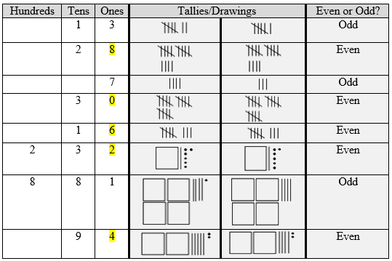

* For example, students use counters to identify if numbers are even or odd by sorting into two equal groups and enter numbers into a place value chart.

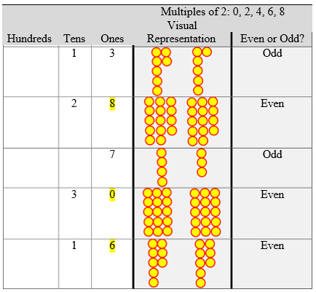

* As in the previous example, the students use counters by sorting into two equal groups. The teacher asks, “How many total counters are there, and what is the digit in the ones place?” Students should explain that even numbers all have digits in the ones place that are multiples of 2 (0, 2, 4, 6, or 8). Additional examples are used in the place-value chart to practice identifying if numbers are even or odd by looking at the digits in the ones place

Instructional Tasks

*Instructional Task 1*

Is the number 461 even or odd? Explain how you know.

*Instructional Task 2*

Kylie sees a pattern that whenever she multiplies a number by 2, the product is even. Explain why this is true using words, equations, or a visual model.

Instructional Items

*Instructional Item 1*

Determine whether the numbers are even or odd in the table below.

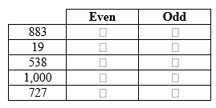

*Instructional Item 2*

Which place value in the number 3,480 indicates whether the number is even or odd?

1. 3 *thousands*
2. 4 *hundreds*
3. 8 *tens*
4. 0 *ones*

*\*The strategies, tasks and items included in the B1G-M are examples and should not be considered comprehensive.*

### 

### MA.32.AR.3.2

Benchmark

MA.3.AR.3.2 Determine whether a whole number from 1 to 144 is a multiple of a given one- digit number.

Benchmark Clarifications:

*Clarification 1:* Instruction includes determining if a number is a multiple of a given number by using multiplication or division.

Connecting Benchmarks/Horizontal Alignment

* MA.3.NSO.2.2/2.4

Terms from the K-12 Glossary

Vertical Alignment

|  |  |
| --- | --- |
| **Previous Benchmarks**   * MA.2.AR.3.2 | **Next Benchmarks**   * MA.4.NSO.2.1 * MA.4.AR.3.1 |

Purpose and Instructional Strategies

The purpose of this benchmark is for students to determine whether a whole number is a multiple of a given one-digit number (e.g., Is 45 a multiple of 5?). Understanding of multiples extends what students learned in Grade 2 about skip-counting (e.g., skip-counting by 2s results in multiples of 2). Building a strong foundational understanding of multiples prepares students for relating multiples and factors to prime and composite numbers in Grade 4 (MA.4.AR.3.1).

* Understanding of multiples extends from multiplication by expecting students to understand that the products of the given one-digit number and other factors create multiples of that one-digit number. For example, the products of $5×1, 5×2, 5×3,…$ are multiples of 5 (5, 10, 15,…). Understanding of multiples extends from division in that if a given whole number from 1 to 144 is divisible by a given-one- digit number (divisor), then that divisor is a multiple of the number (e.g., 45 is divisible by 5, therefore 45 is a multiple of 5) *(MTR.5.1)*.
* The focus of instruction should be on the vocabulary of multiples as it relates to multiplication and division. Students should first have a strong understanding of how multiplication and division relate before developing their knowledge of multiples. Instruction can include real-world applications (e.g., Can 45 cookies be placed into 5 bags with an equal number in each bag?) *(MTR.4.1, MTR.5.1)*.

Common Misconceptions or Errors

* + When listing multiples of numbers, students may not list the number itself. It is important to emphasize that the smallest multiple is the number itself. Having students write multiples of a number by consecutive factors beginning with one.

Strategies to Support Tiered Instruction

* Instruction includes opportunities to write multiples of a number by consecutive factors beginning with the factor,1.
* Instruction includes opportunities to connect finding multiples to skip counting.
  + For example, to find the multiples of 8, students can generate lists of multiples beginning with 1 × 8. Their generated list should include each of the counting numbers through 12 × 8. Students model generating multiples with counters. The teacher asks students to make one group of 8, having them record how many counters there are in an equation (1 × 8 = 8). Next, students add another group of 8, recording the number of counters in an equation (2 × 8 = 16). Students add more groups of 8 while recording the number of counters they have in an equation. Students should make all multiples of 8 through 12 × 8 = 96. When students have created their multiples, they record the products in a horizontal list in order from 1 × 8 = 8 to 12 × 8 = 96 and explain the connection between the products in their equations and the multiples in their list.

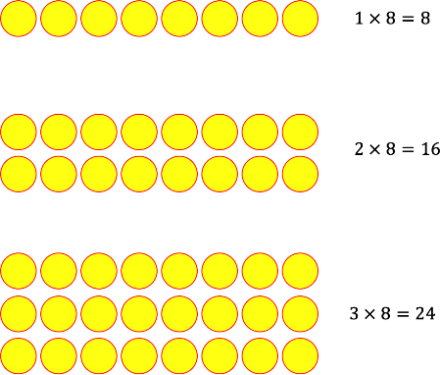

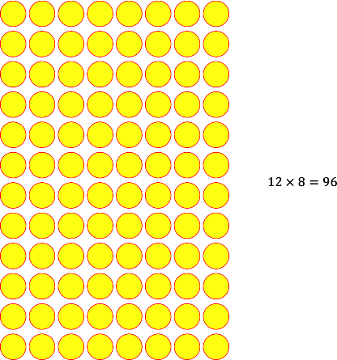

Multiples of 8: 8, 16, 24, 32, 40, 48, 56, 64, 72, 80, 88, 96

Instructional Tasks

*Instructional Task 1*

Use a visual model or write an equation to show whether 27 is a multiple of 3.

*Instructional Task 2*

Use a visual model or write an equation to show whether 36 is a multiple of 8.

*Instructional Task 3*

Penelope says that when she counts by 6s, the numbers are also multiples of 3.

6, 12, 18, 24,…

Is she correct or incorrect? Explain.

Instructional Items

*Instructional Item 1*

Select all the numbers below that are multiples of 8.

|  |  |
| --- | --- |
| a. | 28 |
| b. | 56 |
| c. | 18 |
| d. | 24 |
| e. | 30 |

*Instructional Item 2*

Which number is NOT a multiple of 3?

1. 30
2. 32
3. 33
4. 36

*\*The strategies, tasks and items included in the B1G-M are examples and should not be considered comprehensive.*

### MA.3.AR.3.3

Benchmark

MA.3.AR.3.3 Identify, create and extend numerical patterns.

*Example:* Bailey collects 6 baseball cards every day. This generates the pattern 6, 12, 18, … How many baseball cards will Bailey have at the end of the sixth day?

Benchmark Clarifications:

*Clarification 1:* The expectation is to use ordinal numbers (1st, 2nd, 3rd, …) to describe the position of a number within a sequence.

*Clarification 2:* Problem types include patterns involving addition, subtraction, multiplication or division of whole numbers.

Connecting Benchmarks/Horizontal Alignment

* MA.3.NSO.2.2/2.4

Terms from the K-12 Glossary

Vertical Alignment

|  |  |
| --- | --- |
| **Previous Benchmarks**   * MA.K.NSO.1.3 | **Next Benchmarks**   * MA.4.AR.3.2 |

Purpose and Instructional Strategies

The purpose of this benchmark is for students to identify, create and extend numerical patterns using all four operations. Understanding of ordinal numbers from Kindergarten is the foundation for describing the sequence of numbers in a pattern.

* *Identifying* a numerical pattern requires students to determine when a pattern exists in a sequence of numbers, and to determine a possible rule that can be used to find each term in the sequence. For example, students may be asked whether a pattern exists in the numbers 20, 17, 14, 11,... and to discuss various rules that could be used to determine the next term.
* *Creating* a numerical pattern requires students to write a pattern given a rule and starting value. For example, students may be asked to write the first five terms of a sequence that begins with 500 and then create each successive term by subtracting 35 from the previous term.
* Finally, *extending* asks students to identify a future term in a sequence when provided with a rule. For example, students may be asked to find the next three terms in which each term is multiplied by 2 to get the next term 2: 1, 2, , , *(MTR.2.1, MTR.5.1)*.
* Instruction of this benchmark can begin by relating patterns to skip-counting to explore patterns in sequences of numbers and look for relationships in the patterns and be able to generalize possible rules When exploring patterns, teachers can allow for students to describe pattern rules flexibly. For example, in the pattern 6, 12, 18,…, one student may describe the pattern’s rule as “add 6.” Another student may describe the rule as, “add 7, then subtract 1” or “list the multiples of 6.” Classroom discussion could compare these rules *(MTR.2.1, MTR.4.1)*.
* Instruction should be limited to whole numbers and operations that are appropriate for Grade 3.
* This foundation for identifying and using patterns extends into Grades 4 and 5 to build algebraic thinking for functions in middle and high school.

Common Misconceptions or Errors

* + Students can confuse a term’s number and its value in the sequence. For example, in the pattern 6, 12, 18,…, students can struggle to understand that even though 12 is the 2nd term, 6 is being added to it to find the value of the 3rd term (18). Encourage students to use precise vocabulary while describing patterns to address this confusion.

Strategies to Support Tiered Instruction

* Instruction includes explicit vocabulary instruction regarding patterns (first term, second term, third term…, rule, value, etc.). Instruction also includes relating the pattern to skip counting where appropriate.
  + Example.

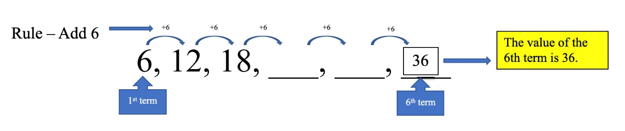

* + For example, a 100 chart may be a referent that can be used for arithmetic patterns. The teacher makes connections between the rule and counting on the 100s chart.

Rule – Add 6 Value of the 6th Term – 34

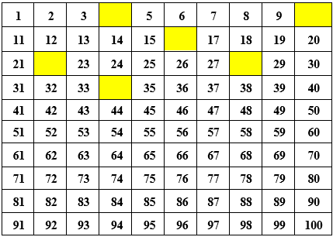

Instructional Tasks

*Instructional Task 1*

Part A. Write a pattern that shows the first 10 multiples of 6.

Part B. What do you notice about the ones digits of the pattern’s numbers?

Part C. What would you expect the ones digit of the 12th multiple to be? Explain how you know using the pattern you.

*Instructional Task 2*

Part A. The rule of the pattern below is “add 8.” What is the missing number?

14, 22, __, 38,…

Part B. If you extend the pattern, will all the values be odd or even?

*Instructional Task 3*

The third number in a pattern is 17. If the rule is to “subtract 3,” what are the values of the first and second numbers in the pattern?

Instructional Items

*Instructional Item 1*

What are the fourth and fifth terms of the sequence below that follows the rule “subtract 4”?

34, 30, 26, ,

*Instructional Item 2*

The rule of the pattern below is a “multiply by 2.” What are the values of the third and fourth numbers in the pattern?

3, 6, 12, ___, ___

* + - 1. 15, 18
      2. 18, 24
      3. 24, 48
      4. 15, 30

*Instructional Item 3*

A pattern starts with the number 19. The rule of the pattern is to add 4. Which of the following will not be a number in the pattern?

1. 23
2. 27
3. 30
4. 35

*\*The strategies, tasks and items included in the B1G-M are examples and should not be considered comprehensive.*

Measurement

**MA.3.M.1** *Measure attributes of objects and solve problems involving measurement.*

### MA.3.M.1.1

Benchmark

MA. 3.M.1.1 Select and use appropriate tools to measure the length of an object, the volume of liquid within a beaker and temperature.

Benchmark Clarifications:

*Clarification 1:* Instruction focuses on identifying measurement on a linear scale, making the connection to the number line.

*Clarification 2:* When measuring the length, limited to the nearest centimeter and half or quarter inch.

*Clarification 3:* When measuring the temperature, limited to the nearest degree.

*Clarification 4:* When measuring the volume of liquid, limited to nearest milliliter and half or quarter cup.

Connecting Benchmarks/Horizontal Alignment

* MA.3.FR.1.1/1.2
* MA.3.FR.2.1/2.2
* MA.3.GR.1.2
* MA.3.GR.2.3/2.4

Terms from the K-12 Glossary

Vertical Alignment

|  |  |
| --- | --- |
| **Previous Benchmarks**   * MA.2.M.1.1/1.2 | **Next Benchmarks**   * MA.4.M.1.1 |

Purpose and Instructional Strategies

The purpose of this benchmark is for students to choose appropriate tools to measure length, liquid volume, and temperature. In Grade 3, students continue to build their understanding of measuring lengths from Grades 1 and 2. In Grade 3, they also measure liquid volume and temperature.

* Instruction should connect students’ understandings about number lines and rulers to tools that measure liquid volume and temperature. This will help students make sense of measuring units (including half and quarter) with different tools *(MTR.1.1, MTR.2.1)*.
* Instruction includes having students measure liquid volume with different scientific beakers and glass measuring cups so that both metric and customary units are used.
* Connecting instruction of this benchmark with MA.3.M.1.2 will allow for students to choose appropriate tools when given problems in real-world contexts.
* Instruction can model and allow students to interact with hands-on activities to choose tools and measure appropriately.

Common Misconceptions or Errors

* Students who struggle to identify benchmarks on number lines can also struggle to measure units of length, liquid volume, and temperature. Instruction can have students measure often and provide feedback. Students can also complete error and reasoning analysis activities to identify this common measurement difficulty.

Strategies to Support Tiered Instruction

* Instruction includes opportunities to measure often and provide feedback. Use error and reasoning analysis activities to address common measurement difficulties. Error analysis activities can feature both computational and conceptual errors. When presenting an error analysis activity during instruction, teachers can indicate to students that an error is present. From there, the students can identify the error and make recommendations to coach through the error so that it is not made again. Errors can be student- or teacher-generated, the latter of which allows for the teacher to show a specific skill or conceptual issue to the student in a purposeful way. Student-generated errors shown anonymously support a safe environment.
* Instruction includes opportunities to find the locations of points on number lines. Number lines should be represented vertically and horizontally. Instruction includes whole number values and fractions, including fractions greater than one.
  + For example, number lines may be included with benchmarks instead of every number in the sequence included. The blue line below extends from the 0 mark on the number line to the first hashmark beyond 2. The dot plotted on the number line identifies the end of the blue line. Since each whole number interval is partitioned into four equal parts, the first hashmark beyond 2 is represented as

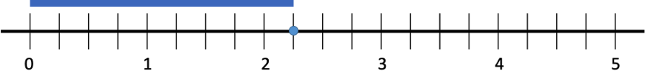

* + For example, number lines can also have all numbers included to represent the values between the benchmarks.

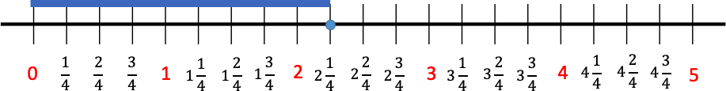

Instructional Tasks

*Instructional Task 1*

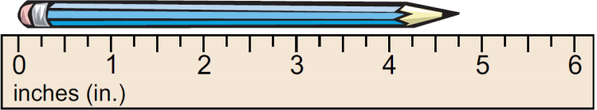Jonah measures the length of his pencil.

Part A. What is the length of his pencil, in inches?

Part B. Why is a ruler an appropriate tool for Jonah to measure the pencil’s length

*Instructional Task 2*

Three thermometers



Use the thermometers above to help you answer the questions. All temperatures are in Fahrenheit.

Part A. What is the temperature on the red thermometer?

Part B. Naomi says that the temperature on the red thermometer is higher than the total temperature of the blue thermometer and the yellow thermometer. Is she correct? How do you know?

Part C. Santiago said that he found the sum of the three temperatures and that it was less than $70°$. Do you agree with him? Why or why not.

*Instructional Task 3*

A group of beakers with blue liquid



A B C D

Four containers are shown holding a blue liquid. Each liquid is measured in milliliters. Demitri says that the flask on the right (Container D) is holding the most liquid. Briana says the graduated cylinder (Container C) is holding the most liquid.

Part A. Which student is correct? Explain.

Part B. What measuring mistake do you think the other student made? Explain.

Part C. Order the containers by the amount of liquid they hold in ascending order.

Instructional Items

*Instructional Item 1*

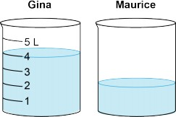Gina and Maurice have same-sized containers filled with different amounts of water, as shown. Gina’s container has 4 liters of water. About how much water, in liters, does Maurice’s container have.

*Instructional Item 2*

Jillian is using an old measuring cup and some of the numbers can no longer be read. What is the missing value that shows the approximate measurement of liquid.

A measuring cup with blue liquid




*Instructional Item 3*

Monica brought home a young bearded dragon. How many centimeters long is her bearded dragon?

A lizard with a ruler



*Instructional Item 4*

*A thermometer showing the temperature

*

The thermometer shows the temperature of the liquid inside a graduated cylinder. What is the temperature in degrees Fahrenheit?

*\*The strategies, tasks and items included in the B1G-M are examples and should not be considered comprehensive.*

### MA.3.M.1.2

Benchmark

MA.3.M.1.2 Solve real-world problems involving any of the four operations with whole- number lengths, masses, weights, temperatures or liquid volumes.

*Example:* Ms. Johnson’s class is having a party. Eight students each brought in a 2-liter bottle of soda for the party. How many liters of soda did the class have for the party?

Benchmark Clarifications:

*Clarification 1:* Within this benchmark, it is the expectation that responses include appropriate units.

*Clarification 2:* Problem types are not expected to include measurement conversions.

*Clarification 3:* Instruction includes the comparison of attributes measured in the same units. *Clarification 4:* Units are limited to yards, feet, inches; meters, centimeters; pounds, ounces; kilograms, grams; degrees Fahrenheit, degrees Celsius; gallons, quarts, pints, cups; and liters, milliliters.

Connecting Benchmarks/Horizontal Alignment

* MA.3.FR.1.1/1.2
* MA.3.FR.2.1/2.2
* MA.3.AR.1.2
* MA.3.GR.1.2
* MA.3.GR.2.3/2.4

Terms from the K-12 Glossary

Vertical Alignment

|  |  |
| --- | --- |
| **Previous Benchmarks**   * MA.2.M.1.3 | **Next Benchmarks**   * MA.4.M.1.2 |

Purpose and Instructional Strategies

The purpose of this benchmark is for students to apply what they have learned about measurement to solve real-world problems. This work extends from the Grade 2 expectation to solve one- and two-step real-world measurement problems involving addition and subtraction of lengths given in the same units (MA.2.M.1.3).

* + When solving real-world problems, instruction can facilitate students understanding of contexts and quantities *(MTR.4.1, MTR.5.1, MTR.7.1)*.
  + Recommendations for helping students comprehend and solve real-world problems can be found in this document for benchmark MA.3.AR.1.2.

Common Misconceptions or Errors

* Students who struggle to identify benchmarks on number lines can also struggle to measure units of length, liquid volume, and temperature. Allow students to measure often and receive feedback. Students can also use error and reasoning analysis activities to identify this common measurement difficulty.
* Students may have difficulty creating effective models (e.g., drawings, equations) that will help them solve real-world problems. To assist students, provide opportunities for them to estimate solutions and try different models before solving. Beginning instruction by showing problems without their quantities is a strategy for helping students determine what steps and operations will be used to solve.
  + Students can struggle to identify when real-world problems require two steps to solve and will complete only one of the steps. Focusing on comprehension of real-world problems helps students determine what step(s) are required to solve.

Strategies to Support Tiered Instruction

* Instruction includes providing opportunities to estimate solutions and try different models before solving. Instruction begins by showing problems without their quantities to determine what steps and operations will be used to solve. Teaching problem-solving strategies builds comprehension of problem contexts and what quantities represent in them.
  + For example, “For a science experiment in Mr. Thomas’s class, each student needs ***some*** milliliters of water. If there are ***some*** students in Mr. Thomas’s class, how many milliliters will be needed in all?” Students will notice that the quantities have been removed from the problem. This will help them to determine what the quantities represent and which operation to choose to solve the problem. The numberless word problem may also be written as students × milliliters of water = milliliters needed in all.
* Teacher encourages exploration of estimation strategies to determine reasonable ranges for solutions (e.g., rounding, finding low and high estimates) and teach problem-solving strategies that build comprehension?
  + For example, the 3-Reads Protocol is a close reading strategy for solving problems that focuses on comprehension of the word problem.
    - The problem is read 3 times, each for a different purpose.
      * What is the problem, context, or story about?
      * What are we trying to find out?
      * What information is important in the problem?

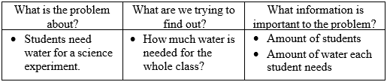

* Instruction includes opportunities to measure often and provide feedback. Use error and reasoning analysis activities to address common measurement difficulties.
* Instruction includes opportunities to find the locations of points on number lines. Number lines represented both vertically and horizontally will help students build measurement skills. Instruction includes whole number values and fractions, including fractions greater than one.
  + For example, number lines should be included with benchmarks instead of every number in the sequence included. The blue line below extends from the 0 mark on the number line to the first hashmark beyond 2. The dot plotted on the number line identifies the end of the blue line. Since each whole number interval is partitioned into four equal parts, the first hashmark beyond 2 is represented as $2\frac{1}{4}$
  + For example, number lines can also have all numbers included to represent the values between the benchmarks.
  + For example, teaching problem-solving strategies can focus on the comprehension of problem contexts and what quantities represent in them.
* Instruction includes an emphasis on teaching problem-solving strategies, focusing on the comprehension of problem contexts and what quantities represent in them.
  + For example, questions that help students comprehend word problems are:
    - What is happening in the real-world problem?
    - What do you need to find out?
    - What do the quantities represent in the problem?
    - What will the solution represent in the problem?
  + For example, “For a science experiment in Mr. Thomas’s class, each student needs 8 milliliters of water. If there are 23 students in Mr. Thomas’s class, how many milliliters will be needed in all

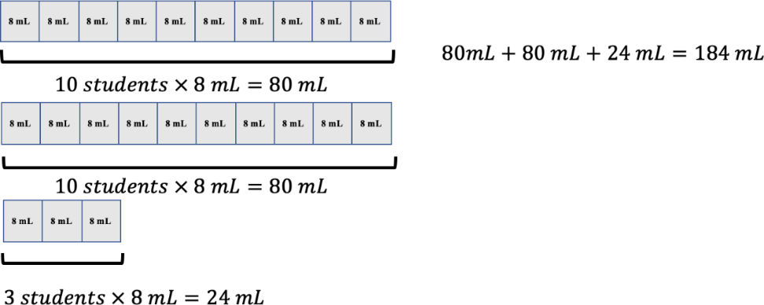

* Teacher guides exploration in estimation strategies to determine reasonable ranges for solutions (e.g., rounding, finding low and high estimates) and teaches problem-solving strategies that build comprehension (e.g., Three Reads).
  + For example, the 3-Reads Protocol is a close reading strategy for solving problems that focuses on comprehension of the word problem.
    - The problem is read 3 times, each for a different purpose.
      * What is the problem, context, or story about?
      * What are we trying to find out?
      * What information is important in the problem?

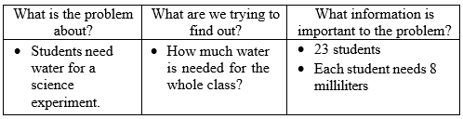

Instructional Tasks

*Instructional Task 1*

Each year, the Tallahassee Pumpkin Festival hosts a contest to find the largest pumpkin grown that season. The winner of the competition has the greatest mass, in grams. The masses of the contest entries are in the table below.

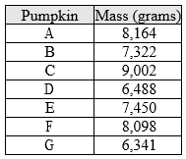

Part A. Which pumpkin won the contest?

Part B. What is the difference of the mass, in grams, between the first and second place winning pumpkins?

*Instructional Task 2*

The high temperatures on April 3 in Detroit, Michigan and Gainesville, Florida are shown below.

A close-up of 2 thermometers



Part A. Which city was warmer on April 3? Explain how you know.

Part B. How much warmer was that city, in degrees Fahrenheit, than the other one? Write an equation to model how you found your answer.

*Instructional Task 3*

Part A. Measure the lengths of three different objects at your desk to the nearest quarter inch. Each should have a different length.

Part B. Plot the three lengths on a number line.

Part C. Write the lengths in ascending order.

Part D. Compare the lengths of two of your objects using.

Instructional Items

*Instructional Item 1*

For a science experiment in Mr. Thomas’s class, each student needs 8 milliliters of water. If there are 23 students in Mr. Thomas’s class, how many milliliters will be needed in all?

*Instructional Item 2*

Beau is 8 years old and 49 inches tall. Carter is 13 years old and 57 inches tall. Determine who the taller student is and by how many inches.

*Instructional Item 3*

Dr. Parker’s fruit punch recipe is made with 300 milliliters of cranberry juice, 80 milliliters of lime juice, 250 milliliters of pineapple juice, and 75 milliliters of club soda. Dr. Parker mixes all the ingredients into a large pitcher. What is the total volume of the fruit punch in the pitcher, in milliliters?

*\*The strategies, tasks and items included in the B1G-M are examples and should not be considered comprehensive.*

### **MA.3.M.2** Tell and write time and solve problems involving time.

### MA.3.M.2.1

Benchmark

MA.3.M.2.1 Using analog and digital clocks tell and write time to the nearest minute using a.m. and p.m. appropriately.

Benchmark Clarifications:

*Clarification 1:* Within this benchmark, the expectation is not to understand military time.

Connecting Benchmarks/Horizontal Alignment

* MA.3.M.1.1

Terms from the K-12 Glossary

Vertical Alignment

|  |  |
| --- | --- |
| **Previous Benchmarks**   * MA.2.M.2.1 | **Next Benchmarks**   * MA.4.M.2.1 |

Purpose and Instructional Strategies

The purpose of this benchmark is for students to tell time to the nearest minute, using a.m. and p.m. appropriately. In Grade 2, students tell and write time on analog and digital clocks to the nearest five minutes, including using language that expressions fractional parts of an hour (e.g., “half of,” “half past,” “quarter of,” “quarter after,” and “quarter til”). Students also bring understanding about a.m. and p.m. from Grade 2, and they also related partitioned circles to number lines with the purpose of helping them count by 5s.

* Instruction can connect how students can count by fives and ones to identify the exact time on an analog clock. For example, if the time on an analog clock shows 3:19, students can demonstrate that they can use the minute hand to count by 5s to land at the 3 on the clock (15 minutes after the hour), and then count ahead 4 more minutes to represent 19 minutes. Students could also count by 5s to get to the 4 on the clock (20 minutes after the hour), and then count back one to get to 3:19. During instruction, allowing students opportunities to use flexible strategies for telling time will build understanding and continue to connect telling time to using number lines *(MTR.4.1, MTR.5.1)*.
* Manipulatives that help students tell and write time are Judy clocks, virtual clocks, and number lines (that can be folded as a circle around a clock and unfolded to show a linear representation) *(MTR.2.1)*. It is important to note that when using number lines during instruction, students can be given the opportunities to determine the intervals and size of jumps on their number line. This approach also connects to measuring lengths (MA.3.M.1.1).

Common Misconceptions or Errors

* Students can misrepresent the location of the hour hand when expressing a given time on an analog clock. For example, when representing the hour hand for 3:19, students can be unsure where the hour hand is located between the 3 and 4. Model reasoning with students that the hour hand would be less than halfway between 3 and 4 because 3:19 is before 3:30 when the hour hand would be in the middle. Allow for classroom discussions that encourage students to justify the location of hour hands between benchmarks when representing analog time.

Strategies to Support Tiered Instruction

* Instruction includes classroom discussions that encourage students to justify the location of hour hands between benchmarks when representing analog time.
* Instruction includes how the hour hand moves around the clock. Instruction includes using a one-handed (hour hand only) clock. As students receive given times from the teacher, they can reason the location of the hour hand for that given time.
  + For example, the teacher models where the hour hand of the clock would be if the time is 2:37, reasoning for the students so they understand that they point the hour hand slightly more than halfway between the 2 and the 3 on the clock because 2:37 is just past 2:30.

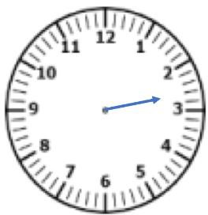

* Instruction includes understanding that the hour hand moves around the clock. Instruction includes using a geared manipulative clock. This clock will demonstrate the relationship between the minute hand and hour hand moving around the clock.
  + For example, the teacher moves the hands on the clock so the hour hand is slightly more than half-way between the 2 and the 3 asking, “What time do you think it is on the clock?” (The clock reads approximately 2:37.) The teacher allows for classroom discussions that encourage students to justify the location of the hour hand between benchmarks when representing analog time.

Instructional Tasks

*Instructional Task 1*

Show the same time represented on the digital clock

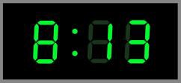

on the analog clock below.

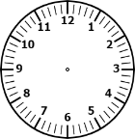

Explain how you know where the hour hand is located on the analog clock.

*Instructional Task 2 (MTR.3.1)*

Show the same time represented on the analog log clock on the digital clock.

A clock with blue hands

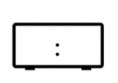

Instructional Items

*Instructional Item 1*

Alex goes to the grocery store in the morning at the time shown.

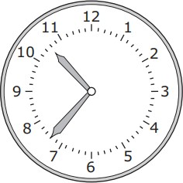

What time does Alex go to the grocery store? Write the time on the line and circle a.m. or p.m.

_______________a.m./p.m

*Instructional Item 2*

Roxy got home from the gym at 6:39 p.m. Which analog clock represents the same time?

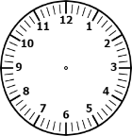

*\*The strategies, tasks and items included in the B1G-M are examples and should not be considered comprehensive.*

### MA.3.M.2.2

Benchmark

MA.3.M.2.2 Solve one- and two-step real-world problems involving elapsed time.

*Example:* A bus picks up Kimberly at 6:45 a.m. and arrives at school at 8:15 a.m. How long was her bus ride?

Benchmark Clarifications:

*Clarification 1:* Within this benchmark, the expectation is not to include crossing between a.m. and p.m.

Connecting Benchmarks/Horizontal Alignment

* MA.3.NSO.2.2
* MA. 3.AR.1.

Terms from the K-12 Glossary

Vertical Alignment

|  |  |
| --- | --- |
| **Previous Benchmarks**   * MA.2.M.2.1 | **Next Benchmarks**  MA. 4.M.2.1 |

Purpose and Instructional Strategies

The purpose of this benchmark is for students to apply their understanding of telling and writing time to solve one- and two-step real-world problems involving elapsed time. This is the first grade level where students are expected to determine elapsed time. Elapsed time can be represented within a single hour (e.g., determining when a half-hour gym class would end if it began at 8:10 a.m.) or crossing into the next hour (e.g., determining when a half-hour gym class will end if it began at 8:45 a.m.). Elapsed time problems should not include crossing between a.m. and p.m. When solving problems with elapsed time, students may see different problem types. Students may see result unknown problems (e.g., determining when an activity ends, given the starting time and length of activity), change unknown problems (e.g. determining the length of an activity, given the starting and end times), or start unknown problems (e.g., determining the starting time, given the length of the activity and ending time) *(MTR.2.1, MTR.7.1).*

* A great way for students to work with elapsed time problems is to use number lines. It is important to note that when using number lines during instruction, students be given the opportunities to determine the intervals and size of jumps on their number line. Students could use pre-marked number lines (intervals every 5 or 15 minutes) or open number lines (intervals determined by students). Open number lines encourage students to jump from one point on the line to another any way they choose, allowing them to calculate flexibly. Students can compare their open number line strategies with one another, and then make connections between them during classroom discussions.
* 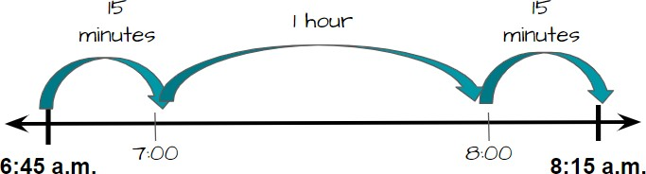In real-world elapsed time problems, students use open number lines to represent solutions in many ways. Two open number lines that represent the benchmark’s example are below
  + this example, the student counted up to benchmark hours, then an addition 15 minutes to jump to 8:15 a.m. The student would reason that the elapsed time is the sum of the jumps, or 1 hour and 30 minutes.

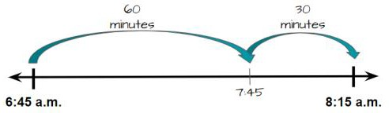

* + In this example, the student jumped 60 minutes to 7:45 a.m., and then another 30 minutes to 8:15 a.m. In this example, the student would represent the answer as 60 minutes + 30 minutes, or 90 minutes.
  + Notice that both the answers of 1 hour and 30 minutes and 90 minutes are acceptable. Students’ solutions may be expressed as hours and minutes or minutes only. Conversion from minutes to hours or hours to minutes is not expected in Grade 3, so students may see both as correct *(MTR.2.1, MTR.5.1).*
* In addition to number lines, Judy clocks provide a great visual to help students identify elapsed time and can be used to help students solve real-world problems *(MTR.2.1)*.
* Elapsed time problems can involve multiplication and division. For example, if Petra starts running laps at 9:55 a.m. and runs 6 laps at 2 minutes per lap, what time does she finish?

Common Misconceptions or Errors

* Students can confuse when time crosses the hour because it does not follow the familiar base ten pattern. For example, students can misinterpret that the elapsed time between 9:55 a.m. and 10:05 a.m. and state that the elapsed time is 50 minutes because they have found the difference from 55 to 105. The use of number lines and clocks side-by-side help students build understanding about how elapsed time is calculated.

Strategies to Support Tiered Instruction

* Instruction includes the use of number lines and clocks side-by-side to help students build understanding about how elapsed time is calculated.
* 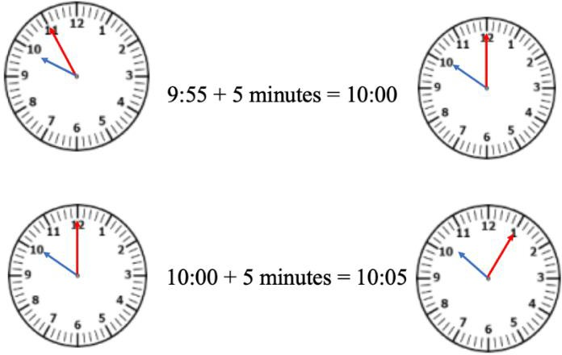Instruction includes using a number line and counting by ones to demonstrate what happens when time crosses the hour because it does not follow the familiar base ten pattern.

Instructional Tasks

*Instructional Task 1*

Recess began at the time shown on Clock A. Recess ended at the time shown on Clock B.

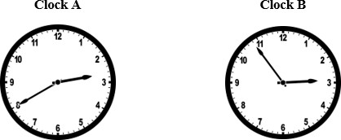

How many minutes were spent at recess?

*Instructional Task 1*

Anthony began reading at the time shown on Clock A. He stopped at the time shown on Clock B.

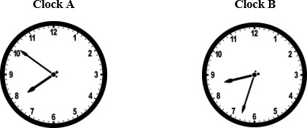

How many minutes did Anthony spend reading?

*Instructional Task 3*

A movie runs for 2 hours, 15 minutes. The movie ends at 2:30 p.m. What time did the movie start?

number line from 11:00 to 2:30

Instructional Items

*Instructional Item 1*

Each week, Victor attends violin lessons that last 55 minutes. If the lesson begins at 4:30 p.m., what time will it end?

*Instructional Item 2*

Robert wants to arrive at the football stadium at 4:00 p.m. He first has to pick up his friend who lives 25 minutes from his house, then he will have another 20 minutes to drive to the stadium. At what time should he leave?

*\*The strategies, tasks and items included in the B1G-M are examples and should not be considered comprehensive.*

Geometric Reasoning

**MA.3.GR.1** *Describe and identify relationships between lines and classify quadrilaterals.*

### MA.3.GR.1.1

Benchmark

MA.3.GR.1.1 Describe and draw points, lines, line segments, rays, intersecting lines, perpendicular lines and parallel lines. Identify these in two-dimensional figures

Benchmark Clarifications:

*Clarification 1:* Instruction includes mathematical and real-world context for identifying points, lines, line segments, rays, intersecting lines, perpendicular lines and parallel lines.

*Clarification 2:* When working with perpendicular lines, right angles can be called square angles or square corners.

Connecting Benchmarks/Horizontal Alignment

* MA.3.GR.2.4
* MA.3.DR.1.1

Terms from the K-12 Glossary

* Line
* Parallelogram
* Rectangle
* Square
* Triangle

Vertical Alignment

|  |  |
| --- | --- |
| **Previous Benchmarks**   * MA.2.GR.1.1 | **Next Benchmarks**   * MA.4.GR.1.1/1.2 |

Purpose and Instructional Strategies

The purpose of this benchmark is to build important vocabulary that allows students to describe

and draw points, lines, line segments, rays, intersecting lines, perpendicular lines and parallel lines, and to identify examples in two-dimensional figures represented in mathematical and real- world contexts. In Grade 2, students were expected to identify and draw two-dimensional figures based on their defining attributes. In Grade 3, students can describe and draw geometric figures using more formal vocabulary developed in this benchmark. Therefore, instruction of this benchmark relies heavily on vocabulary development for students to internalize definitions and make connections between the concepts. In Grade 4, students will explore and draw angles beyond square angles.

* In mathematical contexts, students find evidence of points, lines, line segments, rays, intersecting lines, perpendicular lines and parallel lines in models of two-dimensional figures (e.g., quadrilaterals, triangles). In real-world contexts, students identify evidence of these geometric attributes in real-life images (e.g., aerial views of city maps, photos of objects) *(MTR.4.1, MTR.7.1)*.
* This vocabulary development will be necessary as students identify and draw quadrilaterals based on their defining attributes (MA.3.GR.1.2). It will also be beneficial in other areas as students begin to read, draw and understand graphs and diagrams.
* Instruction may consider activities that encourage student discussions rich in mathematical reasoning opportunities. Mathematical discussions and reasoning activities give students the practice necessary to use the vocabulary and internalize it in meaningful ways. An example of a mathematical reasoning activity that builds vocabulary understanding is in the instructional task below *(MTR.4.1)*.
* Two additional notes about instruction of this benchmark:
* Images of figures used in instruction should not include hatch marks.
* Because formal instruction of angle measurements does not begin until Grade 4, students can refer to right angles in perpendicular lines as “square angles” or “square corners.”

Common Misconceptions or Errors

* Students can confuse some pairs of intersecting lines as perpendicular. Encourage students to justify their thinking whenever they reason about geometric concepts. For example, students can use the corners of a standard sheet of paper or index card as a comparison to determine whether a pair of intersecting lines is perpendicular.
* Students may struggle to identify examples of points, lines, line segments, rays, intersecting lines, perpendicular lines and parallel lines in real-world examples. Teachers can model and include many examples for students to explore within the learning space.

Strategies to Support Tiered Instruction

* Instruction provides opportunities to justify thinking when reasoning about geometric concepts.
  + For example, the teacher demonstrates how to use the corners of a standard sheet of paper as a comparison to determine whether a pair of intersecting lines is perpendicular.
* Instruction includes the use of key vocabulary, referencing definitions for terms such as intersecting lines, right angle, and perpendicular lines. The teacher draws examples of intersecting lines that are both perpendicular and not perpendicular and has students explain which they are and justify their reasoning.
  + For example, teachers provide key vocabulary as shown below for students to reference. The teacher will then draw sets of lines, some that do not intersect, some that intersect but do not create right angles, and other sets that do create right angles. Students determine which pairs of intersecting lines can be classified as perpendicular and explain why.

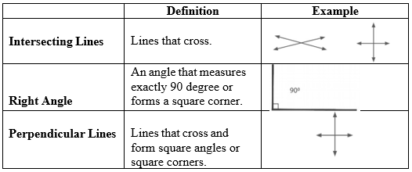

* The teacher provides a tool such as a square tile or the corner of a piece of paper to identify intersecting lines that create right angles and classify those as perpendicular lines and those that do not form right angles as intersecting but not perpendicular. Students use the tool to draw some of their own intersecting lines that would be examples of both
  + For example, the teacher may provide students with a graphic organizer like the one shown below and a set of cards with pairs of lines (examples shown below). The students use the tool to sort the cards into perpendicular and not perpendicular and draw at least one pair of their own lines for each category.

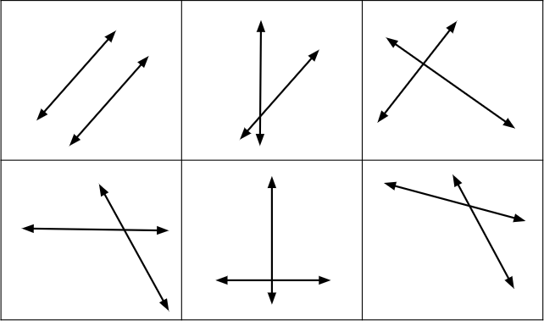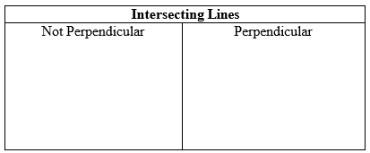

* Instruction includes real-world examples of points, lines, line segments, rays, intersecting lines, perpendicular lines, and parallel lines. The teacher provides images of real-world examples that include geometric figures. Students identify the geometric figure in the example.
  + For example, the teacher provides an image of railroad tracks to represent parallel lines, a speed sign to represent perpendicular lines, a balance beam to represent a line segment, and other common images.
* Instruction includes real-world examples of points, lines, line segments, rays, intersecting lines, perpendicular lines, and parallel lines. The teacher points out items in the classroom that are examples of the geometric terms listed above and has students identify for which term it is an example.
  + For example, if the teacher points out a poster with the number one or the letter l on it, students will say it represents a line segment. If the teacher points out the window, students will say the top and bottom of the window shows parallel lines, while the corners of the window show perpendicular lines.
  + For example, students are to find their own examples within the classroom and explain which geometric term they notice in the figure.

Instructional Tasks

*Instructional Task 1*

Are intersecting lines always, sometimes or never parallel? Show your thinking.

*Instructional Task 2*

Are intersecting lines always, sometimes or never perpendicular? Show your thinking.

*Instructional Task 3*

Draw a geometric figure with parallel and perpendicular sides.

*Instructional Task 4*

Go on a scavenger hunt around your classroom or school to look for examples of points, lines, line segments, rays, intersecting lines, perpendicular lines, and parallel lines. Take pictures or draw the examples that you find. Be sure to label each example

Instructional Items

*Instructional Item 1*

Which of the following figures show perpendicular lines?

II.

III.

* + - 1. I only
      2. II only
      3. II and III
      4. I, II and III

*Instructional Item 2*

A close-up of a road


Which geometric term would you use to describe the divider lanes above?

1. Points
2. Intersecting lines
3. Parallel lines
4. Perpendicular lines

*Instructional Item 2*

Use the table to identify each geometric figure.

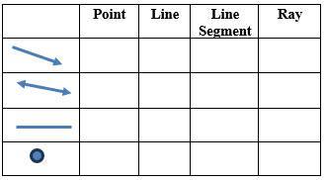

*The strategies, tasks and items included in the B1G-M are examples and should not be considered comprehensive.

### MA.3.GR.1.2

Benchmark

MA.3.GR.1.2 Identify and draw quadrilaterals based on their defining attributes. Quadrilaterals include parallelograms, rhombi, rectangles, squares and trapezoids.

Connecting Benchmarks/Horizontal Alignment

* MA.3.M.1.1
* MA.3.M.1.2
* MA.3.GR.1.1

Terms from the K-12 Glossary

* Line
* Parallelogram
* Rectangle
* Square
* Triangle
* Rhombus

Vertical Alignment

|  |  |
| --- | --- |
| **Previous Benchmarks**   * MA.2.GR.1.1 | **Next Benchmarks**   * MA.4.GR.1.1 |

Purpose and Instructional Strategies

The purpose of this benchmark is to provide opportunities for students to apply their formalized definitions of geometric attributes when identifying and drawing quadrilaterals *(MTR.5.1)*. With the support of vocabulary developed about geometric attributes in benchmark MA.3.GR.1.1, the goal of this benchmark is for students to identify and draw quadrilaterals based on them. In Grade 2, students started to explore and draw quadrilaterals in less formal ways.

* This benchmark gives students opportunities to build vocabulary around examples of quadrilaterals (e.g., parallelograms, rhombi, rectangles, squares, and trapezoids) based on the attributes that define them. Understanding quadrilaterals will help them make comparisons to non-quadrilaterals *(MTR.4.1)*.
* In Grade 4, students will classify types of angles and identify them in two-dimensional figures. In Grade 5, prior learning about quadrilaterals and triangles is synthesized for students to classify these figures based on their attributes.
* Instruction may include highlighting measurement as an attribute to help categorize quadrilaterals.

Common Misconceptions or Errors

* Students can confuse some pairs of intersecting lines as perpendicular. Encourage students to justify their thinking whenever they reason about geometric concepts. For example, students can use the corners of a standard sheet of paper as a comparison to determine whether a pair of intersecting lines is perpendicular.
* Some students may assume all quadrilaterals must have attributes of squares, rhombi, rectangles, and trapezoids. During instruction, it is important for students to determine that a figure lacking further defining attributes (such as a kite) can still be a quadrilateral.

Strategies to Support Tiered Instruction

* Instruction includes real-world examples of points, lines, line segments, rays, intersecting lines, perpendicular lines, and parallel lines. The teacher provides images of real-world examples that include geometric figures. Students identify the geometric figure in the example.
  + For example, the teacher provides an image of railroad tracks to represent parallel lines, a speed sign to represent perpendicular lines, a balance beam to represent a line segment, and other common images.
* Instruction includes real-world examples of points, lines, line segments, rays, intersecting lines, perpendicular lines, and parallel lines. The teacher points out items in the classroom that are examples of the geometric terms listed above and has students identify which term it is an example of.
  + For example, if the teacher points out a poster with the number one or the letter l on it, students will say it represents a line segment. If the teacher points out the window, students will say the top and bottom of the window shows parallel lines, while the corners of the window show perpendicular lines.
  + For example, students to find their own examples within in the classroom and explain which geometric term they notice in the figure.

Quadrilateral with two right angles in bottom two corners.  

* Teacher provides students with key vocabulary from the glossary to identify right angles to help them identify perpendicular sides in shapes. The teacher also provides a tool such as a square tile or the corner of a standard sheet of paper to help students find right angles. Students then matches quadrilaterals that contain this attribute.
  + For example, the teacher provides a vocabulary card or vocabulary information from the glossary for a right angle, similar to the example shown below. Students then uses the tool provided to locate right angles and identifies which quadrilaterals contain that attribute when provided images of parallelograms, rhombi, rectangles, squares, and trapezoids.

|  |  |  |
| --- | --- | --- |
| Right Angle | An angle measuring exactly 90°.  An angle that forms a square corner. | Right Angle An angle measuring exactly 90 degrees. An angle that forms a square corner. A picture of a right angle. |

* Teacher provides a graphic organizer to help students identify given attributes in figures. Students place the figures under the correct columns and identify quadrilaterals that do not contain any of the attributes stated.
  + 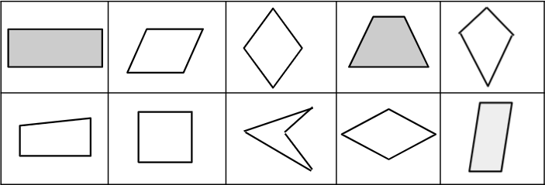For example, the teacher provides sample figures and students draw them in or place the shape cards in the correct columns of the graphic organizer (some figures will fit in more than one column

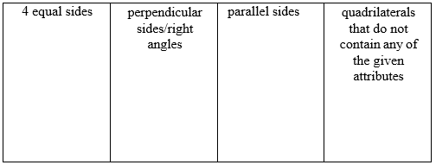

* Teacher provides figures that can be classified as quadrilaterals and those that are not (shapes may include: triangles, squares, pentagons, hexagons, square, rectangles, parallelograms, trapezoids, and other quadrilaterals such as a kite). Students sort the figures into two groups, quadrilaterals and non-quadrilaterals and justify their reasoning by explaining how they used the number of sides each figure has to determine their placement.
  + For example, students will add figures to the chart shown below and explain why the figure belongs in that category.

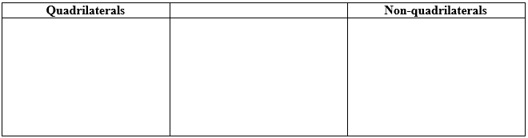

Instructional Tasks

*Instructional Task 1*

Draw an example of a quadrilateral that does not have any defining attributes of a square ( except that it has 4 straight sides and 4 vertices). Then explain how you know.

*Instructional Task 2*

Draw an example of a quadrilateral with 4 equal sides and no right angles. If your quadrilateral can classified as another figure, explain.

Instructional Items

*Instructional Item 1*

Which of the following quadrilaterals always have 2 sets of parallel sides? Select all that apply.

1. Square
2. Rectangle
3. Rhombus
4. Parallelogram
5. Trapezoid

*Instructional Item 2*

Which of the following quadrilaterals always have perpendicular sides? Select all that apply.

1. Square
2. Rectangle
3. Rhombus
4. Parallelogram
5. Trapezoid

*Instructional Item 3*

Which of the following quadrilaterals is NOT a parallelogram.

1. b.

c. d.

*The strategies, tasks and items included in the B1G-M are examples and should not be considered comprehensive.

### MA.3.GR.1.3

Benchmark

MA.3.GR.1.3 Draw line(s) of symmetry in a two-dimensional figure and identify line- symmetric two-dimensional figures.

Benchmark Clarifications:

*Clarification 1:* Instruction develops the understanding that there could be no line of symmetry, exactly one line of symmetry or more than one line of symmetry.

*Clarification 2:* Instruction includes folding paper along a line of symmetry so that both halves match exactly to confirm line-symmetric figures.

Connecting Benchmarks/Horizontal Alignment

* MA.3.FR.1.1
* MA.3AR.3.2

Terms from the K-12 Glossary

* Line of Symmetry

Vertical Alignment

|  |  |
| --- | --- |
| **Previous Benchmarks**   * MA.2.GR.1.3 | **Next Benchmarks**   * MA.6.GR.1.1 * MA.8.GR.2.1 |

Purpose and Instructional Strategies

The purpose of this benchmark is for students to draw lines of symmetry and identify line- symmetric figures. In Grade 2, students identify lines of symmetry in a two-dimensional figure by partitioning (e.g., folding) it and matching its halves. In addition, students in Grade 3 also developed the understanding that a figure can have no lines of symmetry, exactly 1 line of symmetry, or more than 1 line of symmetry.

* Instruction includes encouraging students to partition figures and match their halves to identify line(s) of symmetry Upon identifying a line of symmetry in a figure, students should recognize that each side of the line of symmetry is one-half of the figure. *(MTR.2.1)*
* Instruction can also ask students to build generalizations about which two-dimensional figures are line symmetric and why. For example, students could argue that all squares share similar defining attributes and only differ in size, therefore all squares will be line- symmetric *(MTR.2.1, MTR.4.1)*.
* Instruction includes having students identify the number of lines of symmetry in a figure.
* Instruction builds a foundation for exploring reflections in middle school.

Common Misconceptions or Errors

* Students can miss identifying all lines of symmetry in line-symmetric figures. Encourage classroom discussions and have students justify their arguments about lines of symmetry using their partitioned representations.

Strategies to Support Tiered Instruction

* Teacher provides figures that have at least one line of symmetry and tells how many lines of symmetry the figure has. Students draw lines to show where the lines of symmetry would be.
  + For example, the teacher provides students with images similar to those shown below and has students draw the number of lines of symmetry given and explain how they know the lines they draw are lines of symmetry.

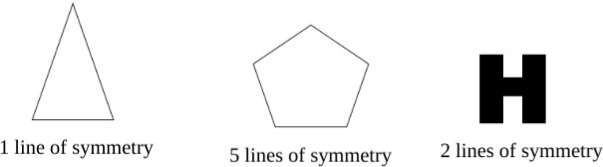

* Teacher provides a figure partitioned in different ways with dotted lines. Students fold the image along the dotted line and determine if it is a line of symmetry (do the two sides match).
  + For example, the teacher gives a triangle like the one shown below. Students fold along the dotted lines and determine if it shows a line of symmetry or not.

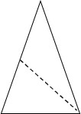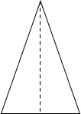

Instructional Tasks

*Instructional Task 1*

Mika says that the uppercase letter H below has 1 line of symmetry. Errol says that the uppercase letter H has 2 lines of symmetry. Who is correct? Show your thinking.

*Instructional Task 2*

Determine if the figure below has 0 lines of symmetry, 1 line of symmetry, or more than 1 line of symmetry. Explain your thinking.

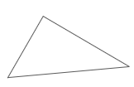

Instructional Items

*Instructional Item 1*

Select all the figures that have at least one line of symmetry.



a.



b.



c.



d.



e.

*Instructional Item 2*

How many lines of symmetry does the following figure have?



*Instructional Item 3*

A figure is shown.



How many lines of symmetry does the figure have?

*Instructional Item 4*

Draw the lines of symmetry on the figure below.

*Instructional Item 5*

In which figure is the line of symmetry NOT drawn correctly?

a. A white circle with a dotted line
in center b. A triangle with a dotted line


c. A white square with a cut out line

 d. A hexagon with a dotted line




*The strategies, tasks and items included in the B1G-M are examples and should not be considered comprehensive.

**MA.3.GR.2** *Solve problems involving the perimeter and area of rectangles.*

### MA.3.GR.2.1

Benchmark

MA.3.GR.2.1 Explore area as an attribute of a two-dimensional figure by covering the figure with unit squares without gaps or overlaps. Find areas of rectangles by counting unit squares.

Benchmark Clarifications:

*Clarification 1:* Instruction emphasizes the conceptual understanding that area is an attribute that can be measured for a two-dimensional figure. The measurement unit for area is the area of a unit square, which is a square with side length of 1 unit.

*Clarification 2:* Two-dimensional figures cannot exceed 12 units by 12 units and responses include the appropriate units in word form (e.g., square centimeter or sq.cm.).

Connecting Benchmarks/Horizontal Alignment

* MA.3.NSO.2.2

Terms from the K-12 Glossary

* Rectangular Array

Vertical Alignment

|  |  |
| --- | --- |
| **Previous Benchmarks**   * MA.2.AR.3.2 * MA.2.GR.2.1 | **Next Benchmarks**   * MA.4.GR.2.1/2.2 |

Purpose and Instructional Strategies

The purpose of this benchmark is to provide the foundation for students to understand area measurement. In Grades 1 and 2, students learned about linear measurement using number lines, rulers and calculating perimeter. In Grade 3, students build on their knowledge of measurement and multiplicative reasoning to explore and understand area measurement. Instruction emphasizes that area is a two-dimensional measurement, therefore it is measured in units that are also two-dimensional – unit squares with side lengths that measure one unit. Area is calculated using unit squares that cover a shape without gaps or overlap *(MTR.5.1)*.

* The expectation of this benchmark is for students to calculate area of rectangles by **counting** unit squares *(MTR.2.1)*.
* Instruction allows for students to draw conclusions about connections to arrays and to determine more efficient counting strategies for calculation, leading to the use of a multiplication formula in MA.3.GR.2.2 *(MTR.4.1, MTR.5.1)*.
* Students have previous experience with calculating the perimeter of rectangles but do not have experience with calculating the area. Explain that the perimeter of a rectangle is the sum of the side lengths of the rectangle and that area of a rectangle is the measure, in square units, of the inside region of the rectangle. Demonstrate with a real-world example such as a bulletin board. To determine the length of border needed, we would calculate the perimeter of the bulletin board and to determine the amount of paper needed to cover the bulletin board, we would calculate the area.

Common Misconceptions or Errors

* Students may miscount unit squares when they are laid out in a figure. Encourage students to mark unit squares as they are counted.
* Students can confuse why area is measured in “square units.” Use this exploratory benchmark for students to relate area measurement to the counting of squares. This benchmark provides the opportunity for students to build vocabulary necessary for area measurement.

Strategies to Support Tiered Instruction

* Instruction includes modeling how to number the unit square tiles, so students don’t miscount when finding area.
  + 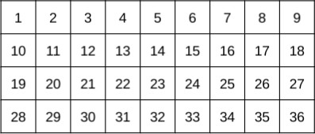For example, the teacher provides students with figures created with squares and has them number each square as they count.
* Instruction includes creating figures with no gaps or overlaps that have a given area. Students mark each unit square with a number as they count to check that the area of the figure they create has the correct area.
  + 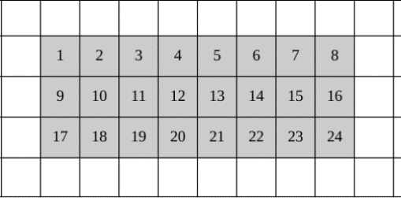For example, the teacher provides students with grid paper and asks them to create a figure with an area of 24 square units. Students count and label 24 connected squares on the grid paper and then shade in the entire figure (see example below).
* Instruction includes measuring the area of given figures by covering them with 1-inch square tiles, leaving no gaps or overlaps. Students count the total number of squares it takes to completely cover the figure and explain how that number represents the area in square units of the figure.
  + For example, the teacher provides a sheet with figures that can be covered perfectly using the square tiles. Students tile the figure and count the square tiles to identify the area.
* Instruction includes students creating their own figures by connecting square tiles with no gaps or overlaps and counting the tiles.
  + For example, the teacher provides a set of 1-inch tiles and asks students to build a figure with an area of 18 square inches. After students have created the figure, they will count and number each tile to ensure they have an area of 18 square inches

Instructional Tasks

*Instructional Task 1*

Kendra used unit squares with 1-centimeter side lengths to find the area of the rectangle below. She started, but then stopped for a lunch break.

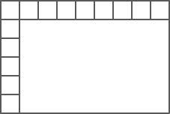

1. What is the area of Kendra’s figure?
2. Explain how you counted.

*Instructional Task 2*

Alex put the tiles shown on the floor.

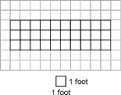

Part A. What is the area in square feet of the portion that Alex has covered?

Part B. What is the area in square feet of the entire floor?

Part C. The area of Alex’s floor is 30 square feet. Select all the floors that could be Alex’s.

*A group of squares with the same number

*

Instructional Items

*Instructional Item 1*

Count the shaded unit squares. Then write the area.

*A grid with a square in the middle


*

*Instructional Item 2*

What is the area of the rectangle?

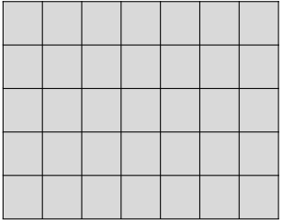

a. 34 square units

b. 25 square units

c. 36 square units

d. 35 square units

*The strategies, tasks and items included in the B1G-M are examples and should not be considered comprehensive.

### MA.3.GR.2.2

Benchmark

MA.3.GR.2.2 Find the area of a rectangle with whole-number side lengths using a visual model and a multiplication formula.

Benchmark Clarifications:

*Clarification 1:* Instruction includes covering the figure with unit squares, a rectangular array or applying a formula.

*Clarification 2:* Two-dimensional figures cannot exceed 12 units by 12 units and responses include the appropriate units in word form.

Connecting Benchmarks/Horizontal Alignment

* MA.3.NSO.2.2/2.3/2.4

Terms from the K-12 Glossary

* Rectangular Array

Vertical Alignment

|  |  |
| --- | --- |
| **Previous Benchmarks**   * MA.2.AR.3.2 * MA.2.GR.2.2 | **Next Benchmarks**   * MA.4.GR.2.1/2.2 |

Purpose and Instructional Strategies

The purpose of this benchmark is for students to calculate the area of rectangles presented visually as arrays or by using a multiplication formula and is connected to MA.3.GR.2.1. *(MTR.5.1)*.

* The benchmark MA.3.GR.2.1 expects students to calculate the area of rectangles by counting unit squares that covered them with no gaps or overlaps. As students count, they will likely connect their calculations to rectangular arrays and connect understanding that multiplication is a more efficient strategy for calculating than counting or adding unit squares.
* Instruction may encourage students to discover a multiplication formula based on patterns they have observed through practice and classroom discussions. This will make a multiplication formula more meaningful for students conceptually *(MTR.5.1)*. Teachers can help students formalize the formula into an equation, like 𝐴 = 𝑙 × 𝑤. In this benchmark, memorization of a multiplication formula is the goal *(MTR.3.1)*.
* Instruction includes making connections between the meaning of multiplication as seen in arrays and finding the area of a rectangle. The area of a rectangle, or the amount of square units covering the rectangle, is the product of the number of rows and the number of columns.

Common Misconceptions or Errors

* When using a formula, students may be confused about which dimension to label the length and width in a rectangle. Instruction can emphasize connections to the commutative property of multiplication to emphasize that the order in which dimensions are multiplied will not change the rectangle’s area, and therefore the length and width can be labeled flexibly.

Strategies to Support Tiered Instruction

* Instruction includes the teacher modeling how to draw in rows and columns to cover a figure based on the side lengths given. Students then count the total number of square units that make up the figure and write a multiplication equation to represent it. Teachers help students make the connection to the commutative property of multiplication by having them create and compare figures with the same factors for their rows and columns, just switched. Emphasize that the order in which dimensions are multiplied will not change the rectangle’s area, and therefore the length and width can be labeled flexibly.
  + For example, when provided with a figure with the dimensions of 4 x 8, students draw in the rows and columns as shown by the dotted lines. The teacher then asks students to do the same for an image with the dimensions 8 x 4and has them compare the area of the two figures.

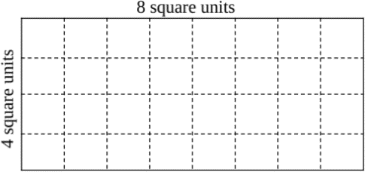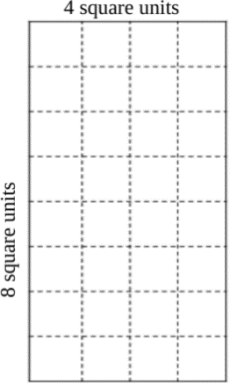

* Teacher provides dimensions for a given rectangle and students use square tiles to build the figure in two ways. Students then count the number of tiles in each row and in each column and create a multiplication expression. Next, the students count the total number of tiles used to make the figure and recognize that as the area of the figure.
  + For example, the teacher asks students to create a rectangle with a length of 5 and a width of 7. Students use the square tiles to create two rectangles applying the commutative property of multiplication and writing multiplication equations to match. Then, students count the total number of tiles to check that the area they found for their equation is correct.

Instructional Tasks

*Instructional Task 1*

***Kendra used unit squares with 1-centimeter side lengths to find the area of the rectangle below. She started, but then stopped for a lunch break.***

**

Part A. Write two equations that can be used to find the area of Kendra’s rectangle.

Part B. What is the area of Kendra’s rectangle?

Part C. Which has greater area, the rectangle above or a square with side lengths of 8 centimeters? Explain.

*Instructional Task 2*

Mya wants to plant tulips in the garden below but first she must figure out how many square feet the garden is. What is the area of the garden in square feet?

*A grid of blue squares

*

.

Instructional Items

*Instructional Item 1*

The rectangle below is composed of unit squares. Which equations can be used to find the area of the rectangle?

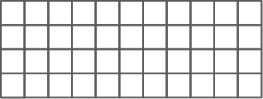

1. 𝐴 = 4 × 10
2. 𝐴 = 10 × 4
3. 𝐴 = 4 + 11
4. 𝐴 = 4 × 11
5. 𝐴 = 11 + 11 + 11 + 11
6. 𝐴 = 11 × 4

*Instructional Item 2*

What is the area of the rectangle below?

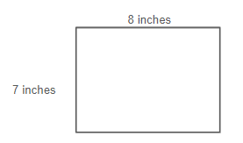

*Instructional Item 3*

What is the area of the rectangle below?

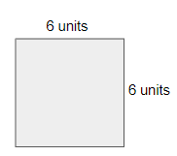

*The strategies, tasks and items included in the B1G-M are examples and should not be considered comprehensive.

### MA.3.GR.2.3

Benchmark

MA.3.GR.2.3 Solve mathematical and real-world problems involving the perimeter and area of rectangles with whole-number side lengths using a visual model and a formula.

Benchmark Clarifications:

*Clarification 1:* Within this benchmark, the expectation is not to find unknown side lengths.

*Clarification 2:* Two-dimensional figures cannot exceed 12 units by 12 units and responses include the appropriate units in word form.

Connecting Benchmarks/Horizontal Alignment

* MA.3.NSO.2.2/2.4
* MA.3.AR.1.2
* MA.3.M.1.1/1.2

Terms from the K-12 Glossary

* Perimeter
* Rectangle

Vertical Alignment

|  |  |
| --- | --- |
| **Previous Benchmarks**   * MA.2.GR.1.1/1.2 | **Next Benchmarks**   * MA.4.GR.2.1/2.2 |

Purpose and Instructional Strategies

The purpose of this benchmark is for students to solve mathematical and real-world problems using the perimeter and area of rectangles using a visual model and/or a formula for each.

* In the provided mathematical and real-world problems, instruction may include cases where students use a ruler to measure lengths before determining its perimeter and/or area *(MTR.3.1)*.
* Mathematical problems include visual models of rectangles, while examples of real- world problems could include photos or classroom objects (e.g., measuring the area of one face on a tissue box). Students will not be expected to find unknown side lengths until Grade 4 *(MTR.7.1)*.
* This benchmark gives students the chance to measure perimeter and area together and understand their differences – perimeter as a one-dimensional length measurement and area as a two-dimensional measurement. (Note: Though students explored and measured perimeter in Grade 2, they were not expected to determine a formula.) *(MTR.5.1)*
* As recommended for MA.3.GR.2.2 for a multiplication formula for area, classroom instruction can include activities that allow students to build formulas for perimeter based on patterns they observe (e.g., 𝑃 = 𝑙 + 𝑙 + 𝑤 + 𝑤, 𝑃 = 2𝑙 + 2𝑤) before expecting them to memorize. Student-created formulas will build conceptual understanding around a formula before memorizing it *(MTR.4.1)*.

Common Misconceptions or Errors

* Students may confuse area and perimeter and use incorrect formulas to find measurements. During instruction, the teacher may continue to emphasize the difference between perimeter as a one-dimensional measurement of length and area as a two-dimensional measurement that covers a shape with unit squares. The teacher can use visuals to show the perimeter (e.g., yarn, string stretched around the rectangle) and area (e.g., square counters, square-shaped sticky notes, square-shaped crackers covering it) to help students differentiate between the measurements.

Strategies to Support Tiered Instruction

* Instruction includes opportunities to explore both area and perimeter of given figures and make connections to the formulas to find each. The teacher provides students with dimensions for a figure that has whole number side lengths that can be measured using inches or centimeters. Students use a ruler to measure the side lengths and place tick marks for each whole number unit. Students then label each side length and use the formula for perimeter to calculate. Next, students use the formula for area to find the area and then use the tick marks made when measuring to draw in the rows and columns to check their work.
  + For example, the teacher asks students to draw a figure with a length of 3 inches and a width of 6 inches. Students use a ruler to draw the figure and place tick marks along each side for each inch. Students then use the formula to find the perimeter (P = 3 + 3 + 6 + 6 ). Next, students use the tick marks made when measuring to draw in the rows and columns to cover the figure with square inches and then use the formula to find area (A = 3 × 6 ).

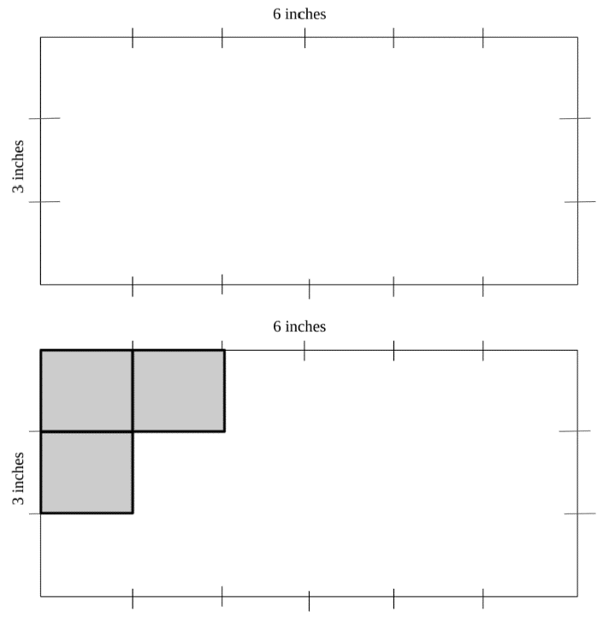

* Teacher provides a figure that has whole number side lengths that can be measured using inches. Students use a visual representation such as string or yarn to measure the distance around the figure and then measure the length of the string to make the connection to perimeter being a one-dimensional measurement. Students then use a different visual representation such as 1-inch tiles or square sticky notes to cover the figure to find the area and make the connection to area being a two-dimensional measurement.
  + For example, the teacher provides an image like the example below. Students use a piece of string to measure the distance around the figure and then use a tape measure to measure the length of the string. Or students can use the string to measure the 2 sides, then add the 2 lengths and multiply by 2 to determine the perimeter. Students will then use square tiles to cover the image to determine the area.

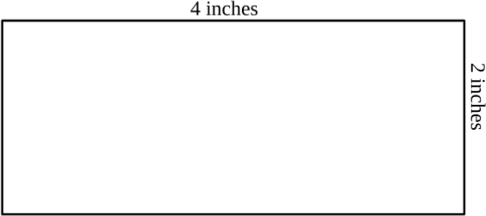

Instructional Tasks

*Instructional Task 1*

Find the whole number length and whole number width of every rectangle with an area of 18 square feet. Record the length, width and perimeter of each rectangle in the table.

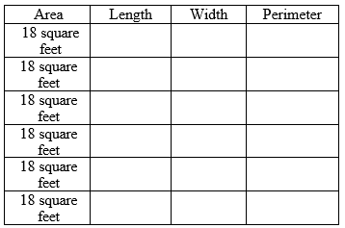

*Instructional Task 2*

Part A. Measure the following rectangle to the nearest centimeter.

Part B. What is the perimeter of the rectangle?

Part C. What is the area of the rectangle.

Instructional Items

*Instructional Item 1*

Which of the following rectangles has a perimeter of 24 inches and an area of 36 square inches?

* + 1. 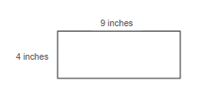
    2. 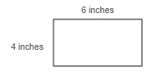
    3. 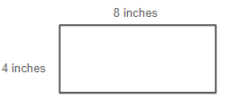

*Instructional Item 2*

A rectangle is 12 centimeters long and 9 centimeters wide. What is the area of the rectangle?

*Instructional Item 3*

Nia is putting a fence in her backyard.

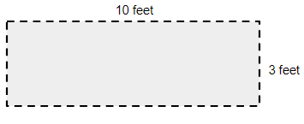

How many feet of fence is needed for Nia’s backyard?

*The strategies, tasks and items included in the B1G-M are examples and should not be considered comprehensive.

### MA.3.GR.2.4

Benchmark

MA.3.GR.2.4 Solve mathematical and real-world problems involving the perimeter and area of composite figures composed of non-overlapping rectangles with whole- number side lengths.

Benchmark Clarifications:

*Clarification 1:* Composite figures must be composed of non-overlapping rectangles.

*Clarification 2:* Each rectangle within the composite figure cannot exceed 12 units by 12 units and responses include the appropriate units in word form.

Connecting Benchmarks/Horizontal Alignment

* MA.3.NSO.2.2/2.4
* MA.3.AR.1.2
* MA.3.M.1.1/1.2

Terms from the K-12 Glossary

* Composite Figure
* Perimeter
* Rectangle

Vertical Alignment

|  |  |
| --- | --- |
| **Previous Benchmarks**   * MA.2.GR.2.2 | **Next Benchmarks**   * MA.4.GR.2.1 |

Purpose and Instructional Strategies

The purpose of this benchmark is for students to solve mathematical and real-world problems involving the perimeter and area of composite figures with whole-number side lengths. This benchmark builds on the work with perimeter done in Grade 2. The area of each rectangle in a composite figure is expected to be within the appropriate multiplication limits for Grade 3 – up to 12 units by 12 units. All side lengths of composite figures should be given, though cases can be provided where students are expected to use a ruler to measure before finding a composite figure’s perimeter and/or area.

* Students have previous experience with decomposing larger rectangles into smaller rectangles to find individual areas. When students utilized the distributive property in area models to multiply 2-digit factors by a 1-digit factors, students decomposed (broke apart) the 2-digit number as the sum of its tens and ones. Students learned that the product was the sum of smaller rectangles’ areas. Students likely used area models to build fluency within 12 x 12 as well. During instruction of this benchmark, instruction includes having students make connections to their previous learning as they begin decomposing the composite figures *(MTR.2.1, MTR.5.1).*
* Instruction of measuring area of composite figures includes opportunities for students to justify how they decompose their composite figures into 2 or more rectangles before calculating. As students share the different ways they decompose their figures, they identify that any correct decomposition will yield the correct calculation *(MTR.2.1, MTR.2.1, MTR.3.1)*.

Common Misconceptions or Errors

* Students can confuse the side lengths when determining area calculations once a composite figure has been decomposed. For example, a potential way to decompose the figure from the task below is seen on the right. A student may not yet understand that once decomposed in this way, the length of 14 centimeters on the right side of the figure is now the sum of 5 centimeters + 9 centimeters. The student may continue to multiply by 14 centimeters to find the areas of each rectangle instead. Likewise, they may multiply 5 centimeters by 6 centimeters (instead of 9 centimeters) to find the area of the upper rectangle. During instruction, encourage students to label how side lengths change once a composite figure has been decomposed.

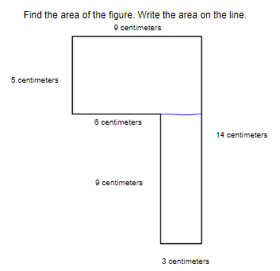

* Students may add all sides of the parts of the figure once it is decomposed to determine the perimeter of the composite figure. For example in the figure shown, the student may find the perimeter to be (9 centimeters + 9 centimeters + 5 centimeters + 5 centimeters) + (9 centimeters + 9 centimeters = 3 centimeters + 3 centimeters) = 52 centimeters, when the correct answer is 9 centimeters + 14 centimeters + 3 centimeters + 9 centimeters + 6 centimeters + 5 centimeters = 46 centimeters.

Strategies to Support Tiered Instruction

* Instruction includes decomposing figures in multiple ways, finding the area of each individual rectangle and then finding the sum of the two rectangles.
  + For example, the teacher provides students with a composite figure and asks them to decompose the figure into two rectangles. Students draw and label the two rectangles as separate parts to show their understanding of how the side lengths have changed once the figure was decomposed. Then, students find the area of each individual rectangle. By drawing the two separate rectangles, students identify which measurements to use due to the decomposing of the figures. One example of how the figure can be decomposed is shown. Students may come up with other ways.

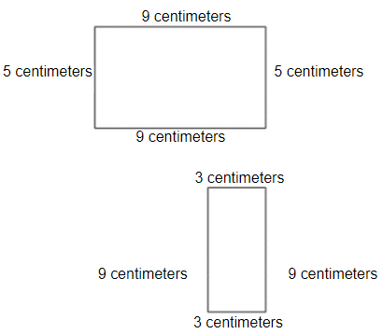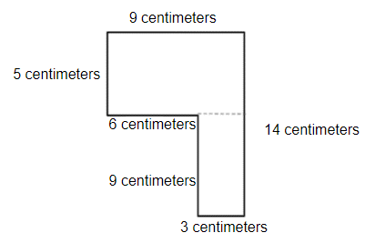

* Teacher provides composite figures created with unit squares. Students cut the figures to decompose them into two separate rectangles and label the dimensions for each figure. Students then find the sum of the area of the two rectangles.
  + For example, teacher provides students with figures similar to the one below. Students determine how they can decompose them into two rectangles (there could be more than one way). Students then cut the figure apart to show the two rectangles and write multiplication equations to represent the area of each part. Finally, students find the sum of the two areas and determine if the area is the same as the whole figure.
  + Students can find the perimeters of the two separate rectangles and then determine if the sum of the two perimeters is the same as the perimeter of the composite figure.

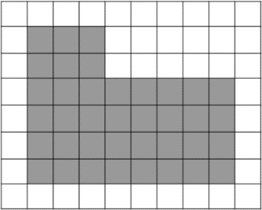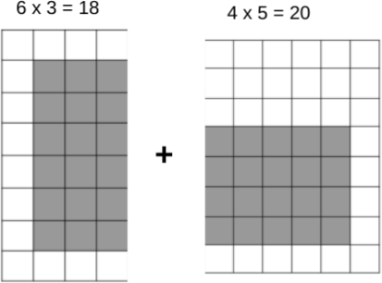

Instructional Tasks

*Instructional Task 1*

diagram for instructional task 1


Part A. Find the perimeter.

Part B. Find the area.

*Instructional Task 2*

Angie and her friends are heading to a fall festival and want to walk through the corn maze. Determine the perimeter and area of the corn maze.

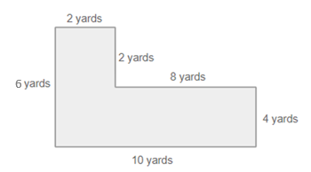

Instructional Items

*Instructional Item 1*

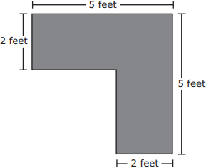A drawing of the top of a desk is shown.

What is the area of the top of the desk?

1. 14 square feet
2. 16 square feet
3. 20 square feet
4. 25 square feet

*Instructional Item 2*

Find the perimeter of the following figure.

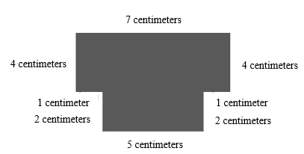

*Instructional Item 3*

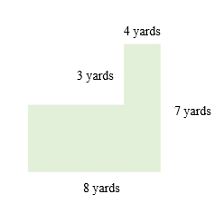A drawing of a field is shown.

What is the perimeter of the field?

|  |  |
| --- | --- |
| a. | 20 yards |
| b. | 30 yards |
| c. | 35 yards |
| d. | 38 yards |

*The strategies, tasks and items included in the B1G-M are examples and should not be considered comprehensive.

## **Data Analysis & Probability**

**MA. 3.DP.1** *Collect, represent and interpret numerical and categorical data.*

### **MA.3.DP.1.1**

Benchmark

MA.3.DP.1.1 Collect and represent numerical and categorical data with whole-number values using tables, scaled pictographs, scaled bar graphs or line plots. Use appropriate titles, labels and units

Benchmark Clarifications:

*Clarification 1:* Within this benchmark, the expectation is to complete a representation or construct a representation from a data set.

*Clarification 2:* Instruction includes the connection between multiplication and the number of data points represented by a bar in scaled bar graph or a scaled column in a pictograph.

*Clarification 3:* Data displays are represented both horizontally and vertically.

Connecting Benchmarks/Horizontal Alignment

* MA.3.NSO.2.2/2.4
* MA.3.GR.1.1

Terms from the K-12 Glossary

* Bar Graph
* Categorical Data
* Whole Number

Vertical Alignment

|  |  |
| --- | --- |
| **Previous Benchmarks**   * MA.2.DP.1.1 | **Next Benchmarks**   * MA.4.DP.1.1 |

Purpose and Instructional Strategies

The purpose of this benchmark is for students to represent numerical and categorical data using tables, scaled pictographs, scaled bar graphs or line plots, using appropriate titles, tables and units. Though there are many skills included in this benchmark, students bring background knowledge from Grades 1 and 2 when they collected, categorized and represented data in tables, pictographs and bar graphs. In Grade 2, students were expected to represent data with appropriate titles, labels and units.

* Before instruction begins, teachers can provide students with opportunities of reading and solving problems using scaled graphs before being asked to draw one. These skills will assist students with determining what they already know. This will save instructional time that can be focused on the Grade 3 extensions explained in the next paragraph *(MTR.3.1)*.
* Instruction may include opportunities for students to collect and display their own numerical and categorical data *(MTR.7.1)*.
* In Grade 3, two extensions of previous understandings about collecting and representing data occur. First, categorical data represented in pictographs and bar graphs are scaled. Students use their understanding of multiplication to read the data representations appropriately. Second, students represent numerical data in line plots, which shows the frequency of data on a number line *(MTR.2.1)*.
* During instruction, it is important to remind students that scales on graphs begin with 0.
* Because the expectation is to represent data with whole-number values, number lines do not need to be partitioned into fractional parts. Students will represent fractional values beginning in Grade 4.
* During instruction, it is important that students have the opportunity to display data horizontally and vertically. Their work with MA.3.GR.1.1 will be beneficial in making graphs that are accurate representations.

Common Misconceptions or Errors

* Students may confuse which types of data (categorical or numerical) can be displayed with a data representation. In Grades 1 and 2, students graphed frequency of categorical data in pictographs and bar graphs. Representing frequency in numerical data graphed via line plots is a new expectation in Grade 3. During instruction, expect students to justify the representations they choose based on the data collected.
* Students tend to count each square as one for intervals on bar graphs that are not single units.

Strategies to Support Tiered Instruction

* Instruction includes how to decide which way to display data (numerical vs. categorical).

The teacher provides examples of when to use pictographs and bar graphs, and when to use line plots.

* + For example, students measure the lengths of pencils to the nearest $\frac{1}{2}$ inch. Because the students are finding a numerical measurement, this data would be graphed on a line plot.
* Instruction includes how to decide which way to display their data (numerical vs. categorical). The teacher provides examples of when to use pictographs and bar graphs, and when to use a line plot. Also, the teacher provides instruction regarding how numerical data refers to data that is in the form of numbers and categorical data is a type of data that is divided into groups.
  + For example, categorical data could be favorite colors, types of pets at home or hair color. Types of numerical data could be ages of students, numbers of siblings at home or the results of the measurement of objects.
* Instruction includes opportunities to count the correct intervals on a scaled bar graph. The teacher provides instruction for identifying the scale and showing students how to read the bars according to the scale.

Instructional Tasks

*Instructional Task 1*

The data below shows the ages of students in an art class and their favorite colors.

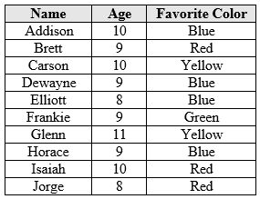

Part A. Represent the ages of the students in the art class using a line plot.

Part B. Represent the favorite colors of the students in an art class using a scaled pictograph.

*Instructional Task 2*

Survey your classmates about their favorite color. Collect the data in a table and represent your data in a pictograph, bar graph or line plot.

Instructional Items

*Instructional Item 1*

Rebecca surveyed the ages of kids visiting a movie theater and displayed the data using a line plot. The customers’ ages are below. Which line plot correctly displays the data that Rebecca collected?

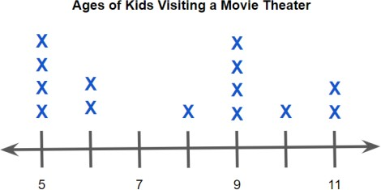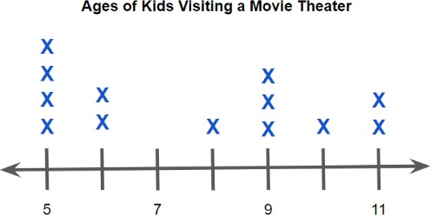

5, 11, 9, 5, 6, 5, 9, 9, 8, 10, 6, 11, 9, 5

**Ages of Kids Visiting a Movie Theater**

a. b.

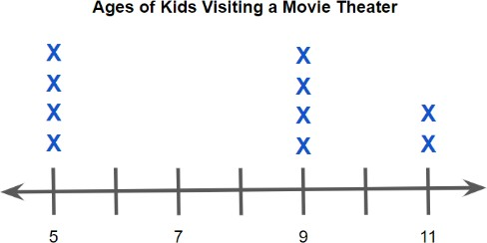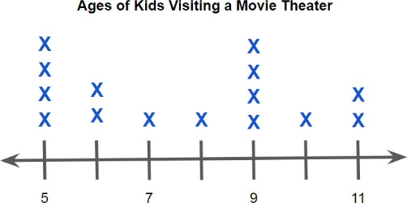

c. d.

*Instructional Item 2*

Matthew surveyed his classmates' favorite animals and displayed the data using a pictograph. The favorite animals are displayed below. Which pictograph correctly displays the data Matthew collected?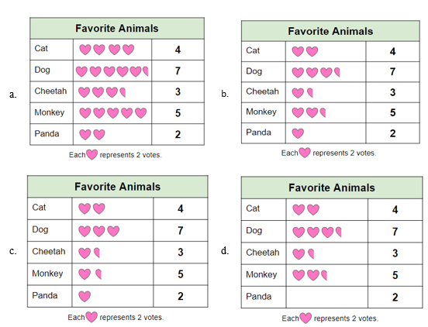

*The strategies, tasks and items included in the B1G-M are examples and should not be considered comprehensive.

### MA.3.DP.1.2

Benchmark

MA.3.DP.1.2 Interpret data with whole-number values represented with tables, scaled pictographs, circle graphs, scaled bar graphs or line plots by solving one- and two-step problems

Benchmark Clarifications:

*Clarification 1:* Problems include the use of data in informal comparisons between two data sets in the same units.

*Clarification 2:* Data displays can be represented both horizontally and vertically.

*Clarification 3:* Circle graphs are limited to showing the total values in each category.

Connecting Benchmarks/Horizontal Alignment

* MA.3.NSO.2.2/2.4

Terms from the K-12 Glossary

* Bar Graph
* Categorical Data
* Circle Graph

Vertical Alignment

|  |  |
| --- | --- |
| **Previous Benchmarks**   * MA.2.DP.1.2 | **Next Benchmarks**   * MA.4.DP.1.3 |

Purpose and Instructional Strategies

The purpose of this benchmark is for students to interpret data displayed in scaled pictographs, circle graphs, scaled bar graphs and line plots. Like MA.3.DP.1.1, the purpose of this benchmark builds on data interpretation skills from Grades 1 and 2. In Grade 1, students interpreted data represented with tally marks and pictographs, and in Grade 2, students also interpreted data represented in pictographs and bar graphs. Additionally, students solved addition and subtraction problems using the data representations.

* In Grade 3, students will interpret categorical data represented in scaled pictographs and bar graphs, whole-number numerical data represented in line plots, and whole-number category totals in circle graphs (e.g., instead of percentages). To interpret the represented data, they will solve one- and two-step problems from a given data set or compare two data sets in the same units *(MTR.5.1)*.
* Instruction can include opportunities for students to interpret their own numerical and categorical data *(MTR.7.1)*.
* Students could use addition, subtraction, multiplication or division to solve the problems. This benchmark is most often taught with MA.3.DP.1.1 (collecting and representing data) *(MTR.2.1, MTR.4.1, MTR.5.1*).

Common Misconceptions or Errors

* Students may confuse the values in scaled pictographs and bar graphs. Utilizing a given key when determining frequency of each category will help build this skill.

Strategies to Support Tiered Instruction

* Instruction includes opportunities to determine the values in a scaled pictograph, pointing

out the importance of paying close attention to the key of the pictograph. The key outlines how much each of the pictures on the graph will represent. Students connect multiplication strategies to this concept. Instruction includes opportunities to practice counting by 2s, 5s and 10s, to be successful with this benchmark. To help students see the connection between the key and what each picture represents, a bar diagram may be helpful.

* + Instruction includes opportunities to determine the values in a scaled pictograph, pointing out the importance of paying close attention to the key of the pictograph. The key outlines how much each of the pictures on the graph will represent. Students connect multiplication strategies to this concept. Instruction includes opportunities to practice counting by 2s, 5s and 10s, to be successful with this benchmark. To help students see the connection between the key and what each picture represents, a bar diagram may be helpful.

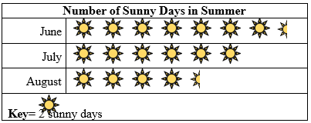

* + 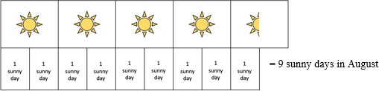For example, students use the key for the pictograph and a bar model to determine the number of sunny days in August.

Instructional Tasks

*Instructional Task 1 (MTR.4.1, MTR.8.1)*

The pictographs show favorite subjects in Grade 3 and Grade 4 at Palm Elementary School.

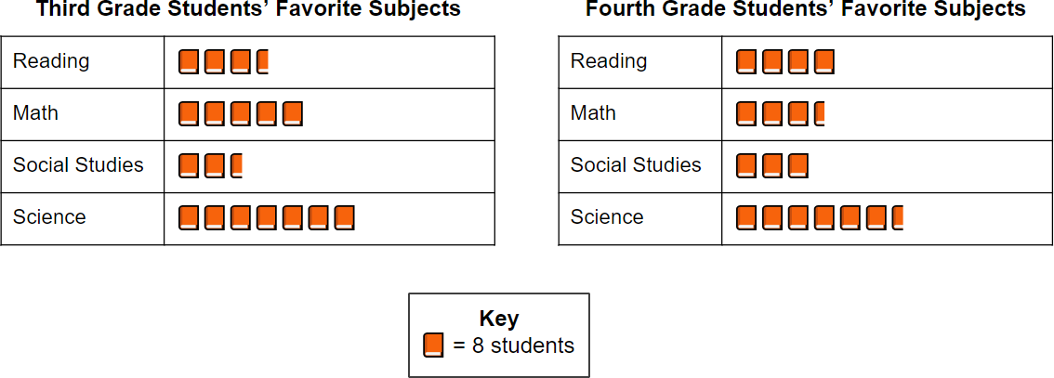

Part A. Write an equation that shows how many fourth graders chose reading as their favorite subject.

Part B. How many third graders chose social studies as their favorite subject?

Part C. How many more students prefer math in Grade 3 than Grade 4?

*Instructional Task 2*

Grade 3 students at Sunshine Elementary were surveyed after their class party to see how many donuts they ate. The results are shown in the line plot below.

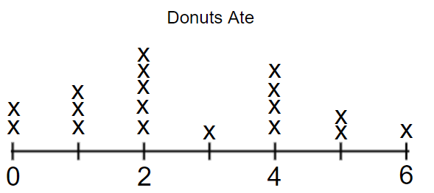

Part A. How many total donuts did the class eat?

Part B. How many students ate less than 3 donuts?

Instructional Items

Instructional Item 1

John surveys his classmates about their favorite foods, as shown in the bar graph. How many more classmates chose pizza as their favorite food than classmates who chose salad?

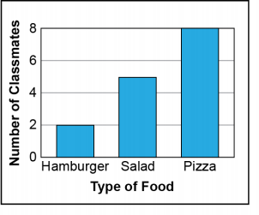

Instructional Item 2

Molly surveys her class about their favorite ice cream flavors, as shown in the circle graph. How many students picked a favorite ice cream flavor other than vanilla?

Mint - 7 students



Vanilla - 11 students

Strawberry - 4 students

Chocolate - 8 students

Instructional Item 3

Andre surveys students in Grade 4 about their favorite types of shoes, as shown in the pictograph. How many more people like sneakers more than flip flops?

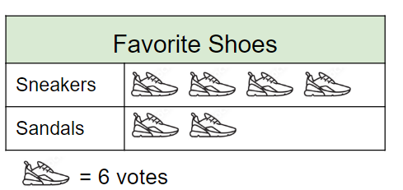

*The strategies, tasks and items included in the B1G-M are examples and should not be considered comprehensive.

Appendix A. Summary of Changes

The purpose of this table is to provide a summary of changes from for the latest version of the B1G-M. For questions or feedback on the B1G-M, please direct them to [BESTMath@fldoe.org](mailto:BESTMath@fldoe.org).

| **Benchmark** | **B1G-M Component** | **Change Made** |
| --- | --- | --- |
| MA.3.NSO.1.1 | Purpose and Instructional Strategies | Added more details |
| MA.3.NSO.1.1 | Previous Benchmarks | Added another benchmark |
| MA.3.NSO.1.1 | Instructional Tasks | Added 2 tasks |
| MA.3.NSO.1.1 | Instructional Items | Added 3 items |
| MA.3.NSO.1.2 | Purpose and Instructional Strategies | Added more details |
| MA.3.NSO.1.2 | Terms from K-12 Glossary | Added 2 new words |
| MA.3.NSO.1.2 | Previous Benchmarks | Added another benchmark |
| MA.3.NSO.1.2 | Instructional Tasks | Added 2 tasks |
| MA.3.NSO.1.2 | Instructional Items | Added 3 items |
| MA.3.NSO.1.3 | Purpose and Instructional Strategies | Added information about ascending and descending order to section |
| MA.3.NSO.1.3 | Connecting Benchmarks | Added 2 benchmarks |
| MA.3.NSO.1.3 | Terms from K-12 Glossary | Added 3 new words |
| MA.3.NSO.1.3 | Instructional Tasks | Added 3 tasks |
| MA.3.NSO.1.3 | Instructional Items | Added 3 tasks |
| MA.3.NSO.1.4 | Purpose and Instructional Strategies | Added more details to section |
| MA.3.NSO.1.4 | Connecting Benchmarks | Added 2 benchmarks |
| MA.3.NSO.1.4 | Instructional Tasks | Added 3 tasks |
| MA.3.NSO.1.4 | Instructional Items | Added 2 items |
| MA.3.NSO.2.1 | Purpose and Instructional Strategies | Added more details to section |
| MA.3.NSO.2.1 | Terms from K-12 Glossary | Added 1 new word |
| MA.3.NSO.2.1 | Next Benchmarks | Added 1 new benchmark |
| MA.3.NSO.2.1 | Common Misconceptions or Errors | Added misconception about learning conceptual understanding prior to using standard algorithms |
| MA.3.NSO.2.1 | Strategies for Tiered Instruction | Added clarification on last bullet point |
| MA.3.NSO.2.1 | Instructional Tasks | Added 3 tasks |
| MA.3.NSO.2.1 | Instructional Tasks | Added 2 items |
| MA.3.NSO.2.2 | Terms from K-12 Glossary | Added 3 new words |
| MA.3.NSO.2.2 | Connecting Benchmarks | Added 4 benchmarks |
| MA.3.NSO.2.2 | Instructional Tasks | Added 3 tasks |
| MA.3.NSO.2.2 | Instructional Items | Added 3 items |
| MA.3.NSO.2.3 | Instructional Tasks | Added 3 tasks |
| MA.3.NSO.2.3 | Instructional Items | Added 2 items |
| MA.3.NSO.2.4 | Connecting Benchmarks | Removed 1 benchmark; Added 2 benchmarks |
| MA.3.NSO.2.4 | Terms from K-12 Glossary | Added 5 new words |
| MA.3.NSO.2.4 | Strategies for Tiered Instruction | Bullet point 3 added new visual for last part (previous one is incorrect mathematically) |
| MA.3.NSO.2.4 | Instructional Tasks | Added 3 tasks |
| MA.3.NSO.2.4 | Instructional Items | Added 2 items |
| MA.3.FR.1.1 | Strategies for Tiered Instruction | Bullet point 1 added new number lines with fraction bars |
| MA.3.FR.1.1 | Instructional Tasks | Added 3 tasks |
| MA.3.FR.1.1 | Instructional Items | Added 3 items |
| MA.3.FR.1.2 | Connecting Benchmarks | Added 1 benchmark |
| MA.3.FR.1.2 | Strategies for Tiered Instruction | Added new number line visual |
| MA.3.FR.1.2 | Terms from K-12 Glossary | Added 2 new words |
| MA.3.FR.1.2 | Instructional Task | Added 1 task |
| MA.3.FR.1.2 | Instructional Items | Added 1 item |
| MA.3.FR.1.3 | Next Benchmarks | Added 1 benchmark |
| MA.3.FR.1.3 | Instructional Tasks | Added 2 tasks |
| MA.3.FR.1.3 | Instructional Items | Edited 2 tasks; added 2 tasks |
| MA.3.FR.2.1 | Purpose and Instructional Strategies | Edited for clarity |
| MA.3.FR.2.1 | Instructional Tasks | Two tasks added |
| MA.3.FR.2.1 | Instructional Items | One item added |
| MA.3.FR.2.2 | Instructional Tasks | Two tasks added |
| MA.3.FR.2.2 | Instructional Items | Edited typo in Instructional Item 1 |
| MA.3.FR.2.2 | Instructional Items | Revised task so that numerical values are within 1 whole |
| MA.3.AR.1.1 | Strategies to Support Tiered Instruction | Added language about using the distributive property to multiply two- and one-digit numbers |
| MA.3.AR.1.1 | Instructional Tasks | One task added |
| MA.3.AR.1.1 | Instructional Items | Revised Instructional Item 1 to remove addition expressions |
| MA.3.AR.1.1 | Instructional Items | Two items added |
| MA.3.AR1.2 | Strategies to Support Tiered Instruction | Added language to describe questions teachers may ask to help students relate real-world problems to visual models and expressions |
| MA.3.AR.1.2 | Instructional Tasks | Three tasks added |
| MA.3.AR.1.2 | Instructional Items | One item added |
| MA.3.AR.2.1 | Instructional Tasks | Three tasks added |
| MA.3.AR.2.1 | Instructional Items | Two items added |
| MA.3.AR.2.2 | Strategies to Support Tiered Instruction | Added multiplication and division examples to tables |
| MA.3.AR.2.2 | Instructional Tasks | Added two tasks |
| MA.3.AR.2.2 | Instructional Items | Added two items |
| MA.3.AR.2.3 | Instructional Tasks | One task added |
| MA.3.AR.2.3 | Instructional Items | One item added |
| MA.3.AR.3.1 | Instructional Tasks | One task added |
| MA.3.AR.3.1 | Instructional Items | One item added |
| MA.3.AR.3.2 | Instructional Tasks | One task added |
| MA.3.AR.3.2 | Instructional Items | One item added |
| MA.3.AR.3.3 | Instructional Tasks | Two tasks added |
| MA.3.AR.3.3 | Instructional Items | Two items added |
| MA.3.M.1.1 | Purpose and Instructional Strategies | Added language to include instruction with different types of measuring containers so that metric and customary units of volume are measured |
| MA.3.M.1.1 | Strategies to Support Tiered Instruction | Added language to include strategies for utilizing error analysis during instruction |
| MA.3.M.1.1 | Instructional Tasks | Two tasks added |
| MA.3.M.1.1 | Instructional Items | One item added |
| MA.3.M.1.2 | Instructional Tasks | Two tasks added |
| MA.3.M.1.2 | Instructional Items | Two items added |
| MA.3.M.2.1 | Instructional Tasks | Added another task |
| MA.3.M.2.1 | Instructional Item | Added another item |
| MA.3.M.2.2 | Instructional Task | Added another task with a pre-marked number line, asked for start time |
| MA.3.M.2.2 | Instructional Item | Added another item- 2 step word problem |
| MA.3.GR.1.1 | Common Misconceptions or Errors | Added in “or index card” |
| MA.3.GR.1.1 | Strategies to Support Tiered Instruction | Change definition of perpendicular lines removing “right angles” and changing to square angles or square corners |
| MA.3.GR.1.1 | Instructional Tasks | Added another task |
| MA.3.GR.1.1 | Instructional Items | Added another item |
| MA.3.GR.1.2 | Instructional Tasks | Added another task-different attribute |
| MA.3.GR.1.2 | Instructional Items | Added another item |
| MA.3.GR.1.3 | Instructional Tasks | Added another task- shape example |
| MA.3.GR.1.3 | Instructional Items | Added another item- which line of symmetry is not drawn correctly |
| MA.3.GR.2.1 | Instructional Tasks | Added another task- count the squares and find the area |
| MA.3.GR.2.1 | Instructional Items | Added another item |
| MA.3.GR.2.2 | Instructional Items | Replaced “in.” abbreviation to inches on image |
| MA.3.GR.2.2 | Instructional Items | Added another item |
| MA.3.GR.2.2 | Instructional Tasks | Added another task |
| MA.3.GR.2.3 | Instructional Tasks | Added another task- students measure a rectangle and then find the area and perimeter. |
| MA.3.GR.2.3 | Instructional Items | Replaced units of measure abbreviations |
| MA.3.GR.2.3 | Instructional Items | Added another item |
| MA.3.GR.2.4 | Common Misconceptions or Errors | Replaced images with units of measure abbreviations |
| MA.3.GR.2.4 | Instructional Task | Added another task |
| MA.3.GR.2.4 | Instructional Item | Added another item |
| MA.3.DP.1.1 | Instructional Task | Added another task |
| MA.3.DP.1.1 | Instructional Items | Added another item- pictograph |
| MA.3.DP.1.2 | Instructional Task | Added another task |
| MA.3.DP.1.2 | Instructional Item | Added another item |