
Series 2009-12D (Revised) February 2009

Trends in Discipline and the Decline in the Use of Corporal Punishment

Introduction
Corporal punishment is defined by Florida Statutes as the moderate use of physical force or physical contact by a teacher or principal to maintain discipline or to enforce school rules. The school board shall have the authority to prohibit the use of corporal punishment, provided that the school board adopts or has adopted a written program of alternative control or discipline (s. 1006.07(1), Florida Statutes).
Over the past twenty years, the use of corporal punishment by Florida school districts has drastically decreased (see table below). For the 2007-08 school year, there were 4,869 students receiving corporal punishment, compared to 84,495 in 1987-88.
In 2007-08, 30 school districts reported students receiving corporal punishment. In 1987-88, all school districts administered corporal punishment except Palm Beach. (Note that these figures reflect the number of students receiving the discipline.) In 1992-93, sixteen districts reported no use of corporal punishment at all. Since then, districts have steadily reported fewer students receiving corporal punishment.
Figure 1: Corporal Punishment versus In-School and Out-of-School Suspensions
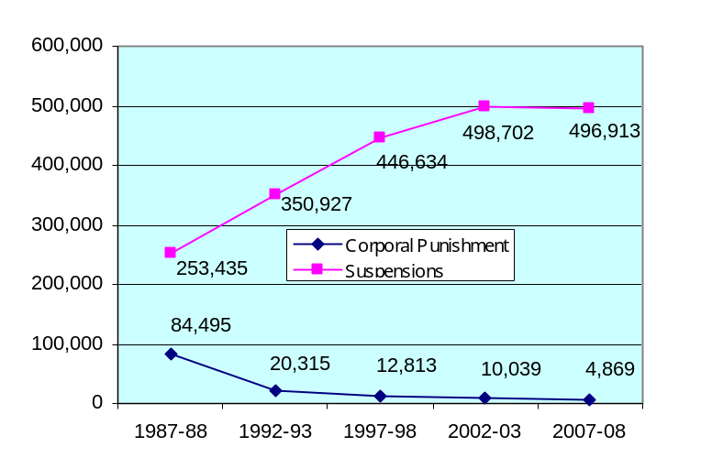
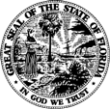
Florida Department of Education
Eric J. Smith, Commissioner

Discipline by Race
The graphs below reflect the racial breakdown within each disciplinary action.
Figure 2: Corporal Punishment
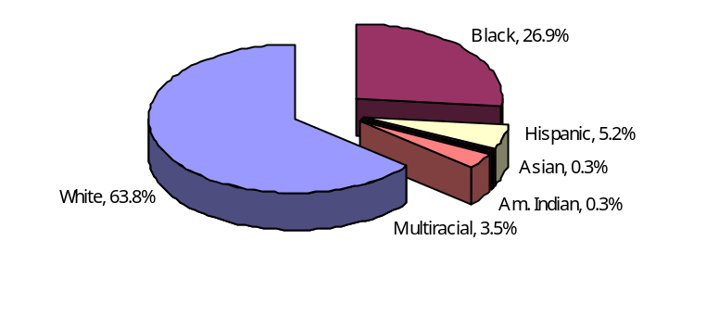
Figure 3: In-School Suspension
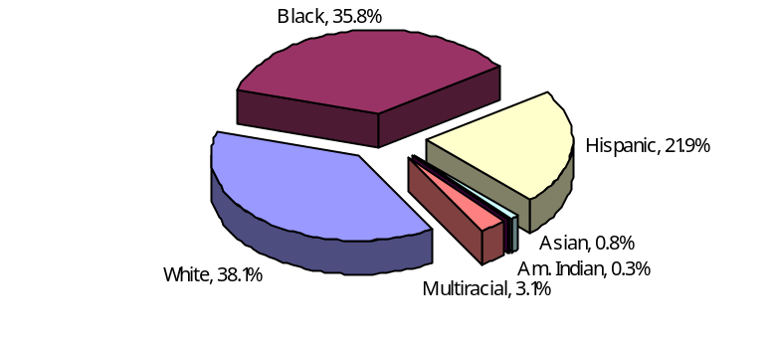
Figure 4: Out-of-School Suspension
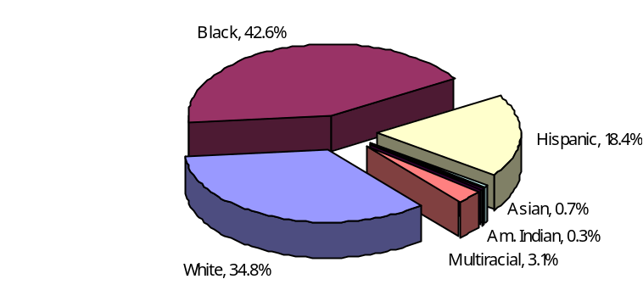
Figure 5: Expulsion
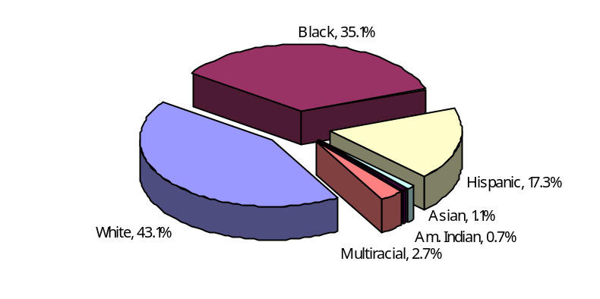

Table 1: Student Discipline Data, 2007-08
 |  | Suspensions
District |  | Out-of-School* | In-School* | Corporal Punishment* | Expulsions | Membership
1 | ALACHUA | 964 | 57 |  |  | 27,203
2 | BAKER | 240 | 123 | 9 | 11 | 5,066
3 | BAY | 2,468 | 2,708 | 27 | 51 | 25,956
4 | BRADFORD | 375 | 795 |  |  | 3,400
5 | BREVARD | 8,518 | 3,452 |  | 60 | 73,076
6 | BROWARD | 10,833 | 20,566 |  |  | 256,186
7 | CALHOUN | 80 | 190 | 153 | 1 | 2,246
8 | CHARLOTTE | 1,431 | 1,879 |  | 5 | 17,361
9 | CITRUS | 1,557 | 1,942 |  | 44 | 16,028
10 | CLAY | 2,691 | 5,993 | 116 | 15 | 35,996
11 | COLLIER | 1,303 | 5,705 |  |  | 42,530
12 | COLUMBIA | 1,170 | 2,071 |  | 4 | 10,058
13 | DADE | 20,517 | 28,323 |  |  | 344,913
14 | DESOTO | 300 | 3 | 33 | 10 | 4,952
15 | DIXIE | 243 | 356 | 18 | 2 | 2,119
16 | DUVAL | 22,849 | 18,409 |  | 1 | 122,606
17 | ESCAMBIA | 7,482 | 1,767 |  |  | 40,921
18 | FLAGLER | 1,119 | 1,784 |  |  | 12,890
19 | FRANKLIN | 101 | 167 | 14 |  | 1,285
20 | GADSDEN | 1,509 | 1,070 |  | 39 | 6,414
21 | GILCHRIST | 258 | 395 | 104 | 3 | 2,750
22 | GLADES | 204 | 201 | 13 | 5 | 1,388
23 | GULF | 216 | 383 | 123 |  | 2,050
24 | HAMILTON | 388 | 455 | 176 | 9 | 1,952
25 | HARDEE | 420 | 64 | 182 | 8 | 5,107
26 | HENDRY | 1,021 | 934 | 216 |  | 7,039
27 | HERNANDO | 2,330 | 3,859 |  | 11 | 22,721
28 | HIGHLANDS | 1,248 | 2,943 | 62 | 15 | 12,281
29 | HILLSBOROUGH | 13,510 | 29,783 |  | 66 | 191,965
30 | HOLMES | 186 | 43 | 455 |  | 3,399
31 | INDIAN RIVER | 1,997 | 1,730 |  | 6 | 17,606
32 | JACKSON | 867 | 1,039 | 844 | 10 | 7,319
33 | JEFFERSON | 282 | 14 | 18 | 5 | 1,106
34 | LAFAYETTE | 37 | 208 |  |  | 1,118
35 | LAKE | 4,249 | 2,783 |  | 24 | 40,996
36 | LEE | 7,362 | 10,423 |  | 40 | 79,451
37 | LEON | 2,597 | 3,392 |  |  | 32,537
38 | LEVY | 697 | 1,415 | 129 | 14 | 6,022
39 | LIBERTY | 61 | 161 | 133 |  | 1,484
40 | MADISON | 423 | 598 | 83 |  | 2,715
41 | MANATEE | 5,235 | 5,000 |  |  | 42,584
42 | MARION | 4,934 | 3,500 | 185 | 4 | 41,547
43 | MARTIN | 1,805 | 875 |  | 1 | 18,067
44 | MONROE | 499 | 857 | 1 | 1 | 8,278
45 | NASSAU | 841 | 1,330 | 26 | 3 | 10,980
46 | OKALOOSA | 2,553 | 722 |  | 3 | 29,123
47 | OKEECHOBEE | 1,052 | 858 |  | 35 | 7,003
48 | ORANGE | 12,034 | 10,015 |  | 4 | 172,028
49 | OSCEOLA | 6,894 | 5,139 |  | 67 | 51,955
50 | PALM BEACH | 16,417 | 11,387 |  |  | 170,745
51 | PASCO | 5,439 | 8,859 |  | 4 | 66,778
52 | PINELLAS | 8,348 | 15,637 |  | 21 | 106,046
53 | POLK | 14,014 | 8,252 | 26 | 40 | 94,716
54 | PUTNAM | 1,375 | 1,686 |  | 24 | 11,492
55 | ST. JOHNS | 1,996 | 969 |  | 1 | 28,916
56 | ST. LUCIE | 5,920 | 5,861 |  | 25 | 38,837
57 | SANTA ROSA | 1,148 | 1,583 | 517 | 8 | 25,397
58 | SARASOTA | 3,564 | 2,962 |  | 47 | 41,057
59 | SEMINOLE | 3,988 | 4,652 |  | 89 | 64,933
60 | SUMTER | 983 | 1,083 |  | 9 | 7,650
61 | SUWANNEE | 671 | 1,044 | 234 | 18 | 5,978
62 | TAYLOR | 562 | 869 |  | 5 | 3,299
63 | UNION | 236 | 279 | 133 |  | 2,315
64 | VOLUSIA | 6,977 | 10,260 |  |  | 63,065
65 | WAKULLA | 325 | 813 | 237 | 3 | 5,264
66 | WALTON | 405 | 616 | 332 | 7 | 7,002
67 | WASHINGTON | 323 | 603 | 270 |  | 3,534
68 | DEAF/BLIND | 9 | 10 |  |  | 646
72 | FAU LAB SCH | 14 | 77 |  |  | 2,018
73 | FSU CHTR SCH | 121 |  |  |  | 2,248
74 | FAMU LAB SCH | 28 |  |  |  | 462
75 | UF LAB SCH | 39 | 80 |  |  | 1,152
 | STATE | 232,852 | 264,061 | 4,869 | 878 | 2,628,754
*These figures reflect the number of students receiving the discipline within the discipline category.

*These figures reflect the number of students receiving the discipline within the discipline category.

