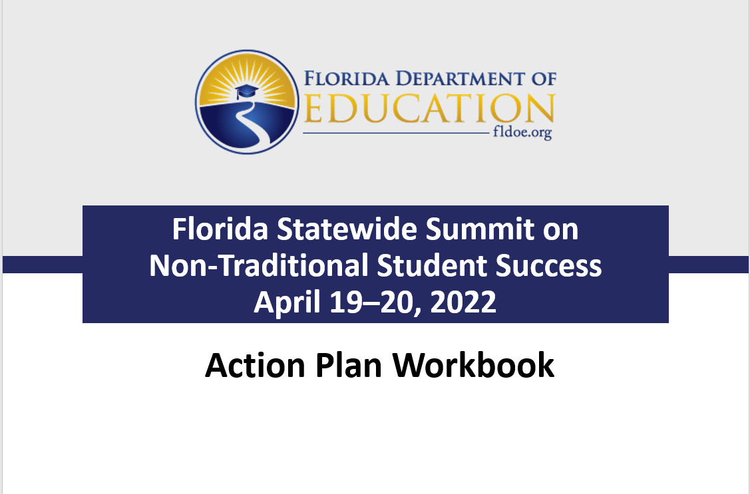

Introduction
This Action Plan Workbook will help you develop ways to reach more students while improving your Perkins performance measures.
These are the state targets for non-traditional concentration. Your initial agency numbers may differ, but the goal is for all agencies to meet or exceed the state level by 2023.
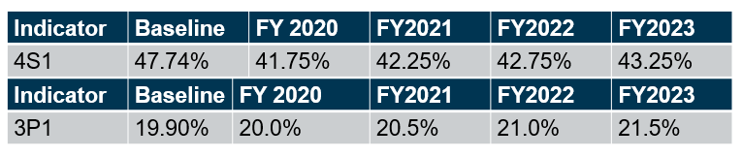
Work together with your group to do the following:
- Respond to discussion questions.
- Examine data to think of enrollment from different angles, and to identify program opportunities informed not only by student interests and goals but also by desired salaries and labor demand.
- Locate root causes behind why more students do not concentrate in non-traditional programs.
- Brainstorm solutions that will help in your location.
- List steps to increase non-traditional concentrators.
- Identify people, resources, information sources, you will need for your plan.
- Revise your plan using what you learned about solutions from research and in the field. Also use feedback from your colleagues.
A blank page is for you write down ideas, contacts, or otherwise take notes as you go.

Discussion Questions
Periodically we will raise discussion questions in our sessions. Here is a sample.
Icebreakers
- Think about a time that you had a good experience learning something (it does not need to be a school memory).
- If you could give your younger self advice about work, what would it be?
Program and employment data
- Where can you find state and national information about careers?
- How do our needs, wants, obligations, and perspectives on wages change with age or other circumstances? How can students learn about wages and career outlook?
Identifying challenges: Root causes
- Have you ever felt like a fish out of water? What helped you? How could you apply that to easing concerns students have about entering non-traditional fields?
- What are some voluntary, and involuntary motivations that determine which occupation a student enters? What factors, other than wages, influence what a job has to offer (e.g., other compensation, hours, flexibility)?
- How do workers adapt if their work does not offer benefits (health/dental insurance, paid time off, retirement)?
Solutions
- Do you think students ever regret entering an occupation? What are ways to avoid or to mitigate that experience?
- How can students get meaningful exposure to an occupation at the secondary and post-secondary level before they commit to it?
- How can basic needs affect student success?
Action plan
- Why should a student enroll/concentrate in your classes/programs of study? Can you give a succinct answer? If the answer includes job security or compensation, why do those matter? Can you address both short-term and long-term advantages? Are there only material benefits?
- It is common today for workers to work several occupations in a lifetime. Will your students be able to adapt if work circumstances change? What skills and tools will they acquire?
Program and Employment Data
Three purposes of the data section are to promote better understanding of non-traditional careers, to place local and state conditions in context, and perhaps even to help you think of non-traditional careers in different ways. In the space below, you can note potentially useful sources or points of information.
Which programs can you focus on to boost student concentration and career success? Are there any you had not previously considered you would like to further investigate?
For additional discussion: How can you find more about your local demographics, and about employment needs levels from the local to national level? How are careers changing? What concerns might students have about non-traditional occupations?

Identifying Challenges
As you complete this section, you can also refer to the US Department of Education, Office of Elementary and Secondary Education: https://oese.ed.gov/resources/oese-technical-assistance-centers/state-support-network/resources/approaches-root-cause-analysis/ .
Root causes
We will talk about the importance of using multiple lines of evidence. In your group, apply the “five whys” and “fishbone” techniques to pinpoint root causes.
The big question is why more workers do not enter non-traditional occupations. More specific to agencies is the question why more students do not concentrate in non-traditional fields.

Five “whys”

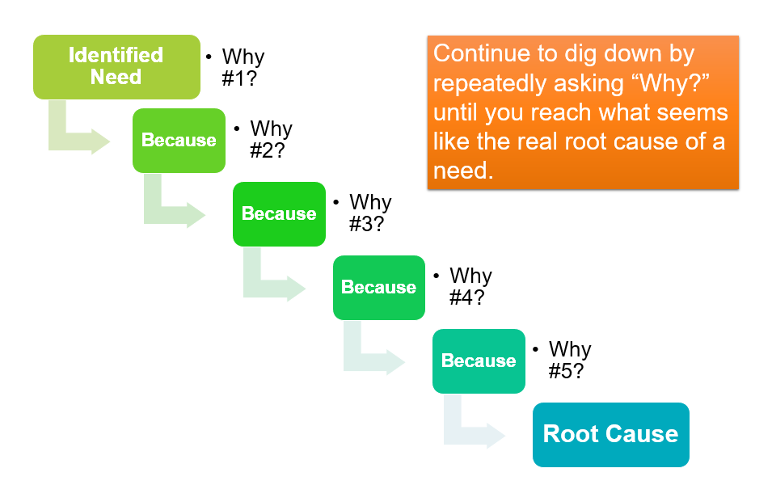
Fishbone diagrams
Another way to visualize both needs and their roots is to use a “fishbone” diagram. Another way to think of this is in terms of cause and effect, with the need (or challenge) being the effect, and the roots being the causes. This technique starts on the right-hand side with an effect and then brainstorms and categorizes potentials causes. Below is an example, followed by a blank chart for you to use regarding your agency.

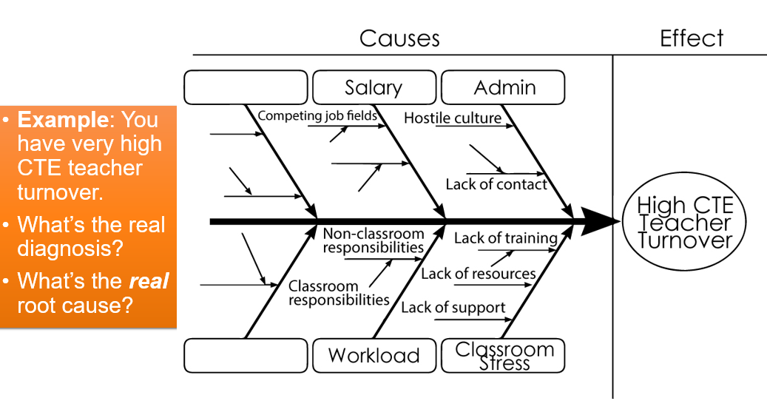

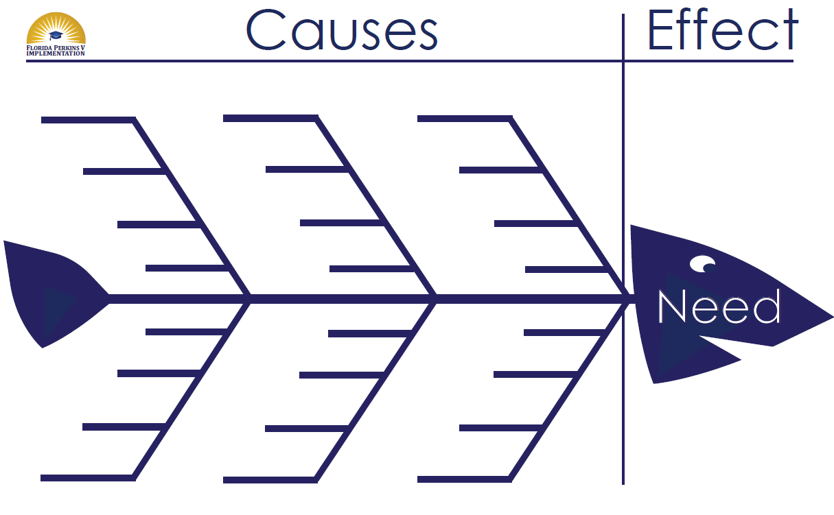

Prioitizing
You will not be able to address all identified needs.
Strategize how you wish to accomplish high-priority and medium-priority needs in your short-term and long-term planning.

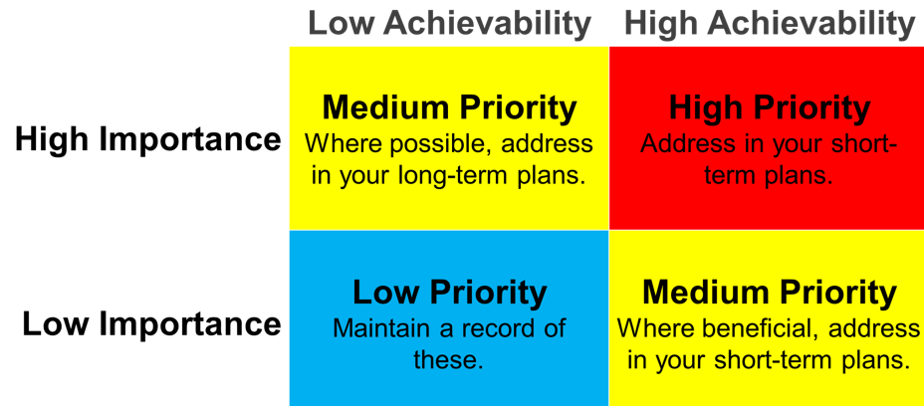

Challenges: Putting it all together
If the goal is to boost non-traditional student concentrators, and ultimately to increase workers in non-traditional fields, what needs or challenges are present at your agency, and what are the causes?
You may not be able to address all needs. Which challenges can you focus on for maximum impact? Prioritizing the top three challenges can help you optimize limited resources (e.g., time, energy, talent, materials). To help you prioritize, see the diagram on the following page.
List the three most important challenges you identified. List the two most important causes for each challenge.
1.

a.

b.

2.

a.

b.

3.

a.

b.

Solutions
Examine your three most important challenges and causes. Brainstorm to think of at least two things you can do to address each challenge.
Write down any ideas from this section of the presentation that you would like to try, or to learn more about.
You can use material from the presentation to help you respond.

Presentation question
How do agencies encourage learners to concentrate in, and complete, programs to enter satisfying, non-traditional careers?
Presentation answer
Agency collaboration informed by field experience, research, and student feedback is key.
To guide those conversations, consider six areas of the student experience as identified by field experience and research.
  - Planting the Seed
  - Defining the Student’s Career
  - Meeting Student Needs
  - Community
  - Education
  - Workplace

Identifying solutions
- Challenge.

- Solution.

- Solution.

- Challenge.

- Solution.

- Solution.

- Challenge.

- Solution.

- Solution.

Action Plan
Calendars, not “to-do-lists”
This does not need to be perfect. Set a tentative deadline for your specific tasks. Working backward from that date, which smaller tasks can you do you to advance your task?
Challenge #1: __________________________
Task #1 of Challenge #1: __________________________
Deadline: ______ Overall number of weeks: ______ Overall start date: ______
Sub-task #1: __________________________
Who will get the job done? __________________________
Deadline: ______ Number of weeks: ______ Start date: ______
Sub-task #2: __________________________
Who will get the job done? __________________________
Deadline: ______ Number of weeks: ______ Start date: ______

Challenge #1: __________________________
Task #2 of Challenge #1: __________________________
Deadline: ______ Overall number of weeks: ______ Overall start date: ______
Sub-task #1: __________________________
Who will get the job done? __________________________
Deadline: ______ Number of weeks: ______ Start date: ______
Sub-task #2: __________________________
Who will get the job done? __________________________
Deadline: ______ Number of weeks: ______ Start date: ______

Challenge #2: __________________________
Task #1 of Challenge #2: __________________________
Deadline: ______ Overall number of weeks: ______ Overall start date: ______
Sub-task #1: __________________________
Who will get the job done? __________________________
Deadline: ______ Number of weeks: ______ Start date: ______
Sub-task #2: __________________________
Who will get the job done? __________________________
Deadline: ______ Number of weeks: ______ Start date: ______

Challenge #2: __________________________
Task #2 of Challenge #2: __________________________
Deadline: ______ Overall number of weeks: ______ Overall start date: ______
Sub-task #1: __________________________
Who will get the job done? __________________________
Deadline: ______ Number of weeks: ______ Start date: ______
Sub-task #2: __________________________
Who will get the job done? __________________________
Deadline: ______ Number of weeks: ______ Start date: ______

Challenge #3: __________________________
Task #1 of Challenge #3: __________________________
Deadline: ______ Overall number of weeks: ______ Overall start date: ______
Sub-task #1: __________________________
Who will get the job done? __________________________
Deadline: ______ Number of weeks: ______ Start date: ______
Sub-task #2: __________________________
Who will get the job done? __________________________
Deadline: ______ Number of weeks: ______ Start date: ______

Challenge #3: __________________________
Task #2 of Challenge #3: __________________________
Deadline: ______ Overall number of weeks: ______ Overall start date: ______
Sub-task #1: __________________________
Who will get the job done? __________________________
Deadline: ______ Number of weeks: ______ Start date: ______
Sub-task #2: __________________________
Who will get the job done? __________________________
Deadline: ______ Number of weeks: ______ Start date: ______

Identifying resources
Identify leaders, volunteers, employers, workers, information sources, or other people and resources you will need for your plan.
Revising your plan
Revise your plan using what you learned about solutions from research and in the field. Also use feedback from your colleagues.

Task list: Putting it all together
Your final plan may look something like this.
Challenge and Root Causes | Solution Tasks or Sub-Tasks |  | Champion | Resources | Success Measures | Deadline | Time for Task | Start Date

Additional Notes
Thank you for joining us! Please use the space below to write down contacts, ideas, questions, or any other thoughts.

