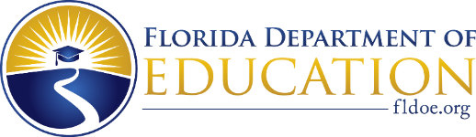

Dear Families,

In the VPK program, our goal is to help develop and nurture students’ early literacy and numeracy skills. This year, your child will be taking Renaissance Star Early Literacy to gauge their performance on early literacy and numeracy skills as part of the FAST Star Early Literacy. At minimum, the assessment will be administered at the beginning, middle and end of the program year to monitor your child’s progress.

Star Early Literacy is a computer-adaptive assessment designed to measure the early literacy skills of beginning readers. The assessment identifies the student’s mastery of literacy concepts that are related to their future success as readers. The assessment uses audio in which a narrator reads the questions to students. The questions get easier or more difficult depending on how the student responds. The assessment typically takes less than 15 minutes to complete. Your child’s score will place your child into a learning progression which helps the teacher know what your child may be ready to learn next to meet your child’s educational needs.

Your child will complete FAST Star Early Literacy assessments during the following dates:

Progress Monitoring 1 (PM1)
Progress Monitoring 2 (PM2)
Progress Monitoring 3 (PM3)

Do not hesitate to contact your child’s teacher with any questions regarding the implementation and progress monitoring of Star Early Literacy.

Thank you for partnering with us and supporting your child’s learning.

Customizable Section for VPK program Contact Information

Parents, you may contact DEL with questions related to FAST Star Early Literacy by completing the VPK Parent Form, the form will be submitted to VPKFAST@del.fldoe.org and a VPK representative will assist you.

