AGENDA

State Apprenticeship Advisory Council Meeting

Lively Technical College

500 Appleyard Dr, Tallahassee, FL 32304

April 19, 2023, 9:00 AM

9:00 AM Welcome/Pledge of Allegiance/ Roll Call/Introductions
Opening Remarks – Dr. Kevin O'Farrell, Chancellor of Career & Adult Education, FDOE
Council Round Table
Approval of November 17, 2022 SAAC Meeting Minutes
Recognition of Meritorious Service

Reports to the Council

9:45 AM

10:00 AM

10:15 AM

10:25 AM

10:55 AM

11:15 AM
Director’s Report, Kathryn Wheeler, FDOE

Legislative Update, Kathleen Taylor, FDOE

Updates from the U.S. Department of Labor, Garfield Garner, USDOL

Apprentice Florida, Samantha Dudley, FDOE

CareerSource Florida Resources for Successful Apprenticeships, Susan Bosse, CareerSource Florida

Pathways to Career Opportunity Grant, Julie Nichols, FDOE

11:30 AM

11:45 AM

12:00 Noon
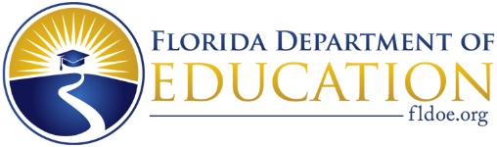
Presentation of Preapprenticeship and Facilitated Discussion

Public Comment Period

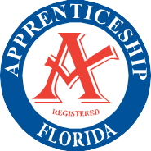
Adjourn

